***Project Name: Ewig Social Media***

This software is must be installed:

These Software are must be installed:

1. Nodejs.org link is: <https://nodejs.org/en/>
2. Git bash link is: <https://git-scm.com/downloads>
3. Visual Studio etc.

Node js:

**Node**.**js** (**Node**) is an open source development platform for executing **JavaScript** code server-side. And which is back-end.

Git Bash:

1. git: It is a version control system (VCS) which tracks the file changes, commonly used for programming in a team setting:
2. bash: It is a Unix shell command line interface commonly used in different Linux machines.

Create a folder.

Firstly, open the folder and open git-Bash.

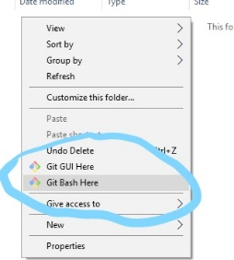

NPM Stands for Node package manager.

Init means inialize the application in first time.

Write commands in git bash:

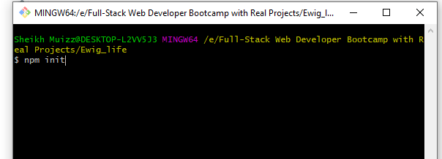

Now write description

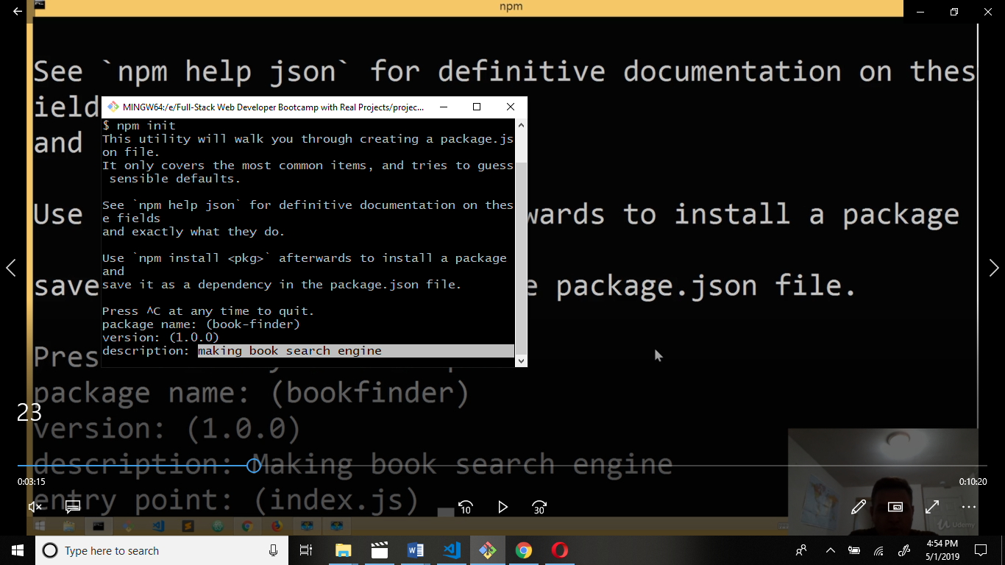

Now enter file name to run in the local server.

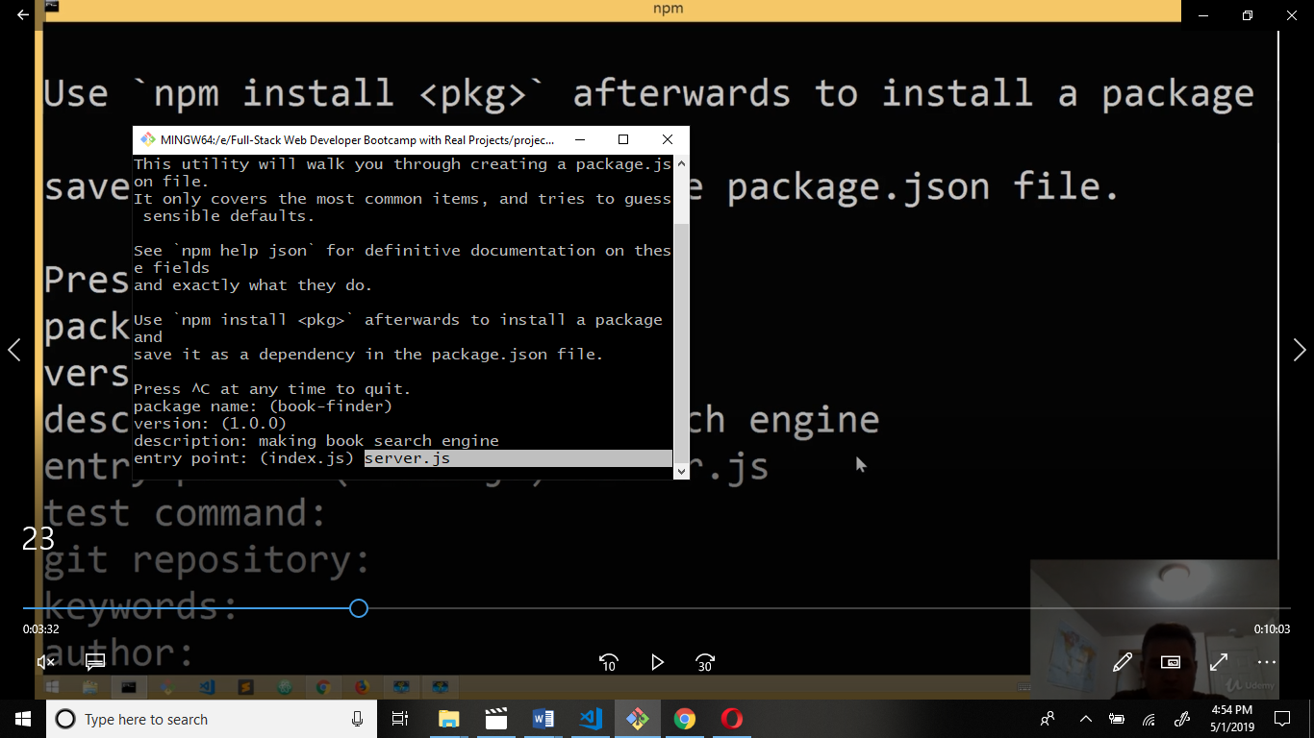

Author name:

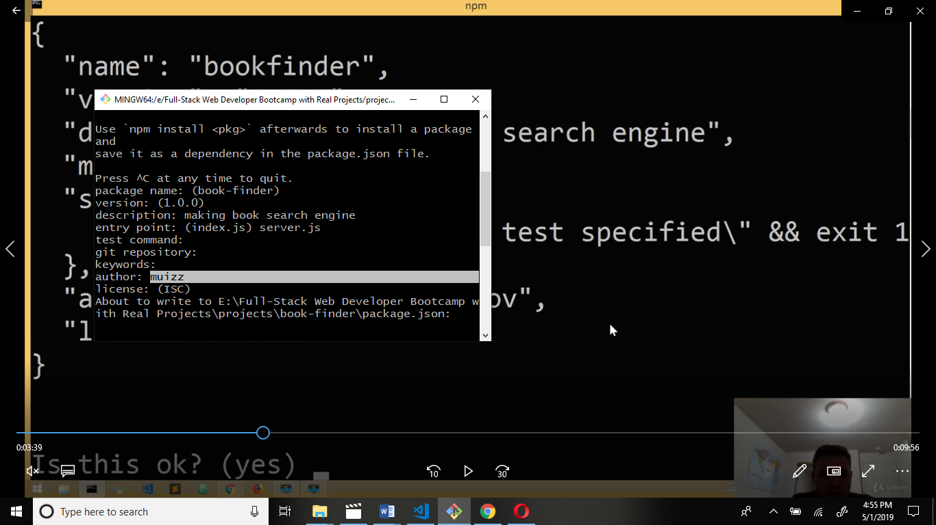

Output:

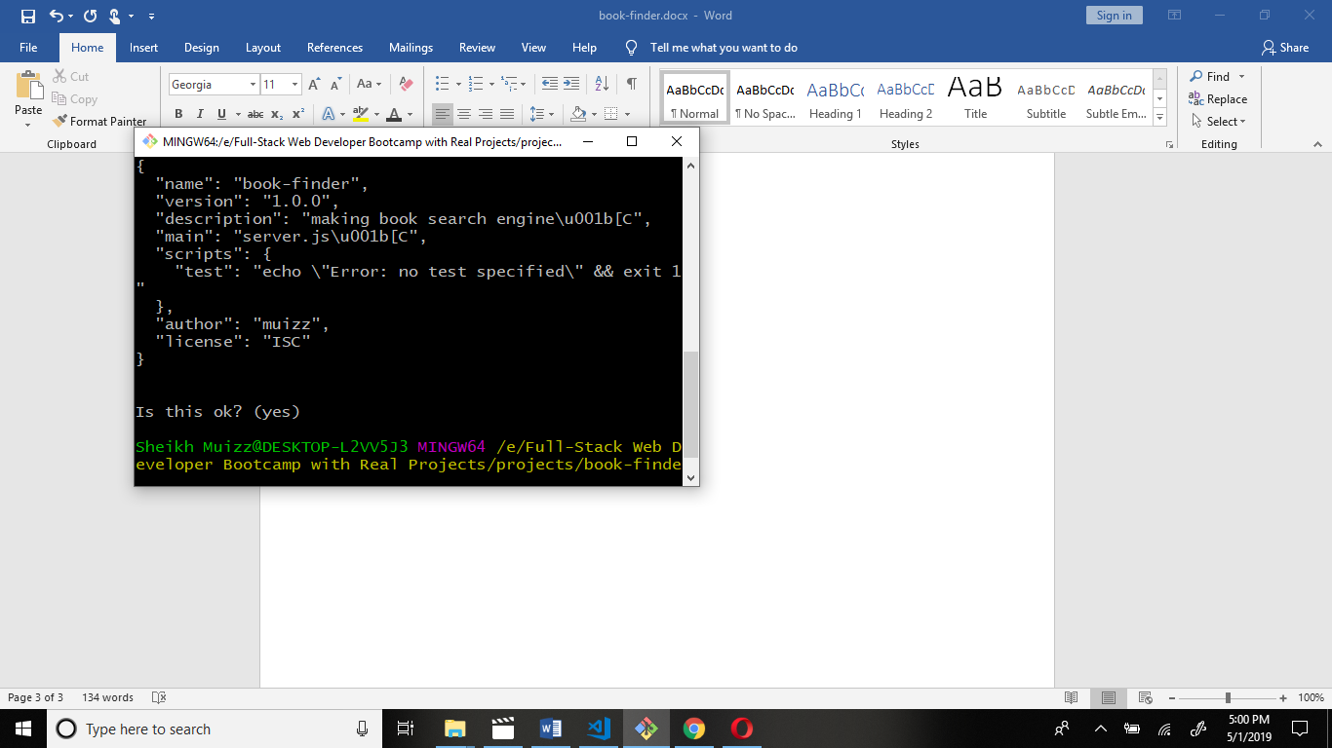

Open your folder in editor.

Open package.json file.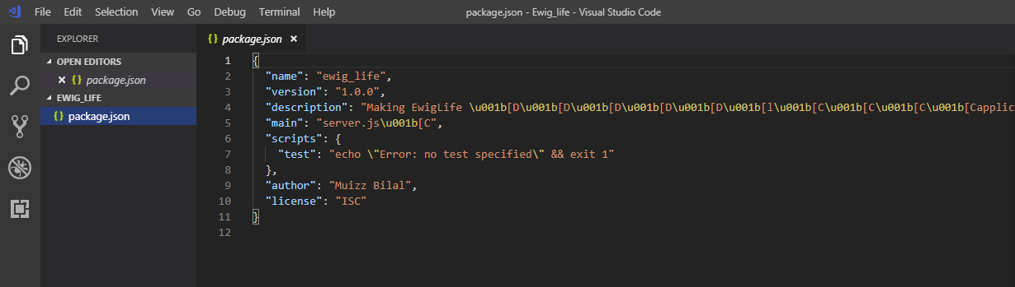

Next git-bash command is npm i or npm install these commands are same functionality So only one command is running.

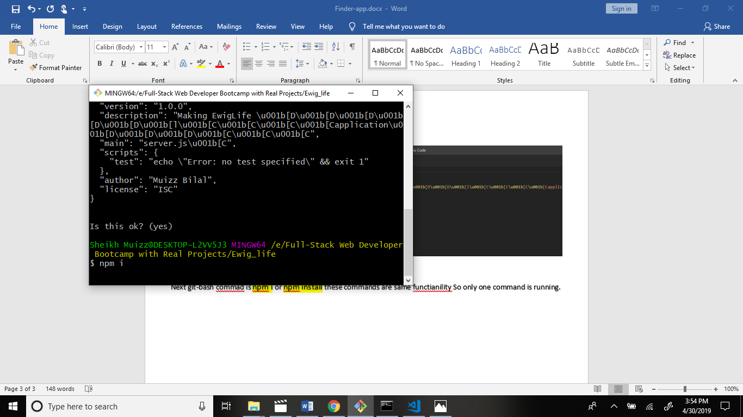

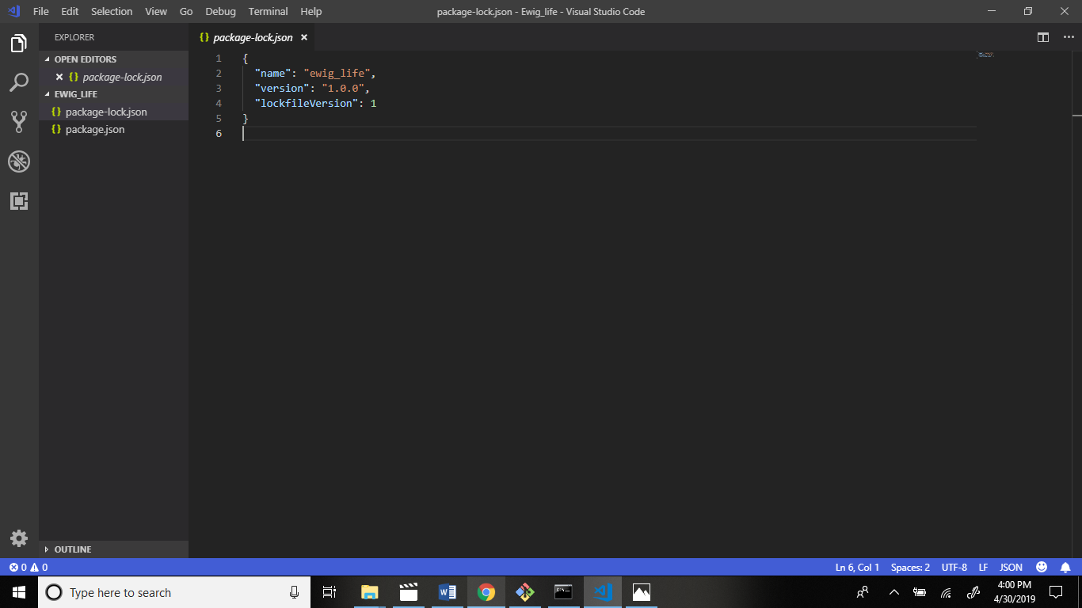

Now I build in local server = localhost:3000

We use express module to build server.

Firstly, install the express module.

Command: npm i express --save

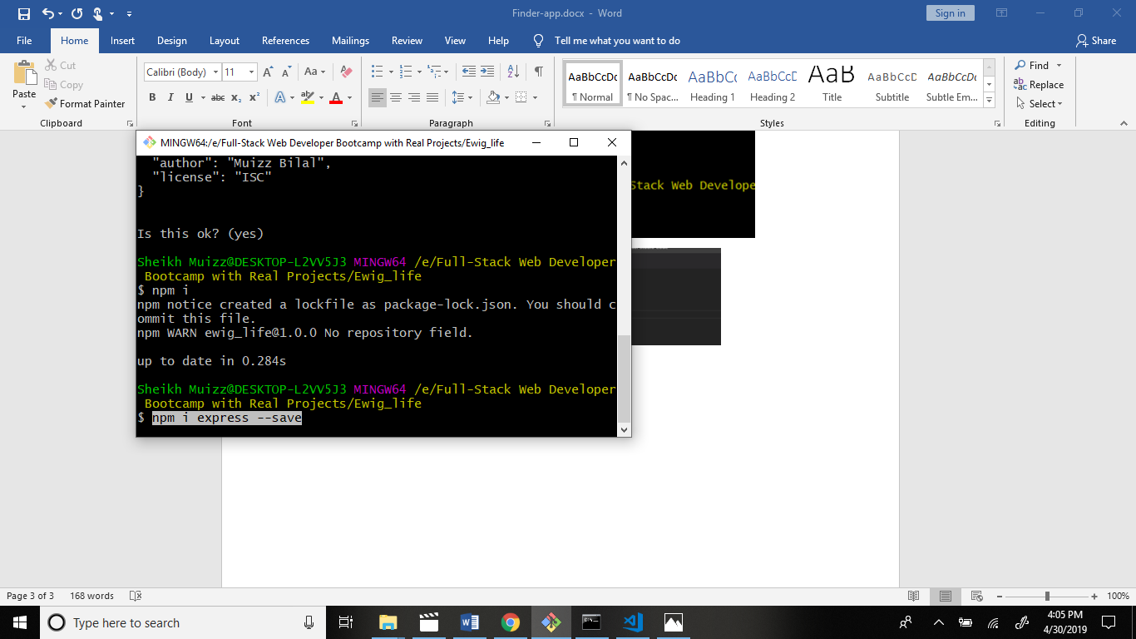

How we use – save? Because –save command is use to save the package in package.json file. Package.json file contain the all information about application.

Now we create file in app.js in main folder

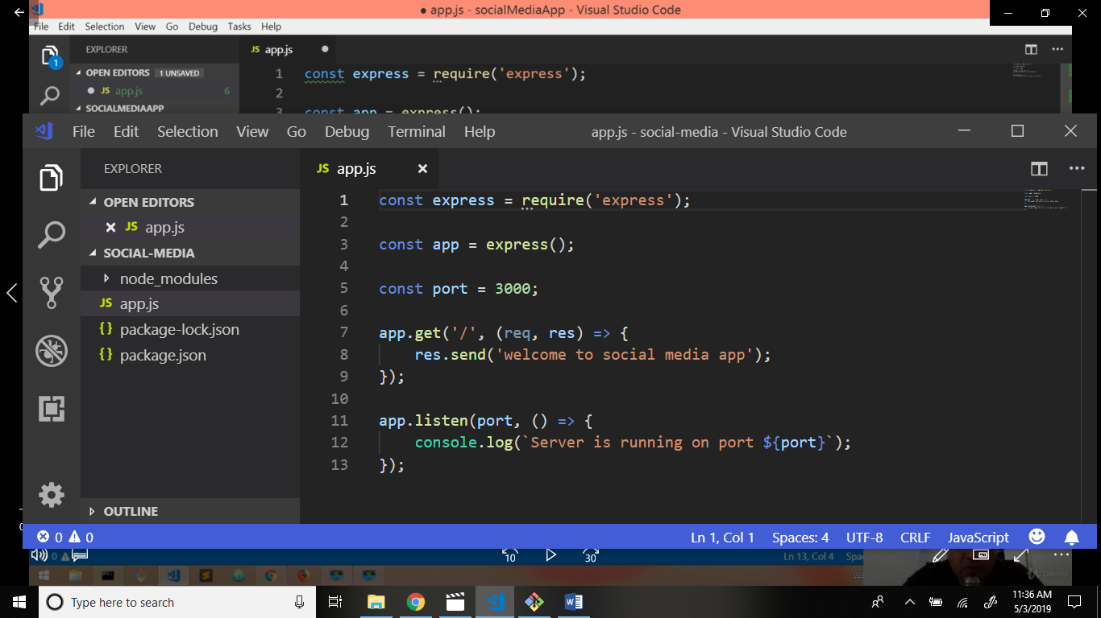

Now connect localserver:3000 through command.

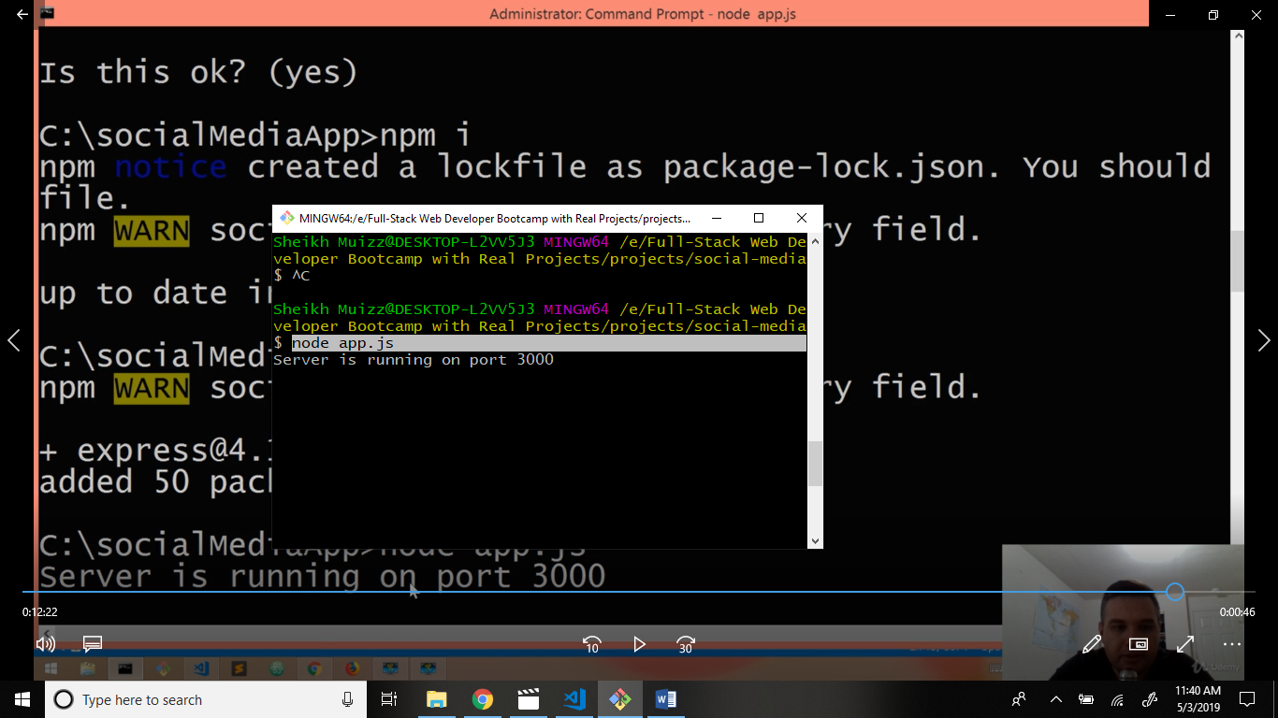

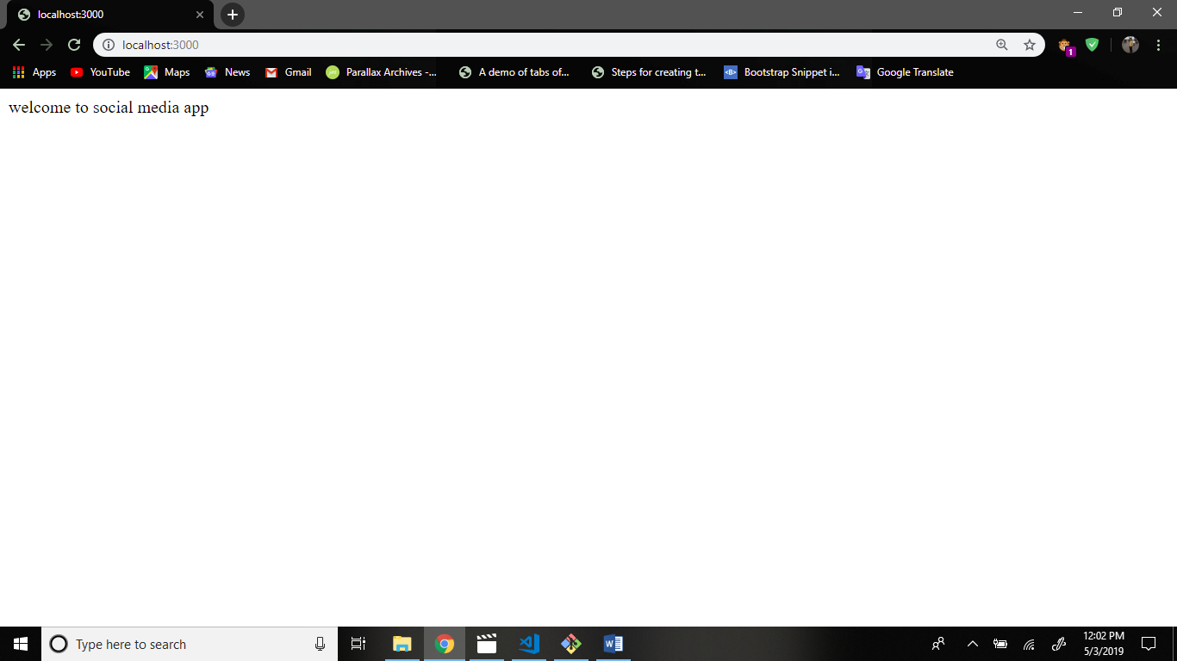

Firstly, Terminate the server through command.

Command: ctrl+c

Now I will install nodemon server this server is automatically restart and run.

Command: npm i nodemon –save-dev -g

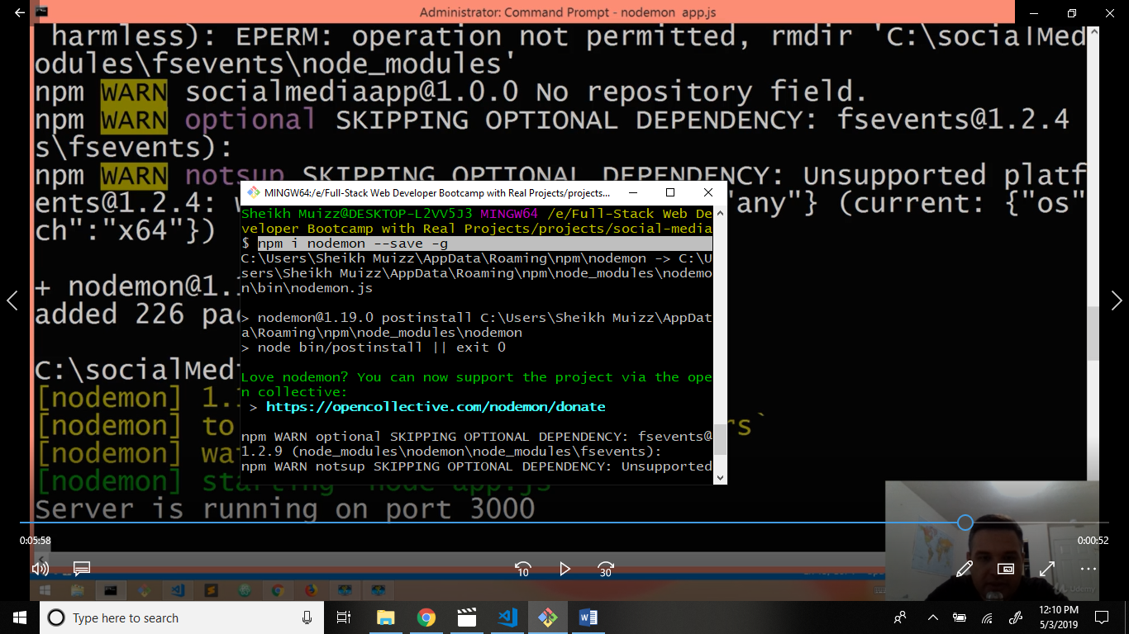

Now run the server.

Command: nodemon app.js

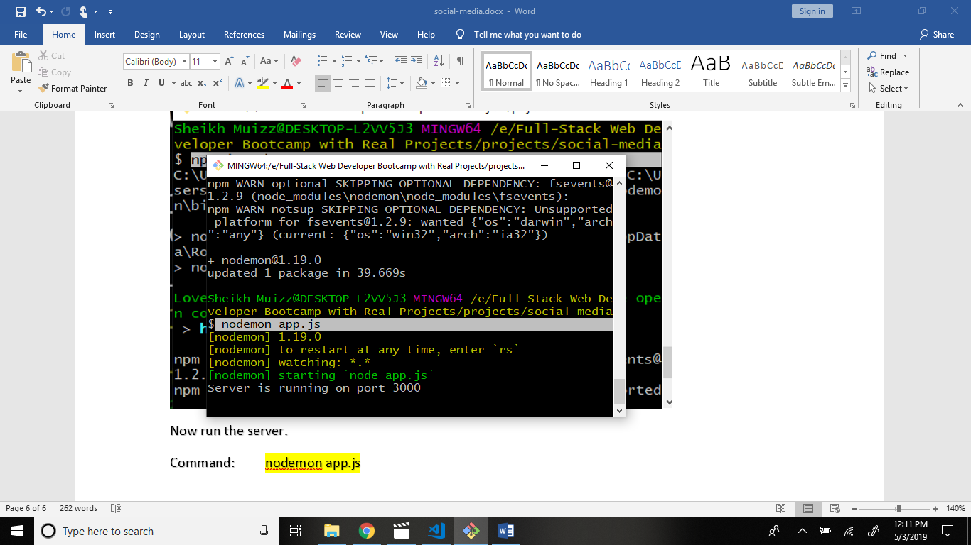

Now go to app.js file and write code.

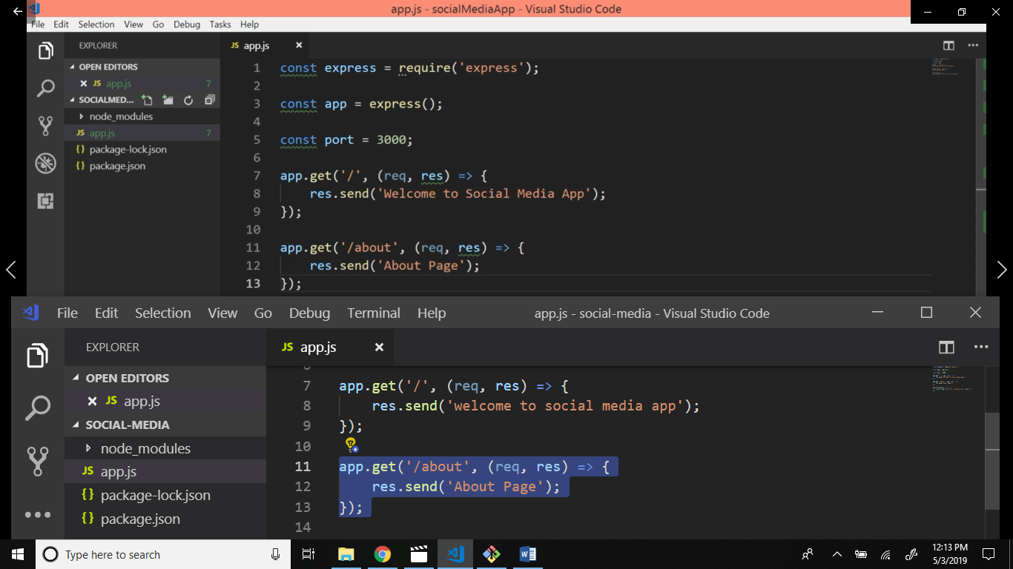

Now check the output:

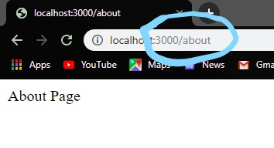

Now I we install express handlebars

Structure: express handlebars

Command: npm i express-handlebars –save-dev

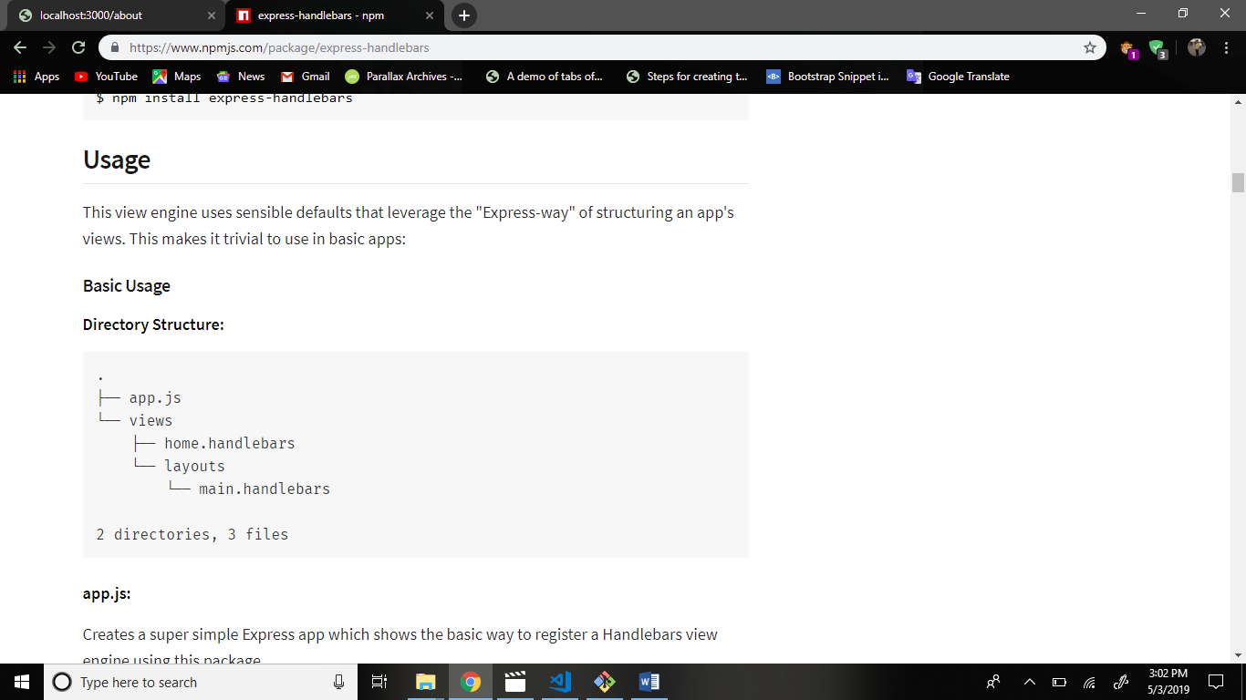

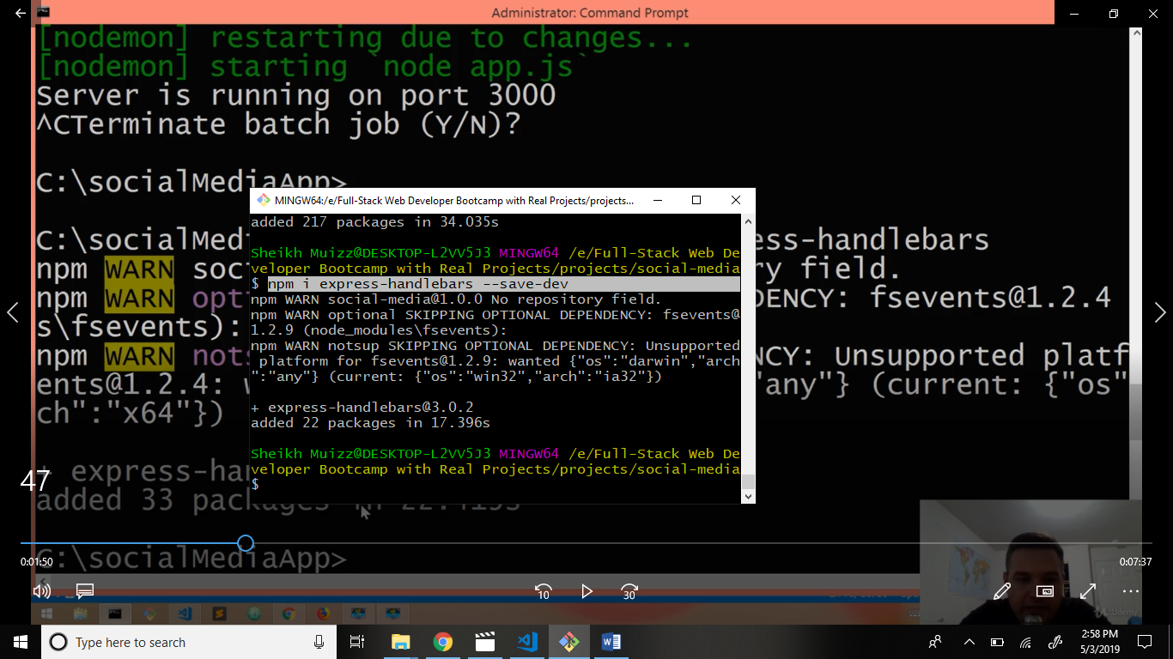

Now go to file app.js and write code.

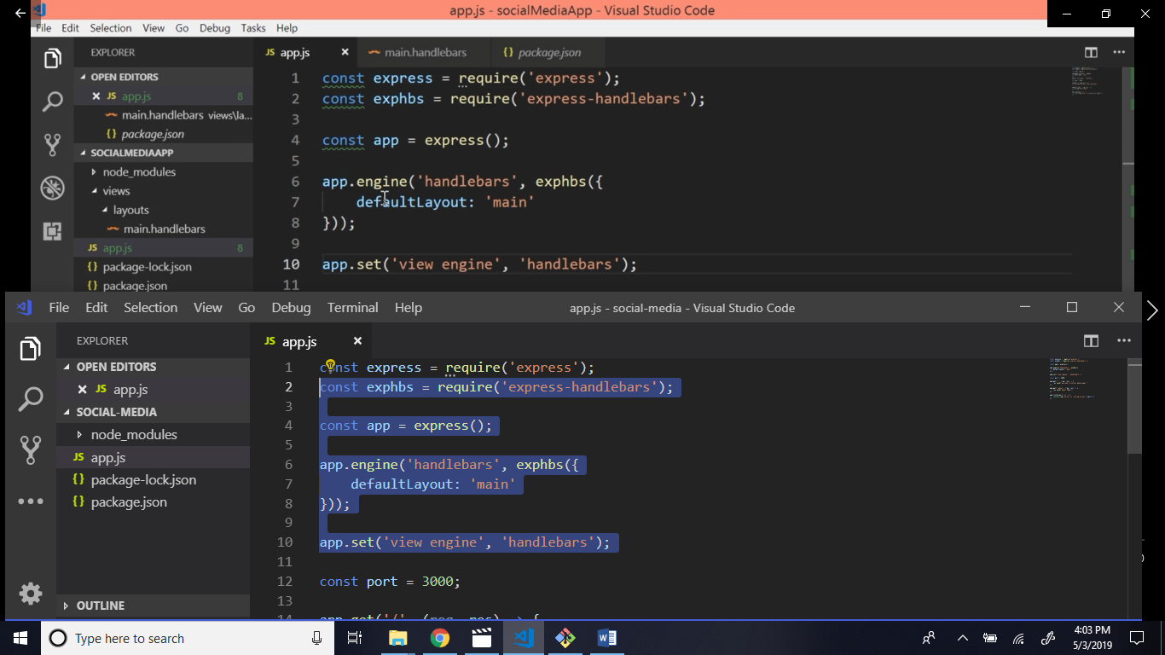

Now create folder views in main folder.

Create folder layouts in views folder.

Create file main.handlebars in layouts folder.

Structure:

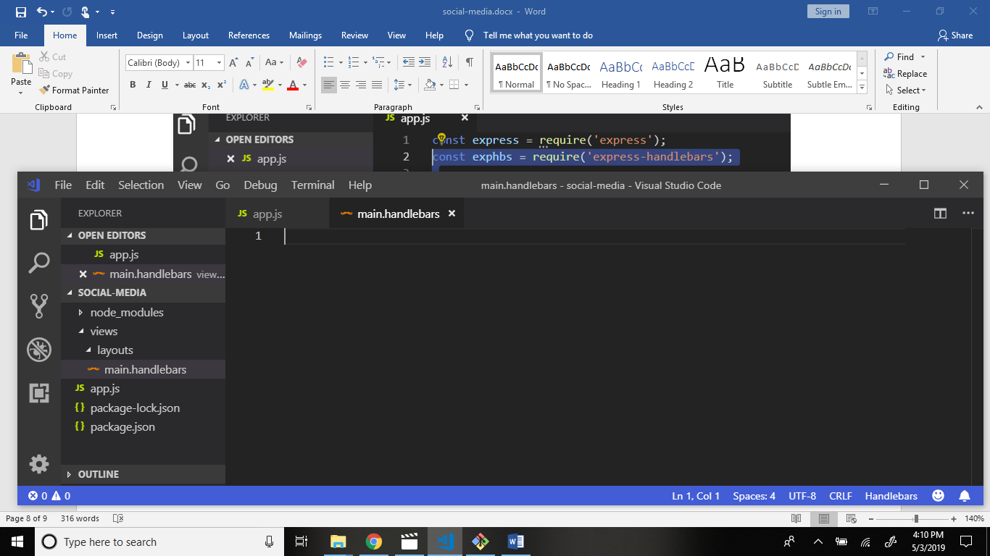

Now go to main.handlebars and write code.

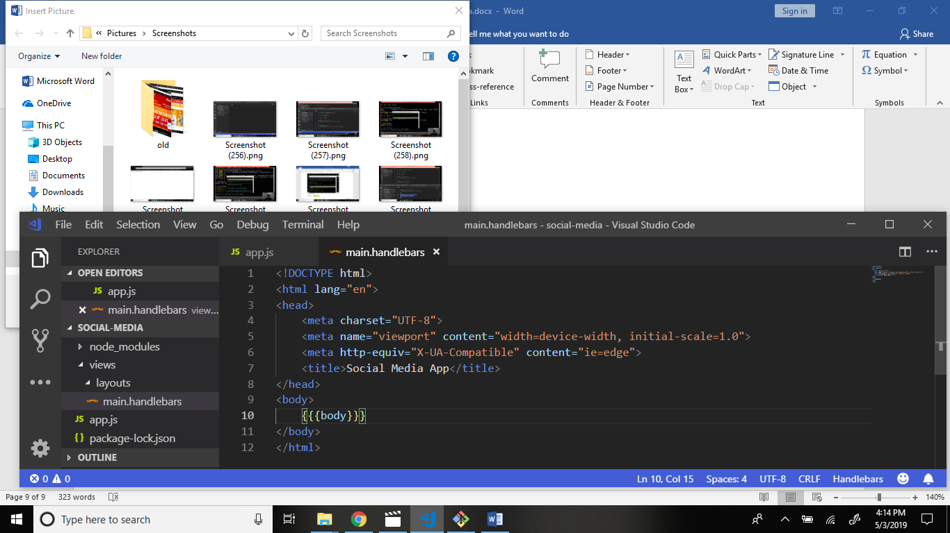

And now create file home.handlebars in views folder.

Structure: views > home.handlebars

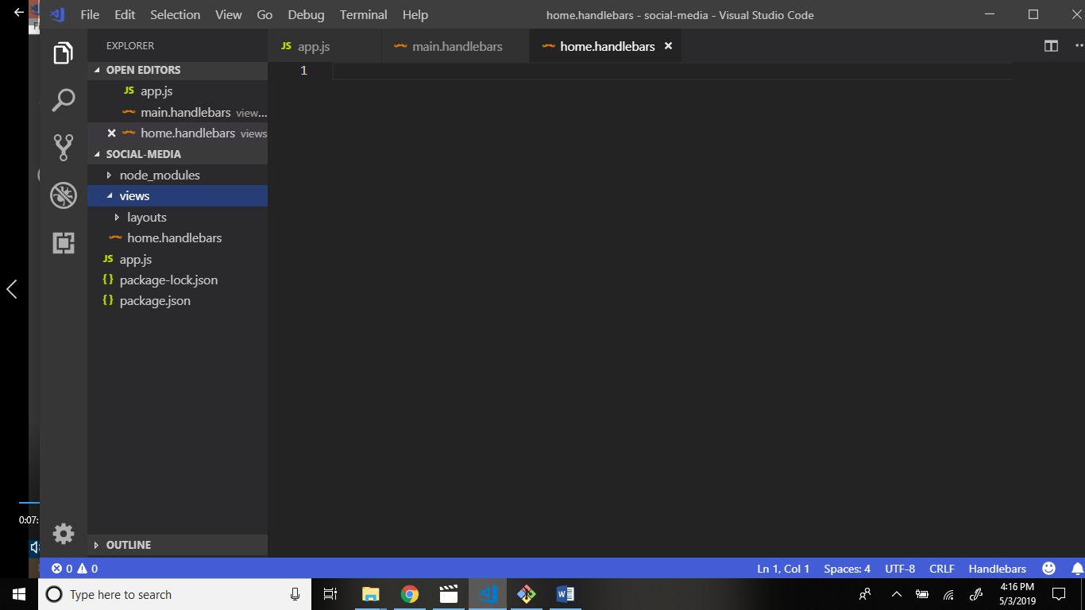

Open home.handlebars and write code.

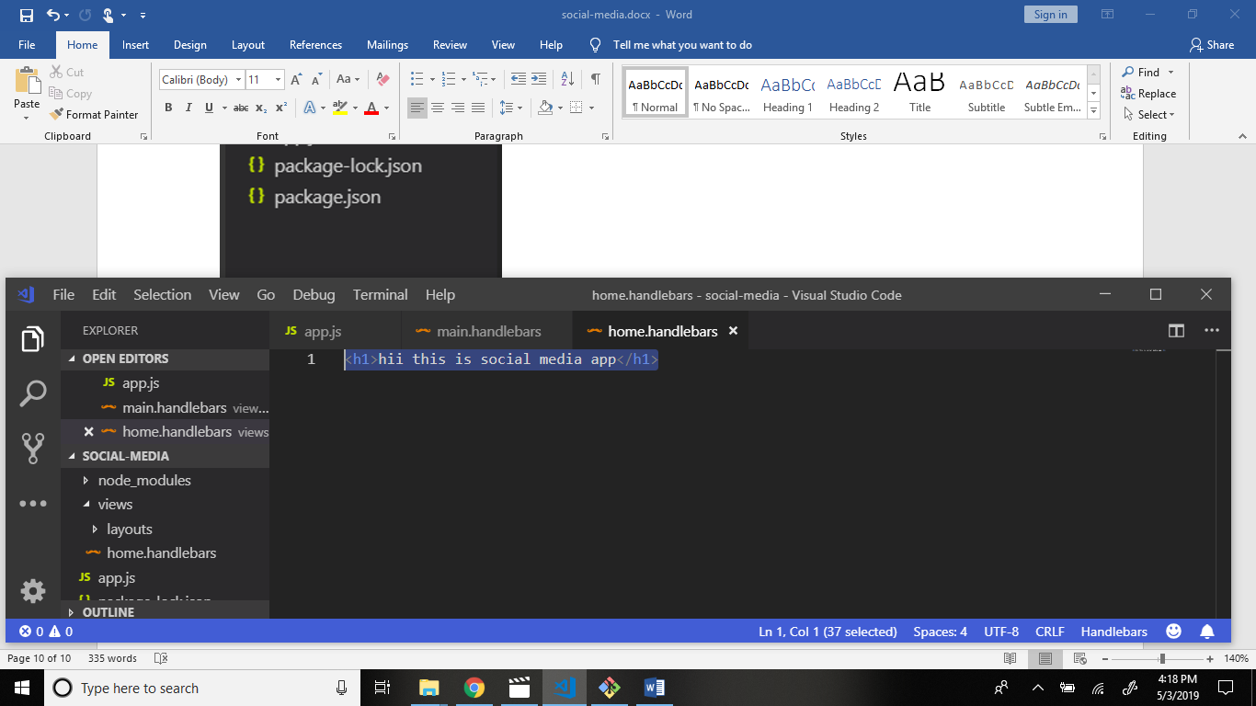

Open app.js file and write code.

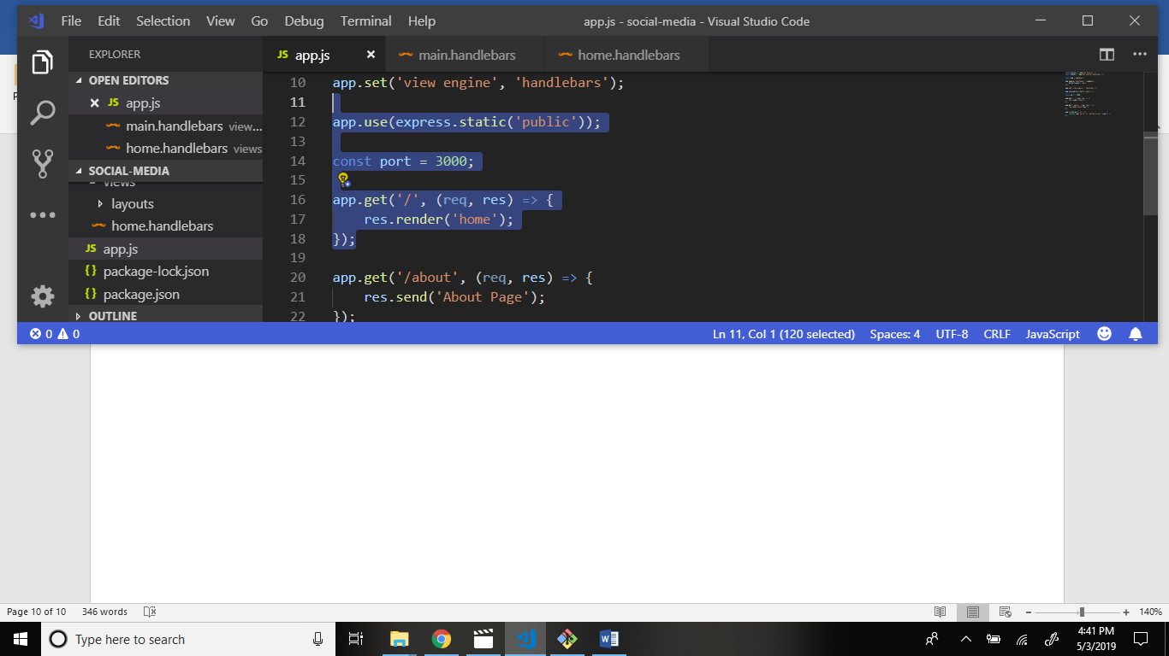

Now create folder public in main project folder.

Create folder img in public folder.

Create folder js in public folder.

Create file script.js file in js folder.

Create folder css in public folder.

Create file style.css in public folder.

Structure: 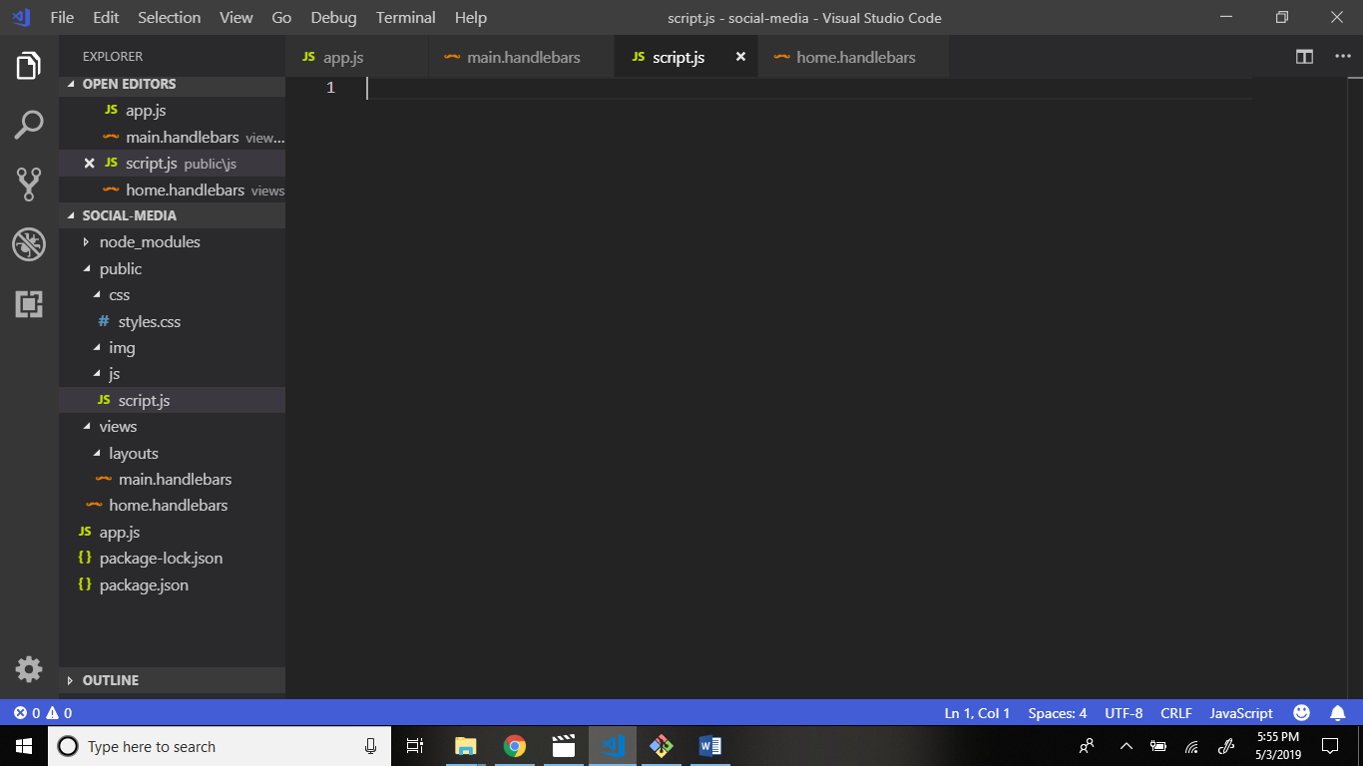

Now go to main.handlebars and link to stylesheet styles.css and link to script.js file.

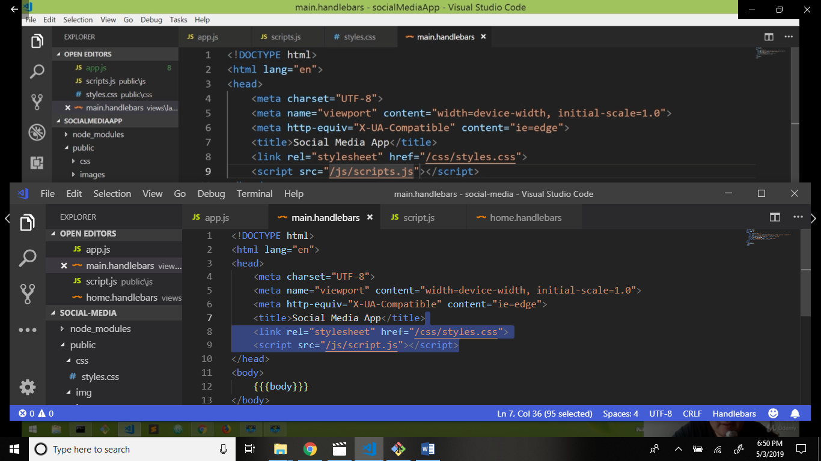

Go to offical bootstrap website copy the cdn and paste to main.handlebars file.

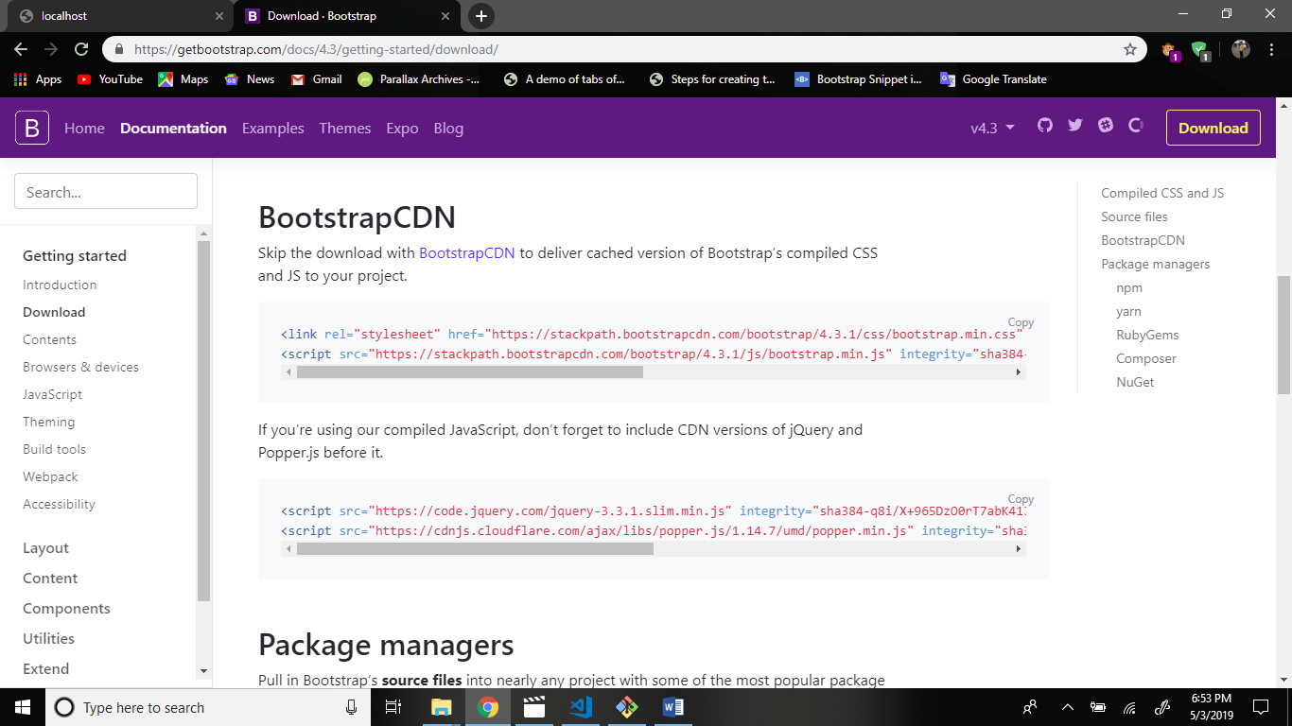

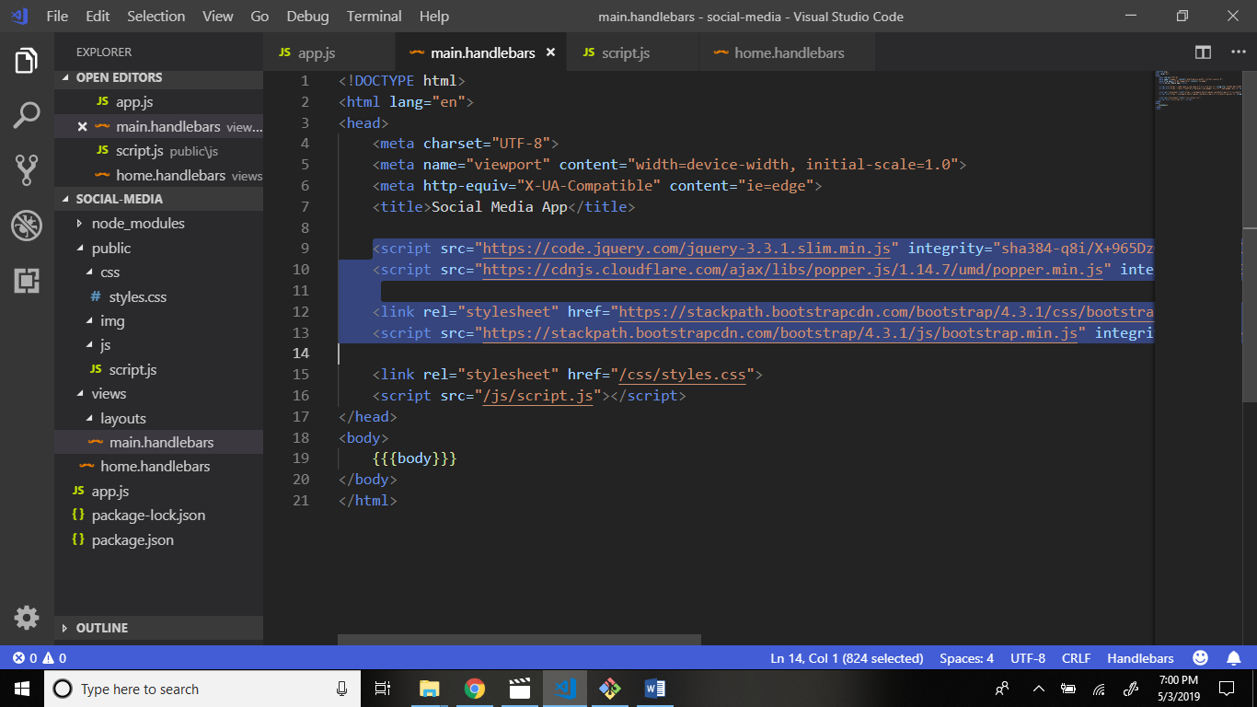

Now we create folder partials in views main folder.

Create file _navbar.handlebars in partials folder.

Structure:

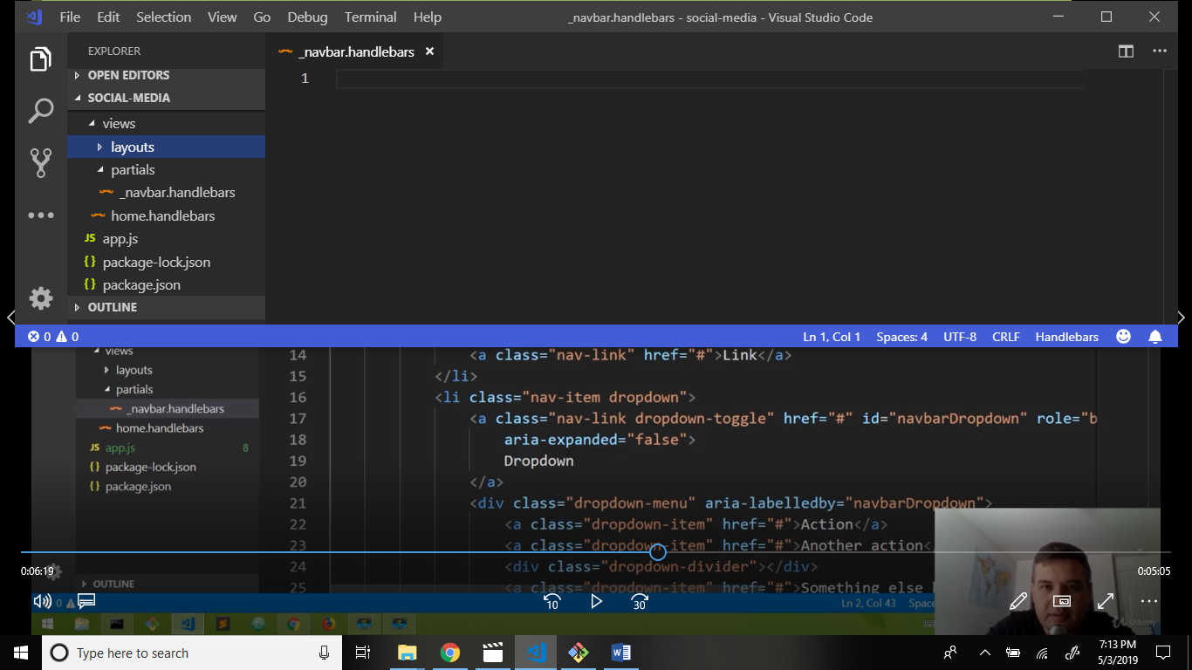

Now open _navbar.handlebars and write code.

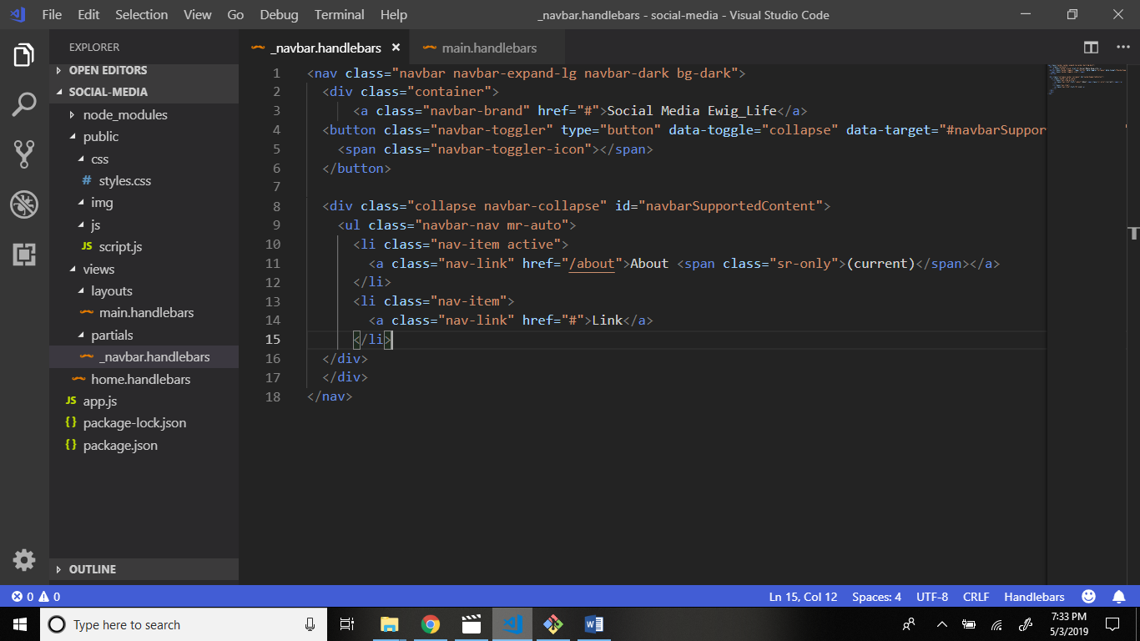

Now go to layouts folder > main.handlebars file and write code.

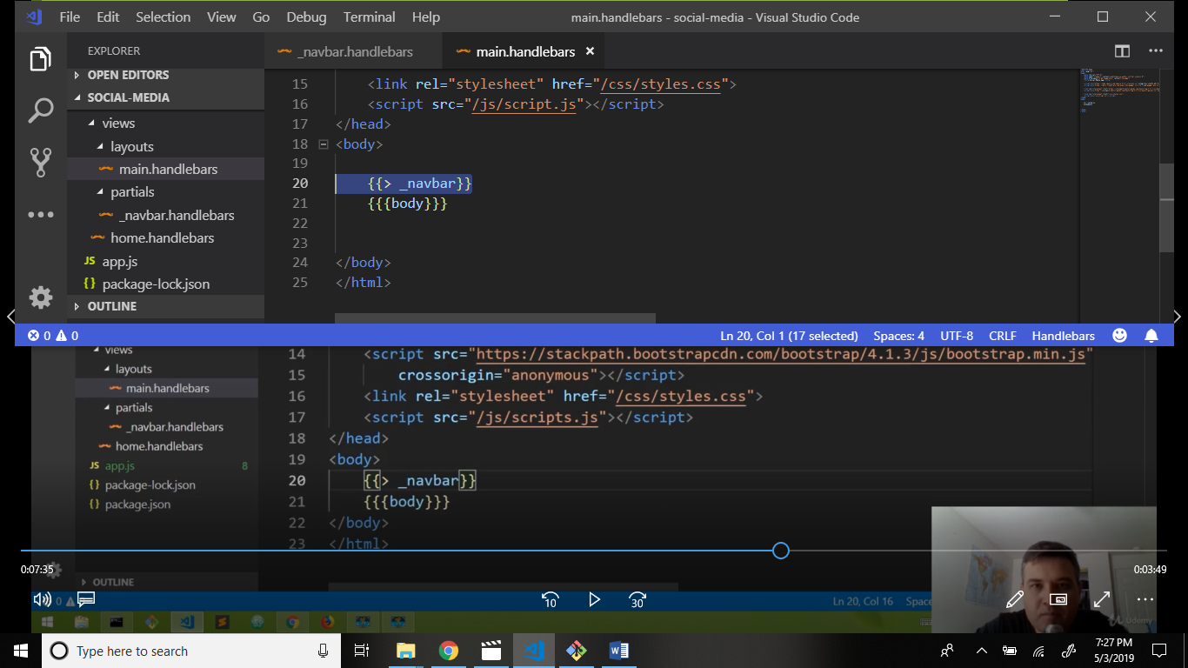

Now start the server and see output:

Command: nodemon app.js

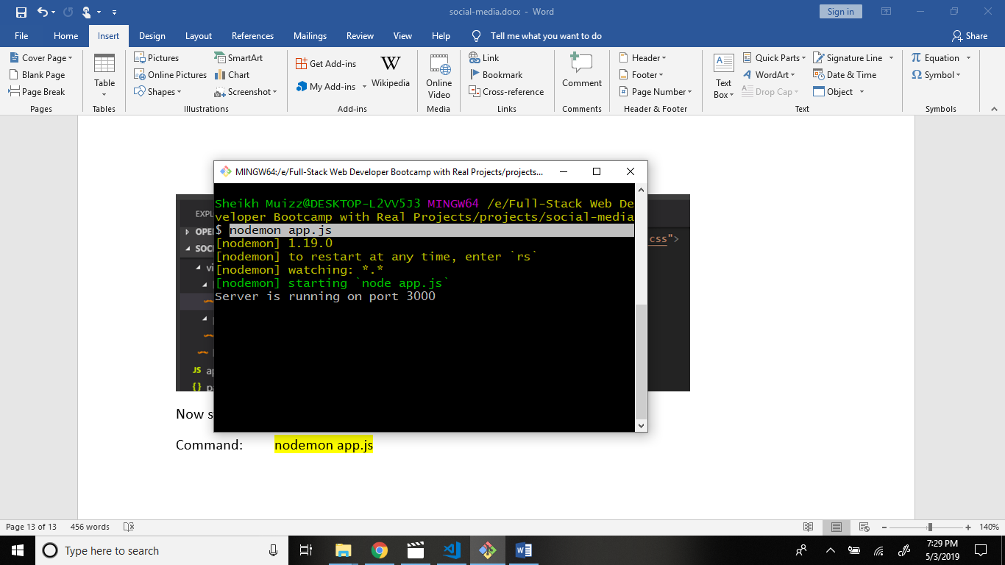

Output:

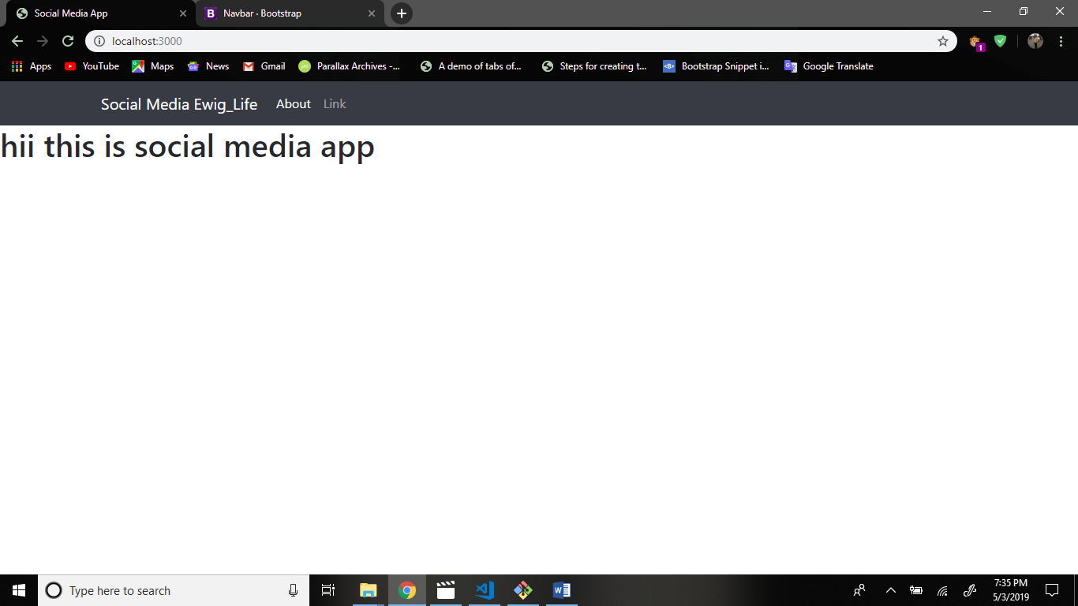

Now click the about link show output change the link and render about page.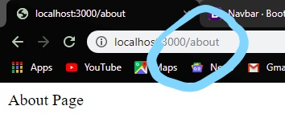

Now we create separate about page.

Go to views folder and create file about.handlebars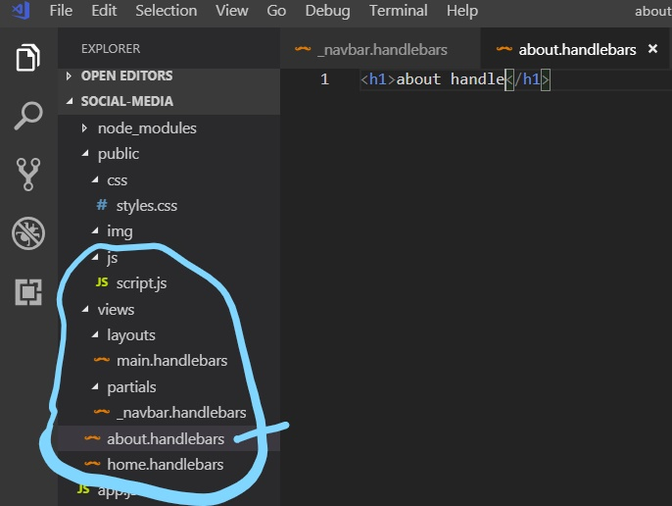

Now go to app.js file and about.handlebars file render.

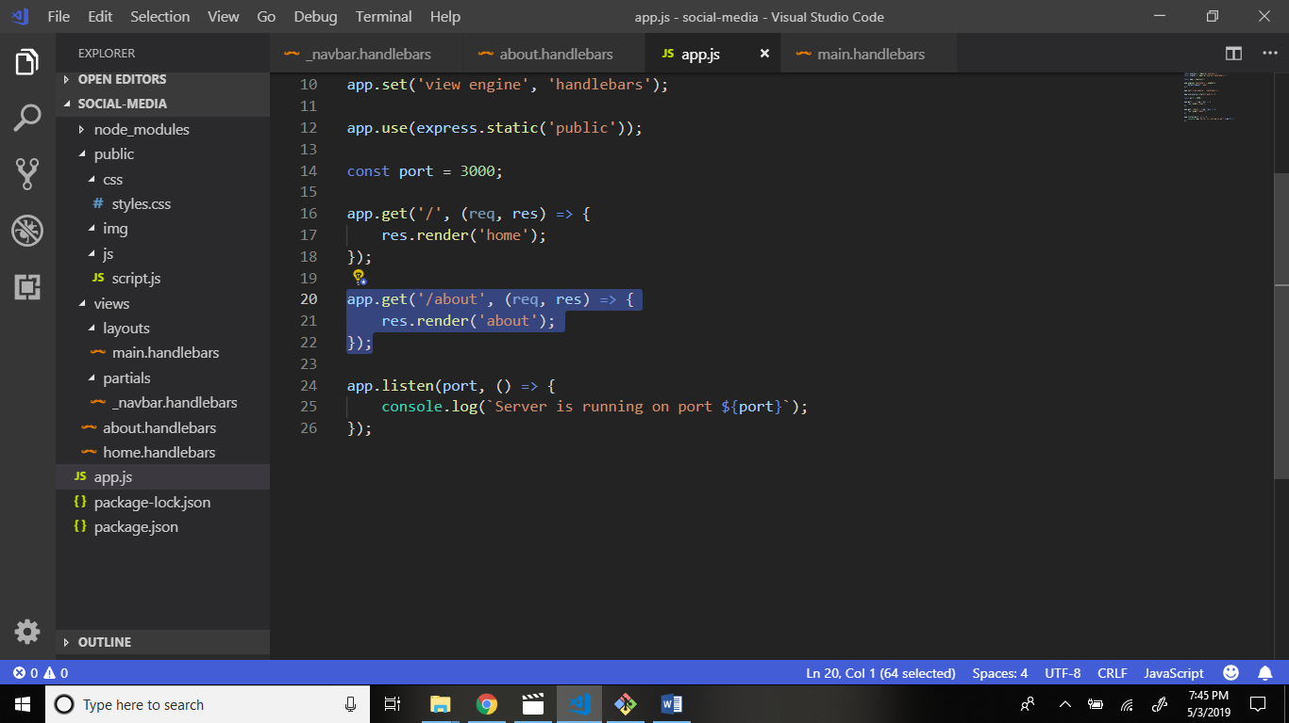

Now we have create folder config in main application folder.

Structure:

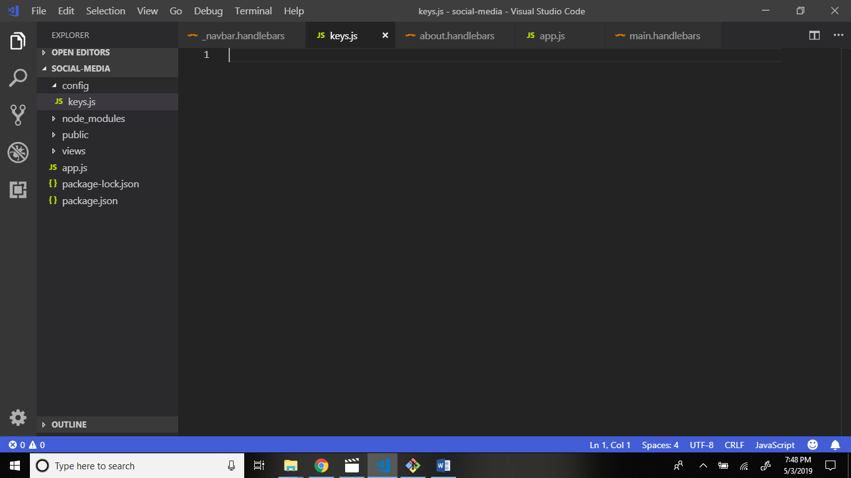

Keys.js write code. Why? Because database connect to the moongodb etc.

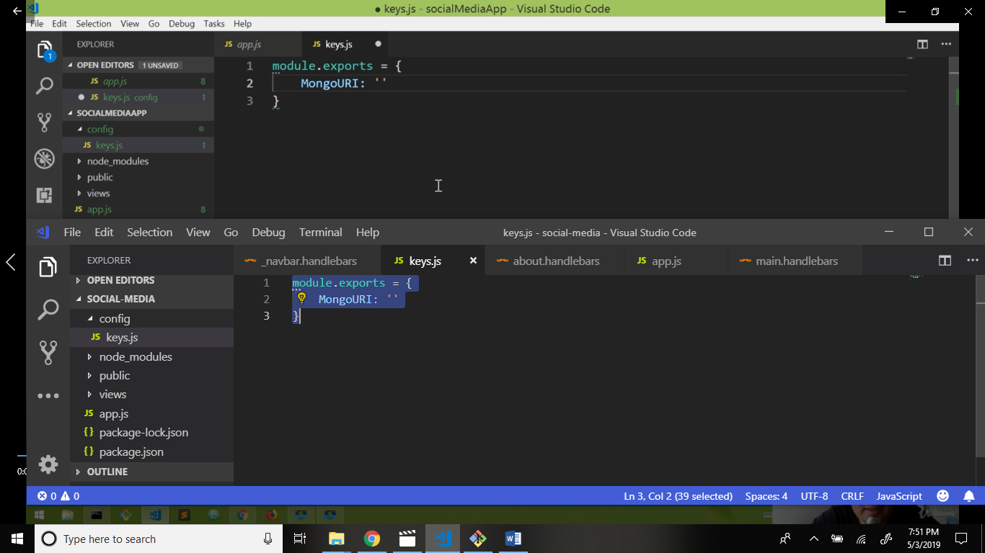

Now go to website mongodb.com

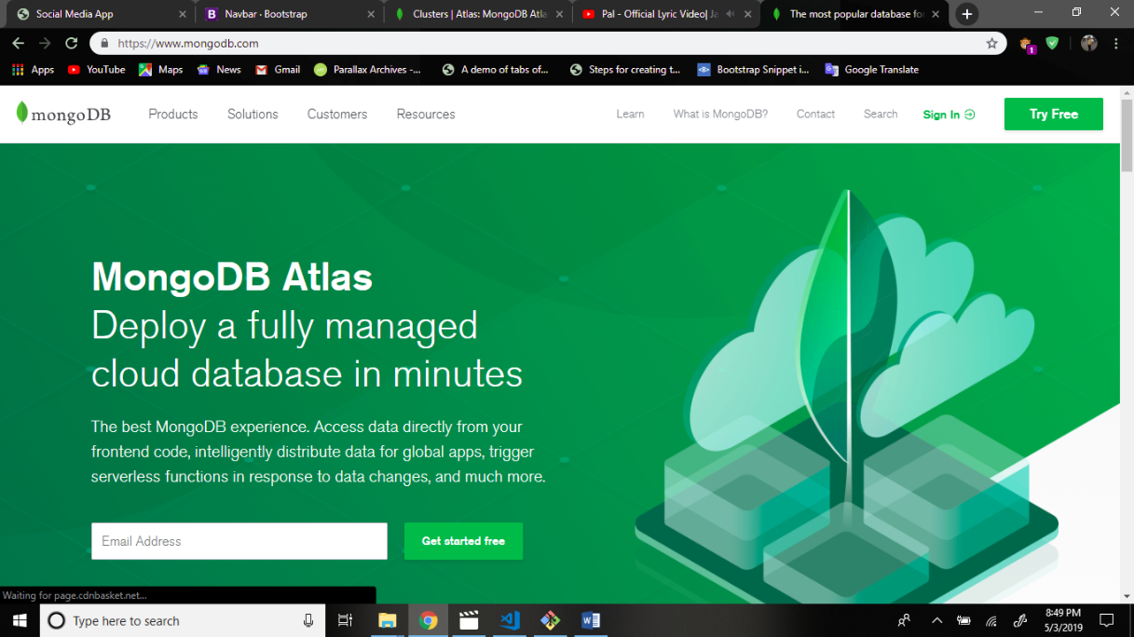

Login to mongodb or signUp to mongodb.

And create new cluster.

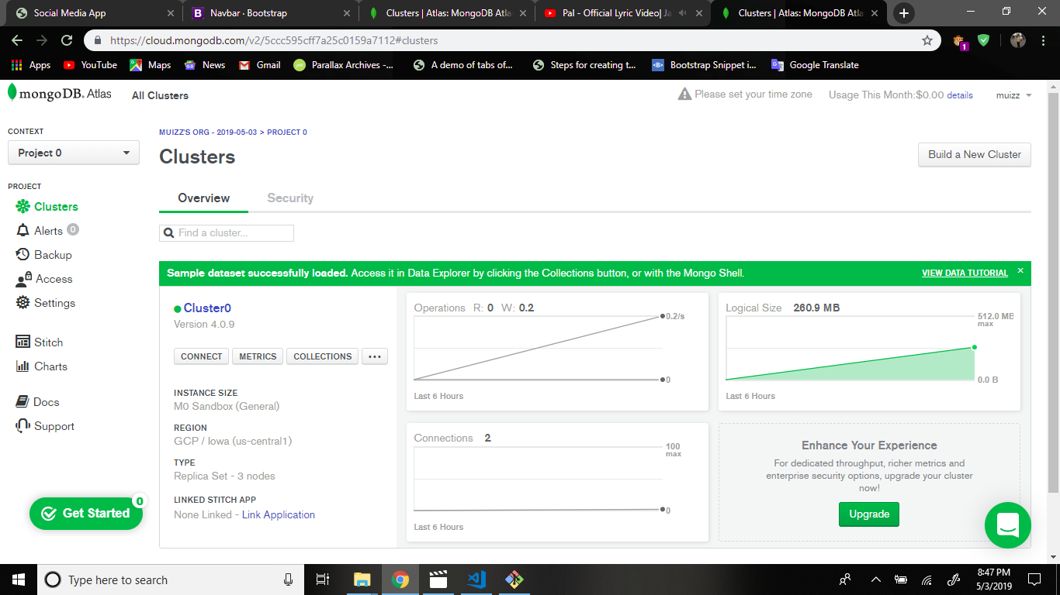

And attempt 4 simple steps.

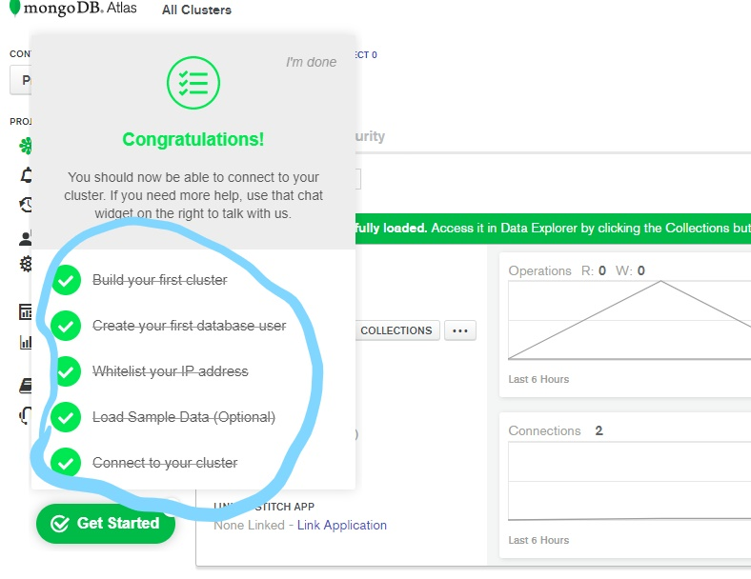

Add user. Username and password

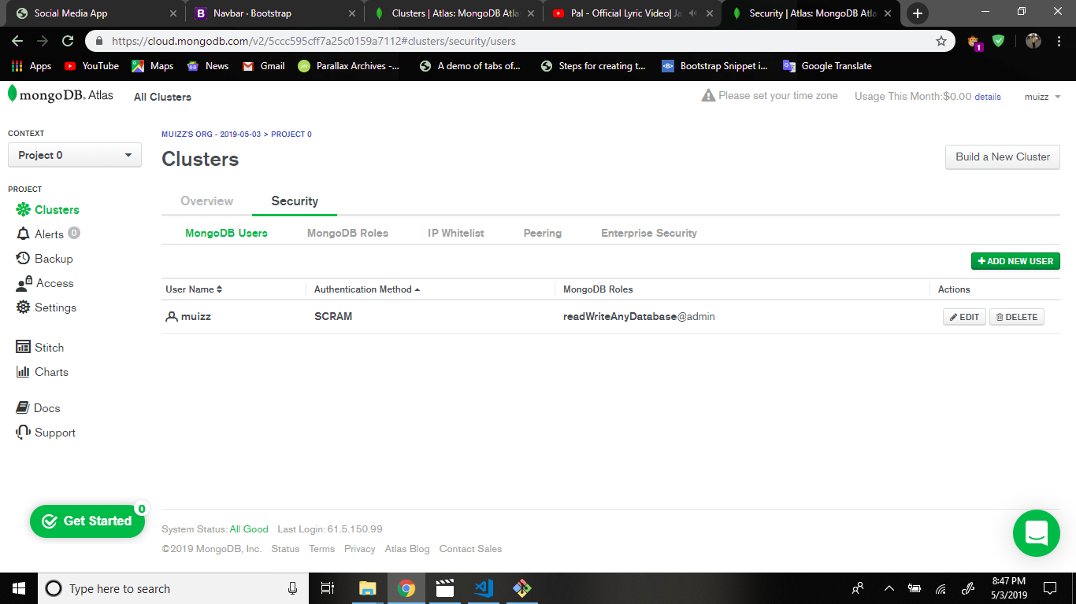

Add ip white list

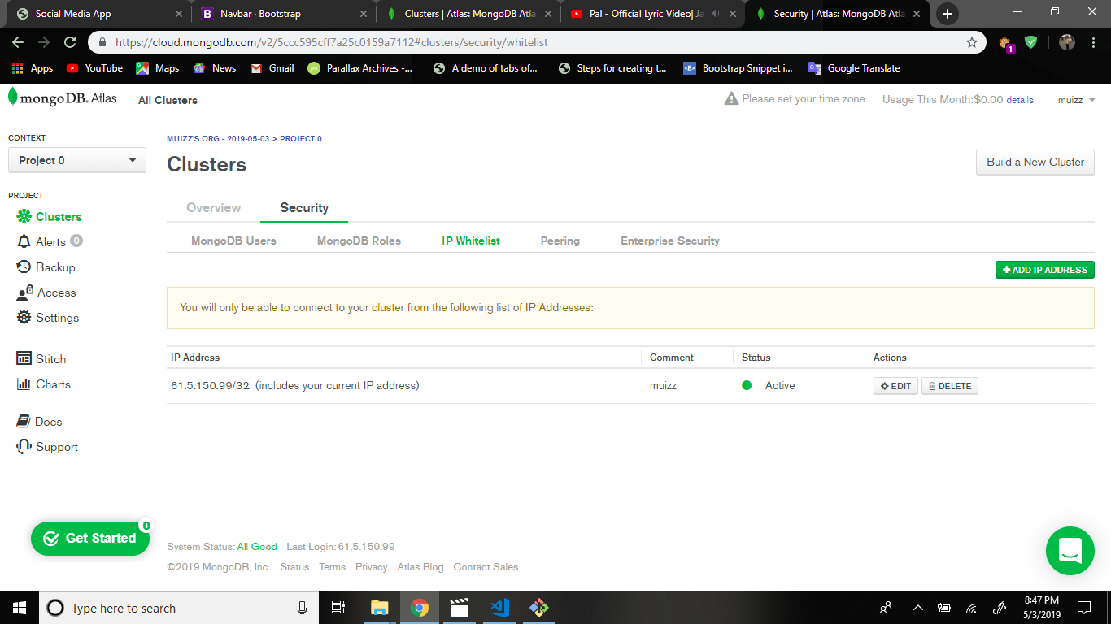

And connect to cluster:

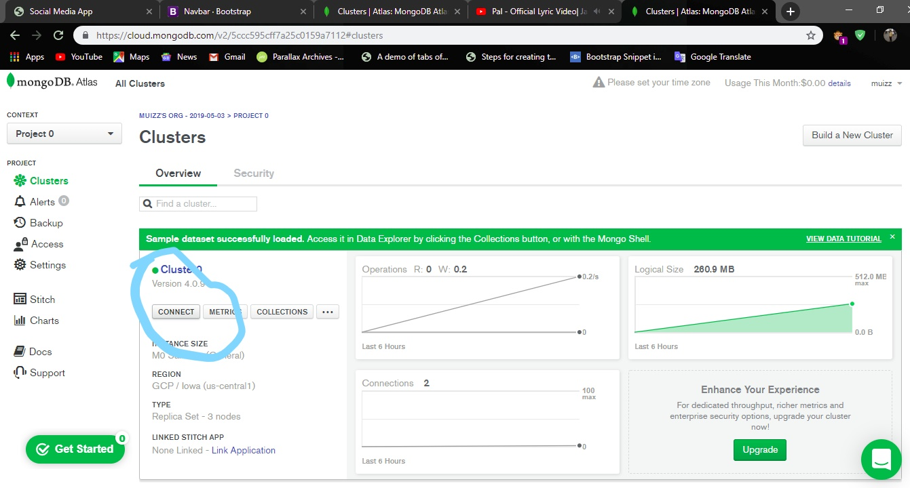

After click connect btn.

Connect your application.

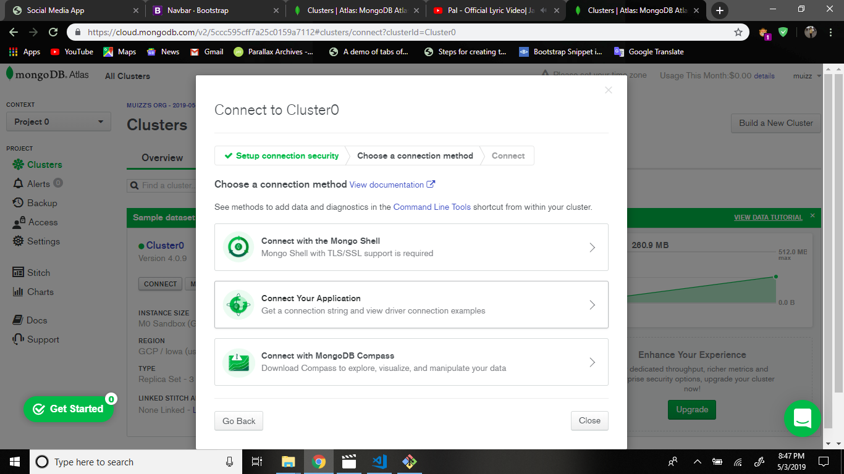

After:

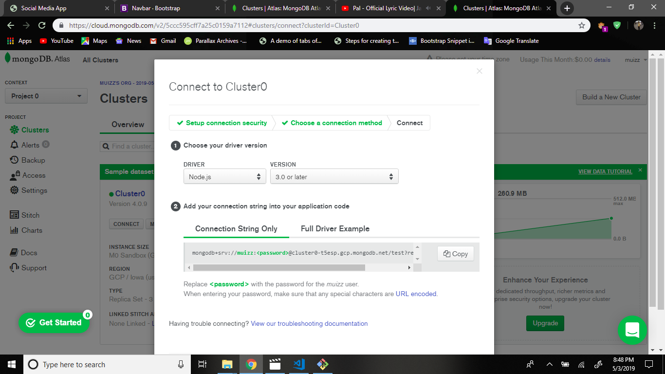

Copy this url and paste the key.js file mongoURI.

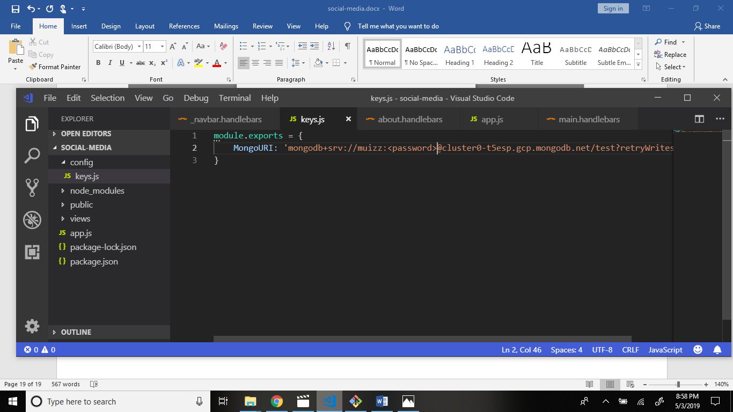

And change this <password> to your orignal password.

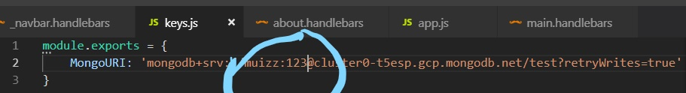

This line is add to the app.js file.

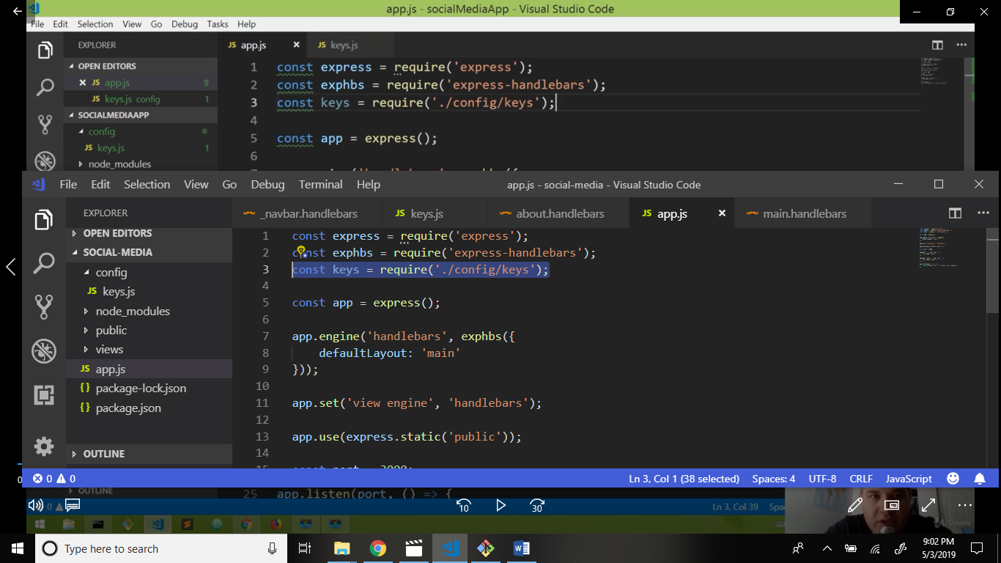

Now I install mongoose

Command: npm i mongoose –save

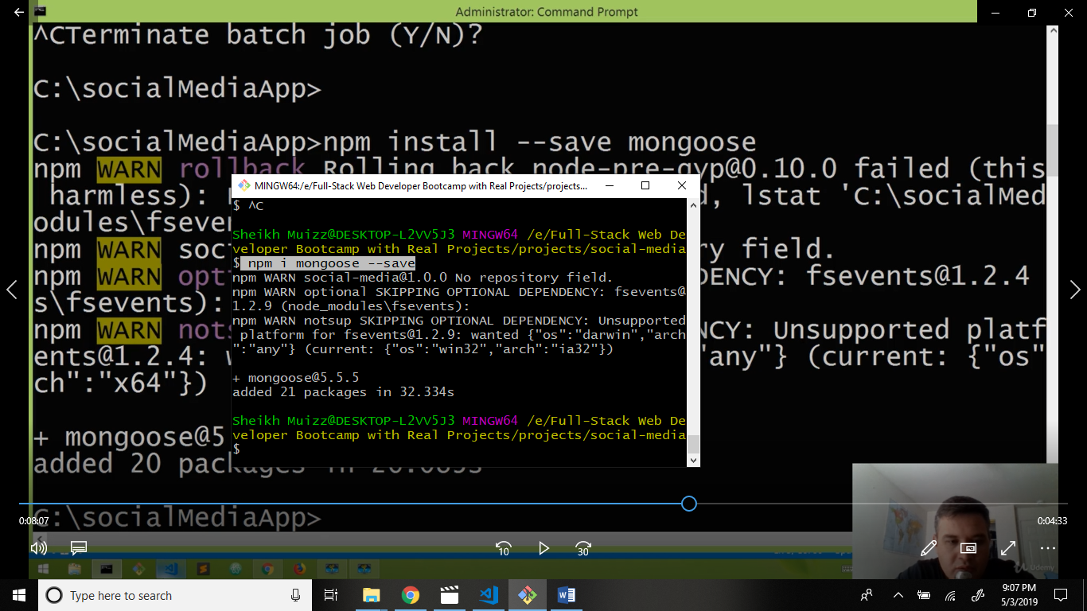

Now go to app.js and write code.

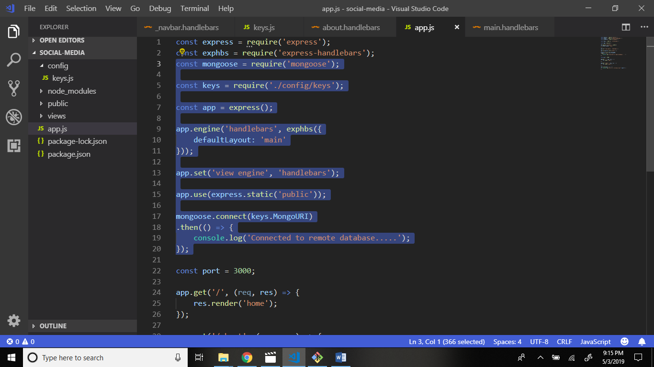

Output:

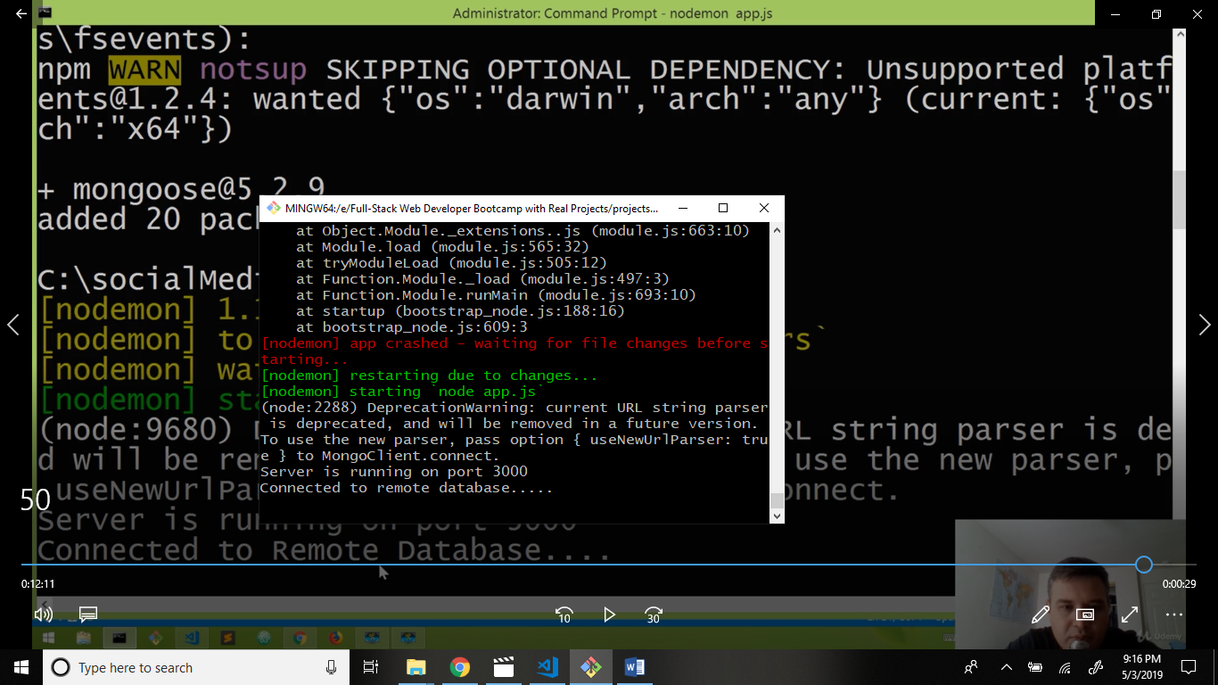

App.js file write code.

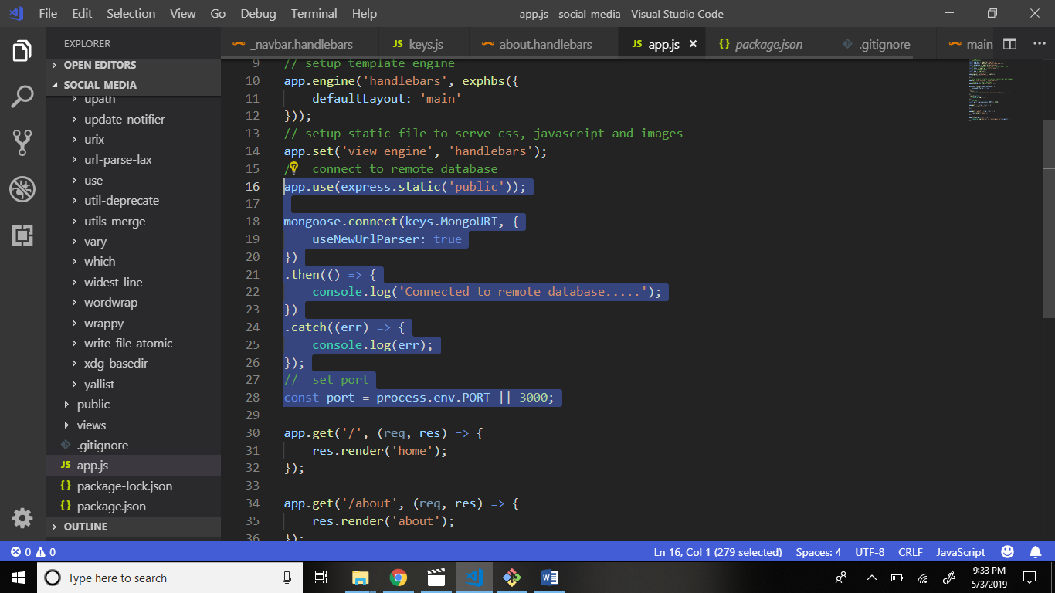

Now create file .gitignore in main folder and write code.

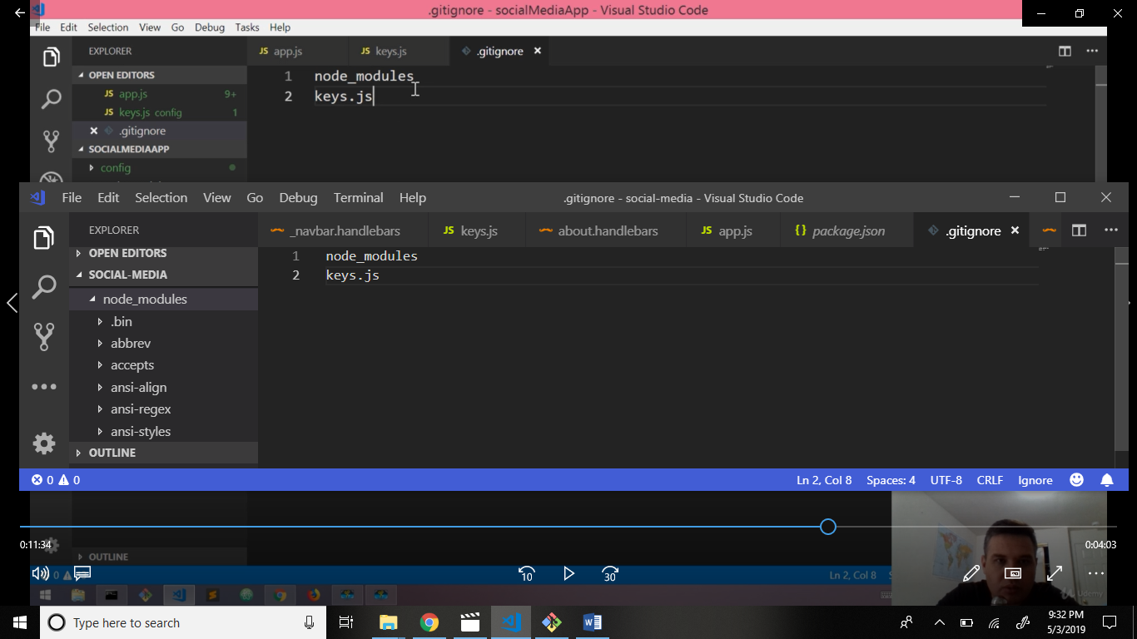

Now go to package.json file and write code.

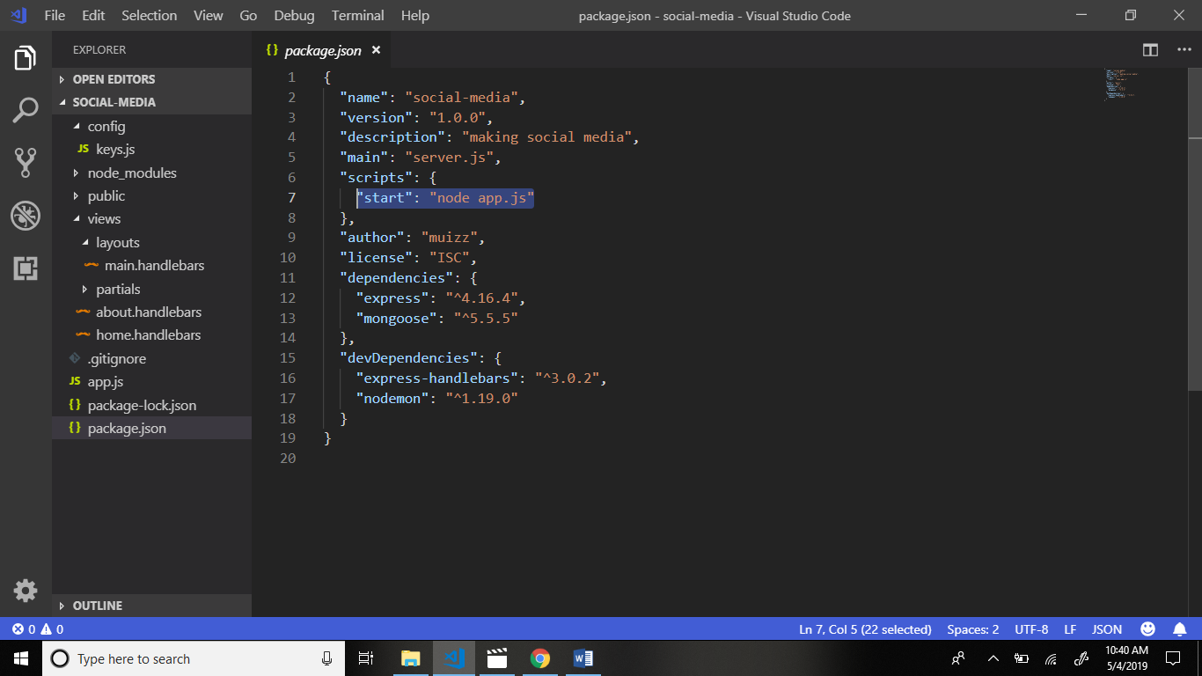

Now start the localserver.

Command: nodemon app.js

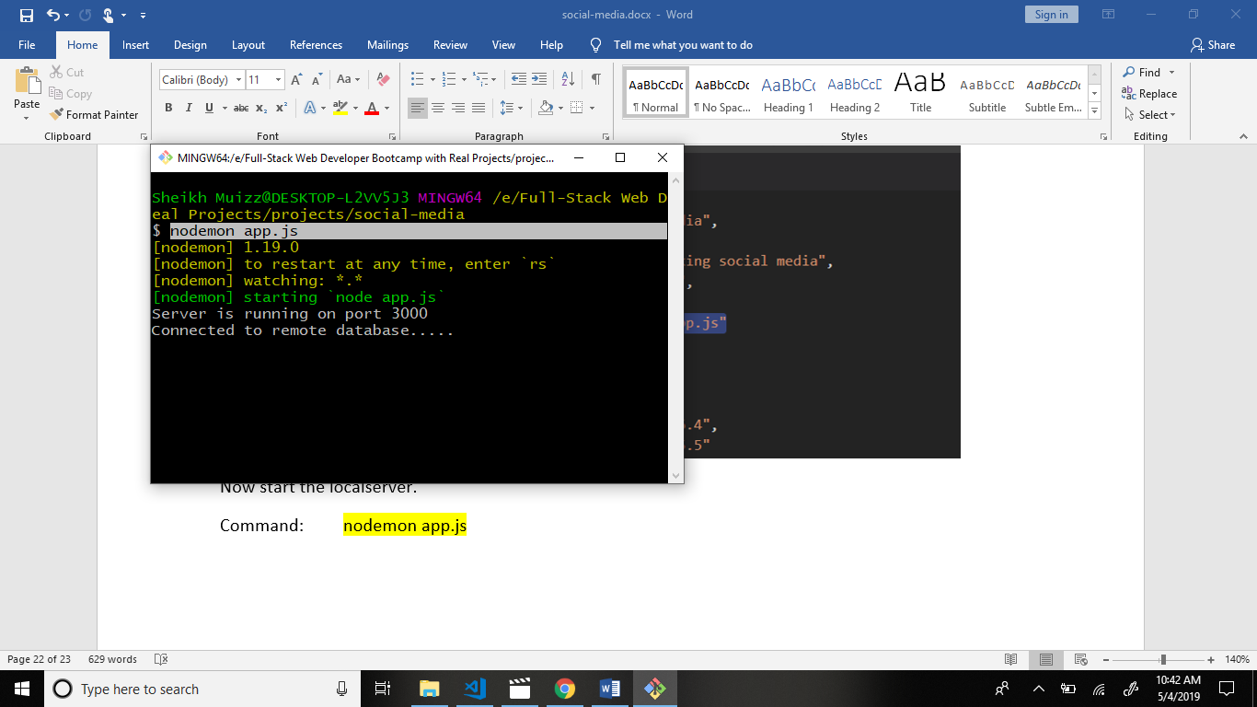

Now go to home.handlebars file and write code.

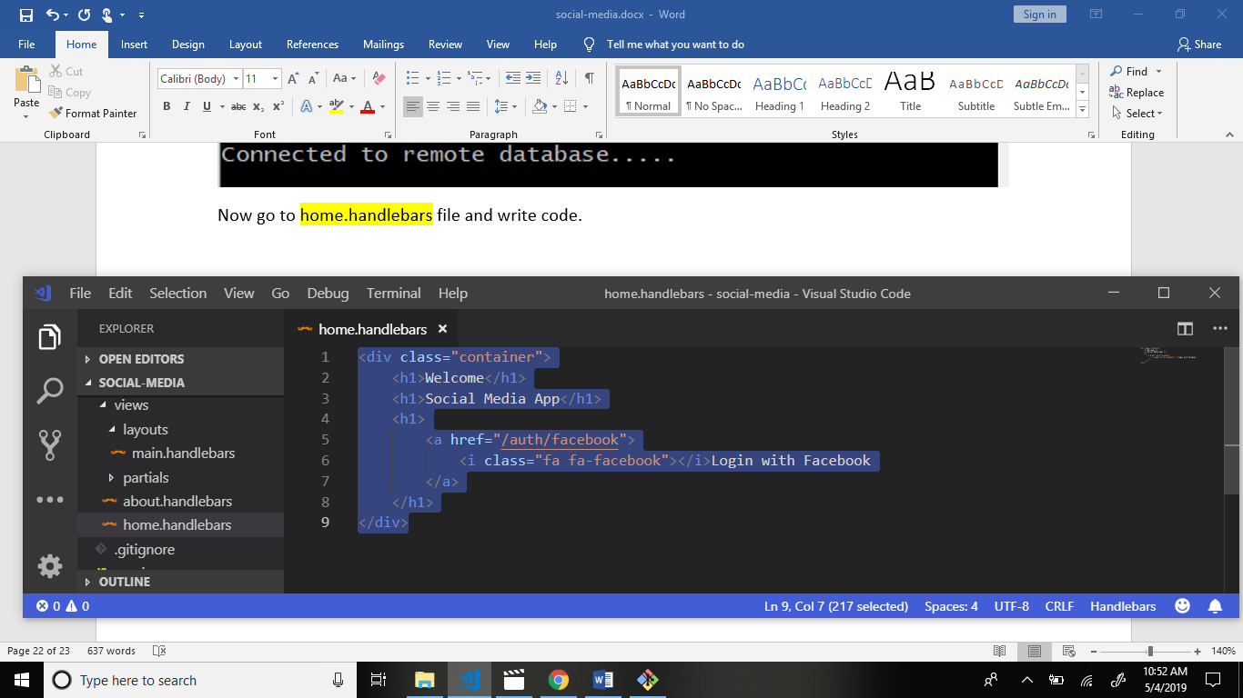

Output:

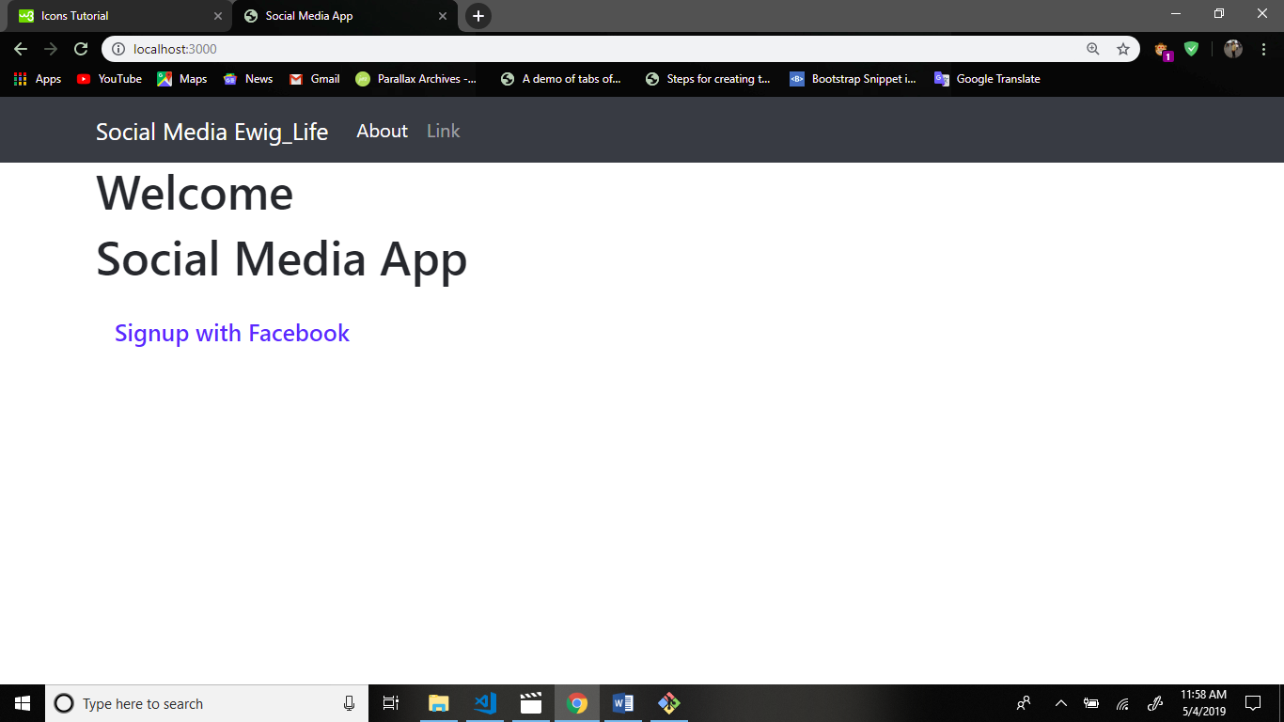

Now go to w3 school website.

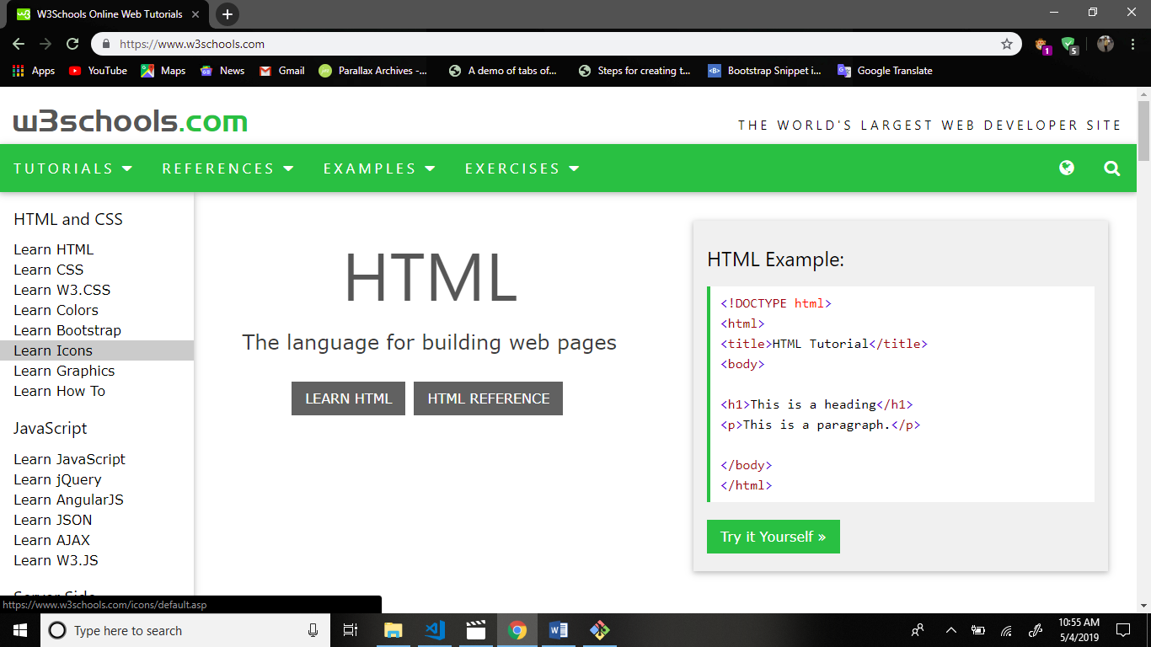

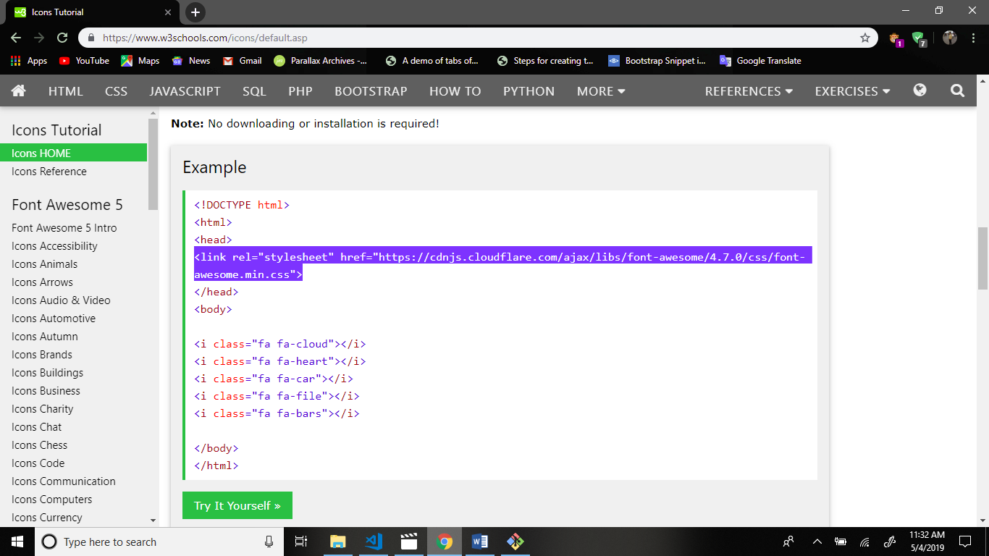

Now add font awesome link add to the main.handlebars file.

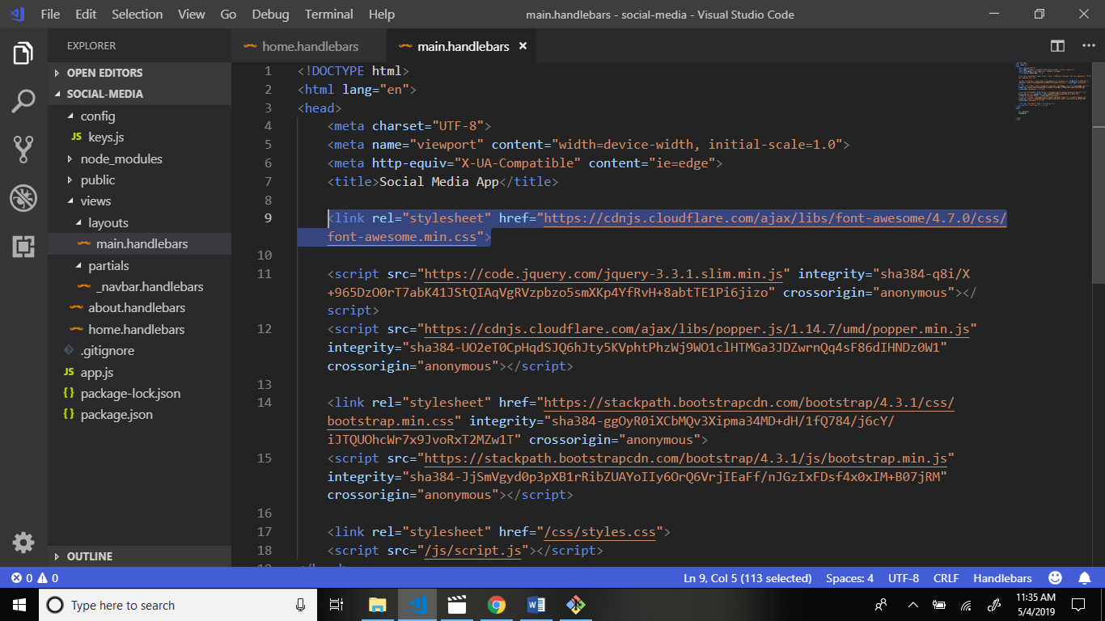

Now add some piece of code in home.handlebars

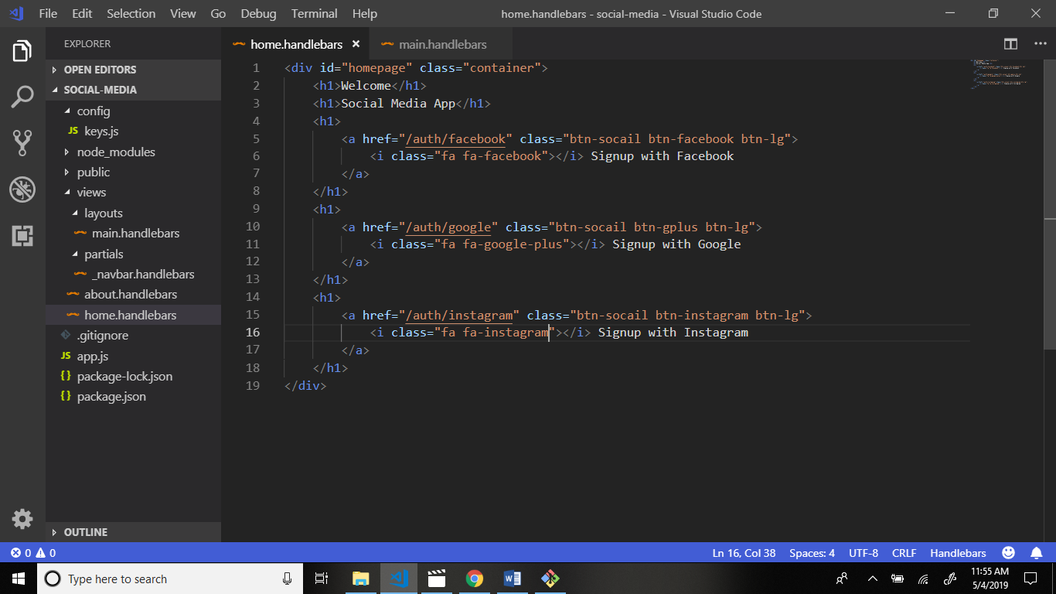

Now go to styles.css file in public folder and write code.

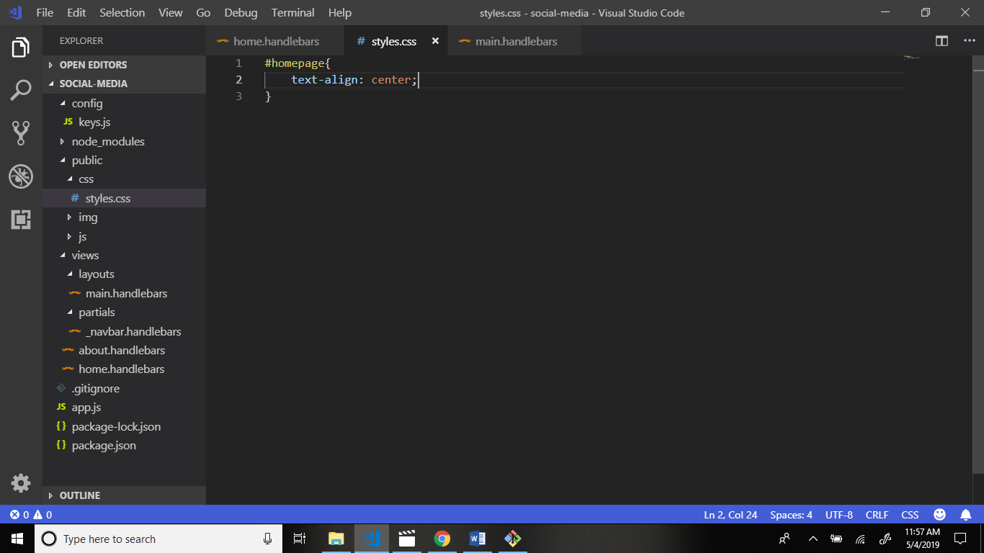

Output:

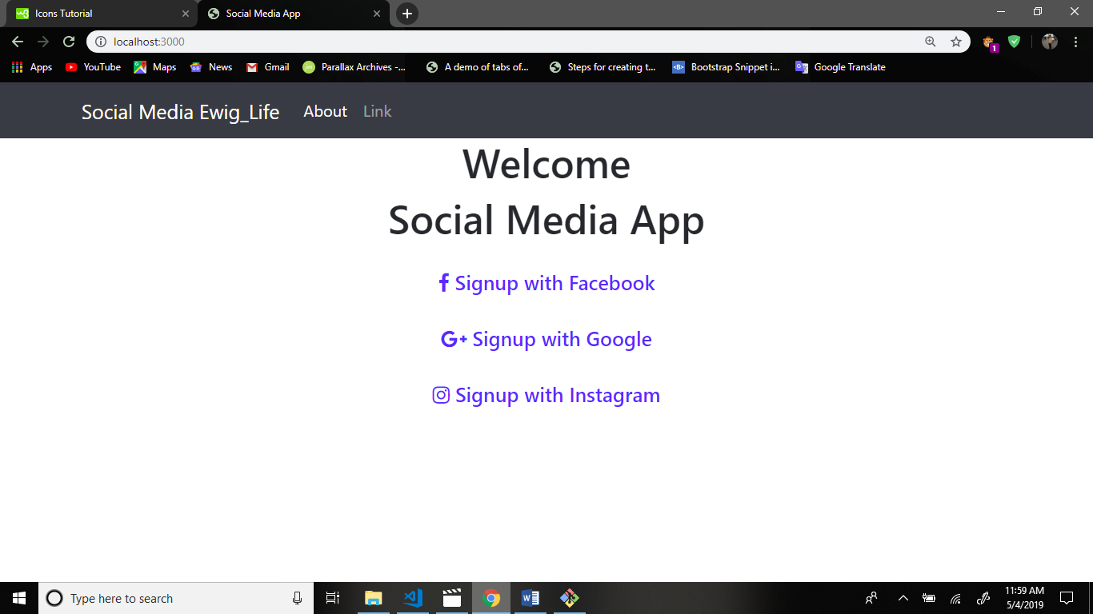

Now go to styles.css file and write code.

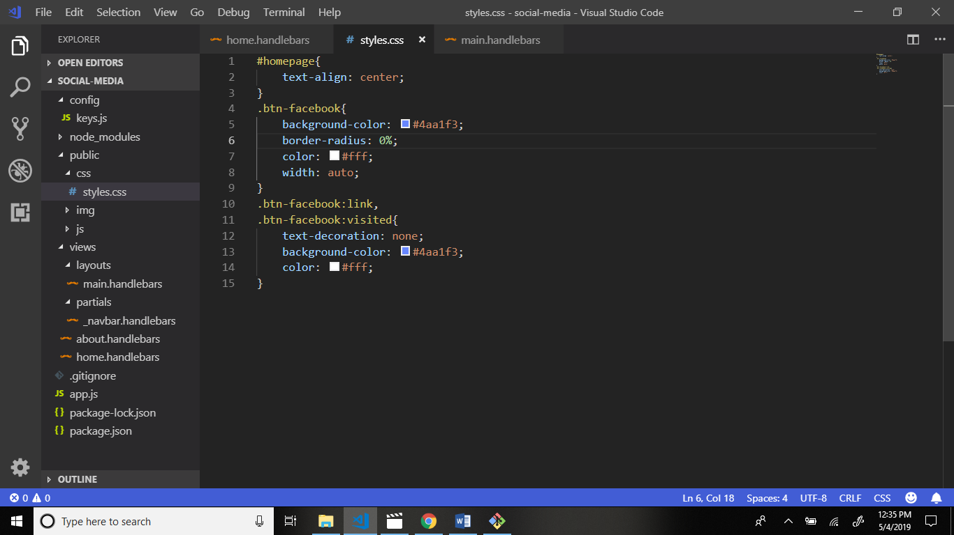

Output :

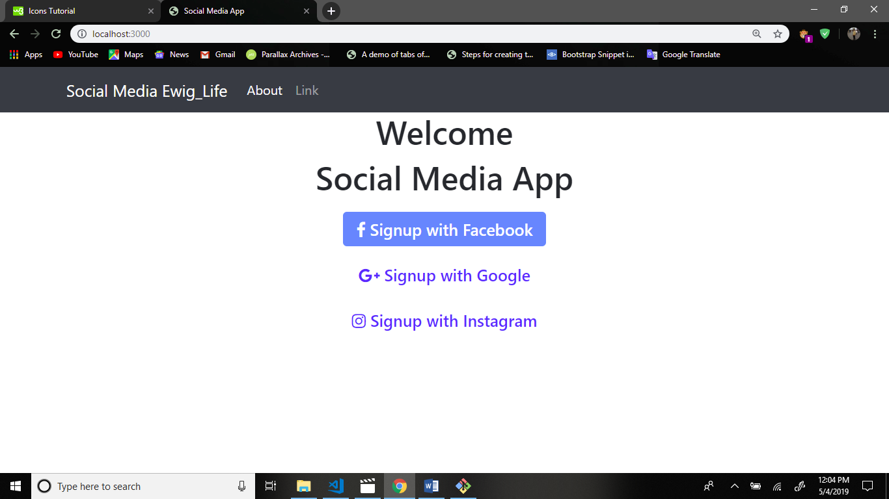

styles.css file write code.

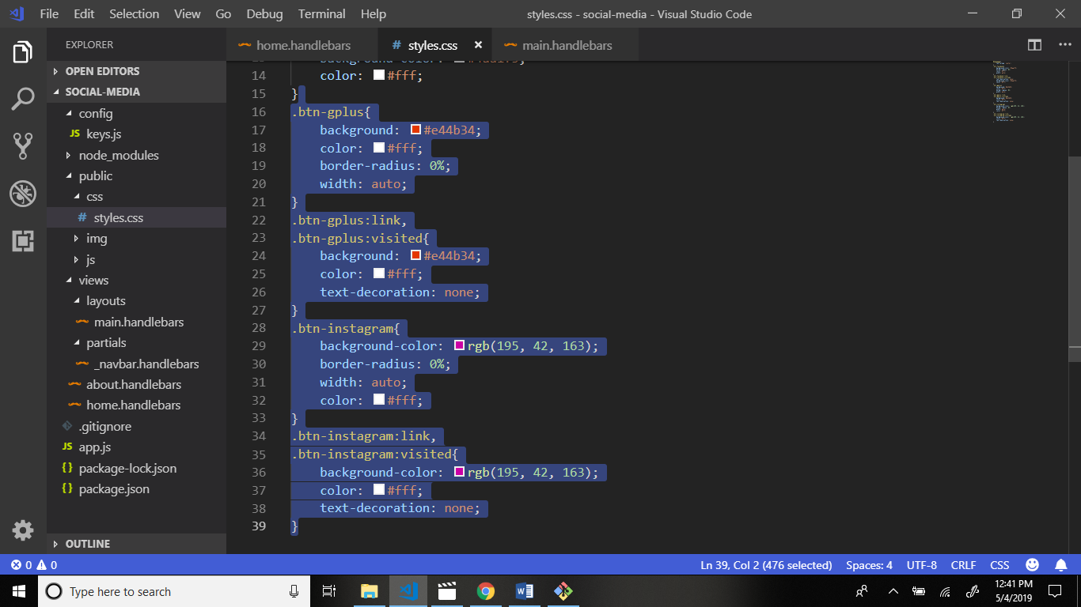

Output:

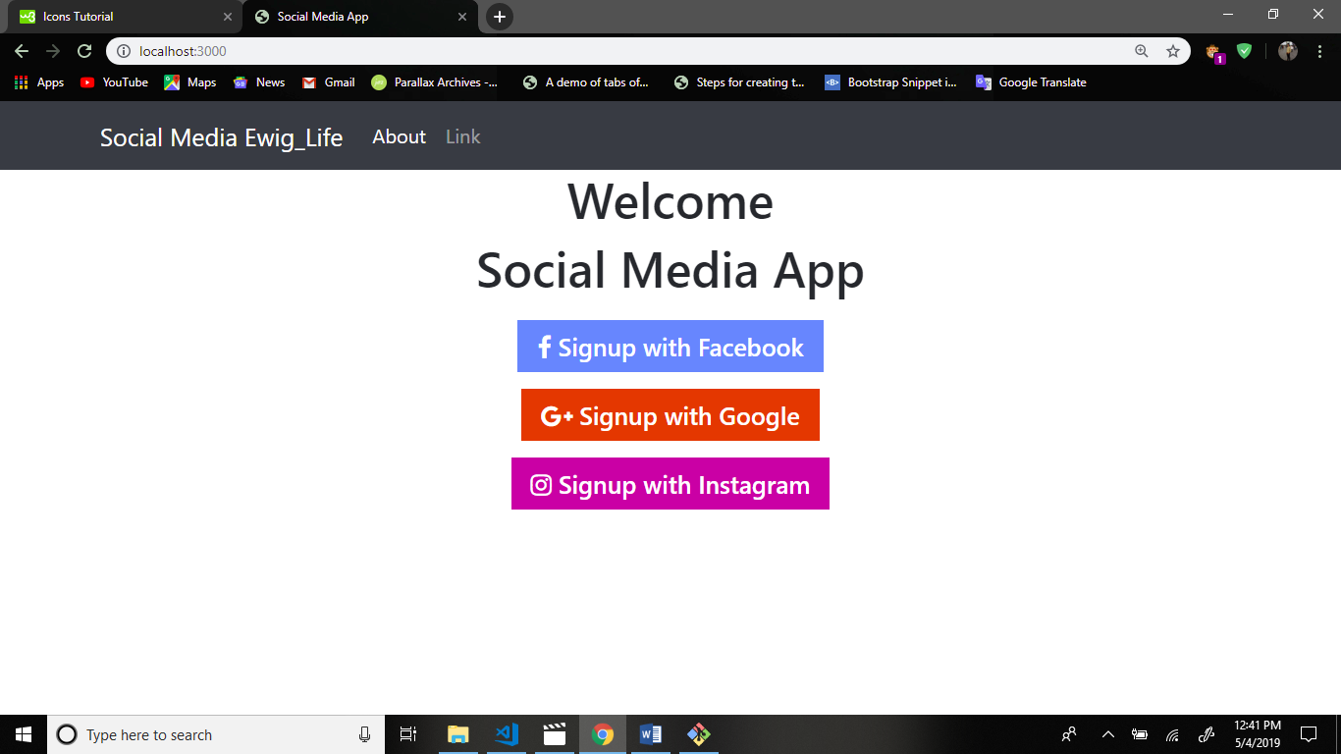

Now we create folder models in main application folder because collection data received this file.

Create file user.js file in models folder.

Structure:

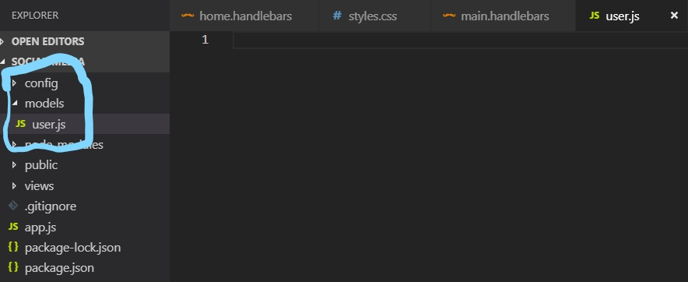

Now we write code in user.js file in models folder.

This code is set to the path for get data.

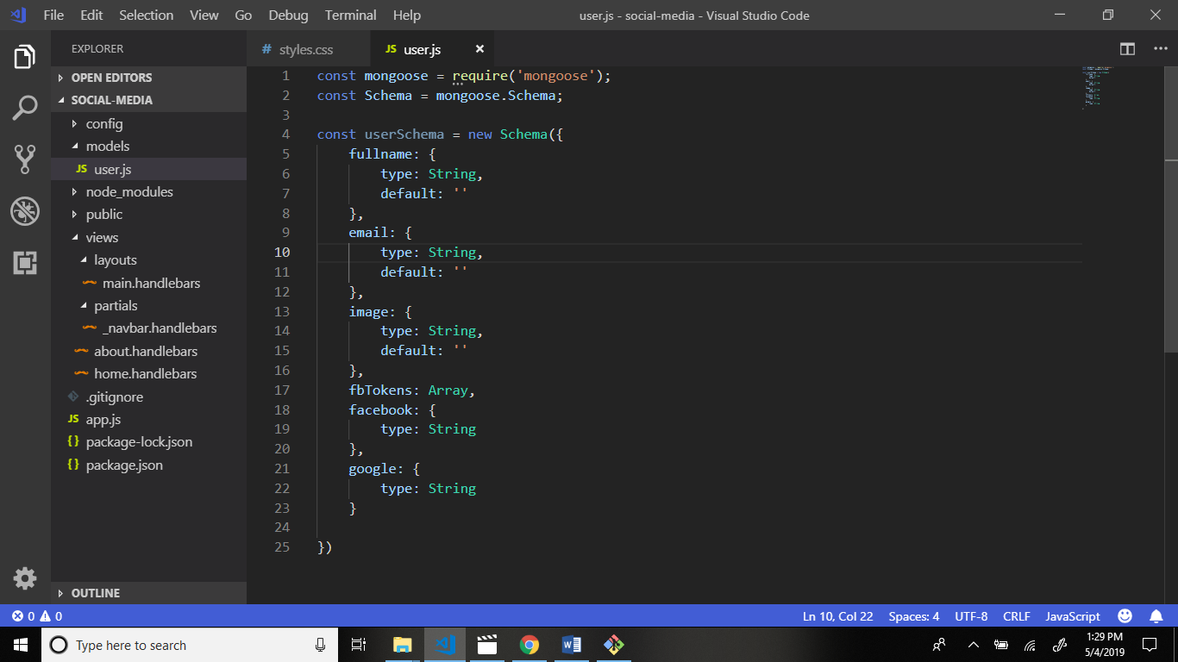

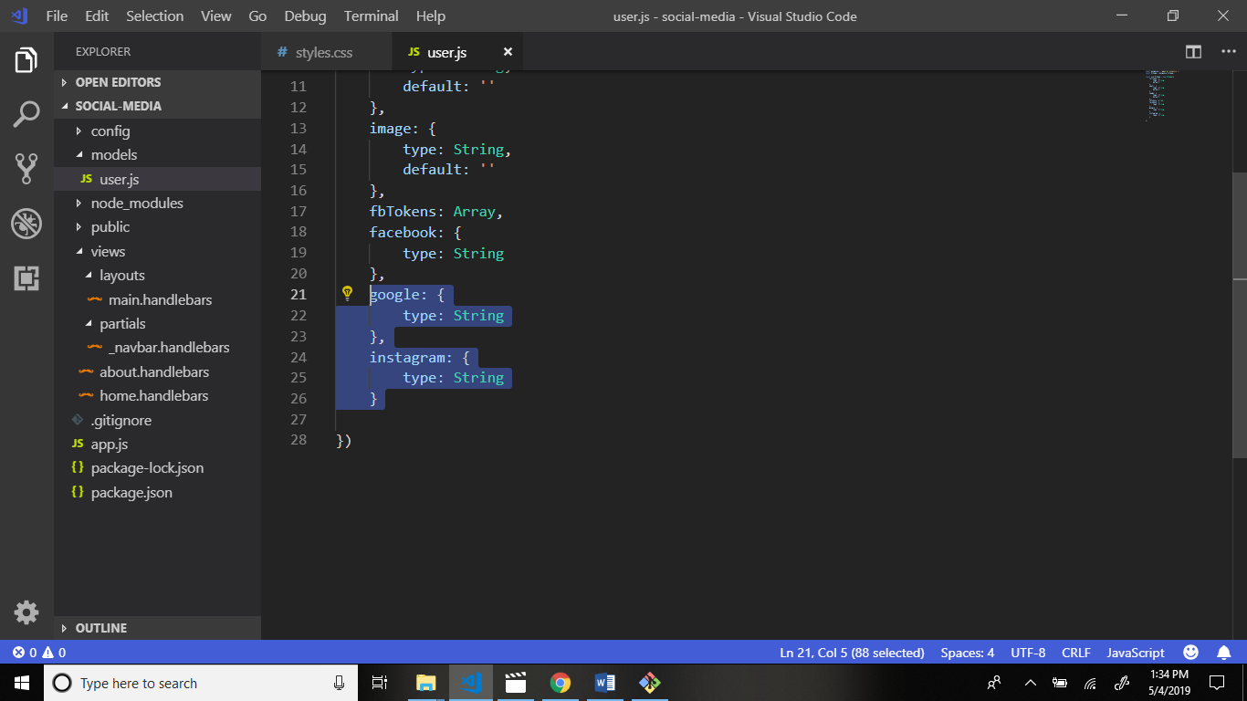

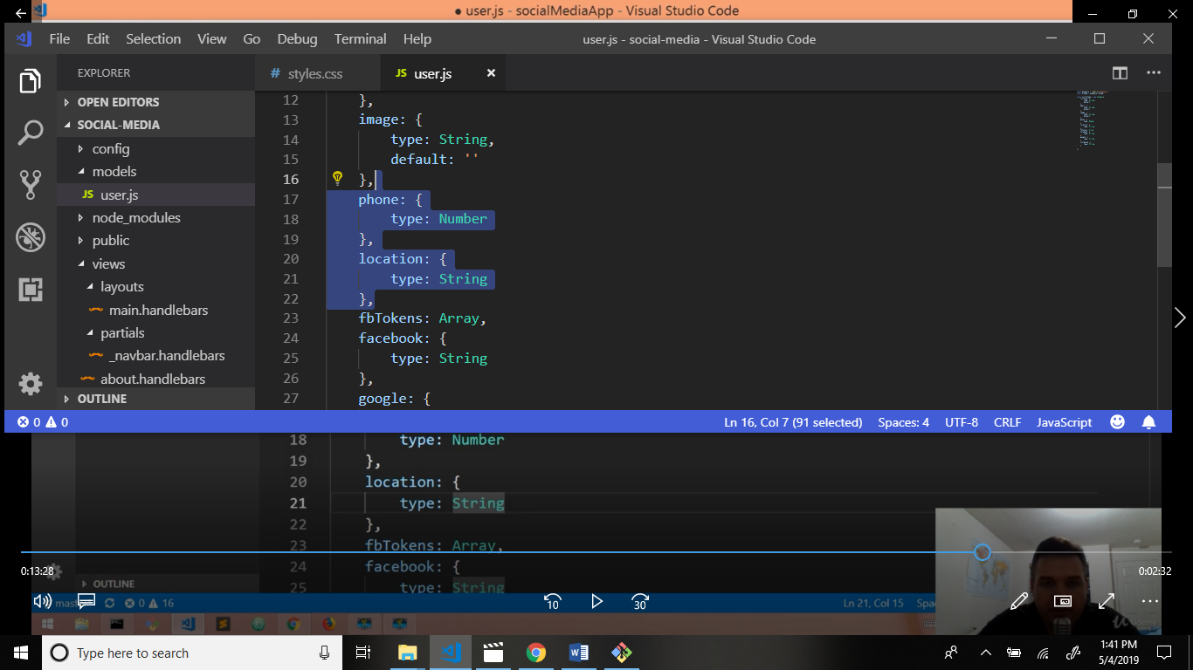

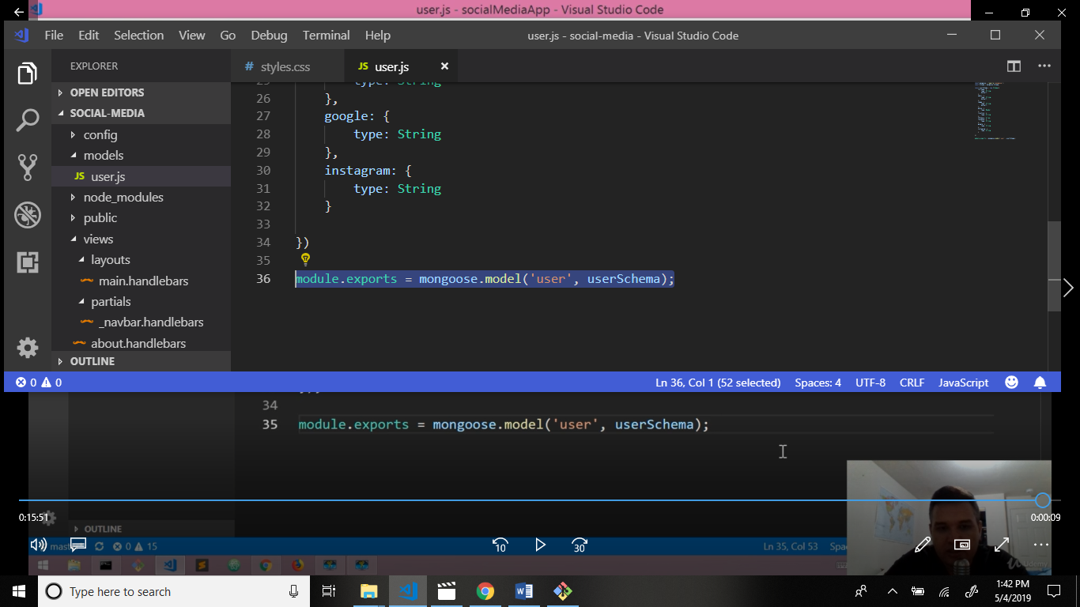

This is send request to the facebook and google and get data to the database and store my database mongoDb.

Output:

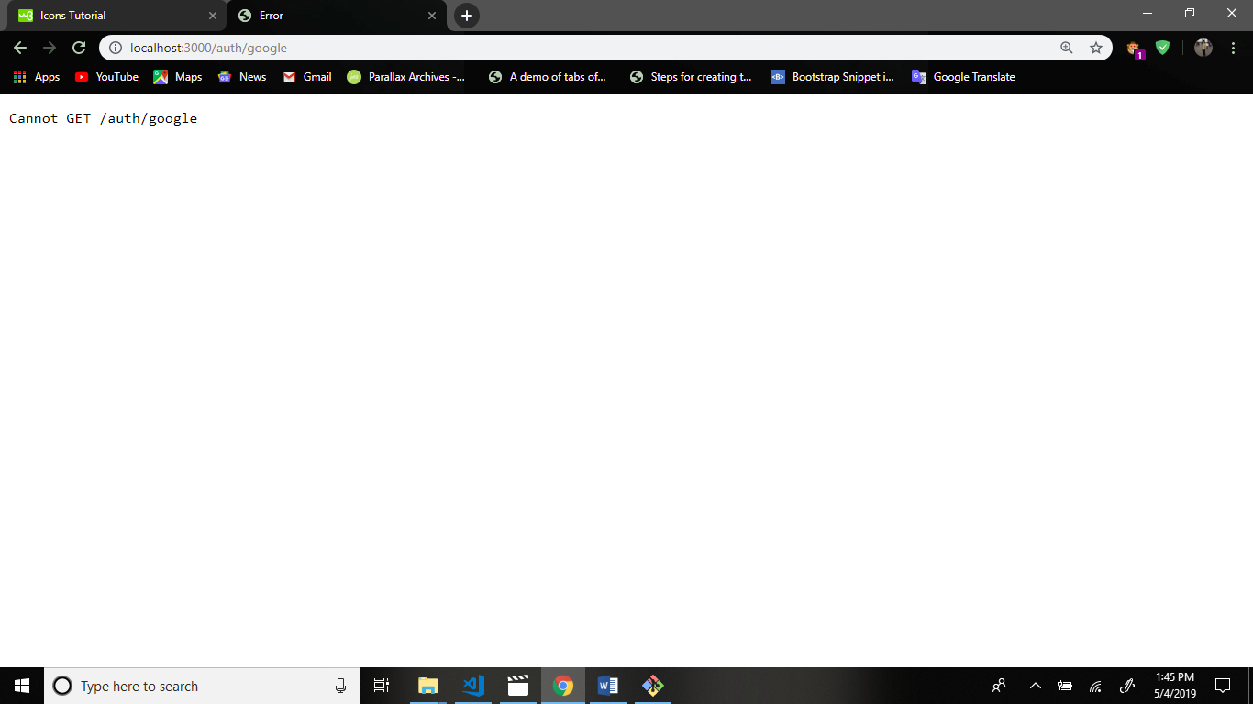

Now we get google personal info get.

Firstly seach the google: passport-google-oauth20 – GitHub

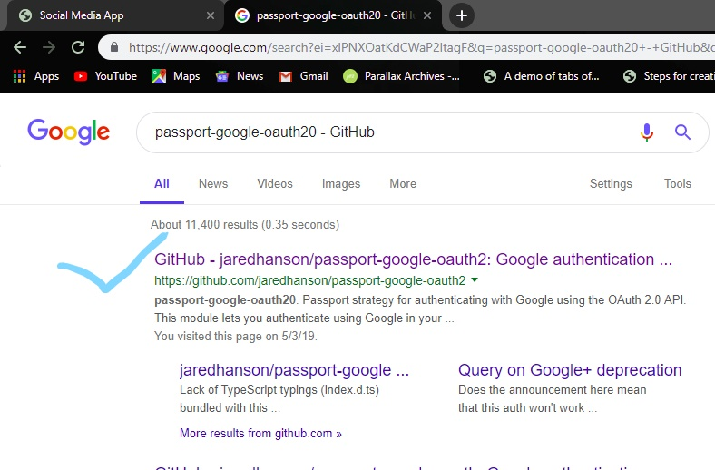

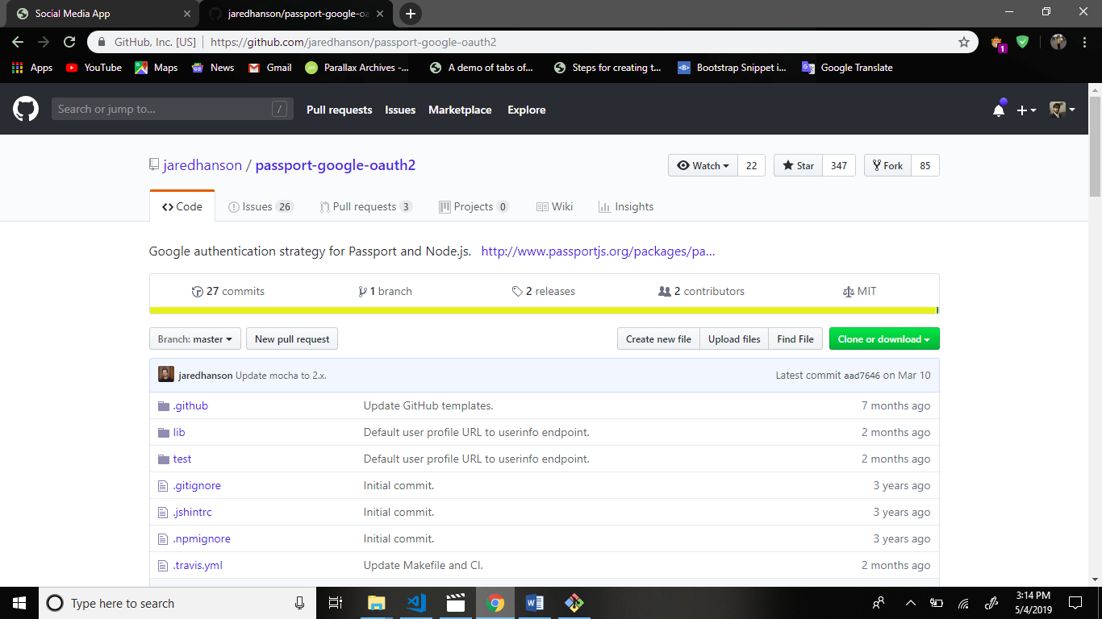

Now go to official website: <http://console.developers.google.com>

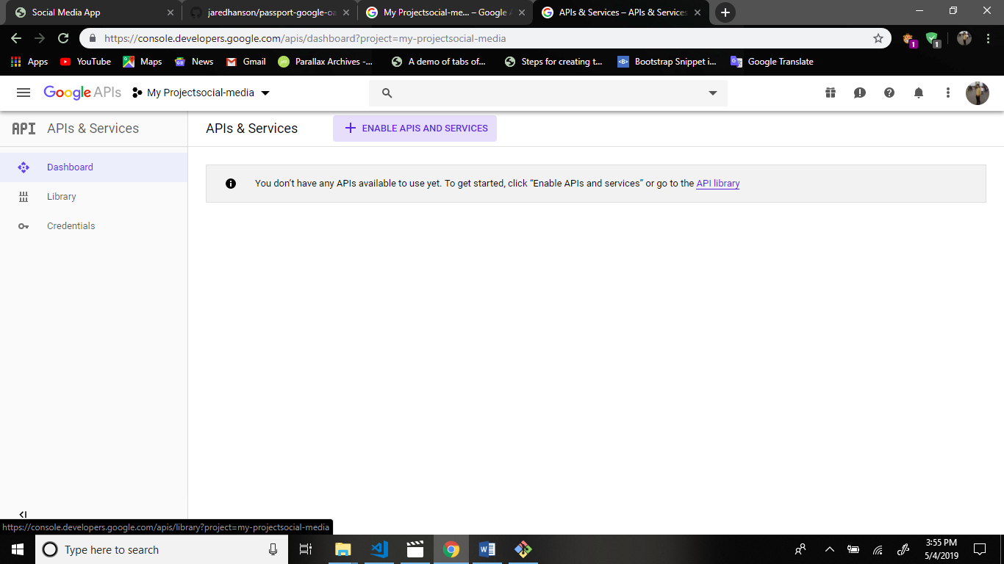

Now we create project.

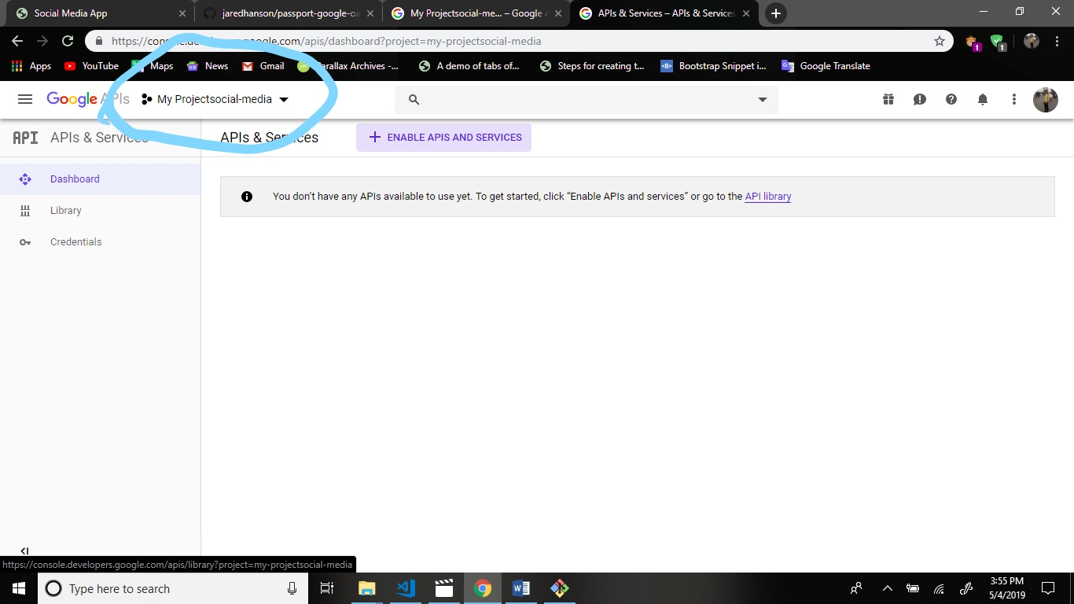

Assign project name.

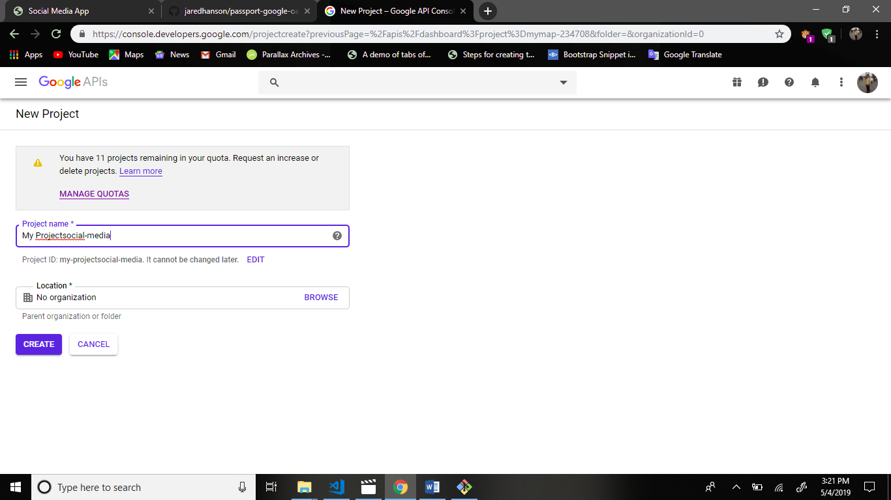

Notification click and open project.

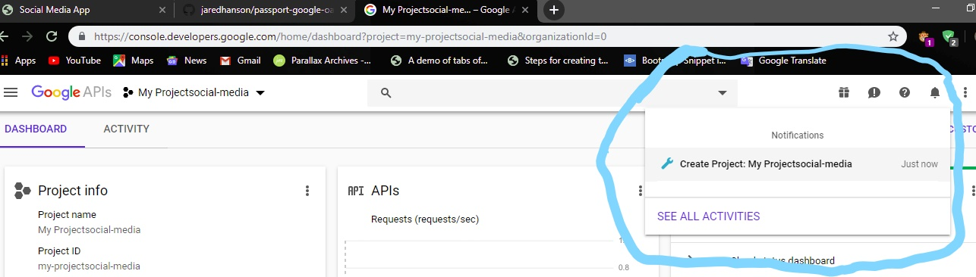

Click your project and open this.

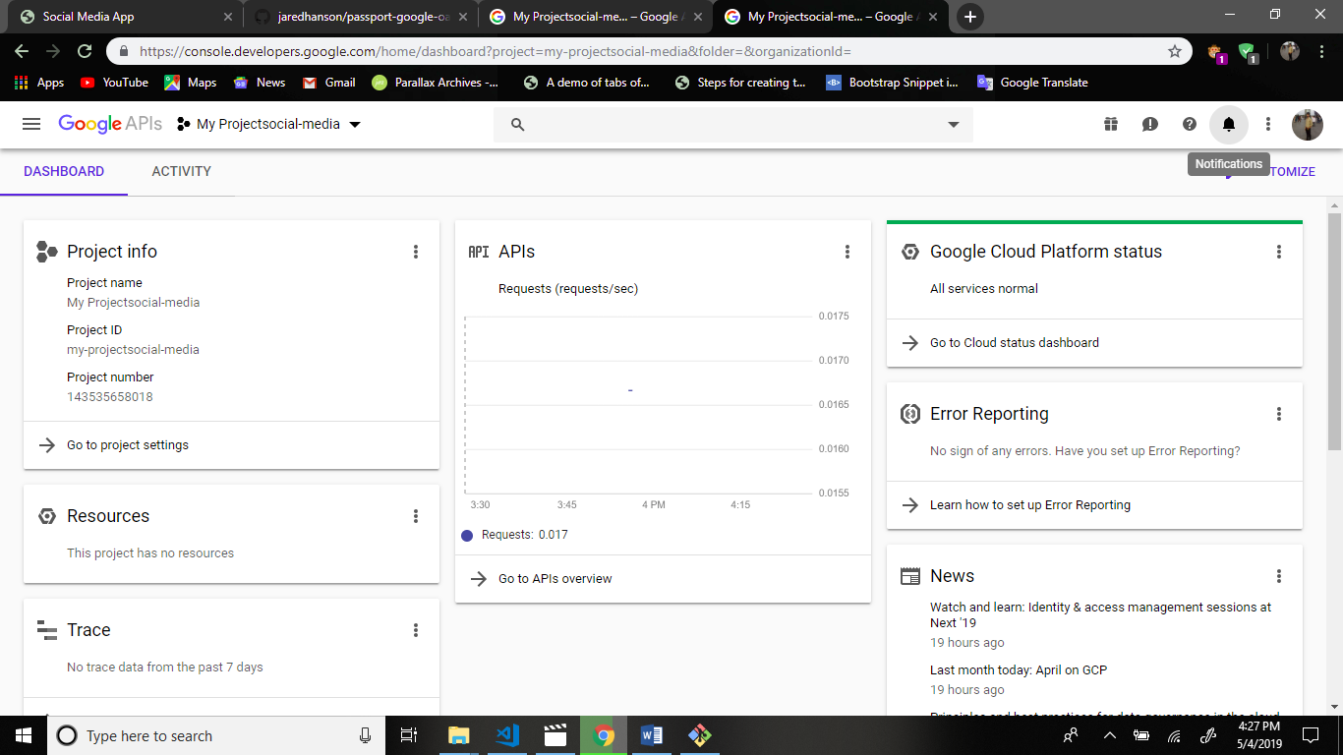

Now search this project in google+ api

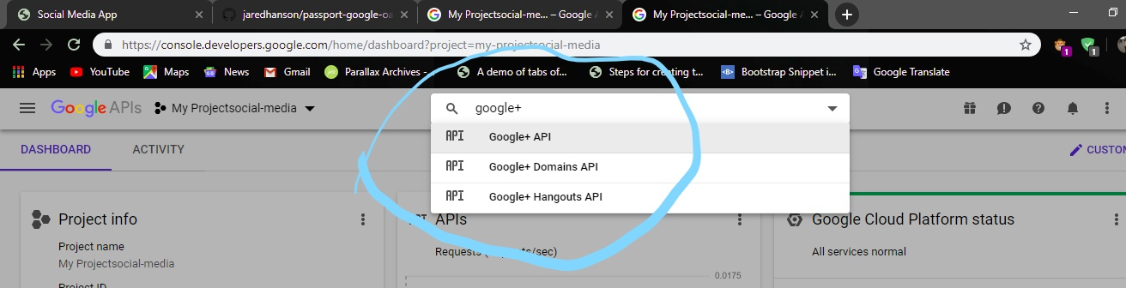

After click

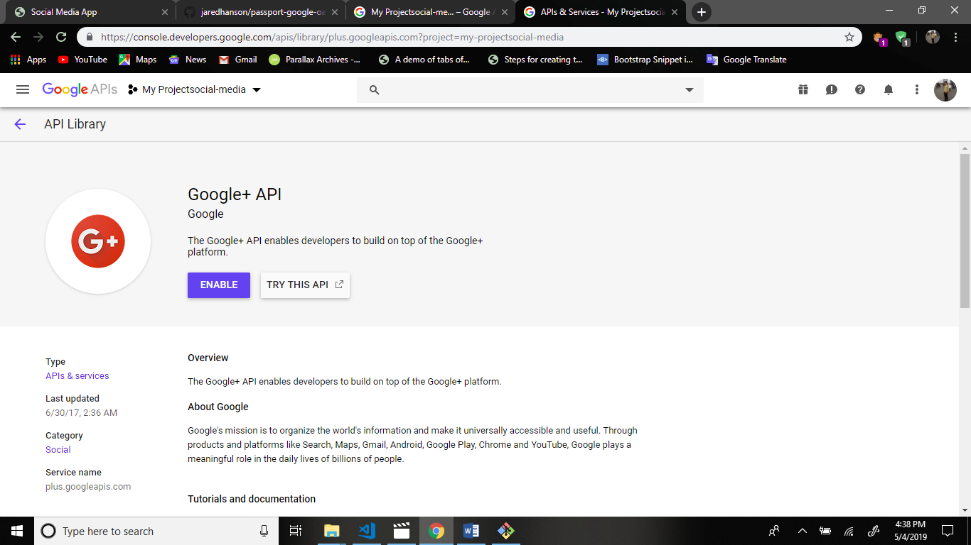

Now click in enable button.

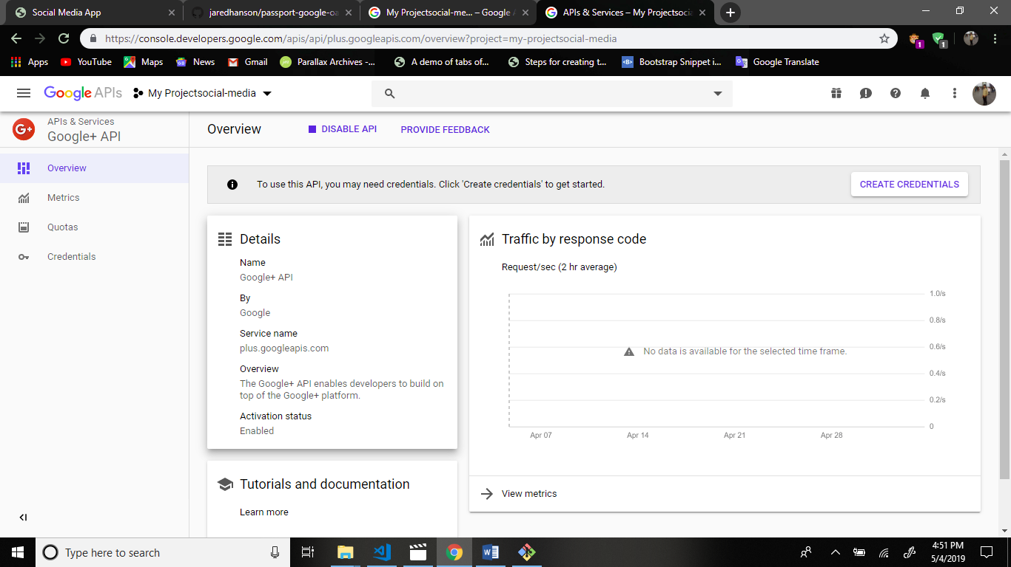

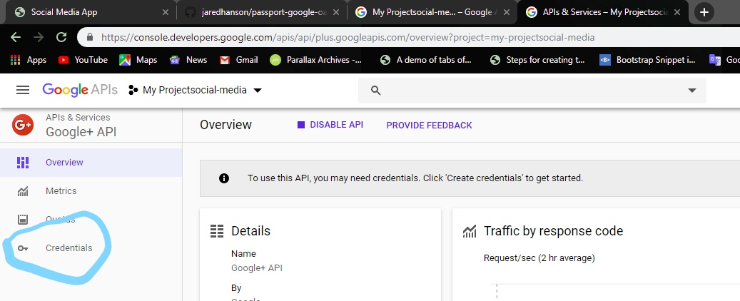

Now we create new credentials.

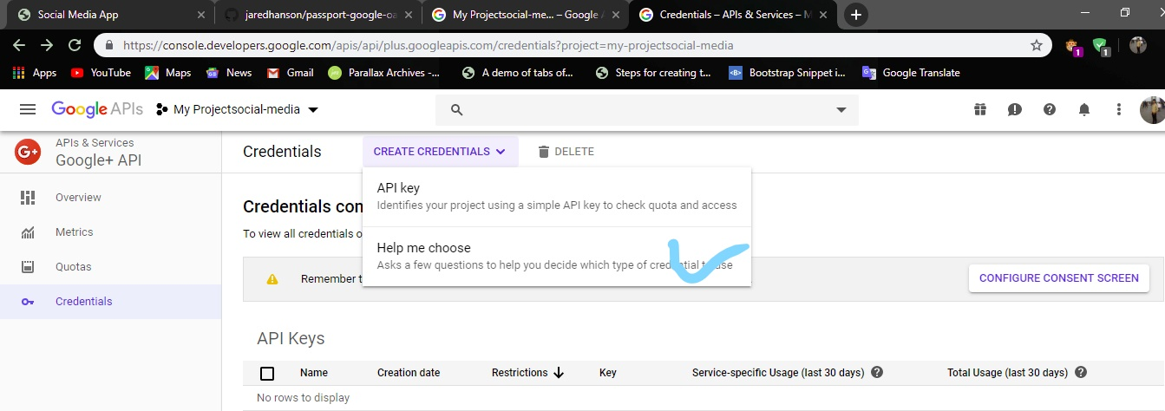

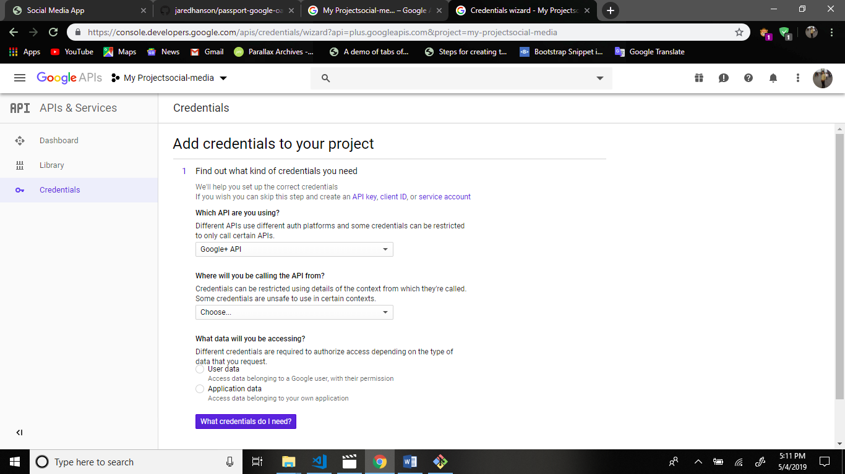

Now create client id.

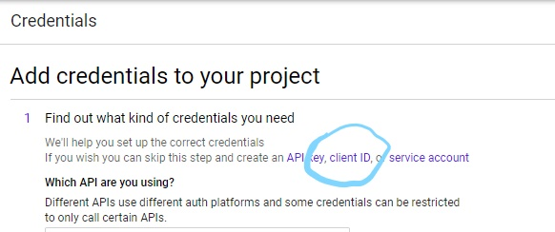

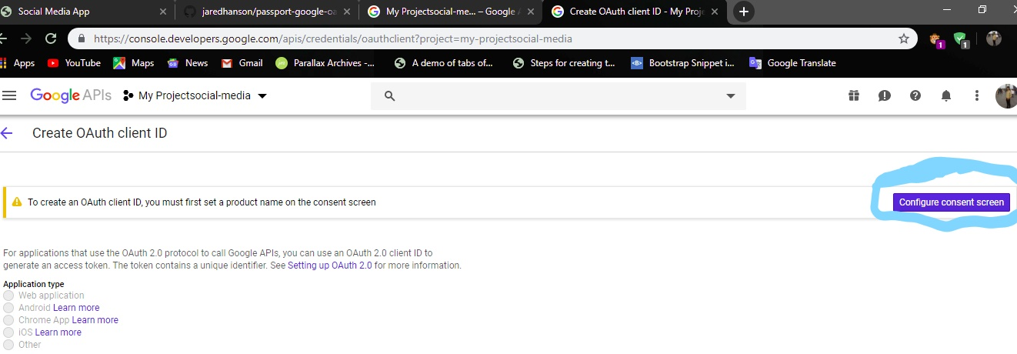

Click this.

Enter information.

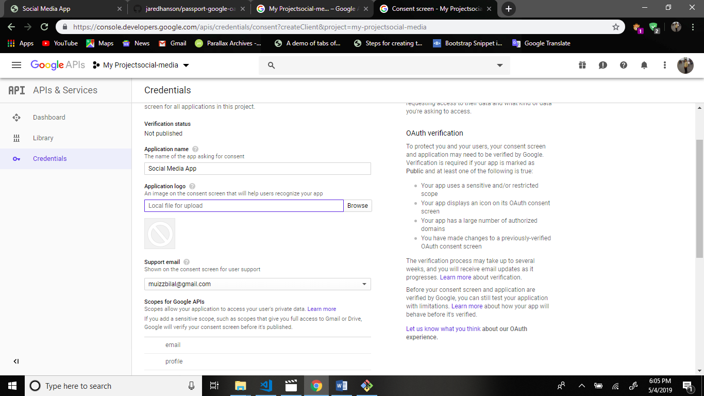

Now click save.

Open click web applicaion.

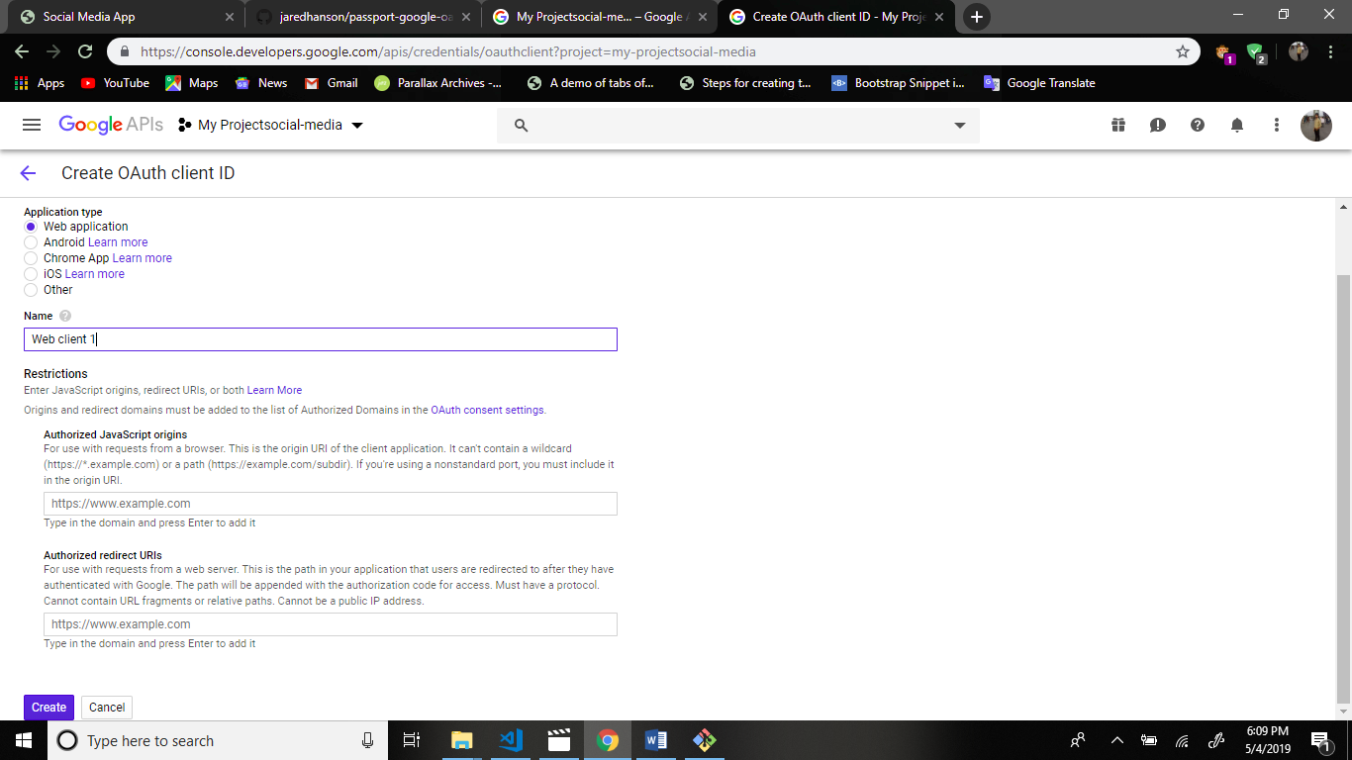

Your application is local so your url is <http://localhost:3000> this url is copy and paste the.

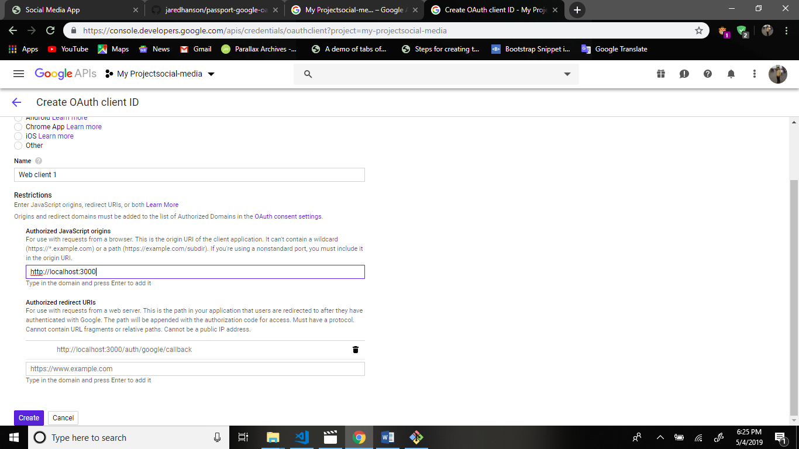

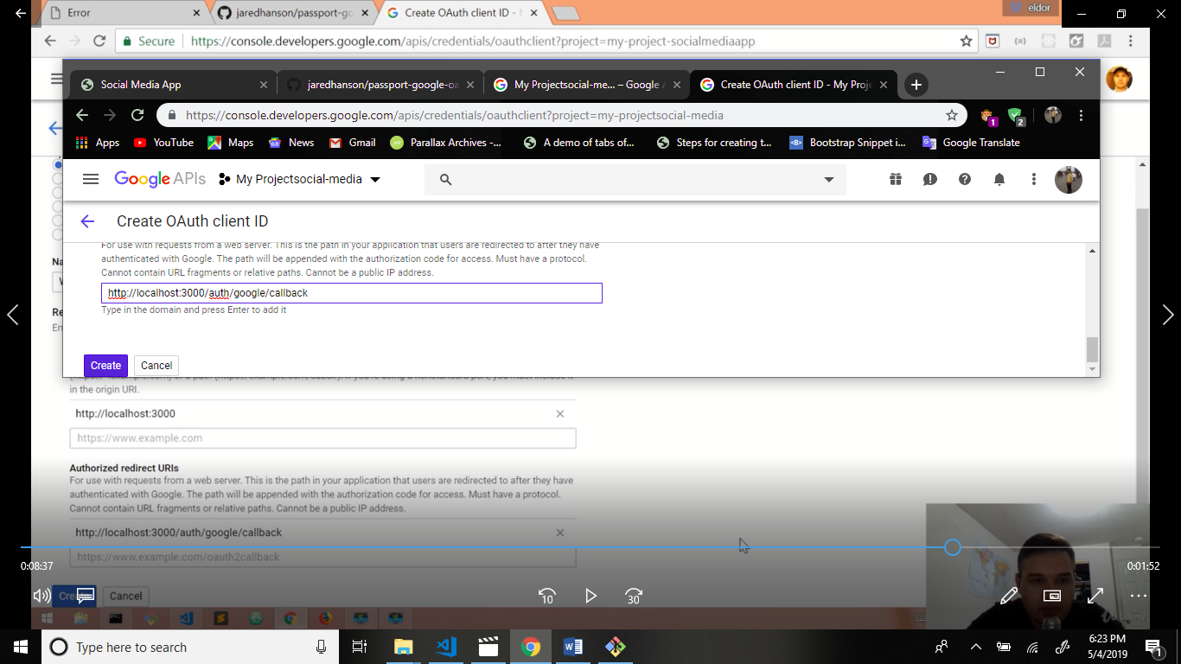

After this create button.

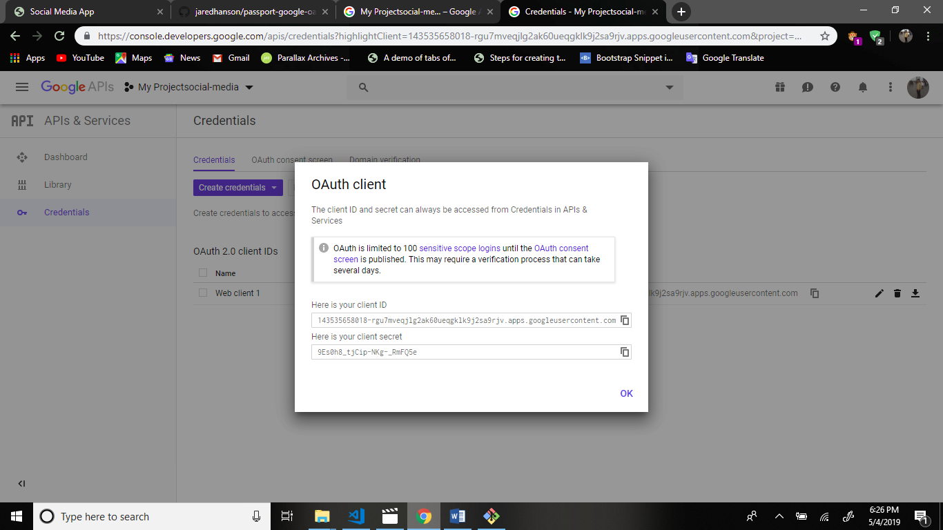

Then copy the google client id first.

Second copy the google client secret.

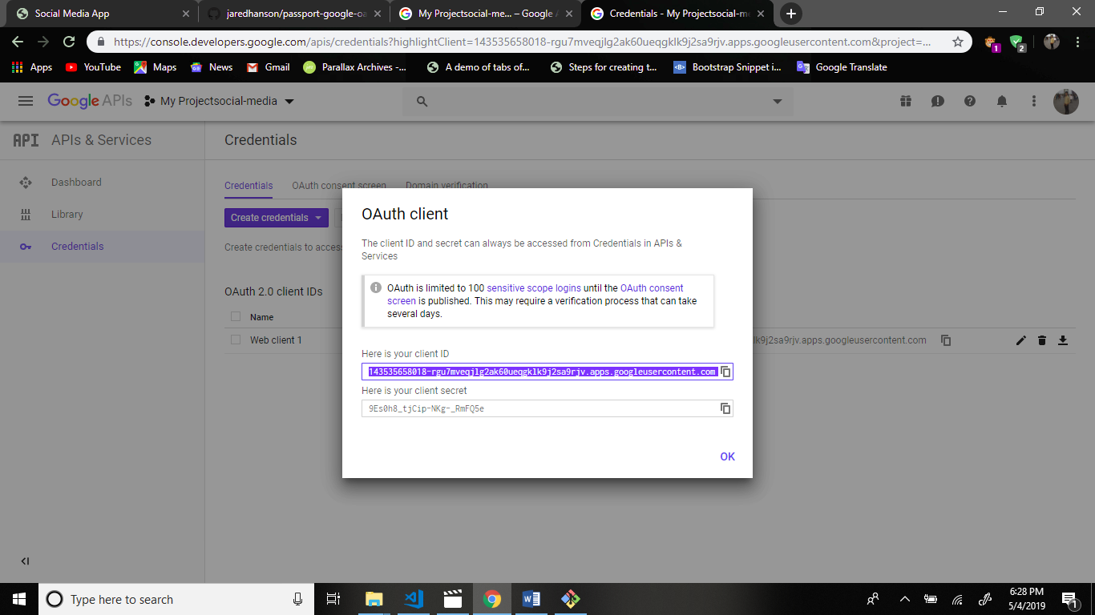

And paste the config > keys.js file

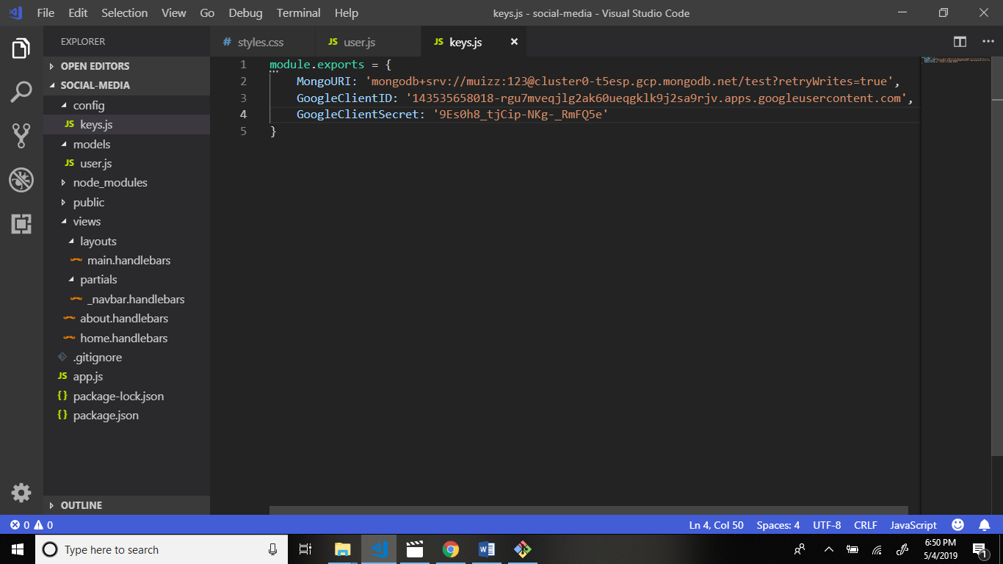

Now create folder passport in main application folder.

Create file in google-passport.js file in passport folder.

Structure:

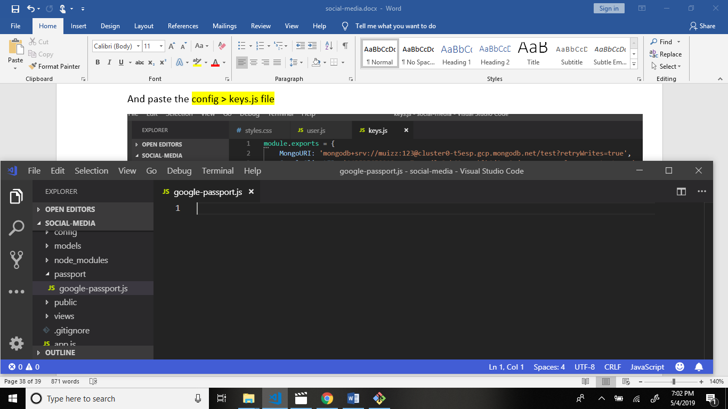

Now I we install passport:

Command: npm i passport –save

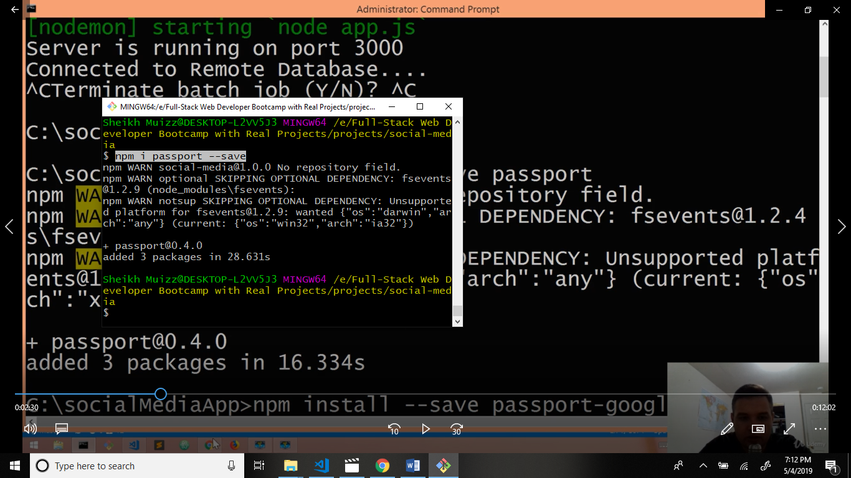

Now I we install passport google oauth20.

Command: npm i passport-google-oauth20 –save

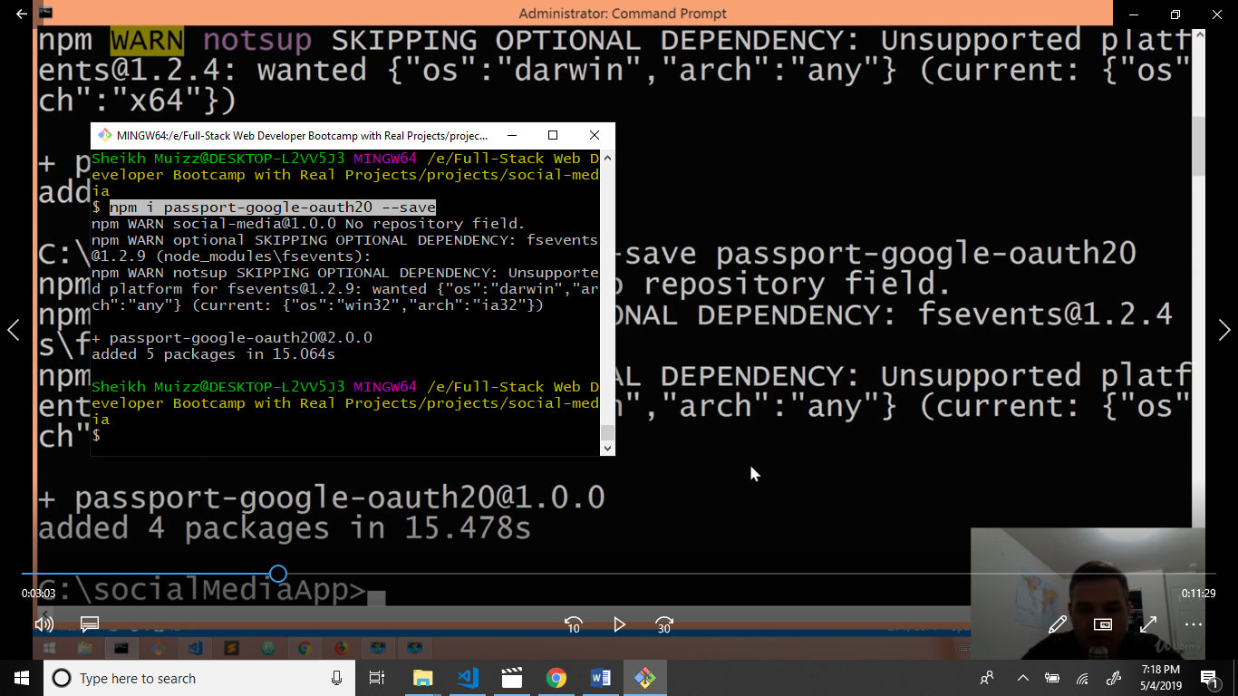

Now we download module express session

Command: npm i express-session –save

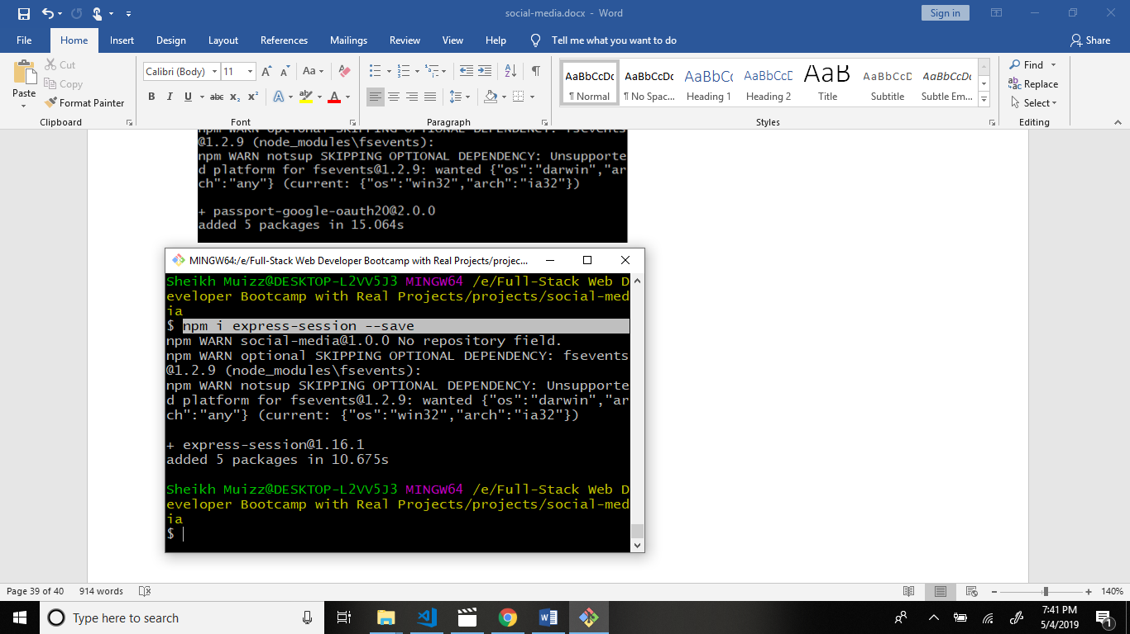

Now we install body parser because body parser receive data and display output.

Command: npm i body-parser –save

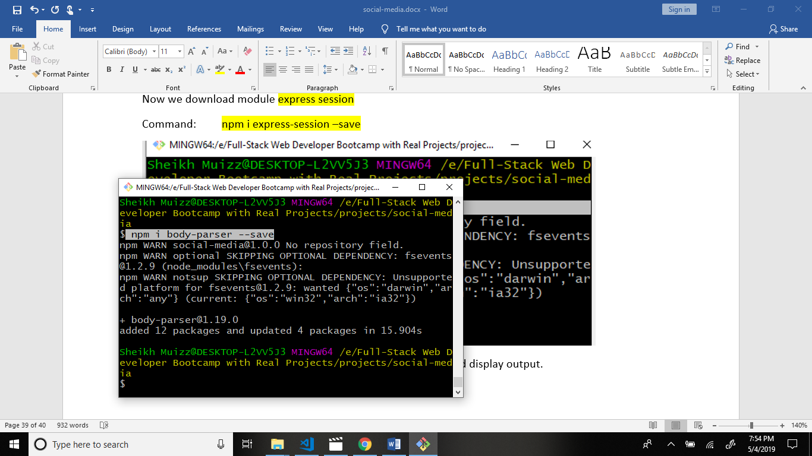

Now we install cookie parser because cookie parser generate cookie id for user collection.

Command: npm i cookie-parser –save

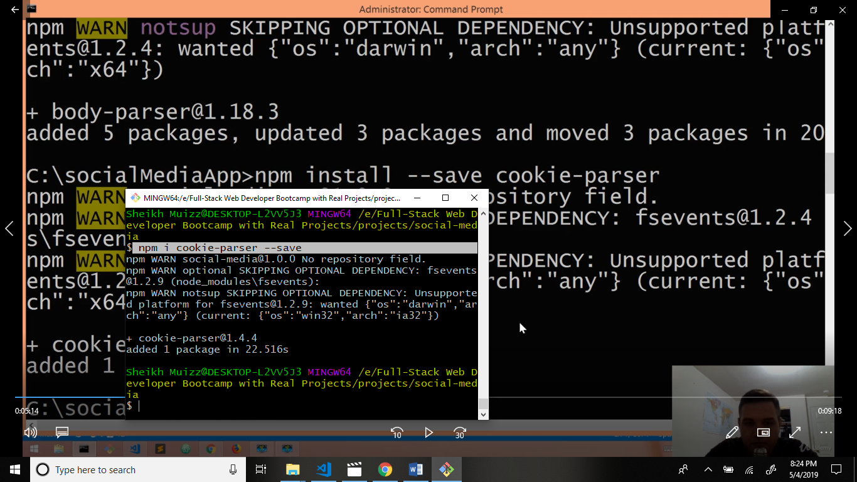

Now go to passport > google-passport.js file and write code.

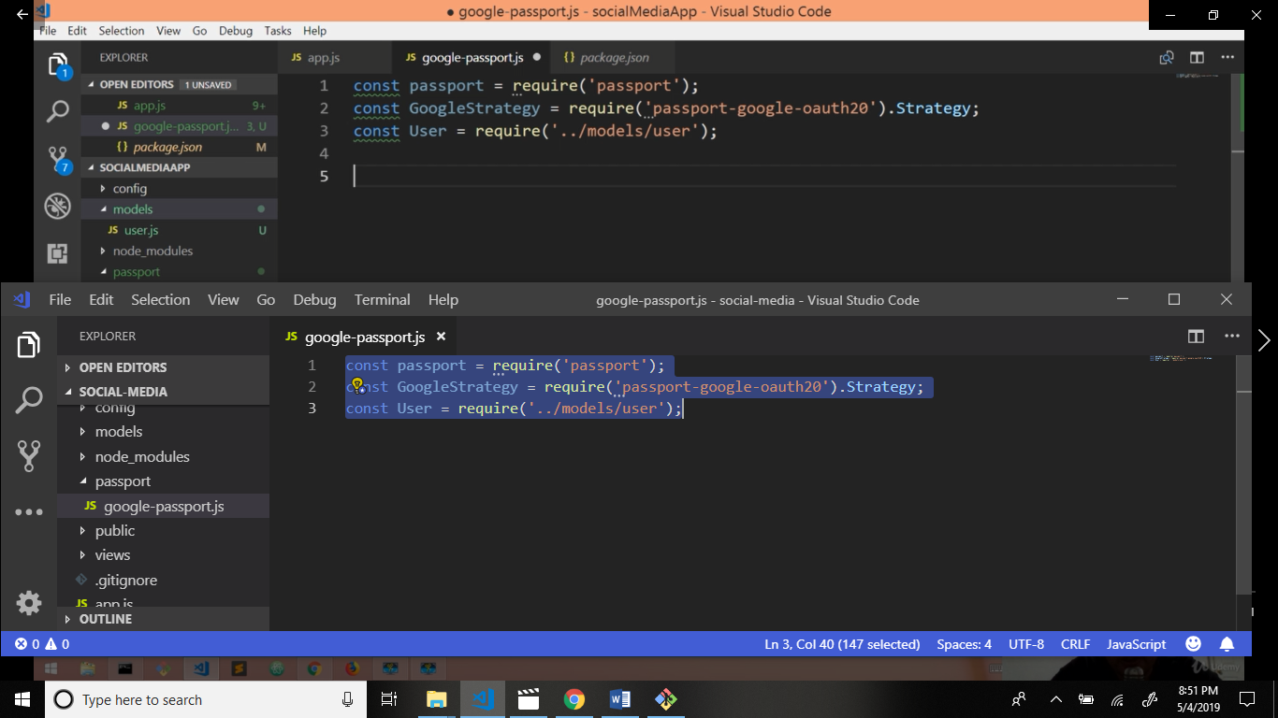

# Now go to github [jaredhanson](https://github.com/jaredhanson)/[passport-google-oauth2](https://github.com/jaredhanson/passport-google-oauth2)

# 

# Scroll down.

# 

Copy this code and paste the google-passport.js file and write code and changes.

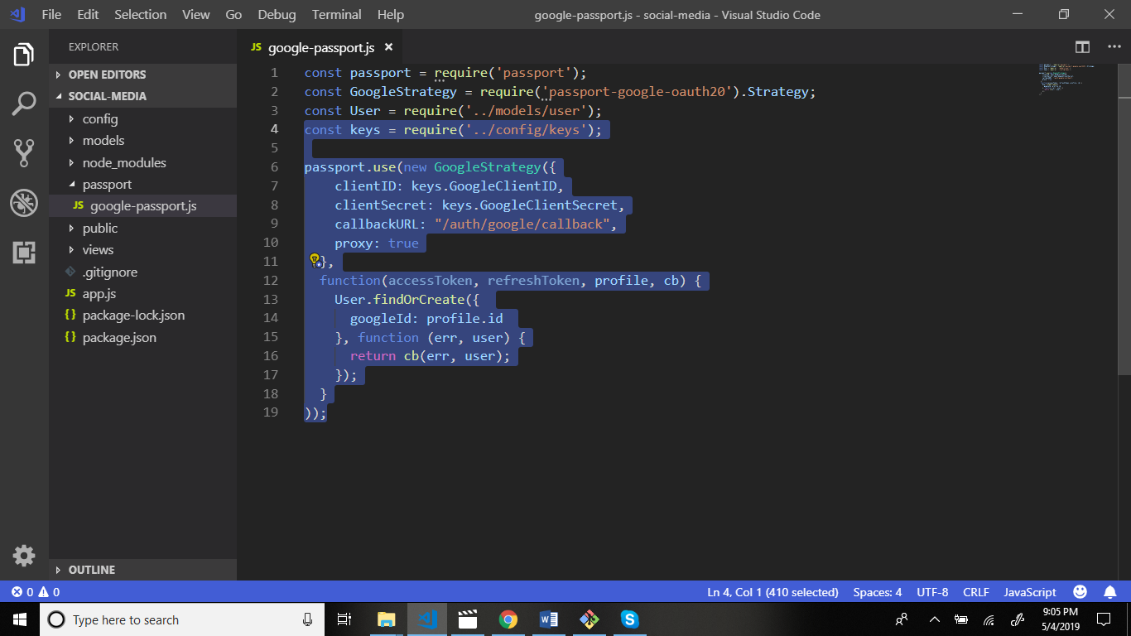

Now you can go to passportjs.org website.

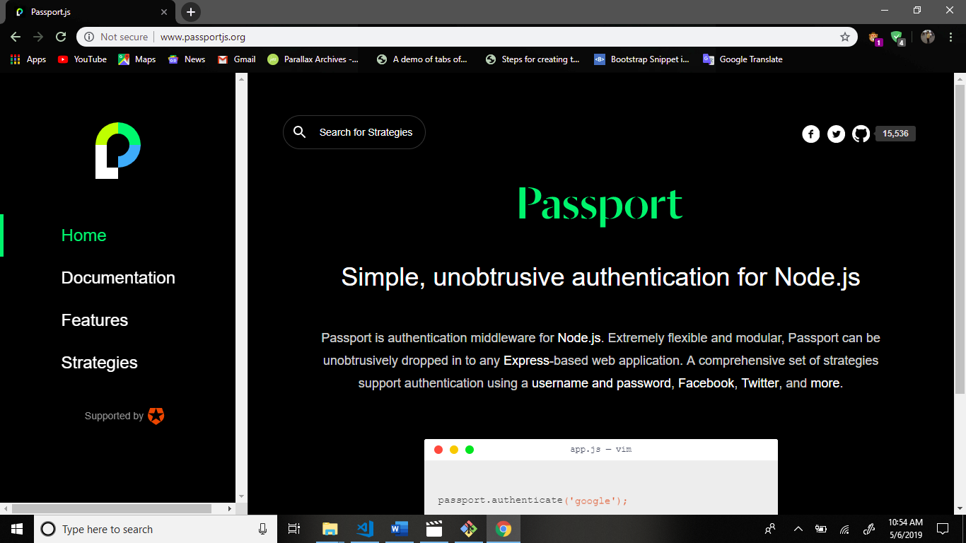

Go to documentation and scroll down.

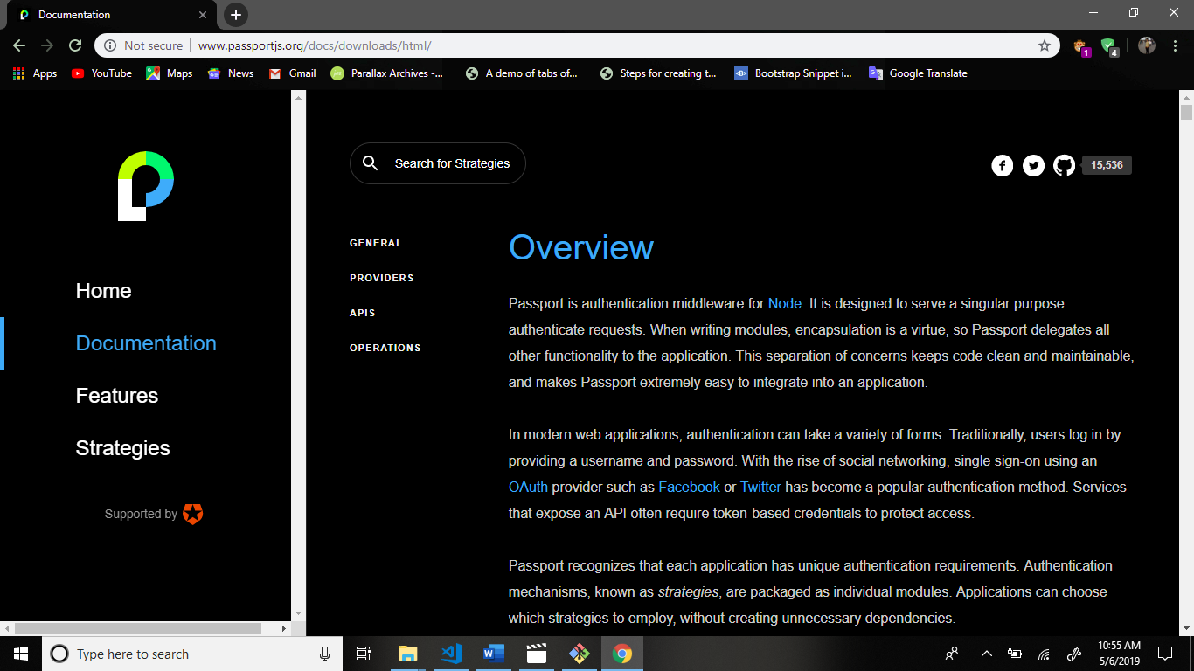

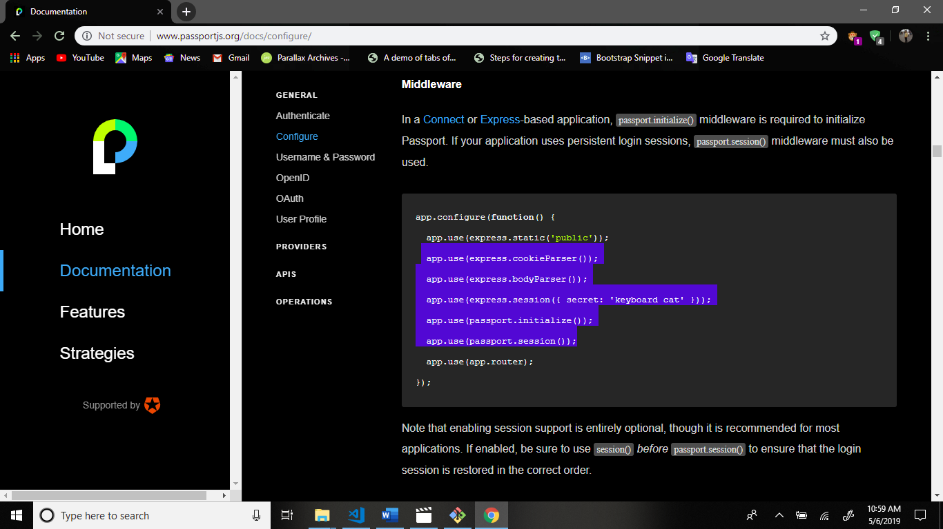

Copy this code and paste the app.js file.

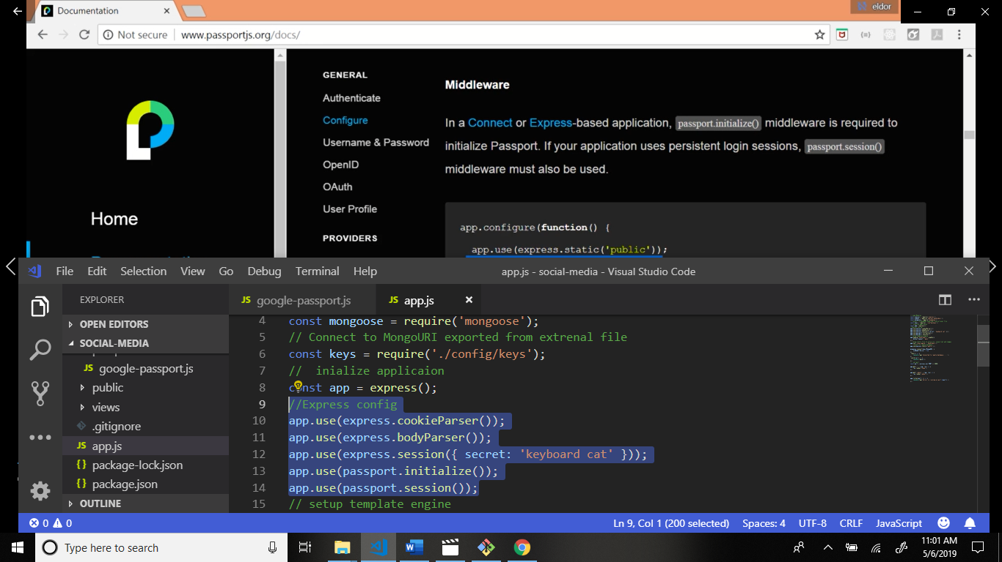

Scroll down.

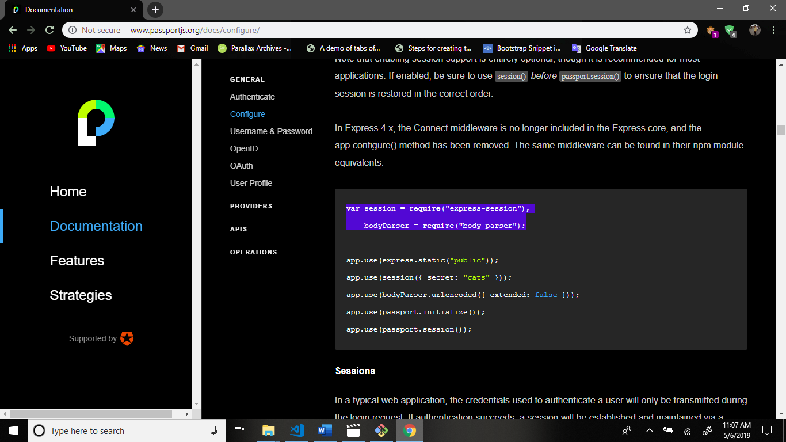

Copy this code and paste the app.js file and some changes.

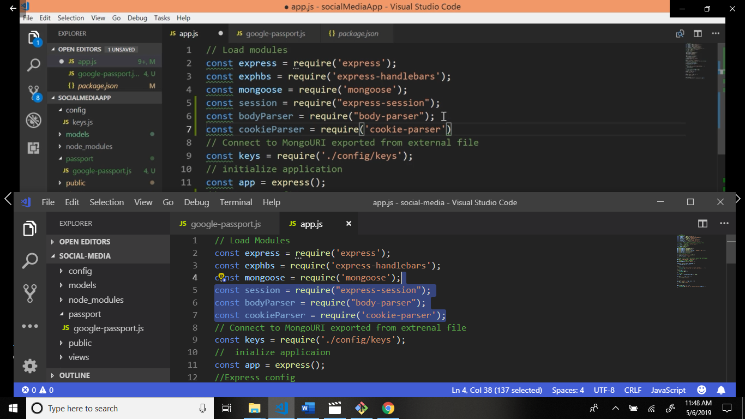

body-parser is convert into json format.

Add this code and some changes.

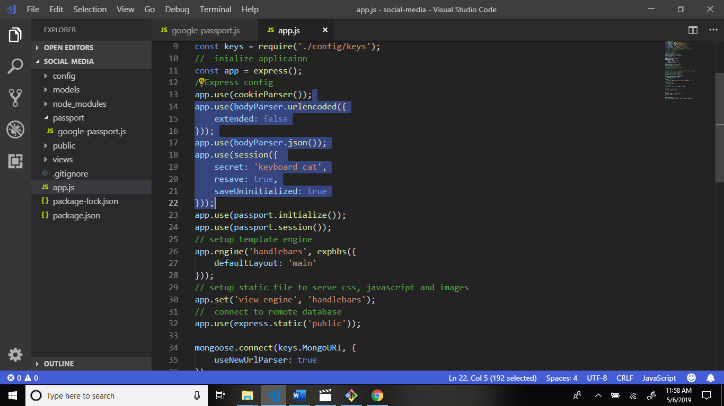

Go to passportjs.org website again.

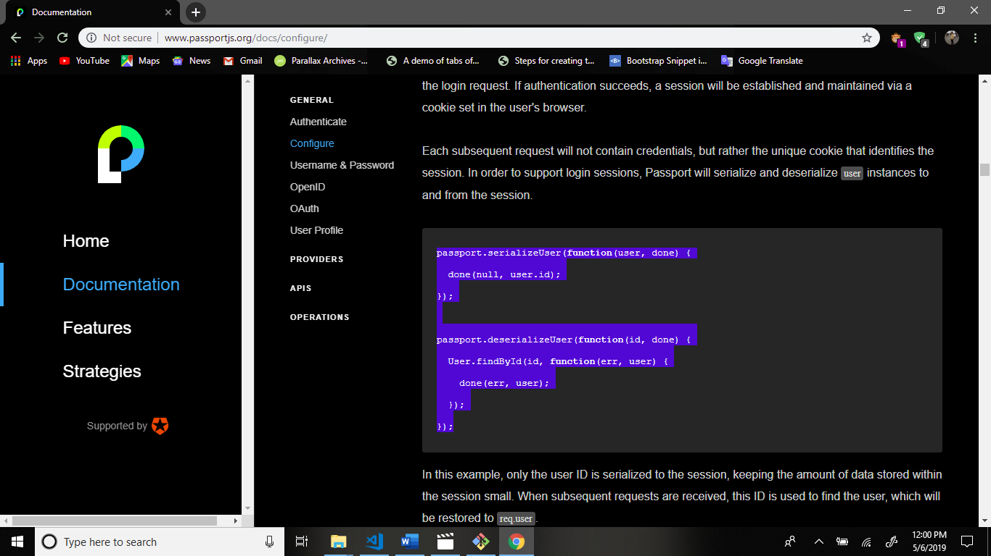

Copy this code and paste the google-passport.js file.

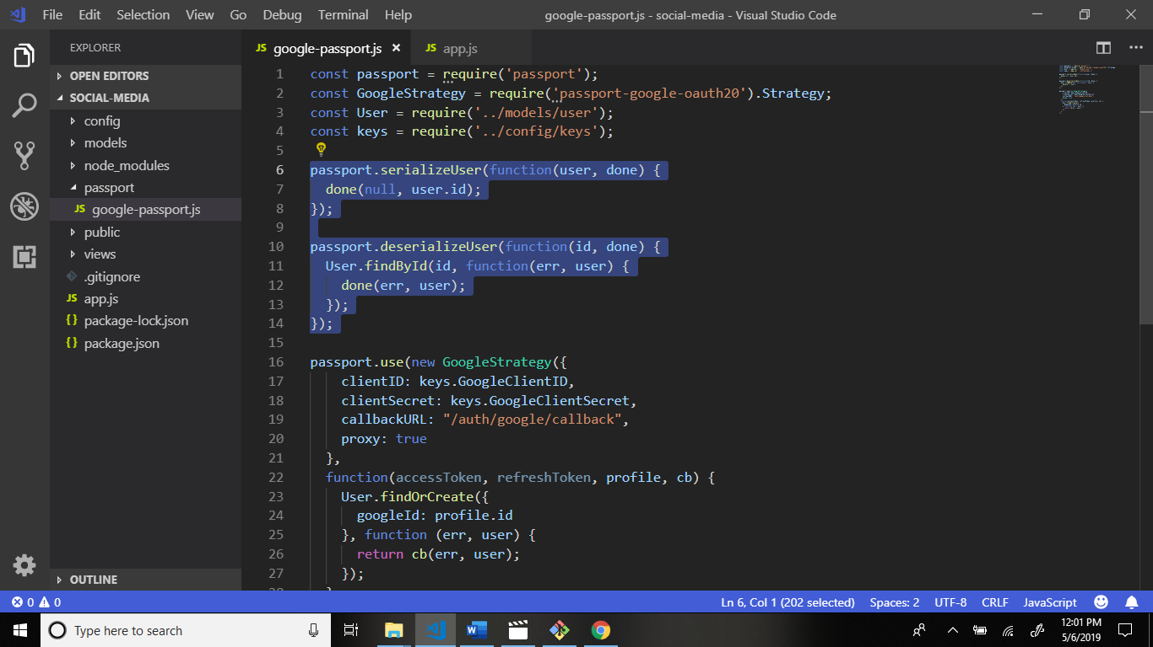

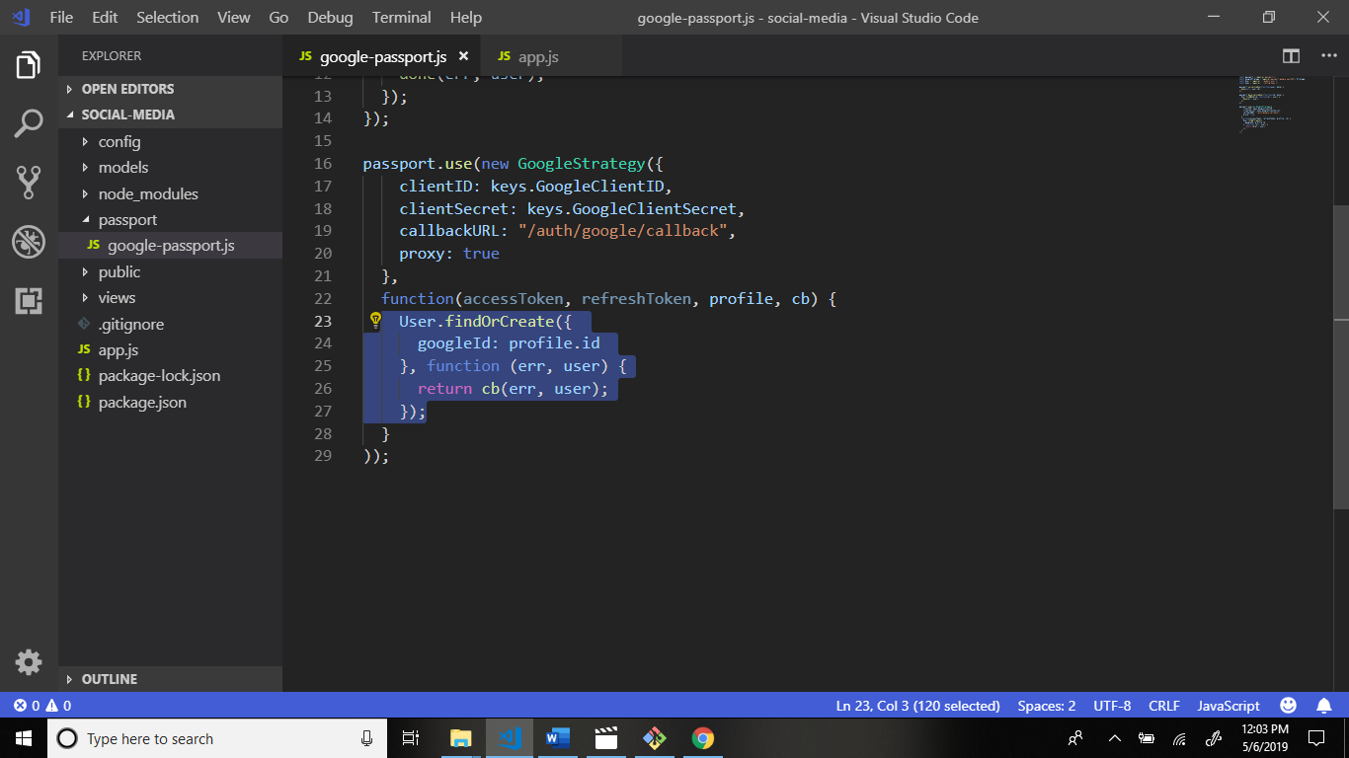

Remove this highlight code.

After this some changes.

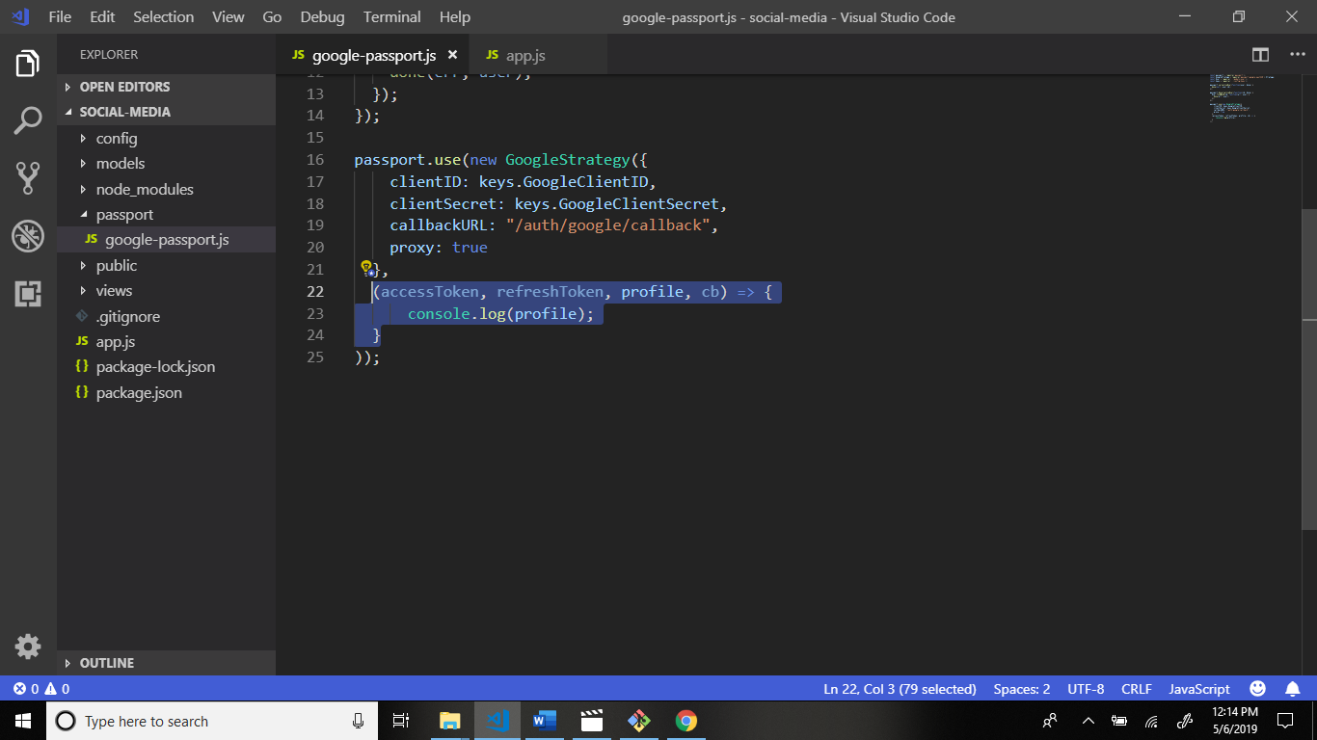

Now go to app.js file and add some code.

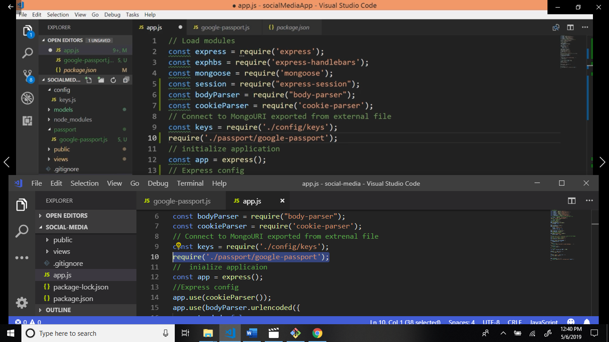

Now define the passport module.

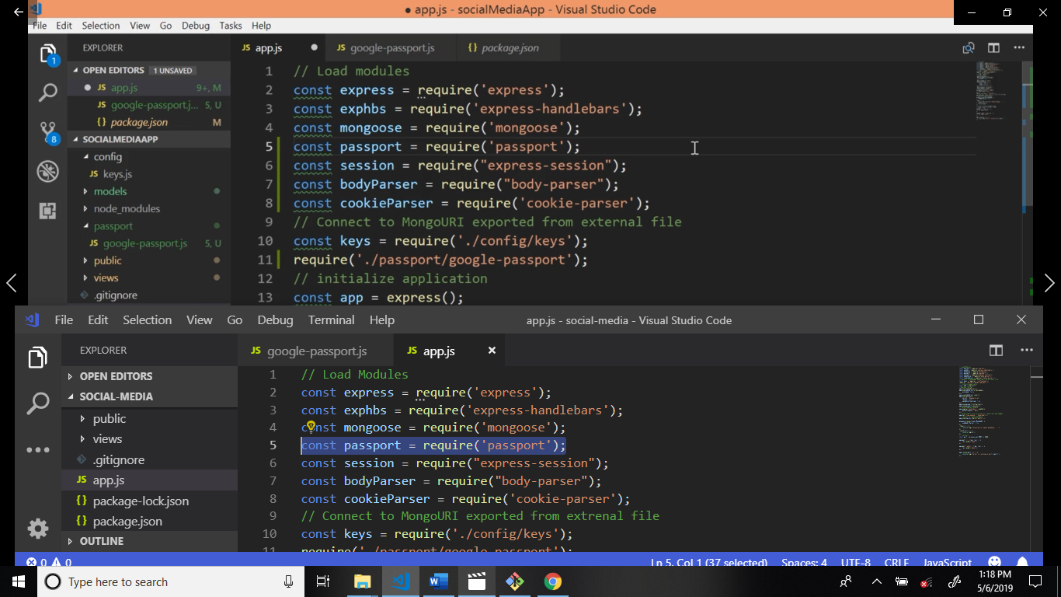

Now go to passport google-oauth20 github. Link: <https://github.com/jaredhanson/passport-google-oauth2>

Scroll down and copy this code and paste the app.js file after about route.

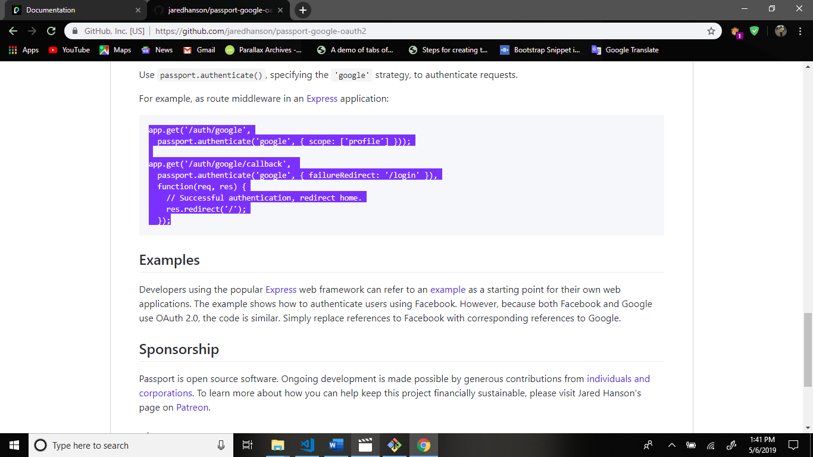

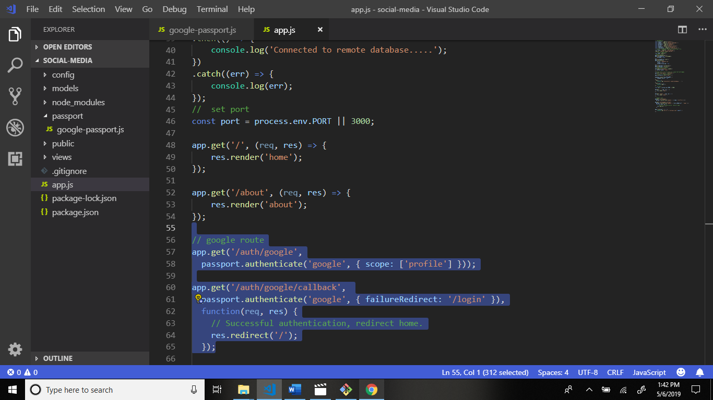

Now some changes this code.

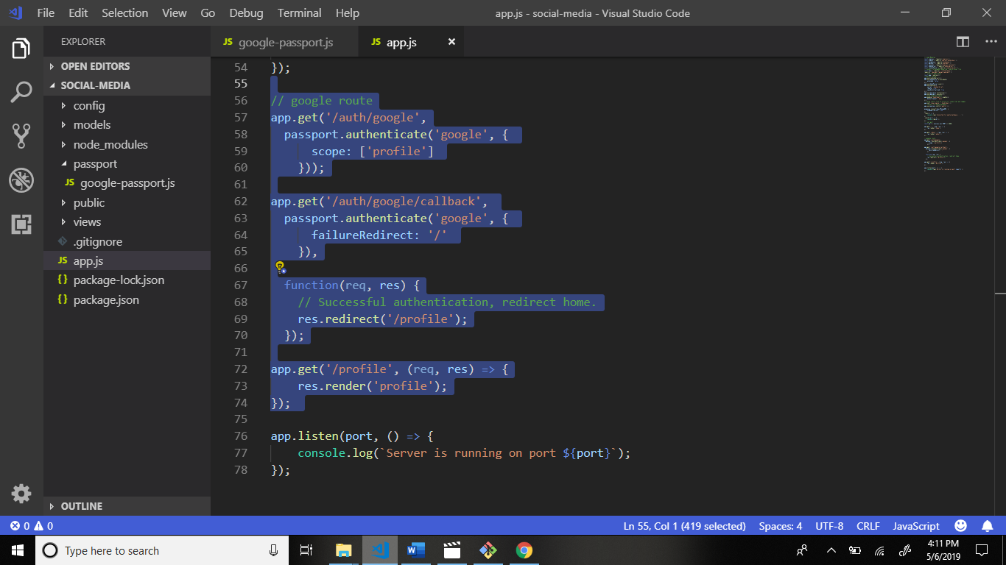

Now we create file home.handlebars in views folder. Structure:

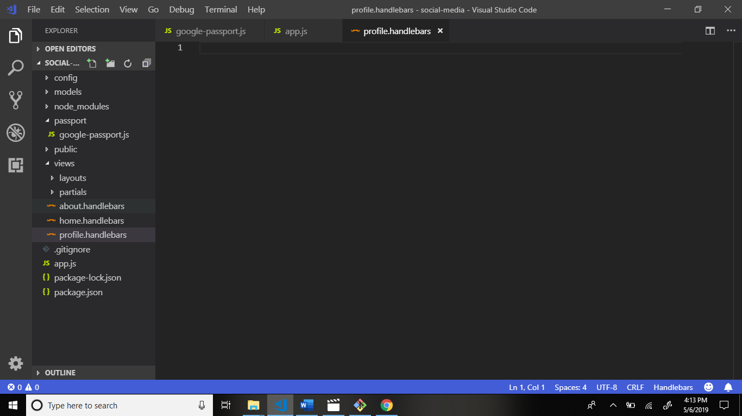

Now add some code in profile.handlebars file and write code.

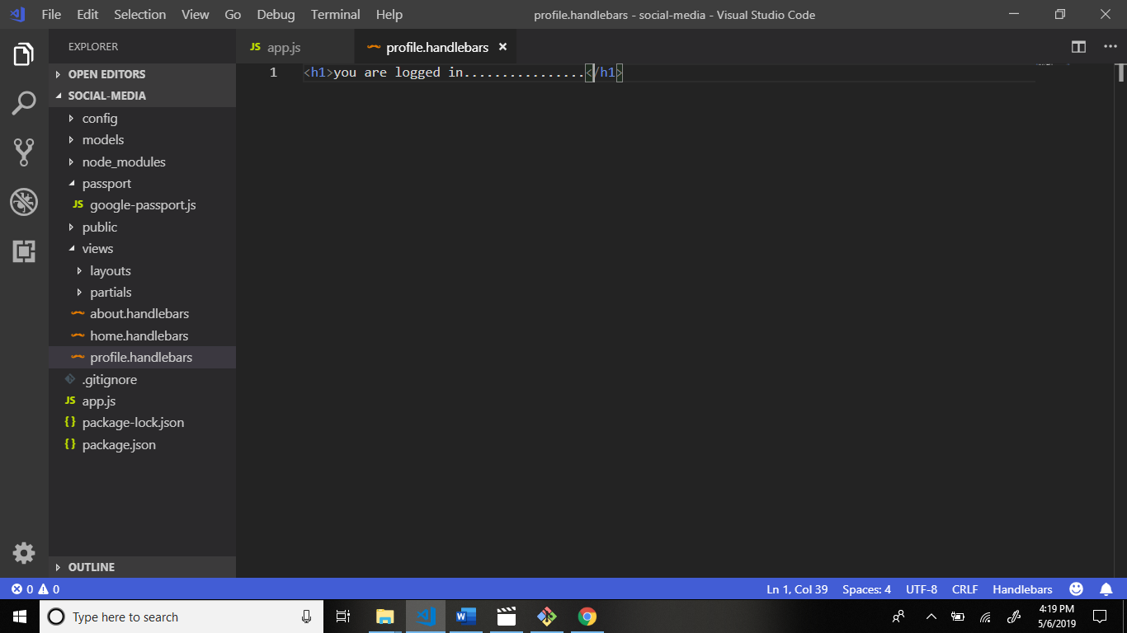

And start the localserver through command.

Command: nodemon app.js

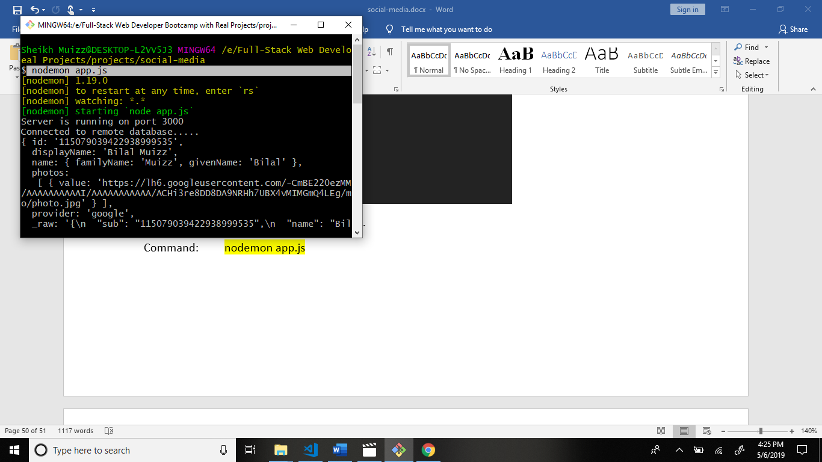

Output: and signup the google.

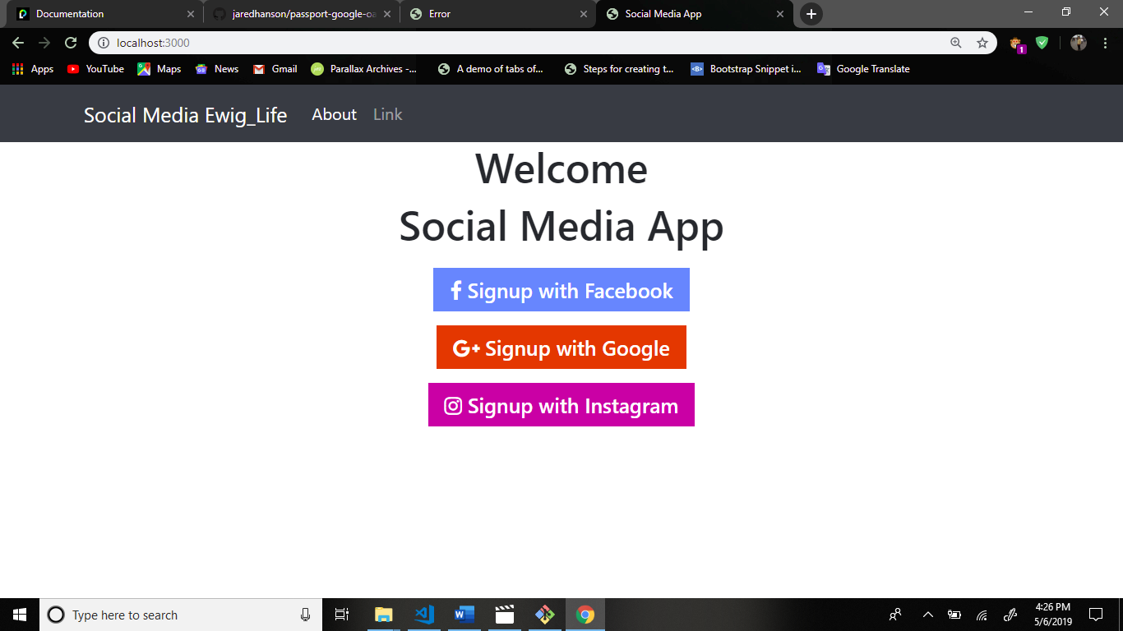

Now see the git bash cli to receive the data to signup.

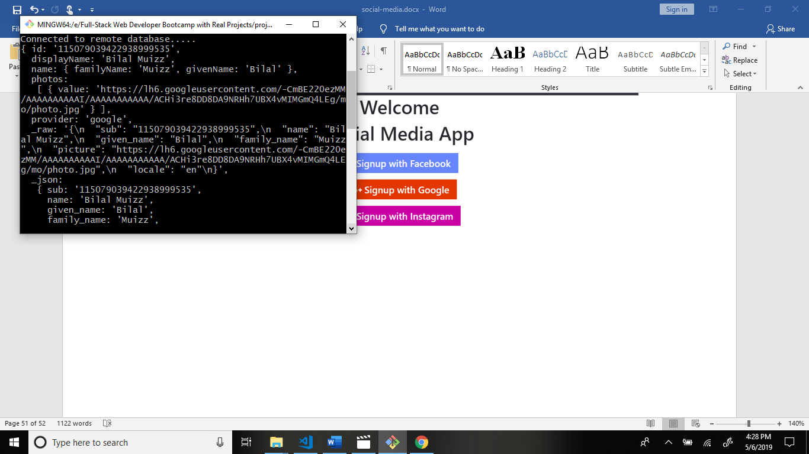

Now add some piece of code in google-passport.js file.

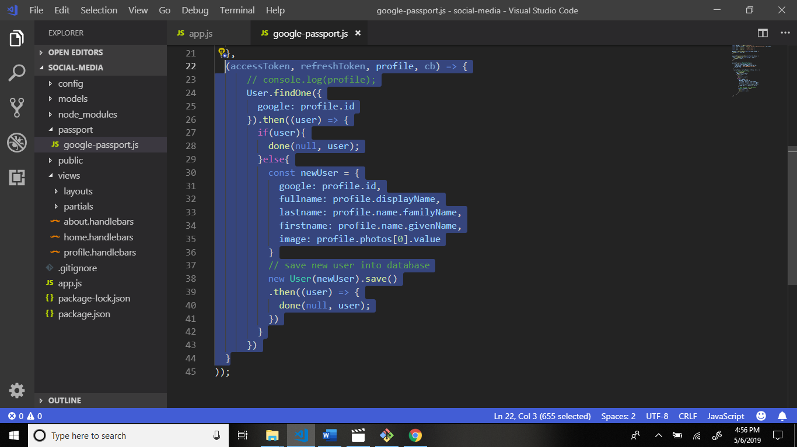

Now see output signup the google and see result monogDB database:

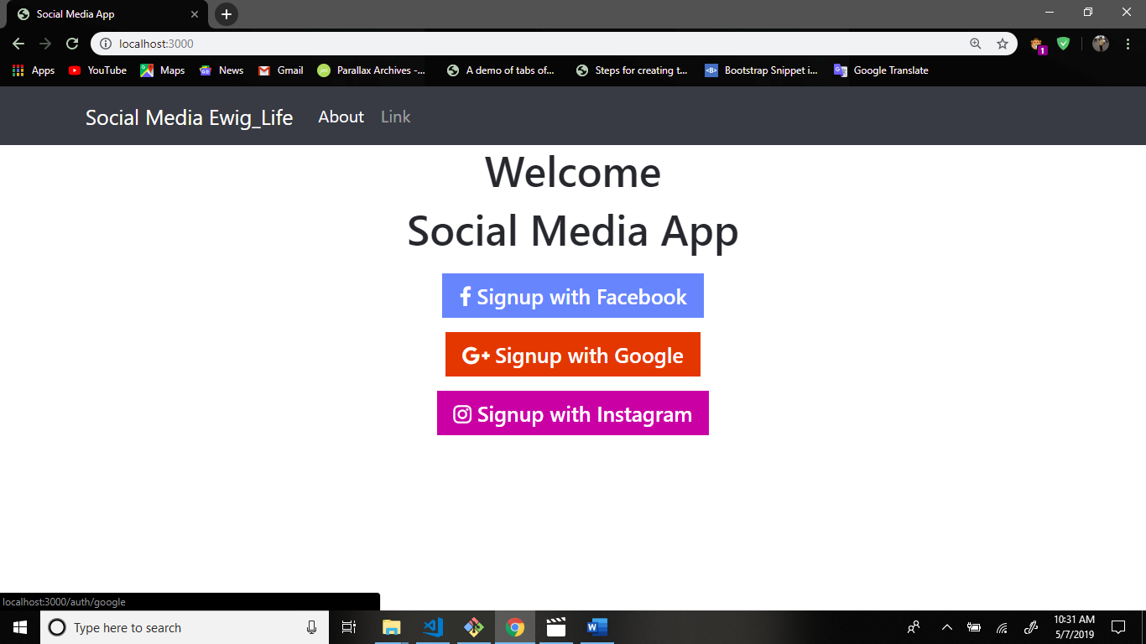

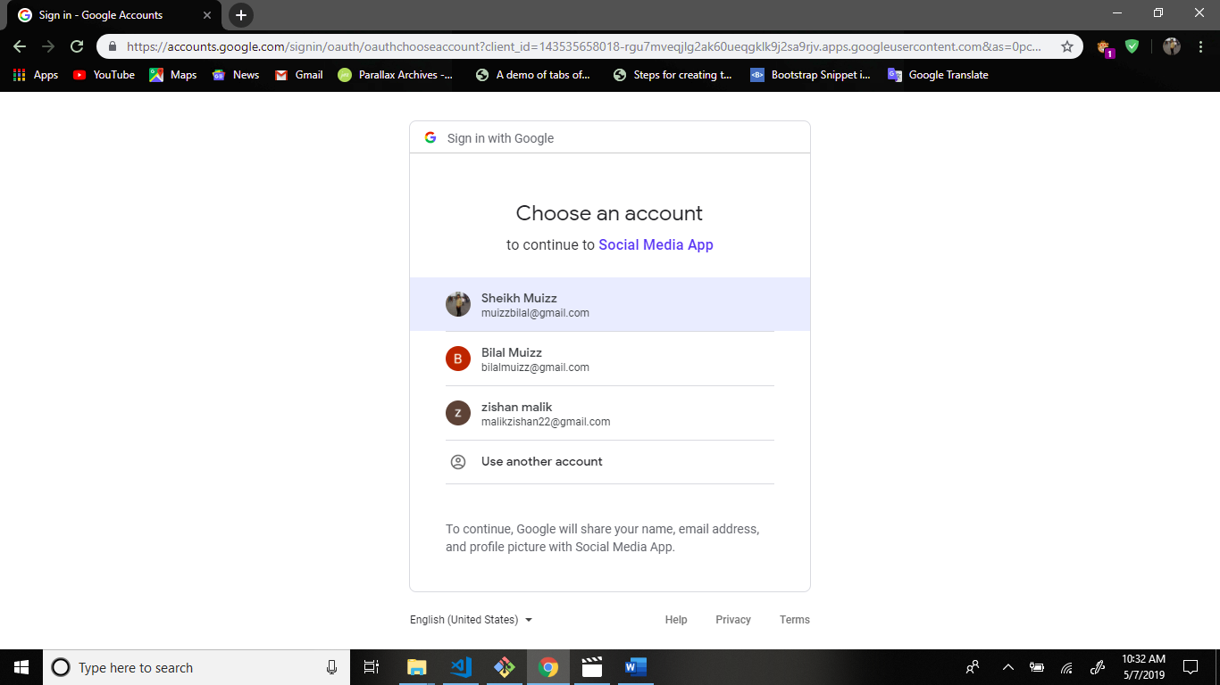

Now go to mongo db collections and see result in collections.

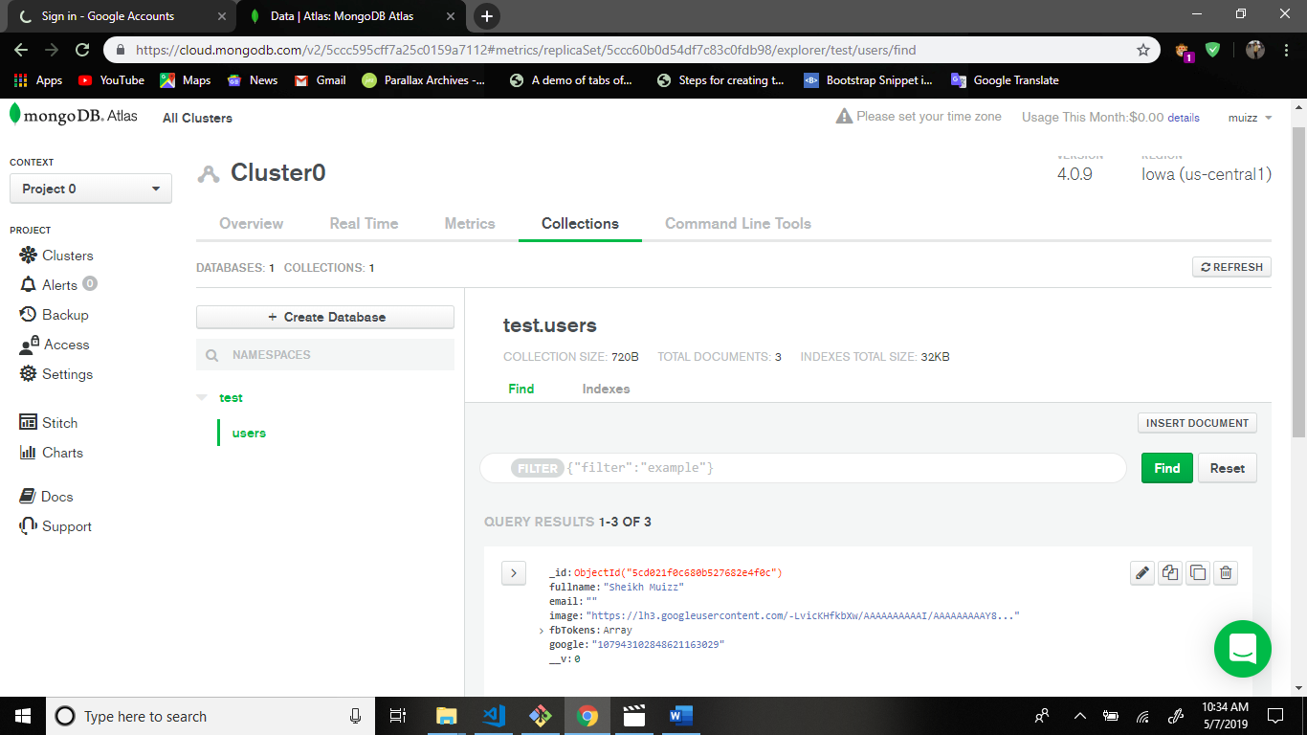

Now add firstName and lastName get into the user and save the mongodb database.

Go to user.js file and add schema firstName and lastName.

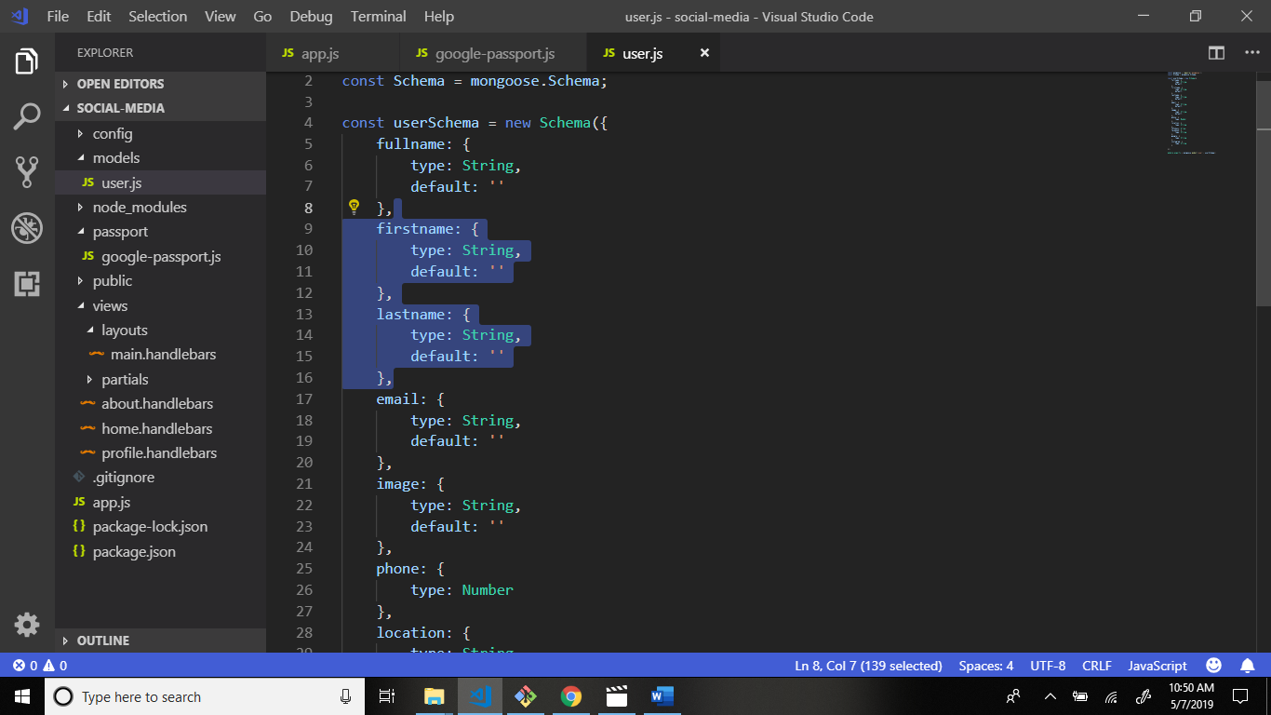

After this see results.

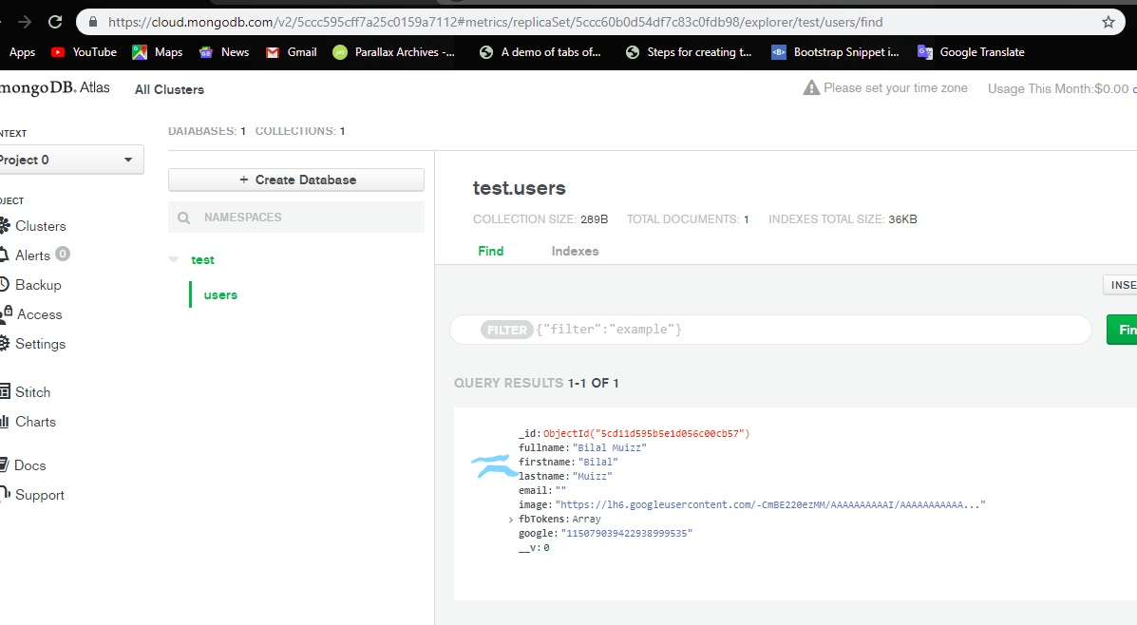

You can don’t receive email. Some code of piece add in app.js file in profile scope.

Now go to google-passport.js file and add email code.

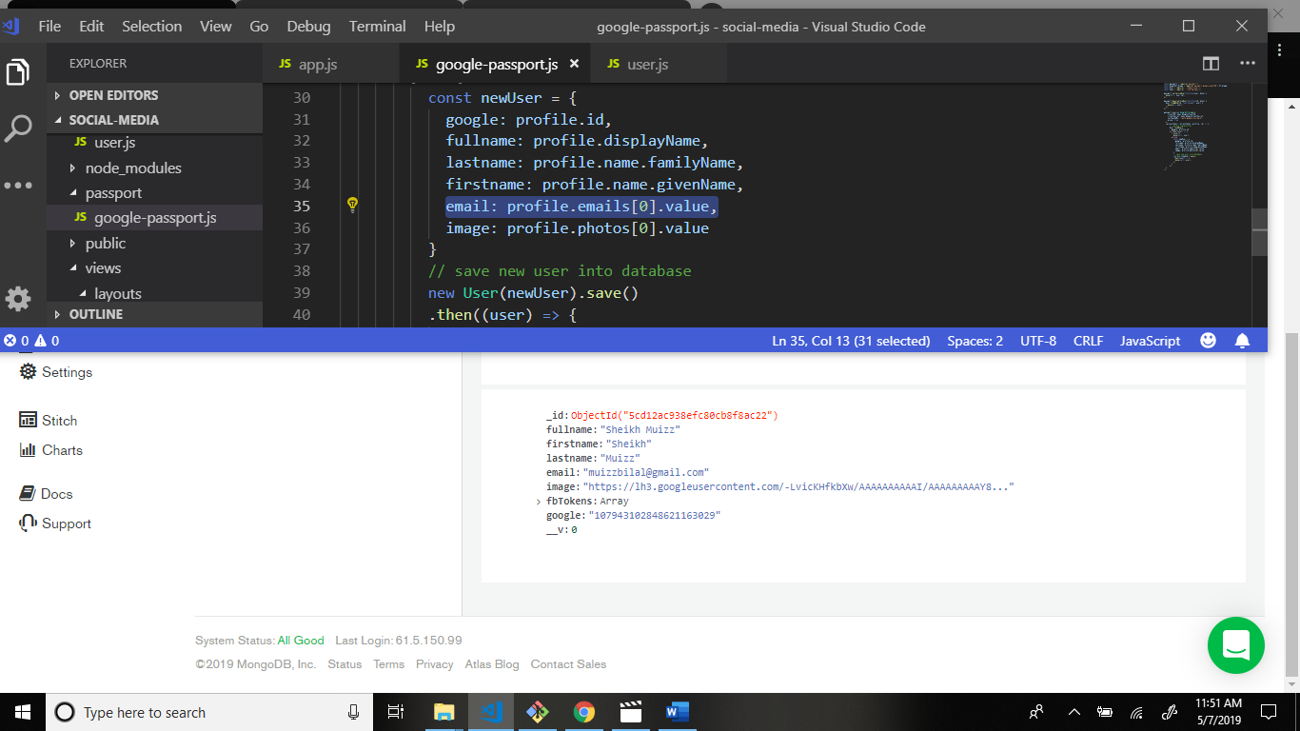

Output:

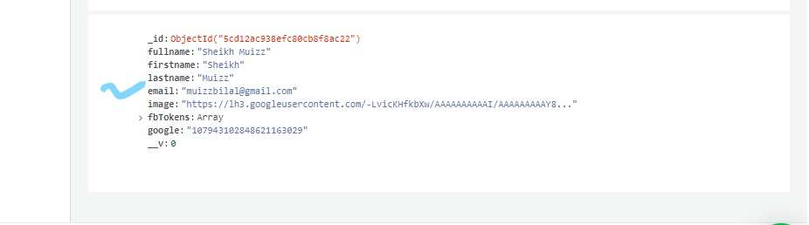

Now some changes google-passport.js file.

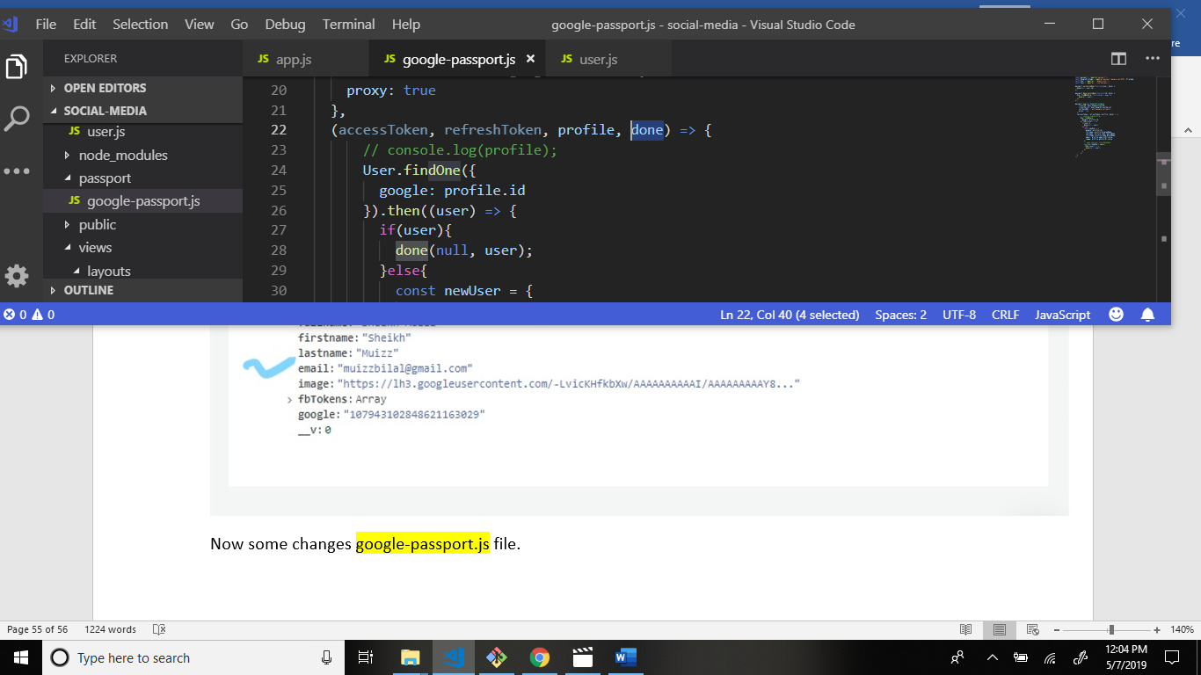

Now add some code in app.js file.

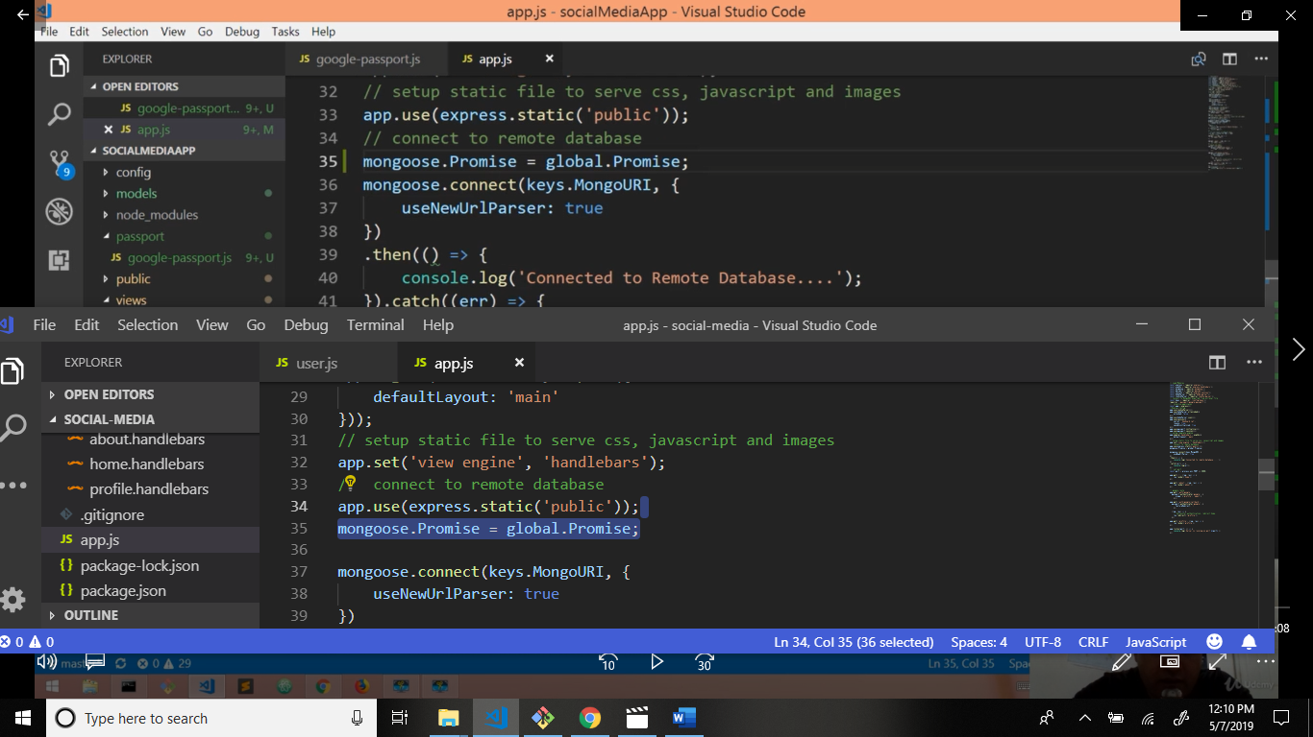

After signup this output.

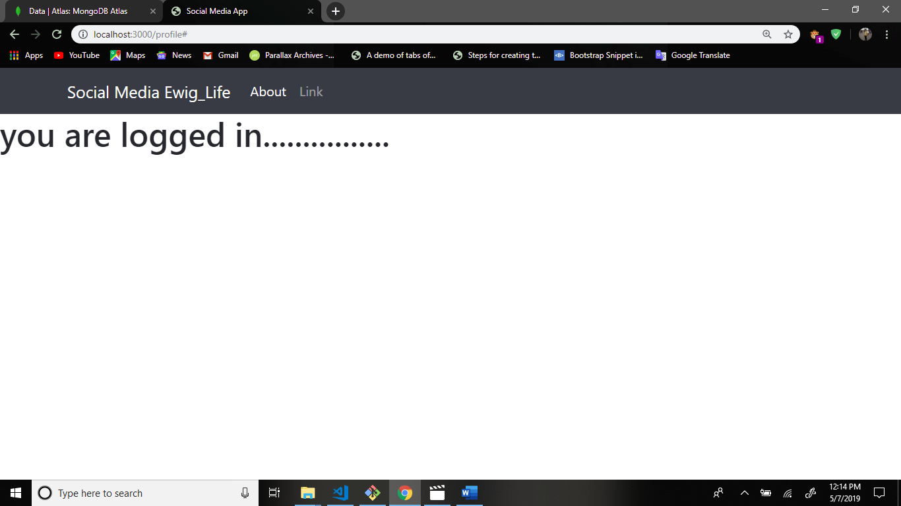

Now go to app.js file and write code set global variables. 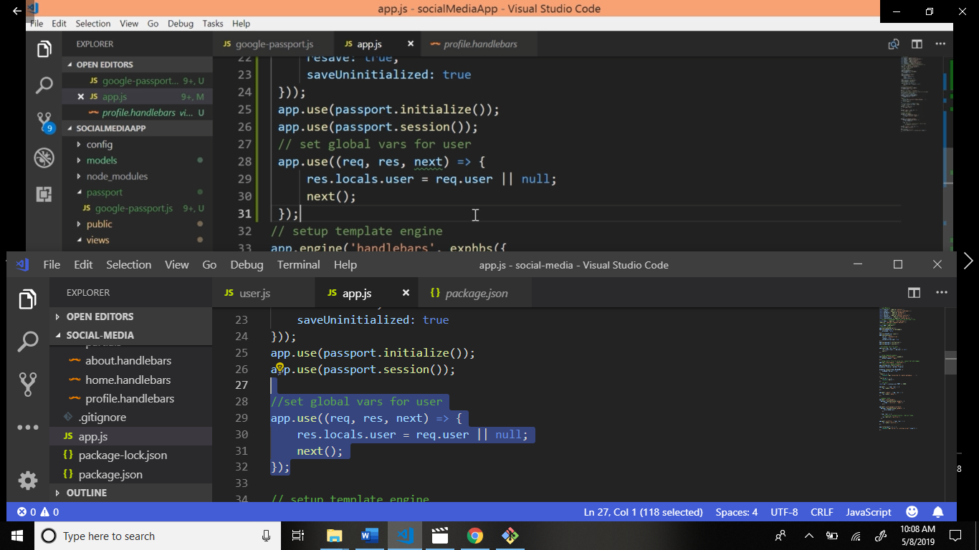

Now add user module require.

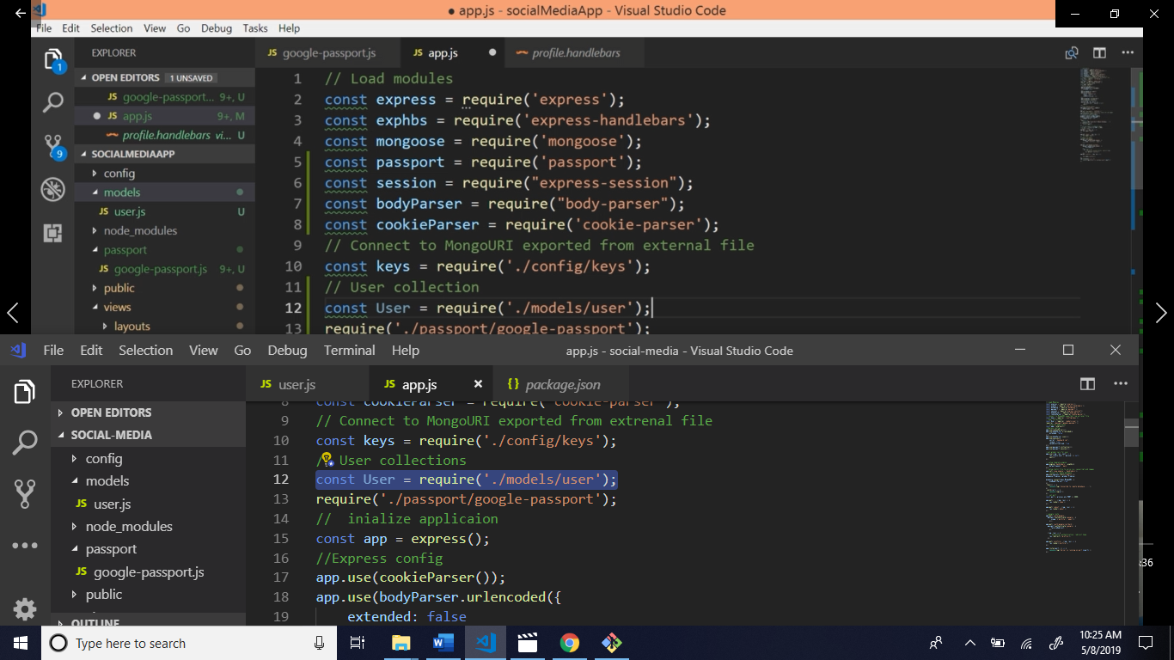

Now user collection display in profile page write code app.js file.

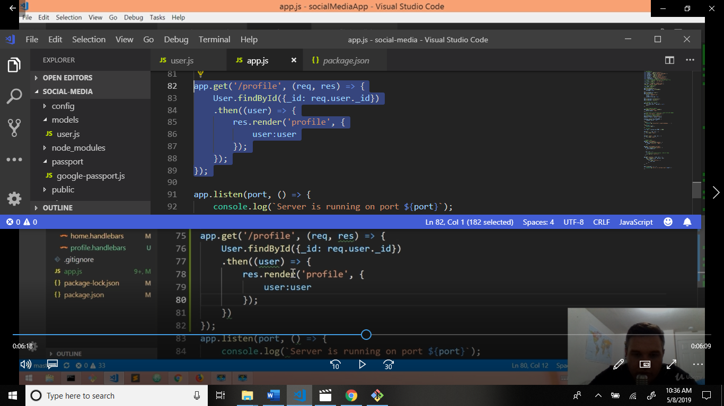

Now write code in profile.handlebars display data in screen.

Now go to official website bootstrap.com and go to documentation media objects.

Copy this code and paste the

profile.handlebars file.

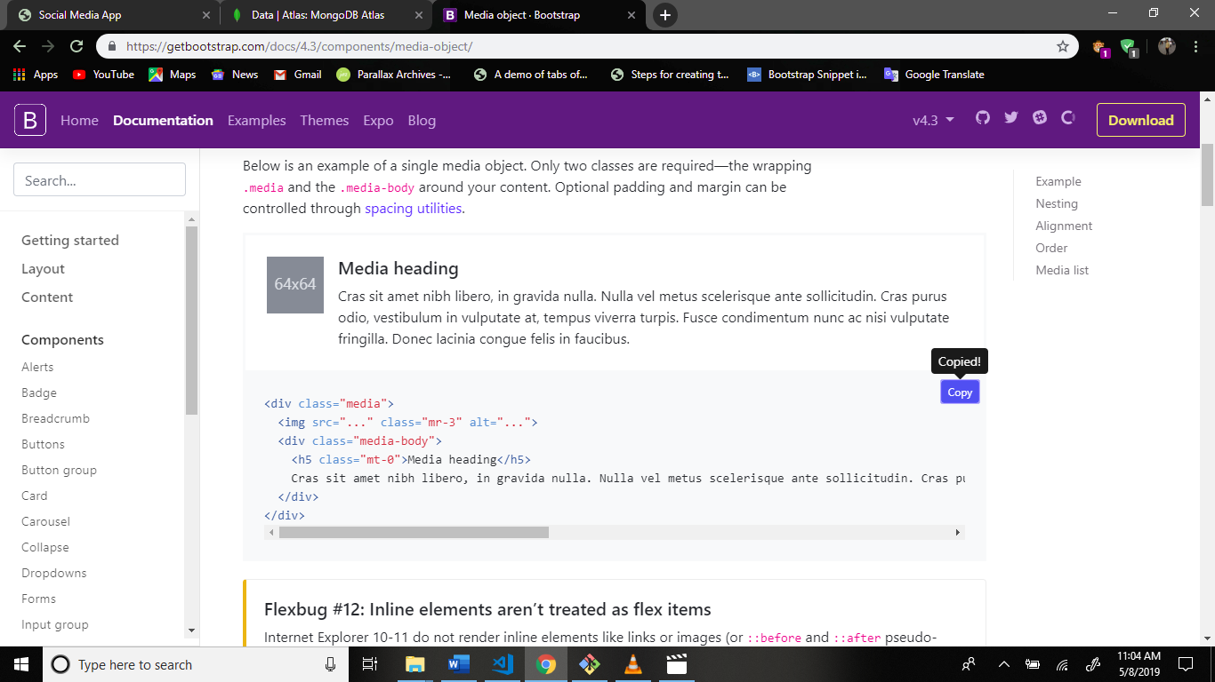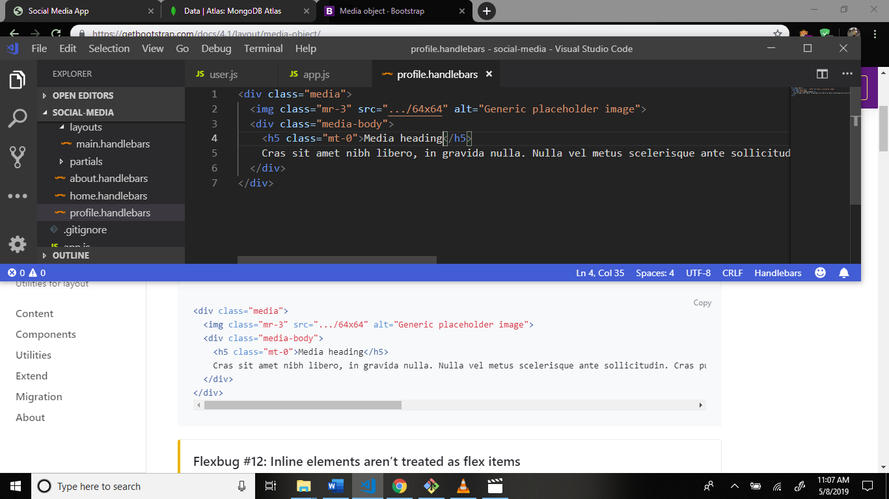

Now some changes this code.

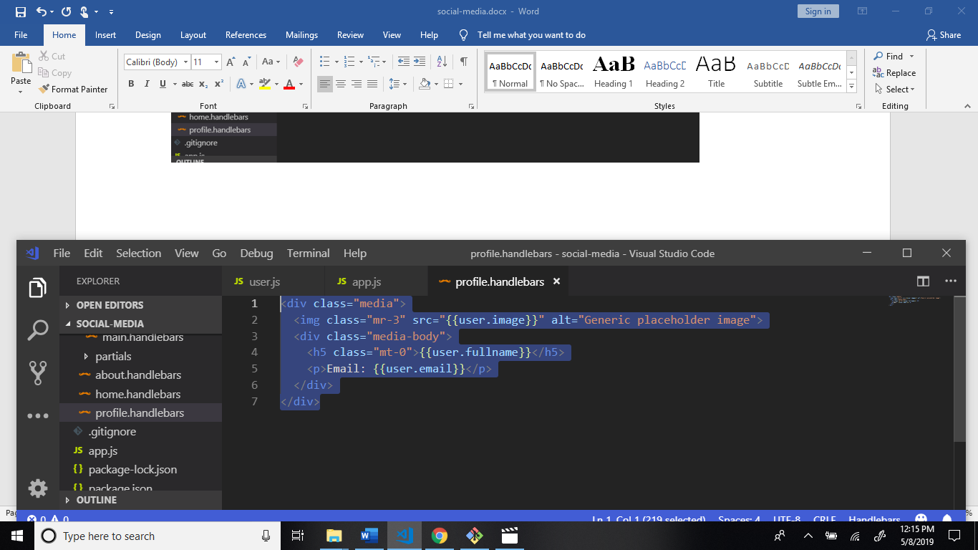

Output:

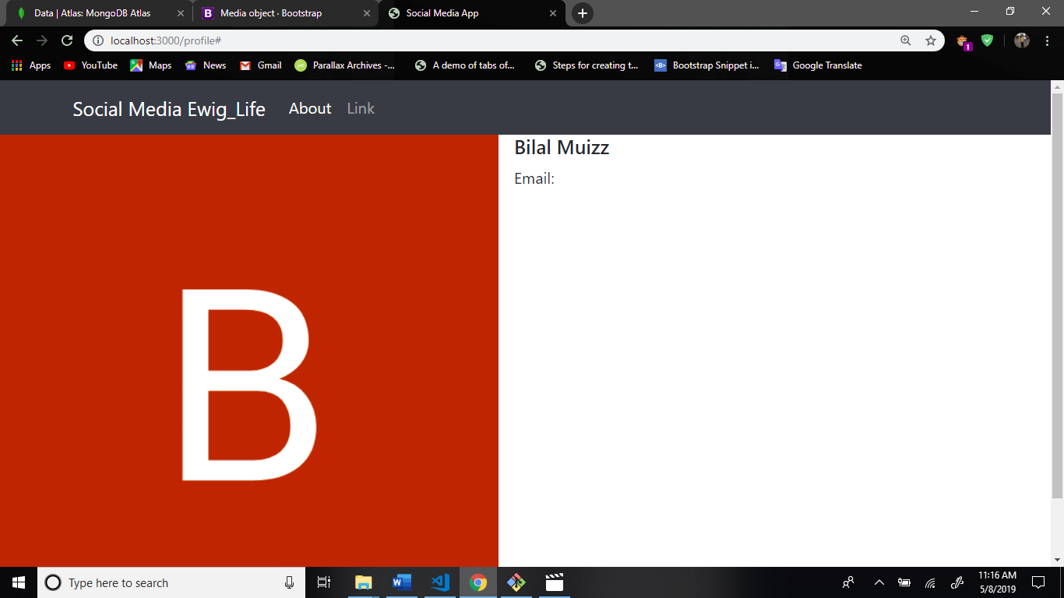

Now some more changes this code.

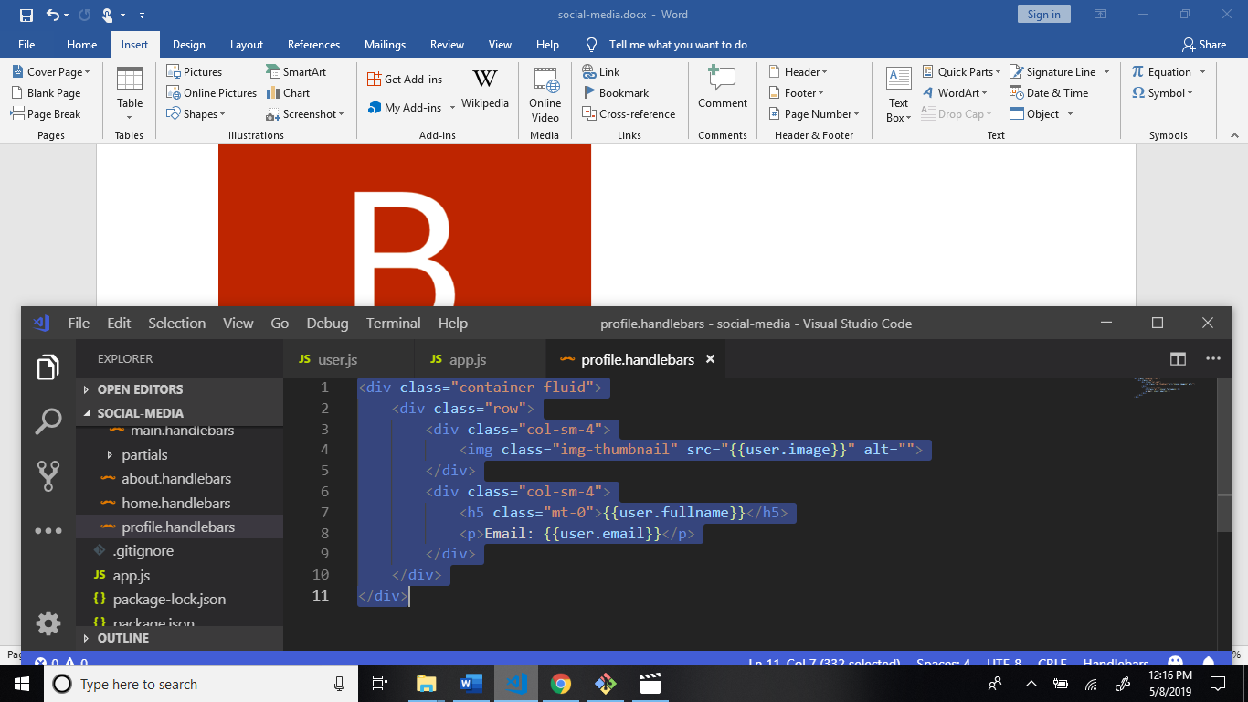

Output:

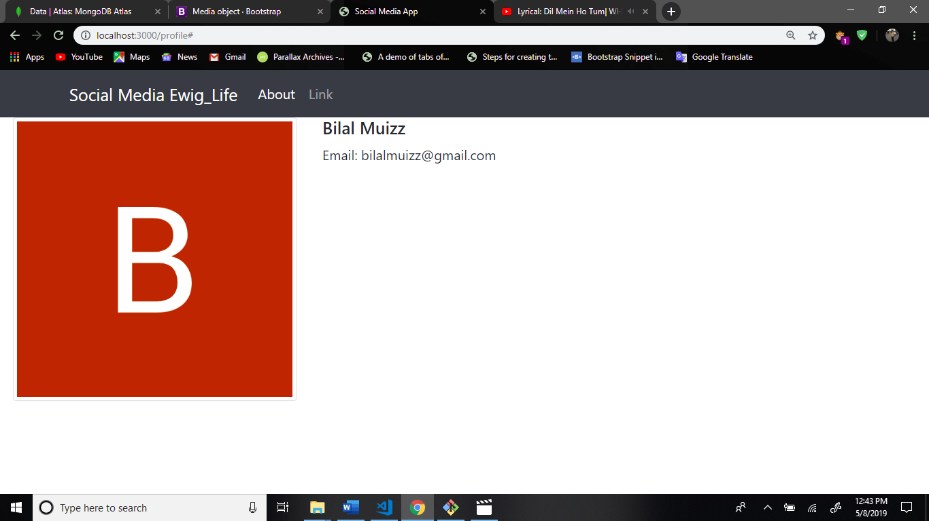

After this add logout button this application. Write code in app.js file.

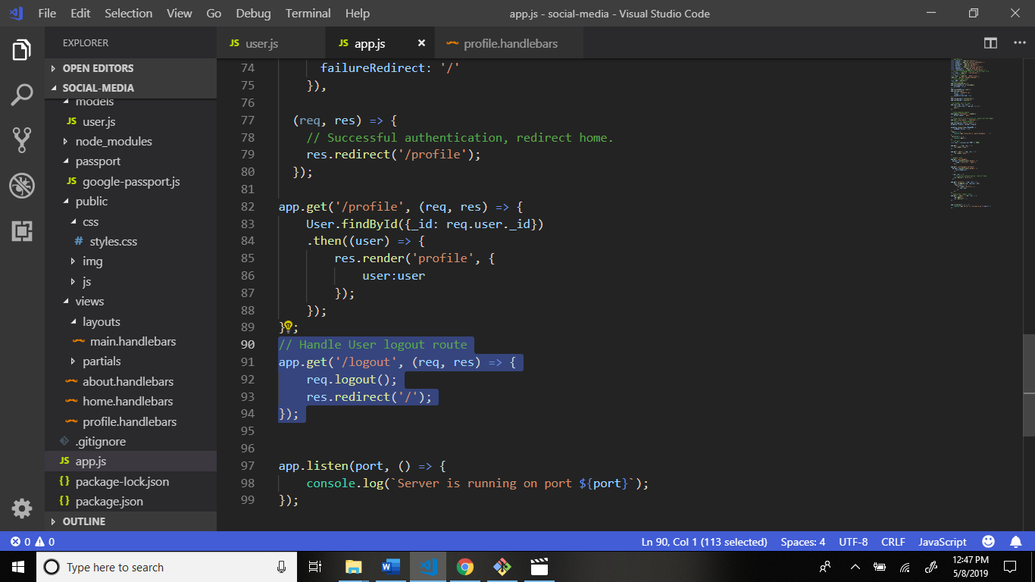

Now go to navbar.handlebars file in structure: views > partials > navbar.handlebars and write code.

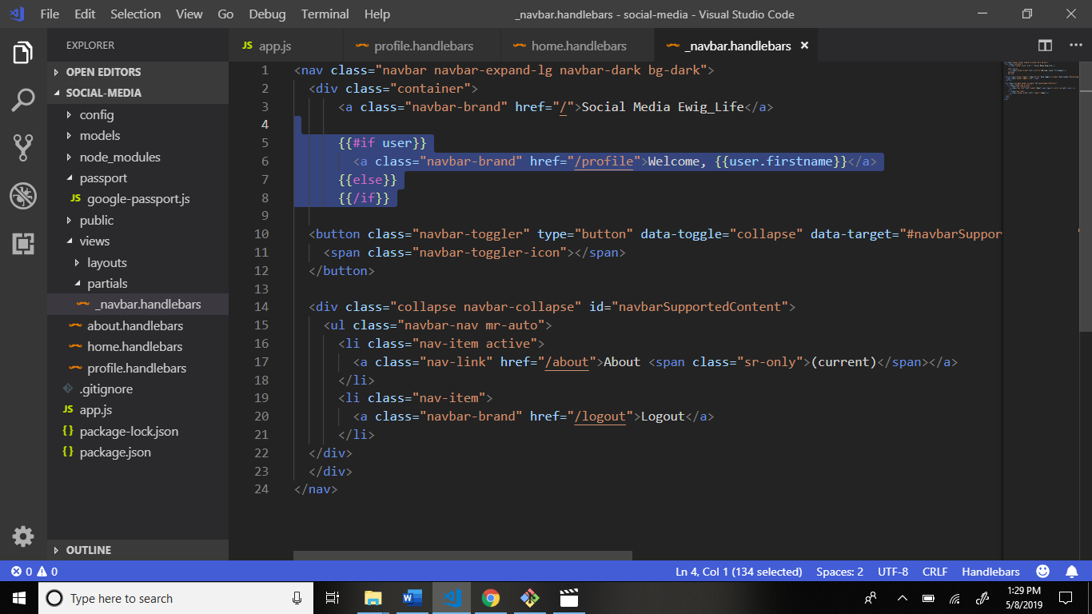

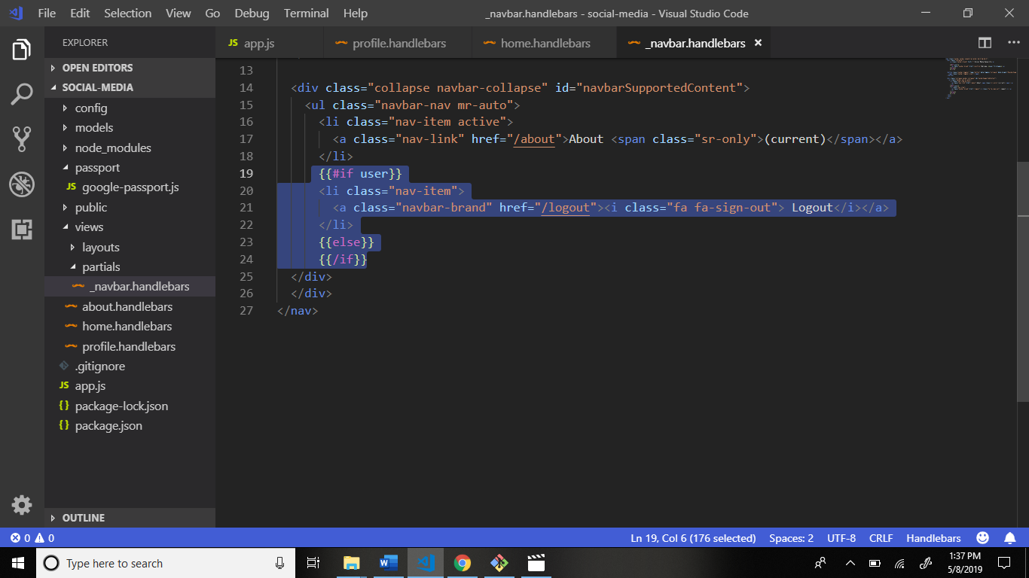

See output after login.

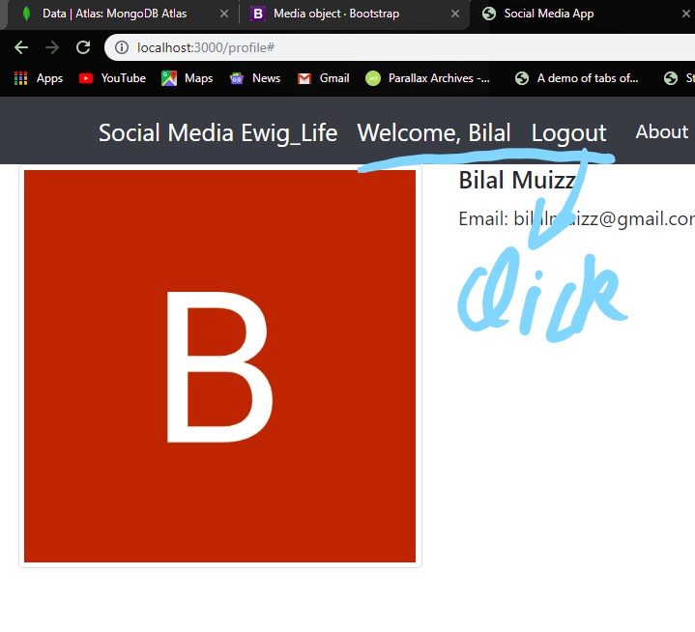

Now go to home.handlebars file structure: views > home.handlebars write code and some changes.

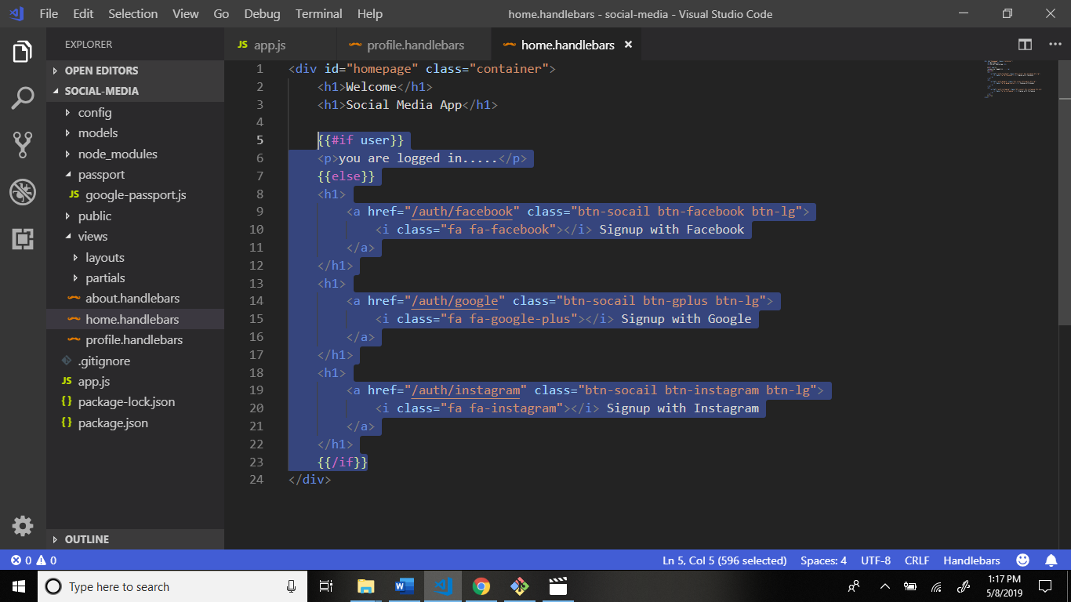

After this go to home screen and see output:

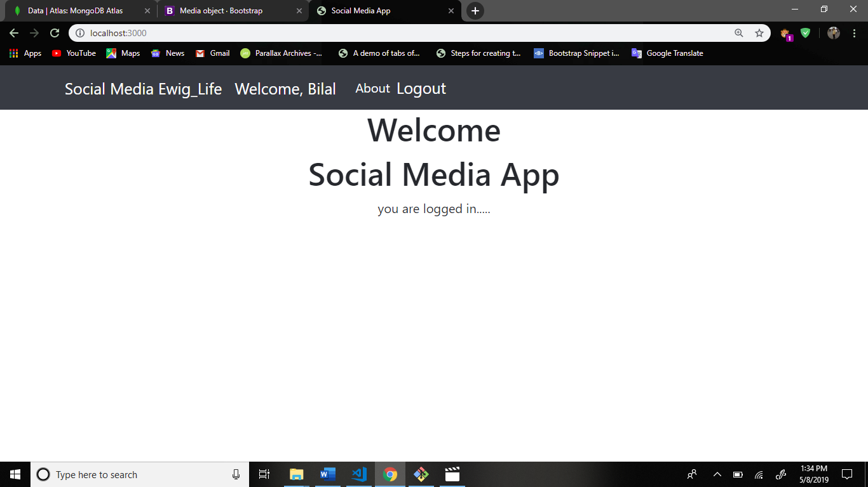

Now create file keys-dev.js file in config folder.

Create one more file in config folder keys-prod.js file.

Structure:

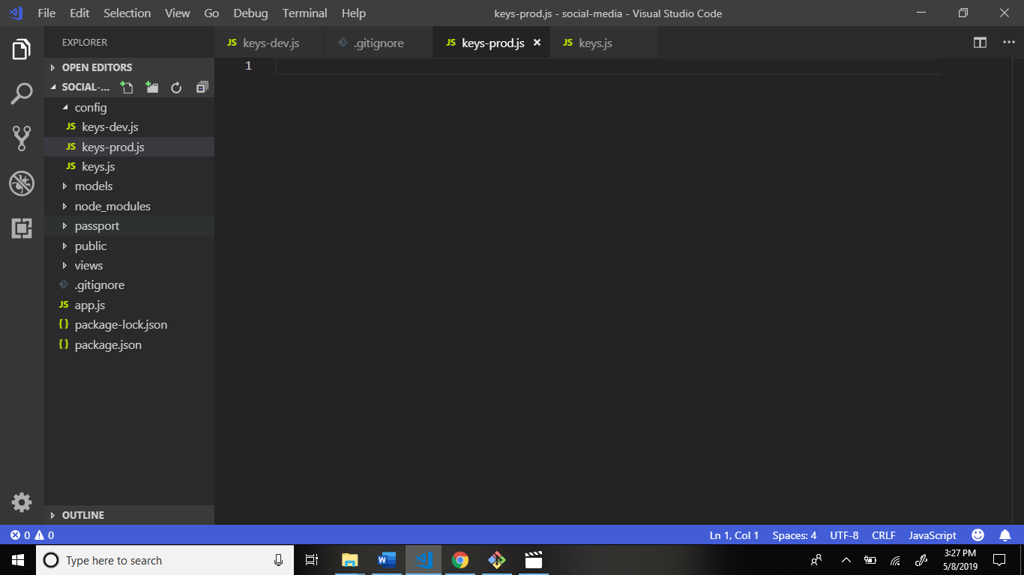

Now go to keys.js file and all code is cut and paste the keys-dev.js file.

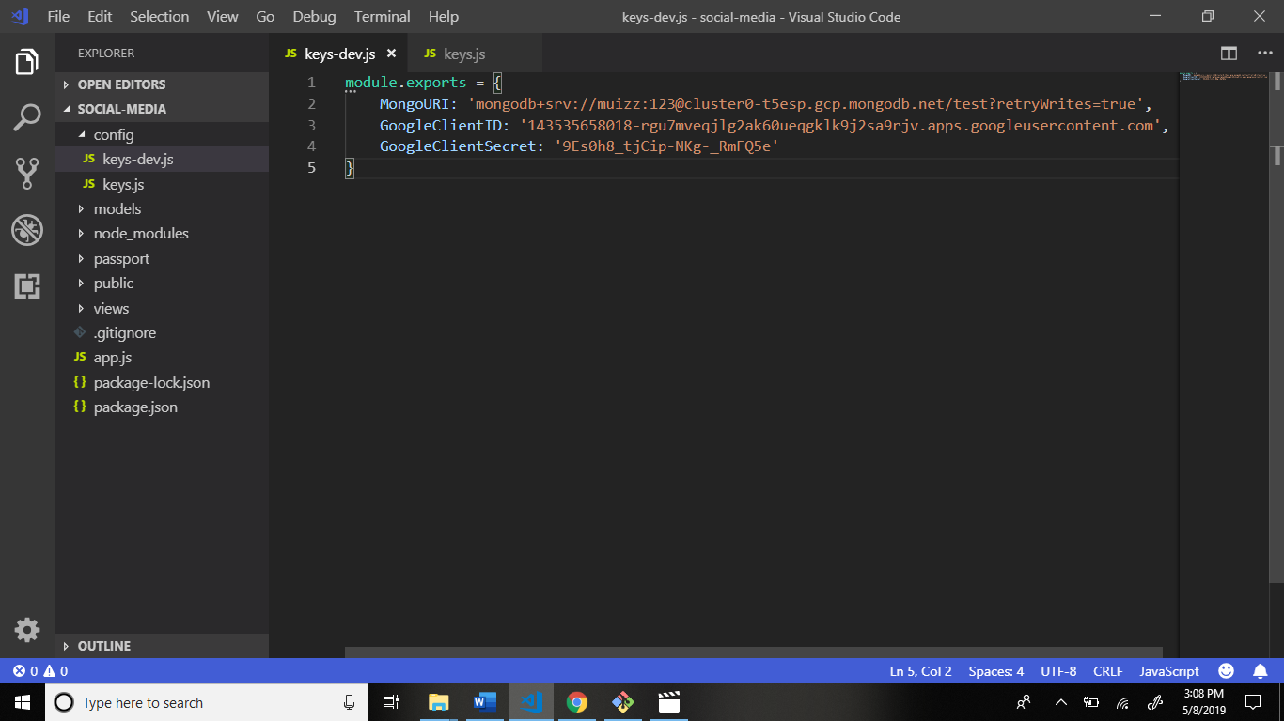

Now go to .gitignore file and change the name keys.js file to keys-dev.js file.

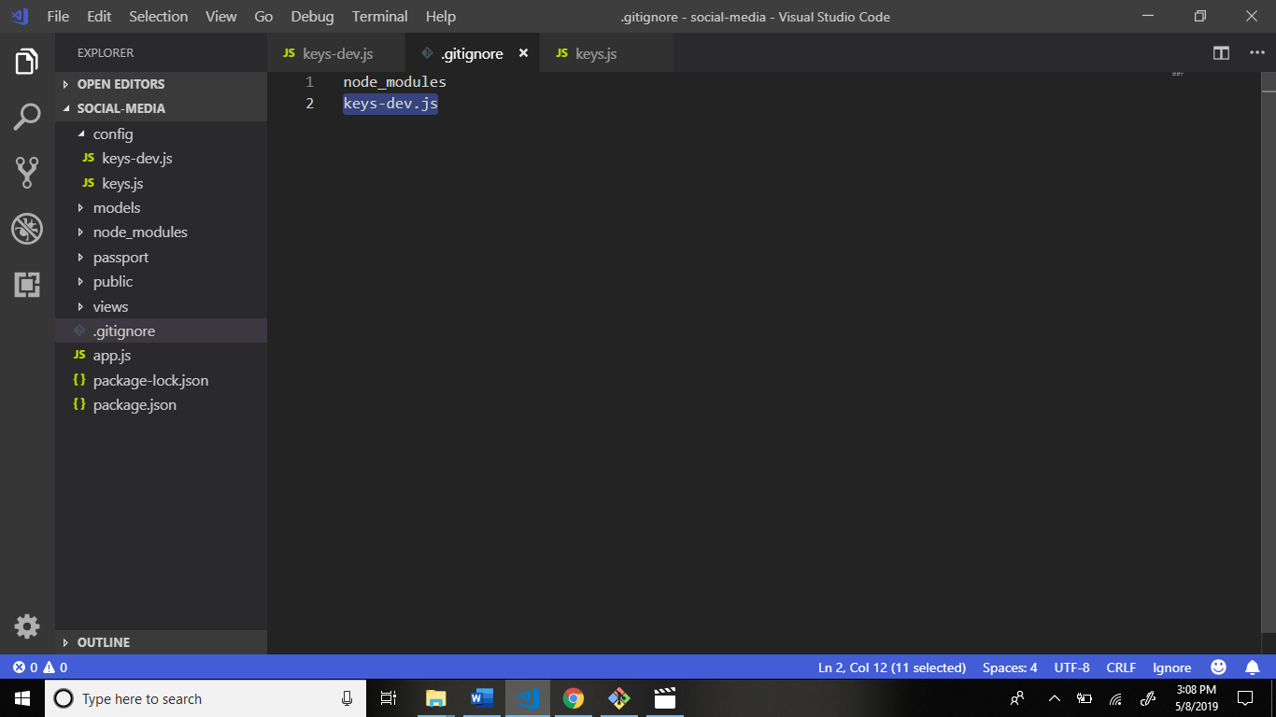

Now go to config > keys.js file and write code.

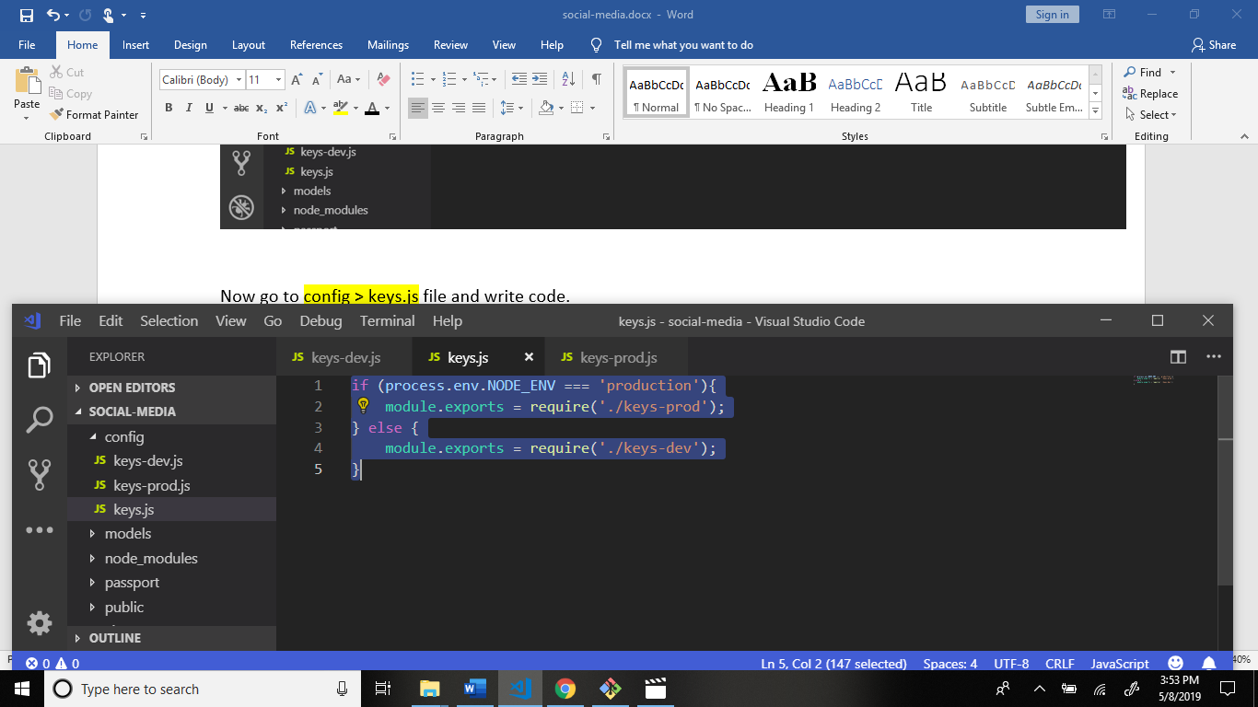

Now go to keys-prod.js file and write code.

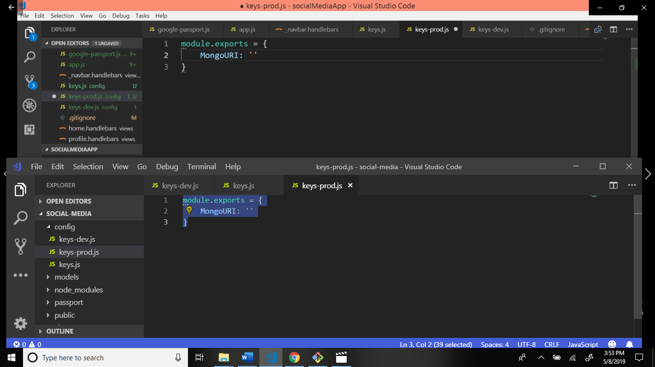

Now go to mongoDB website.

And create new project name socialmedia-prod.

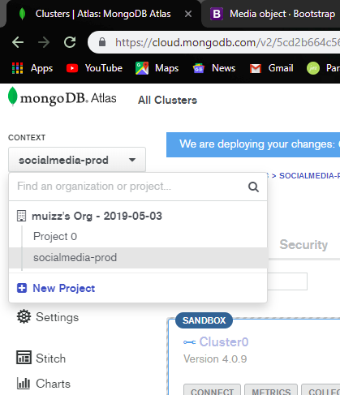

Enter project name: socialmedia-prod.

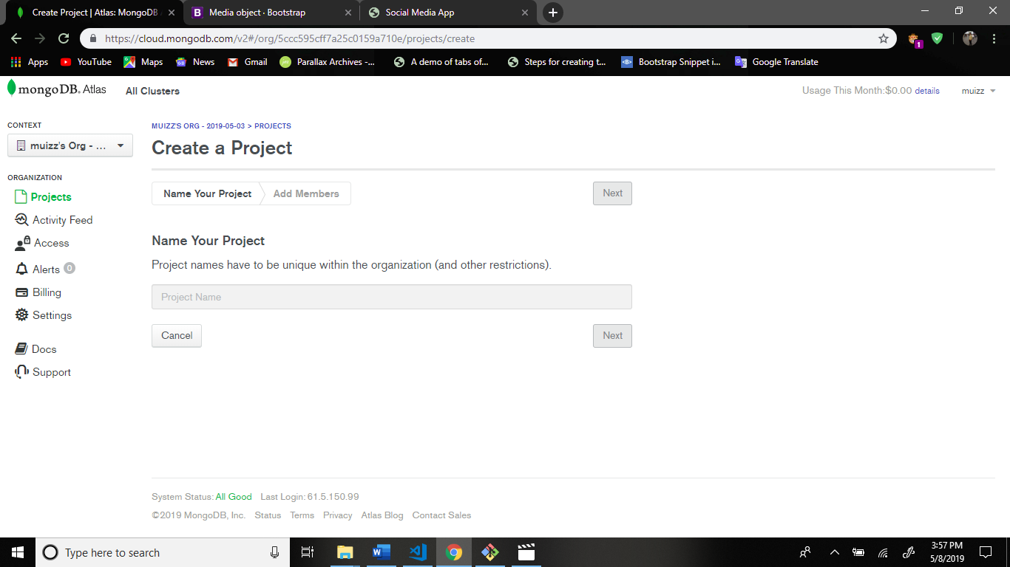

And press button next.

After this click create project button.

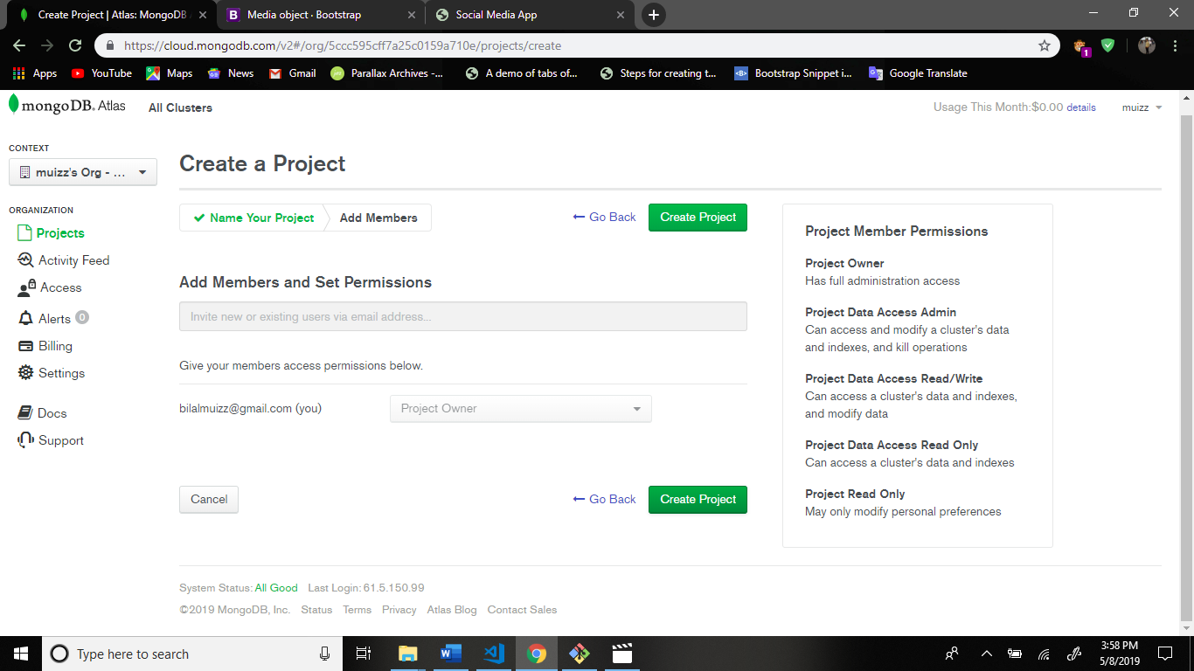

Build cluster.

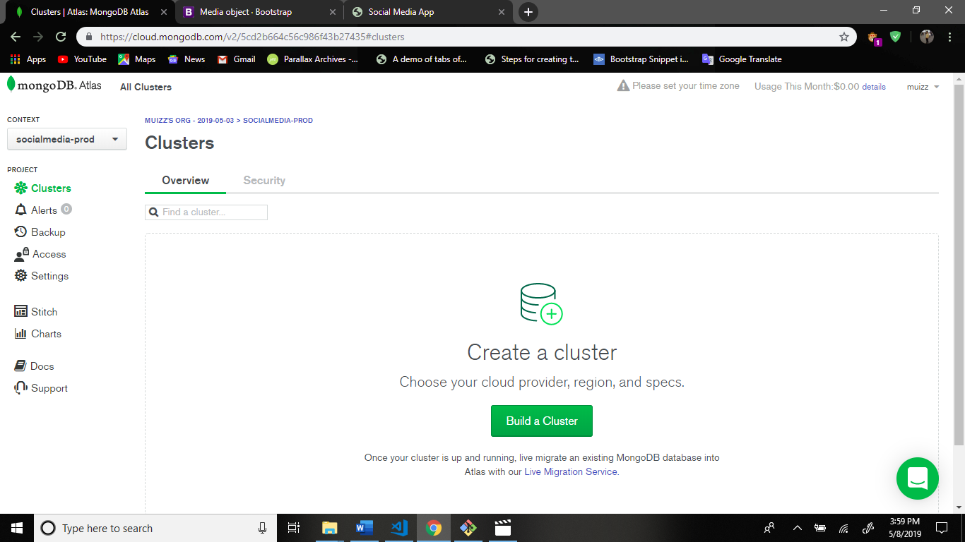

After this choose the amazon first option free. And click the create cluster button.

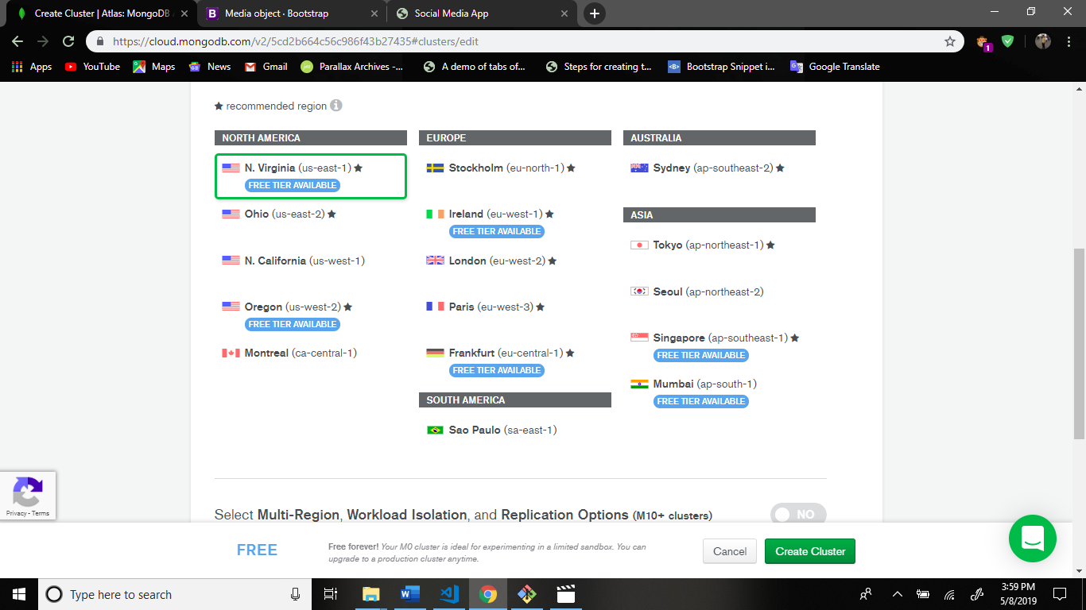

Your cluster is ready.

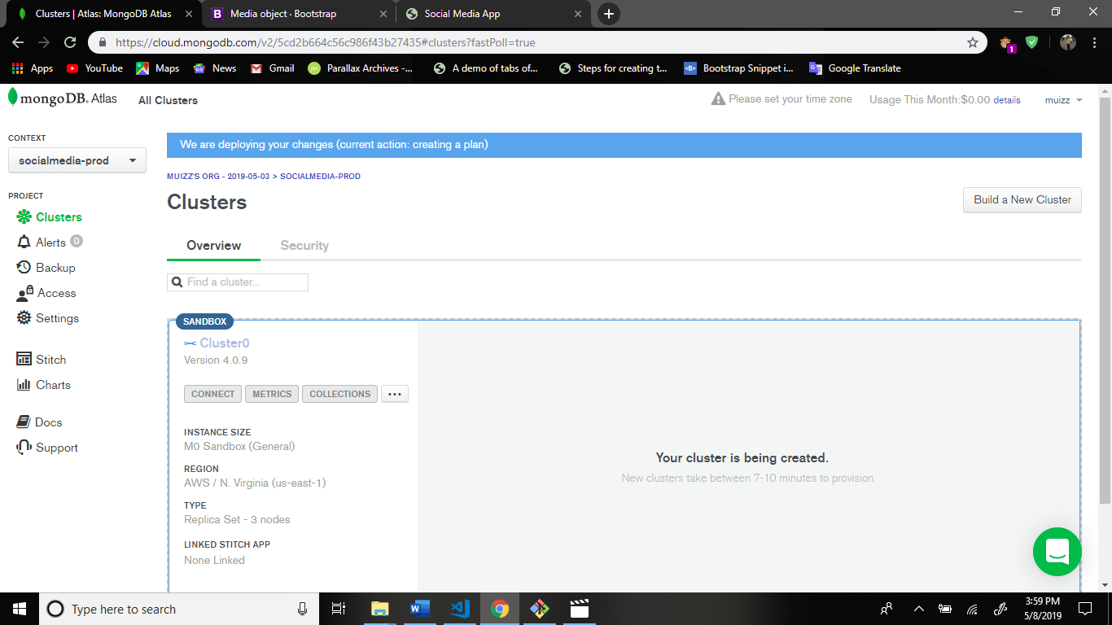

Go to cluster security and click mongoDB users.

Add new user name and password.

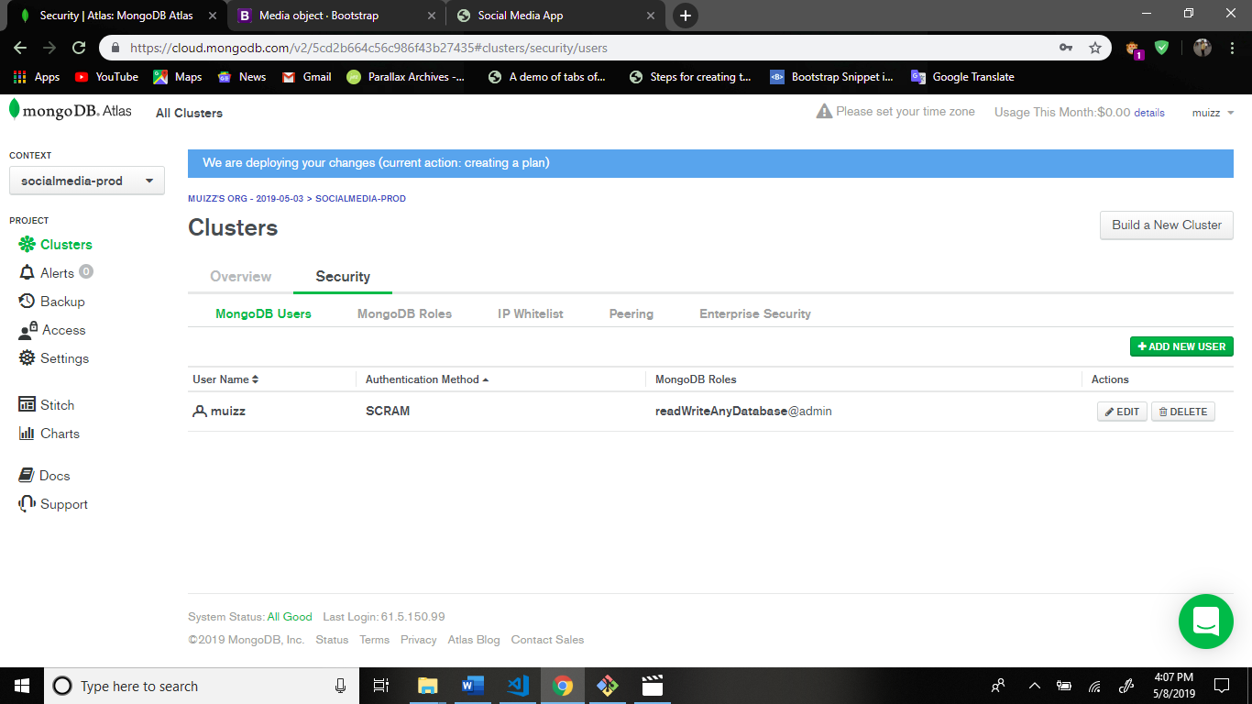

After this go to ip whitelist and add new ip whitelist.

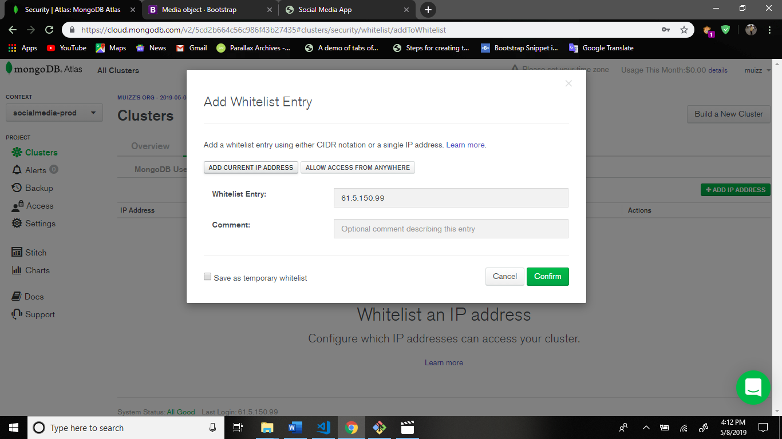

After confirm.

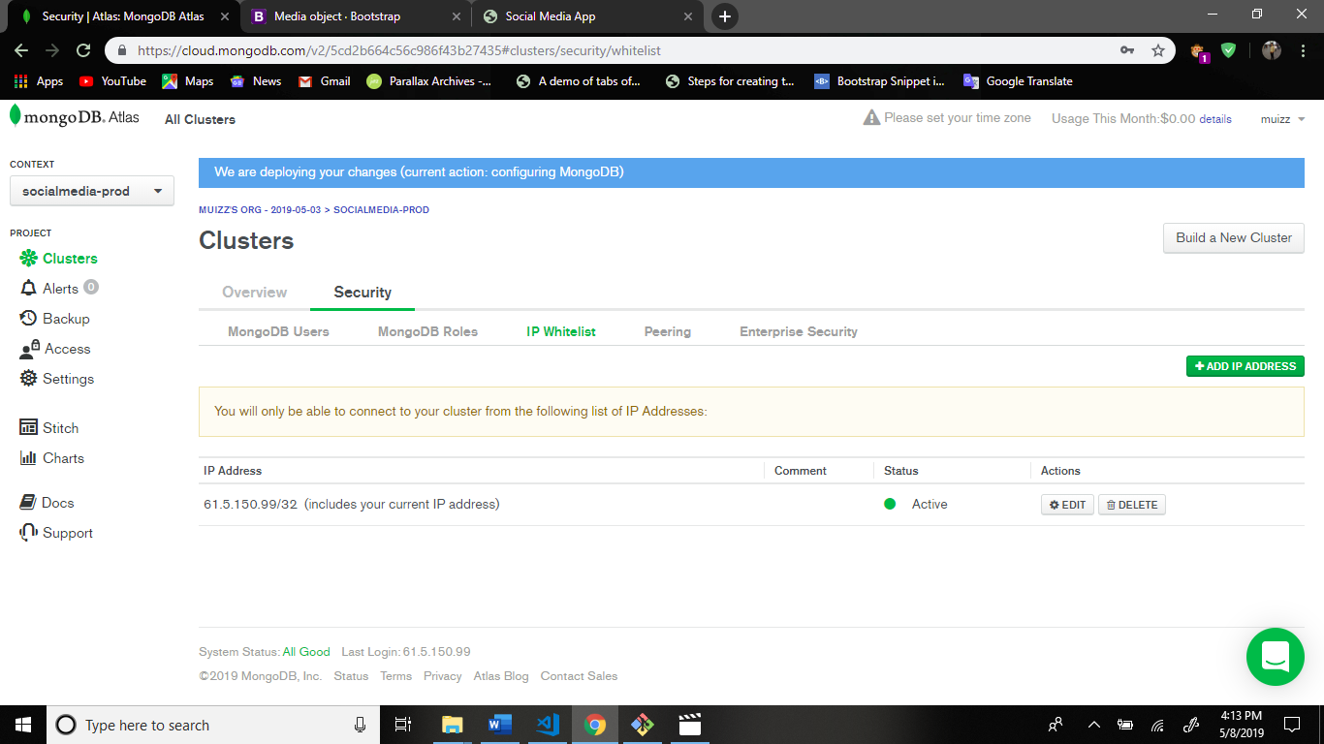

Then again back to main cluter page.

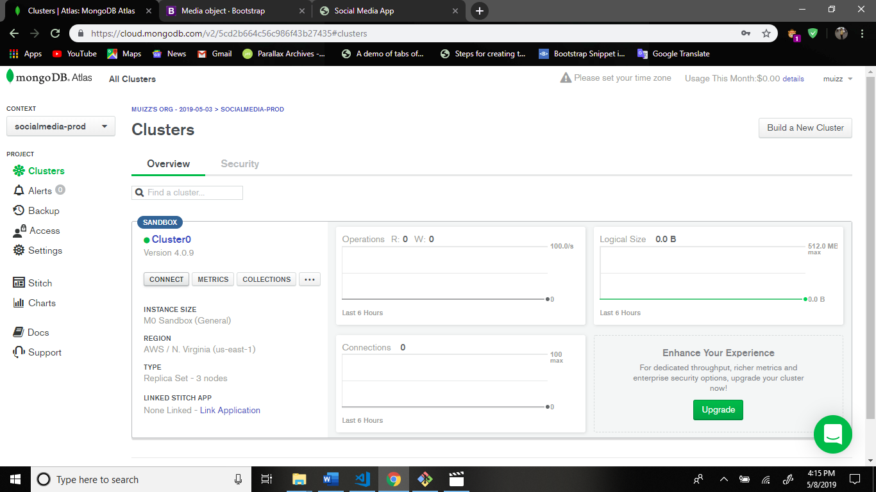

Click connect.

And choose 2nd option connect your application.

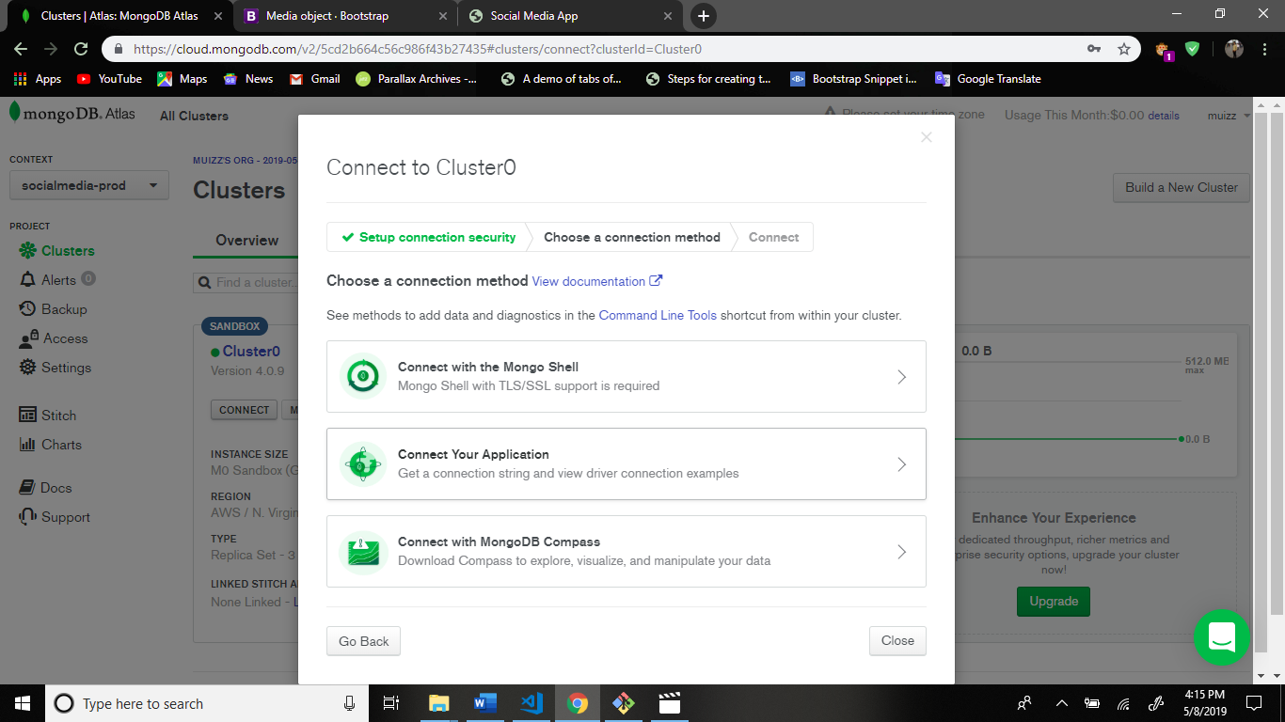

After this.

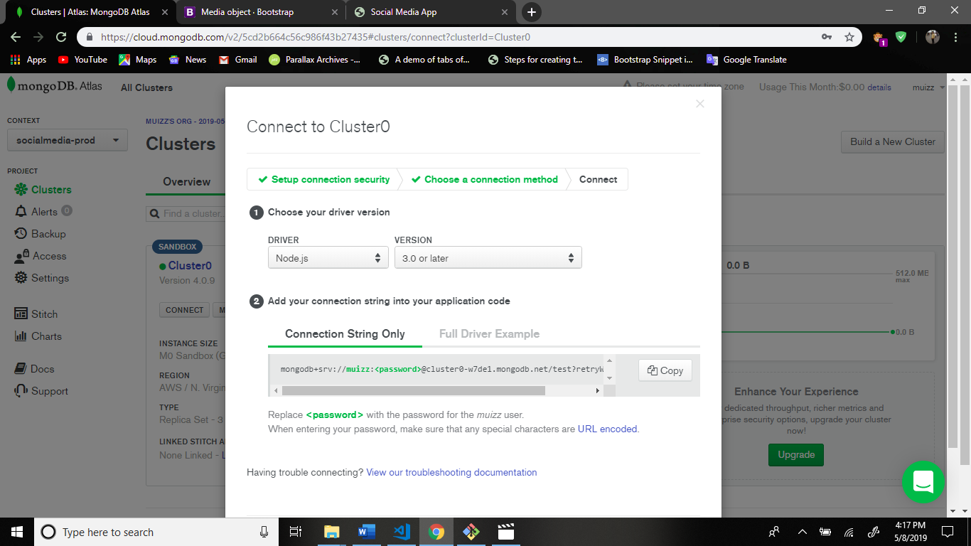

Copy this connection line and paste the keys-prod.js file mongoURI.

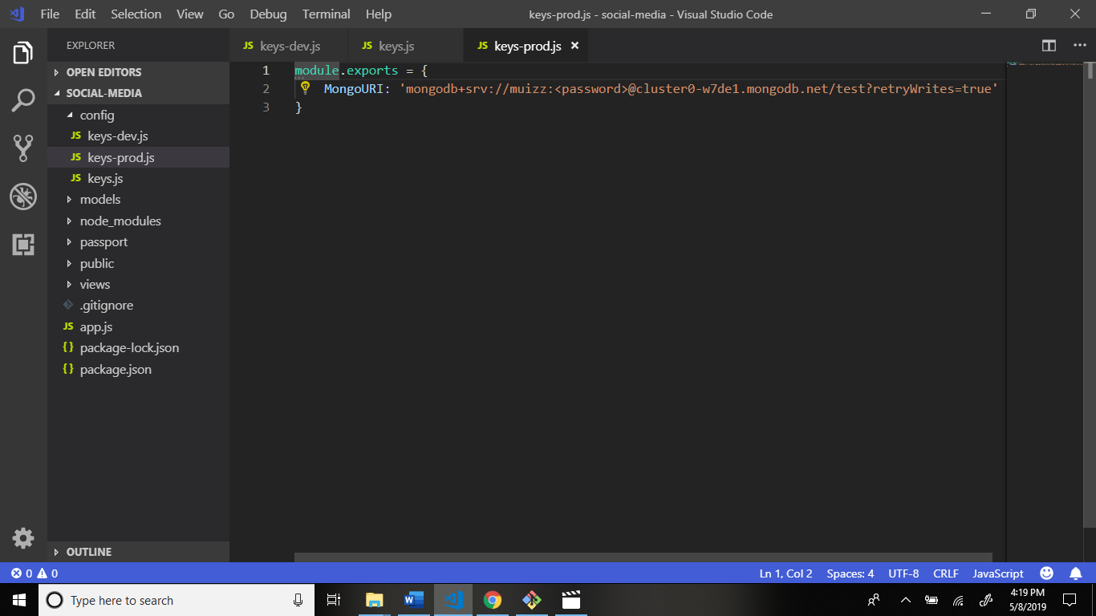

Some code change this file password word is change to the your set password in mongodb user data.

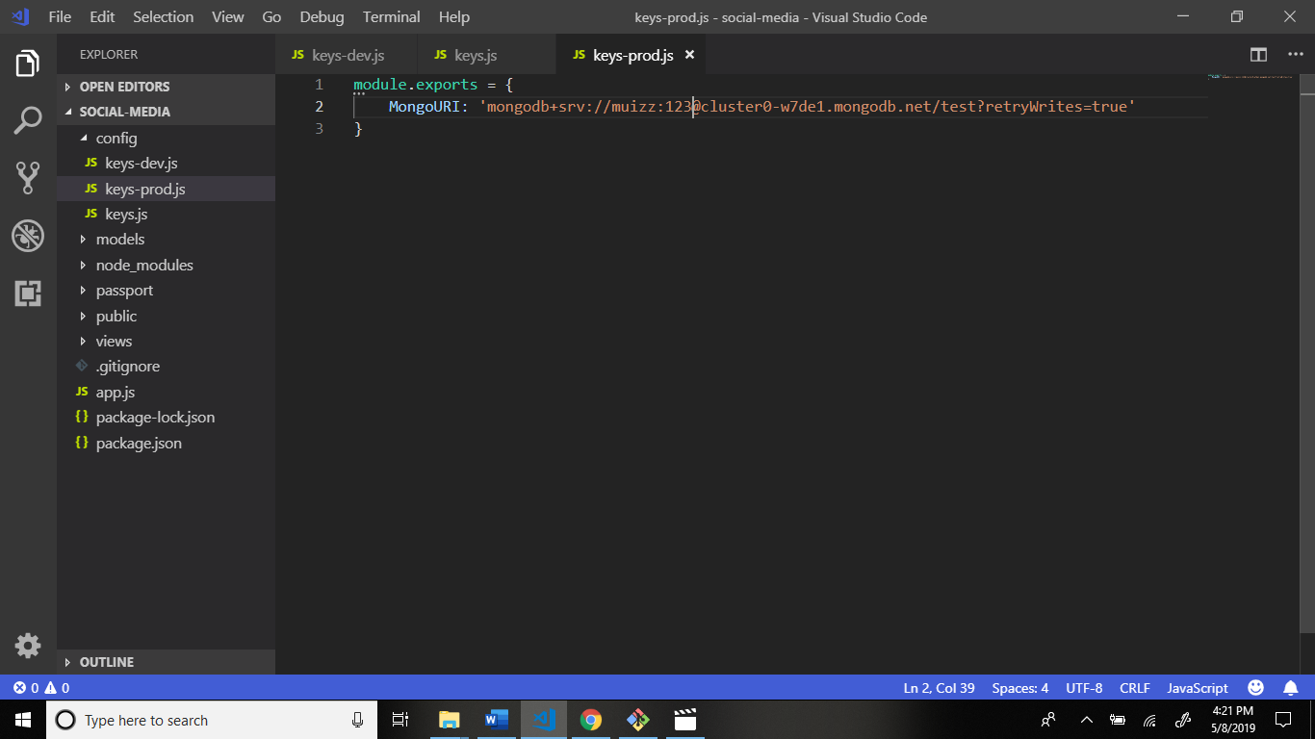

Add some code this file.

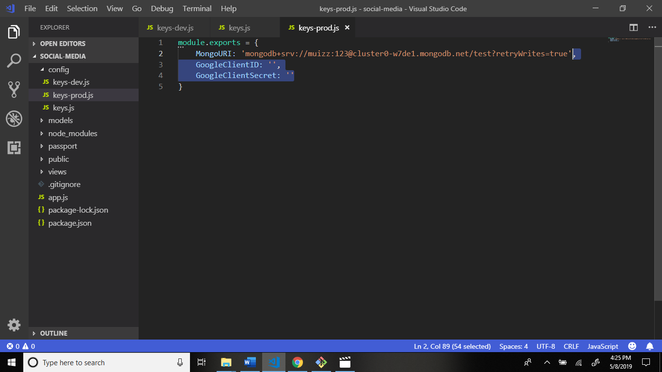

Lets go to google developers webite: <https://console.developers.google.com/>

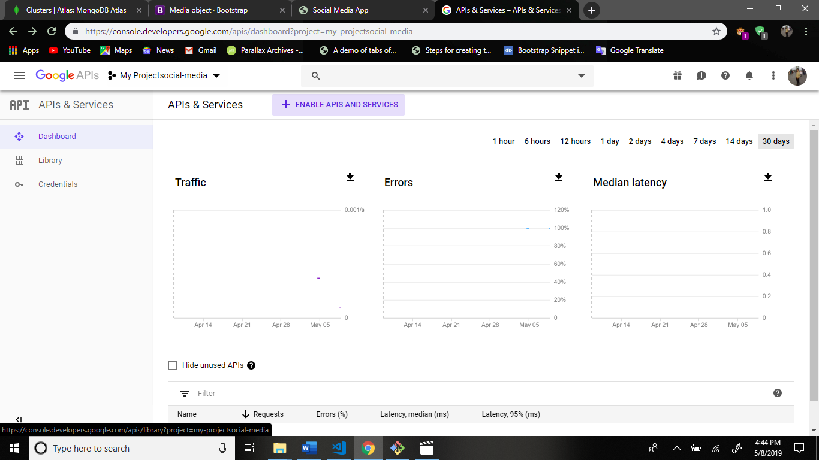

Create new project.

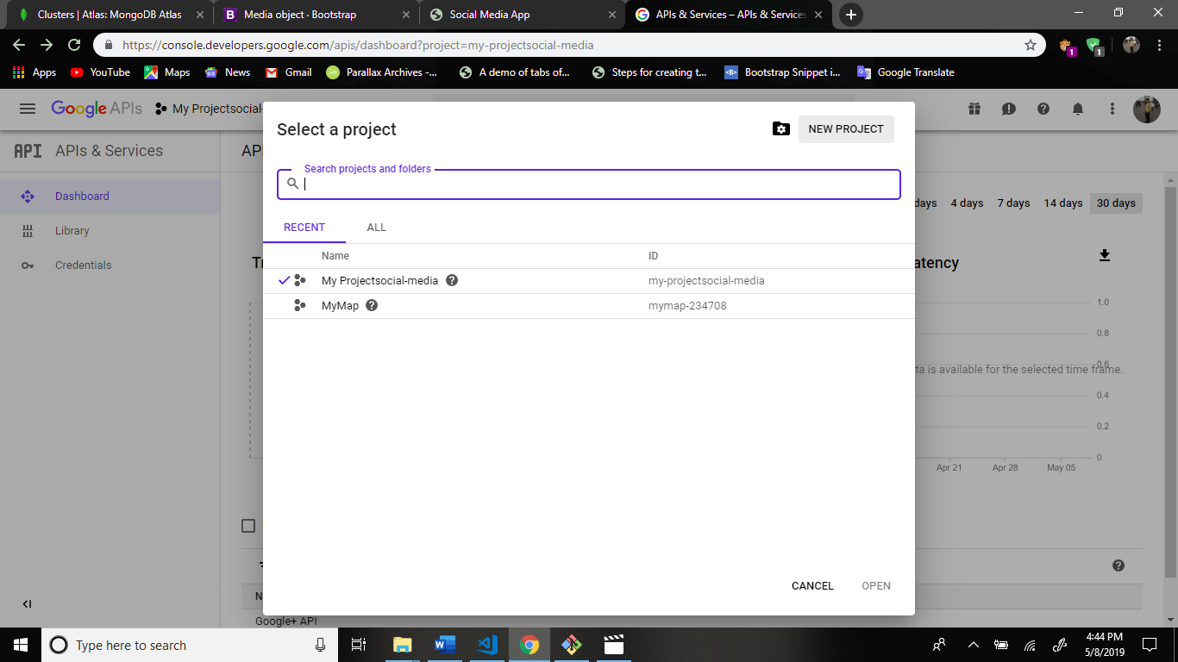

Enter the name and create.

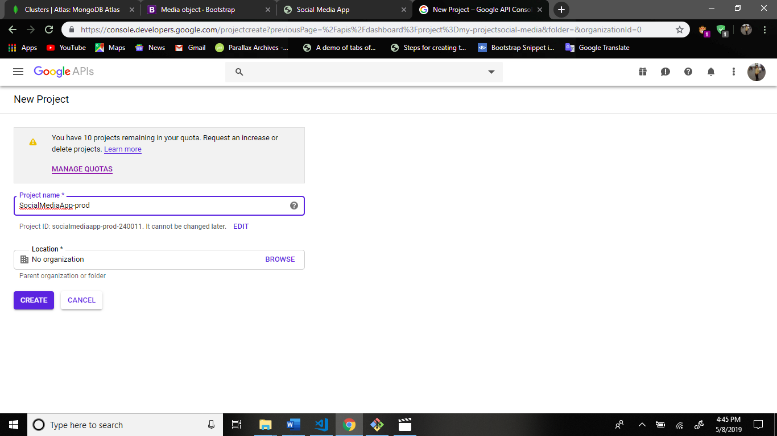

Go to notification in right side and click this project.

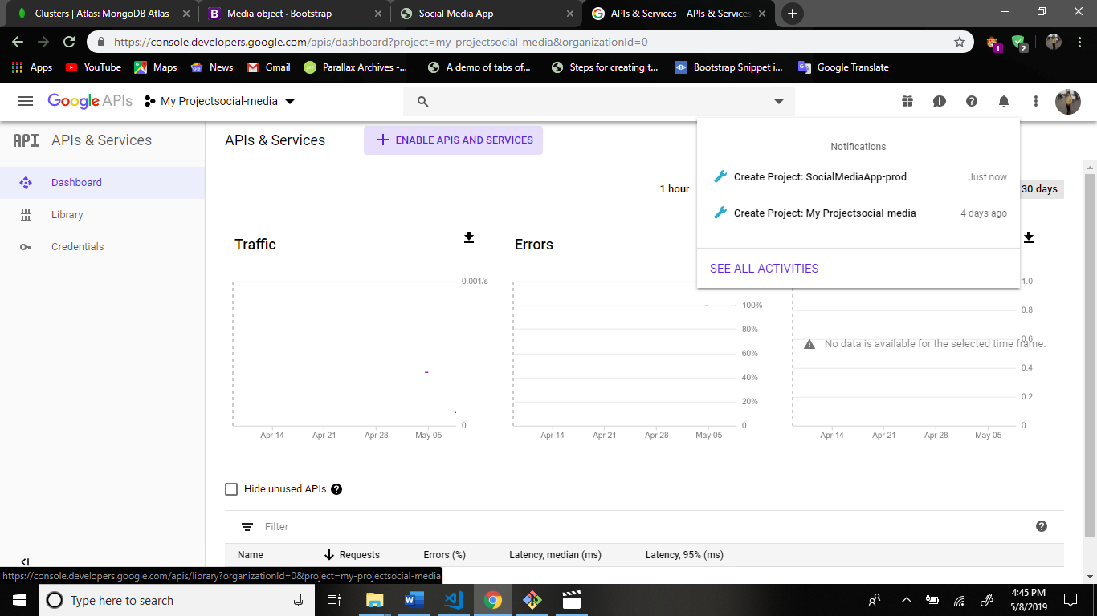

Output:

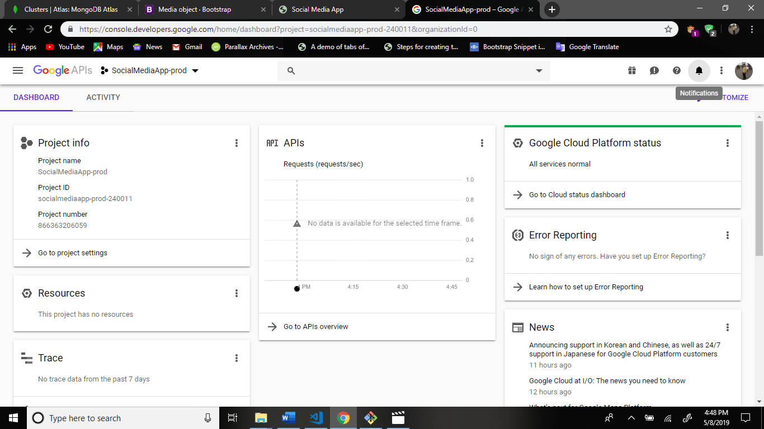

Now search the api google+ API

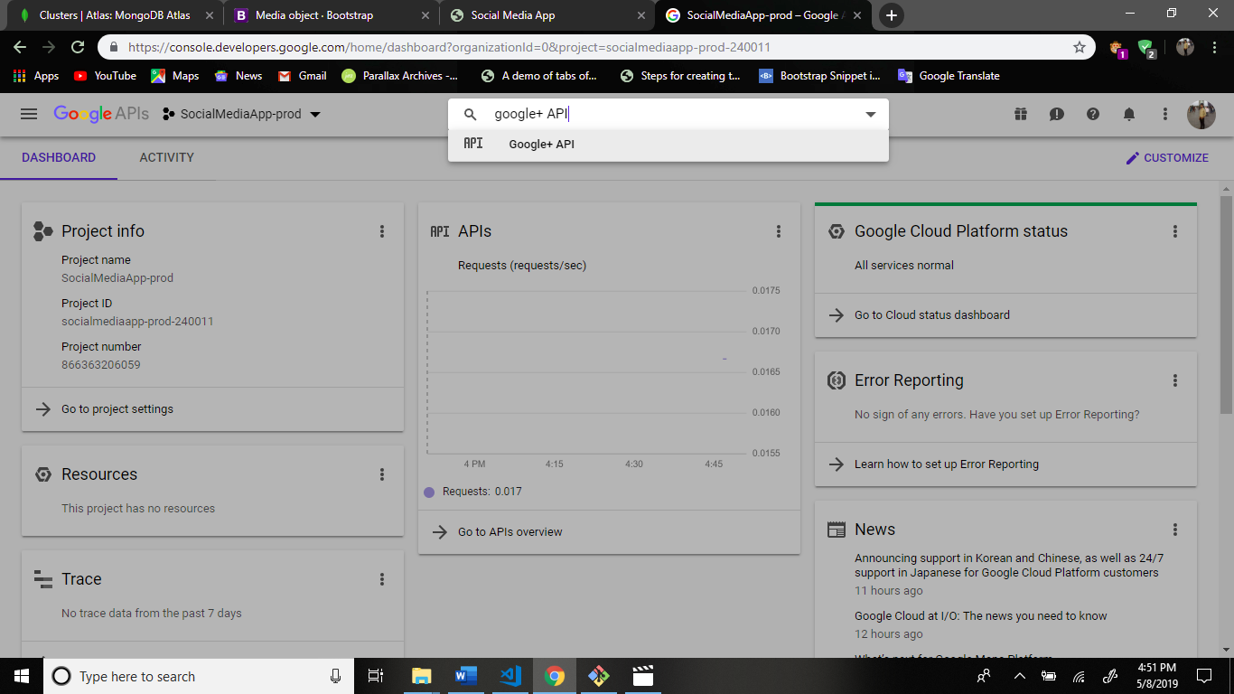

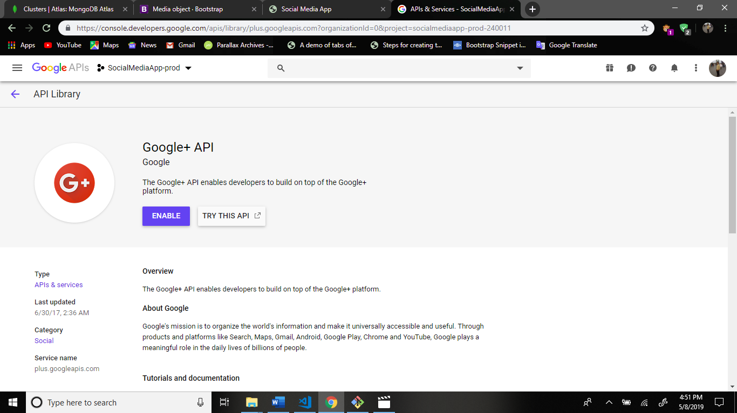

Enable this api.

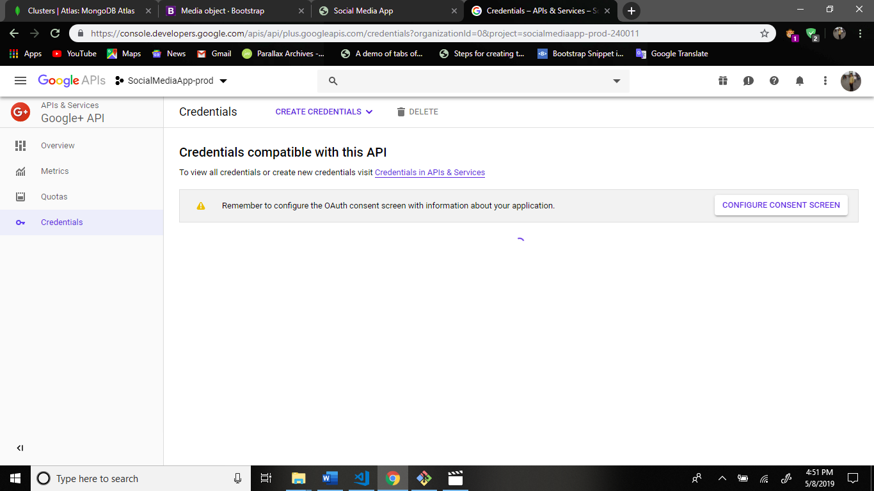

Now click the credentials in apis & services.

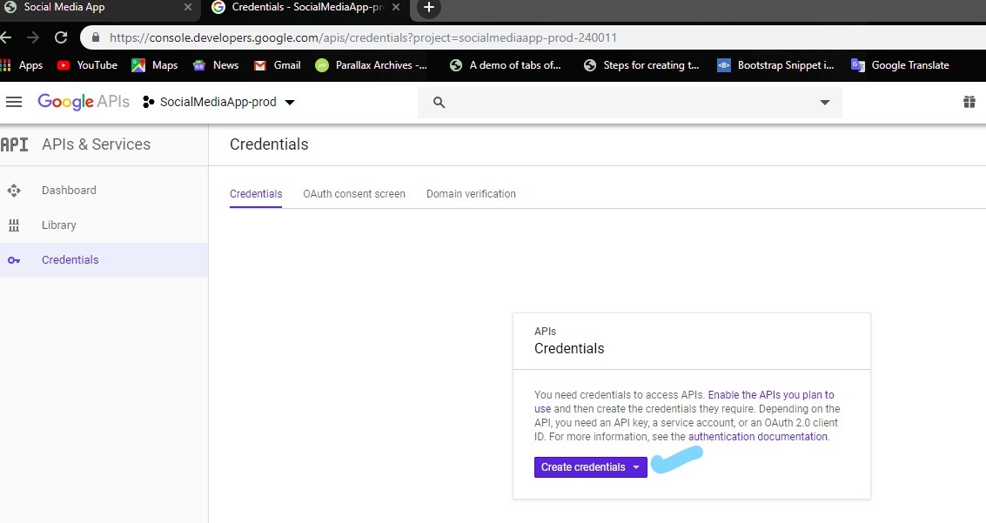

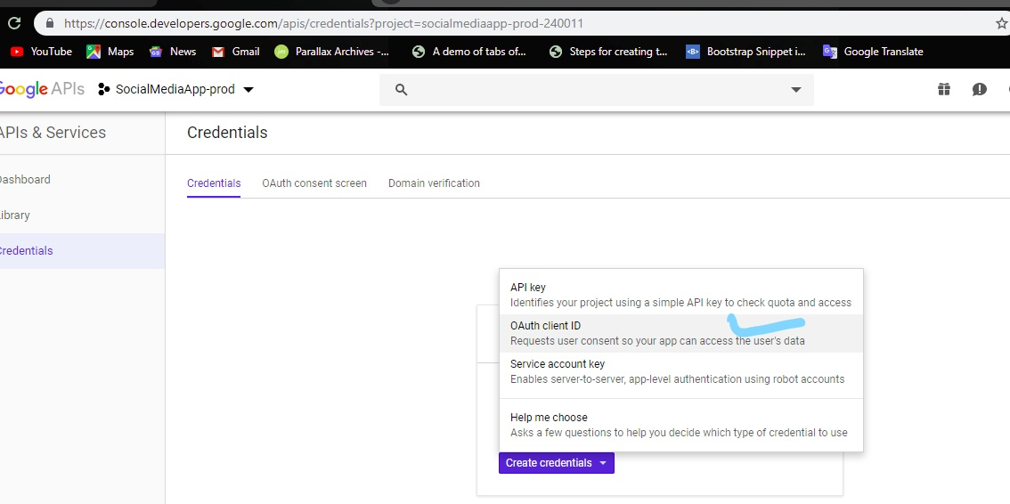

After this.

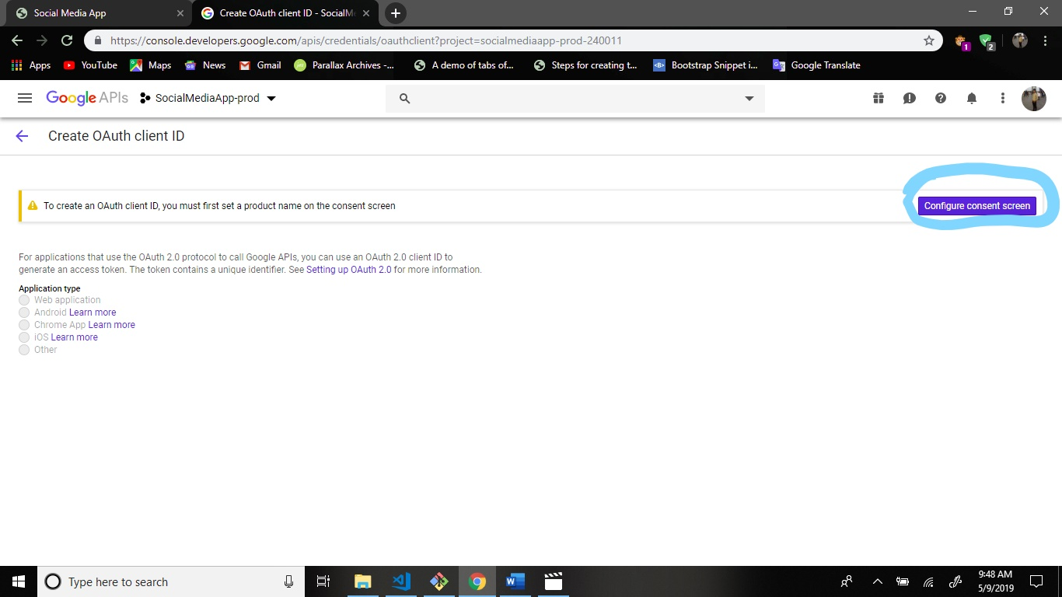

After this fill the given form.

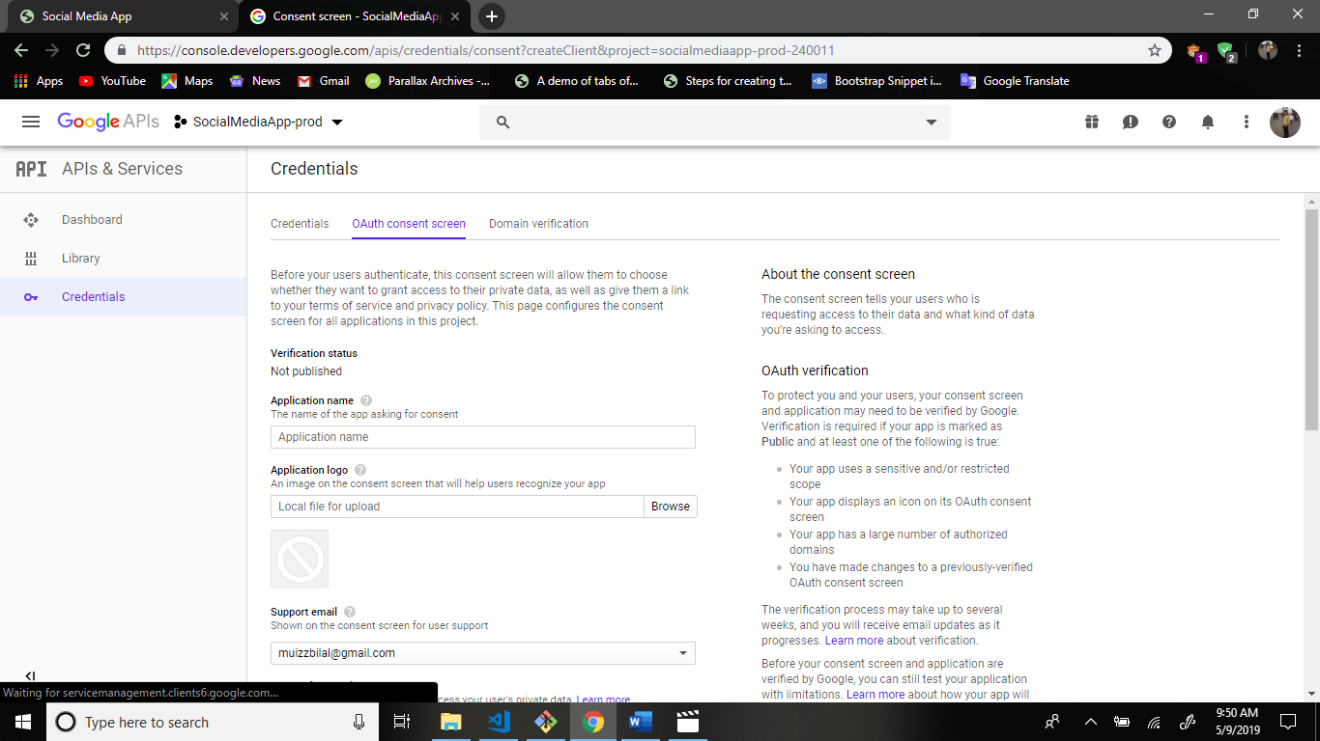

Only enter the application name and save this page.

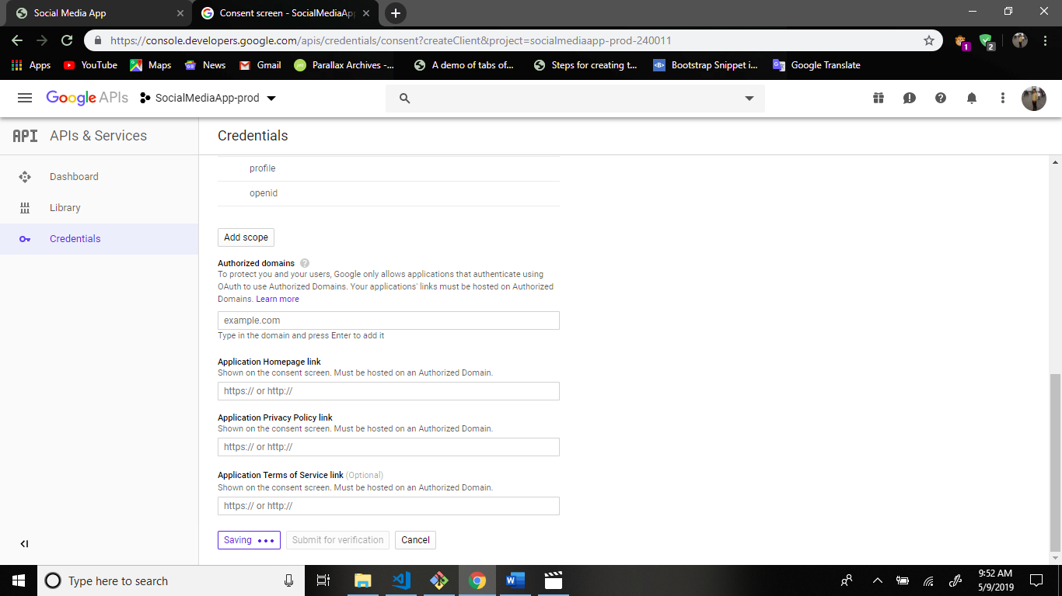

After this create web application.

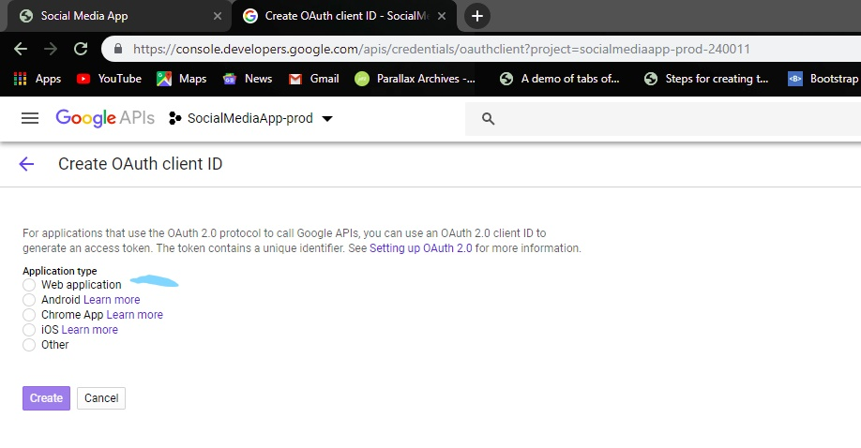

After this fill the form.

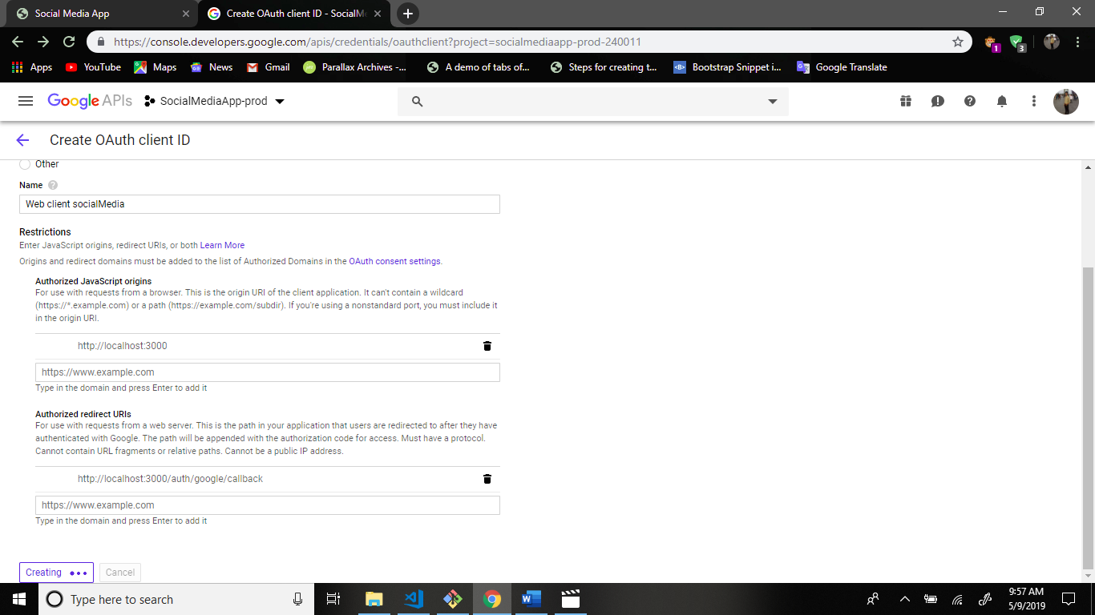

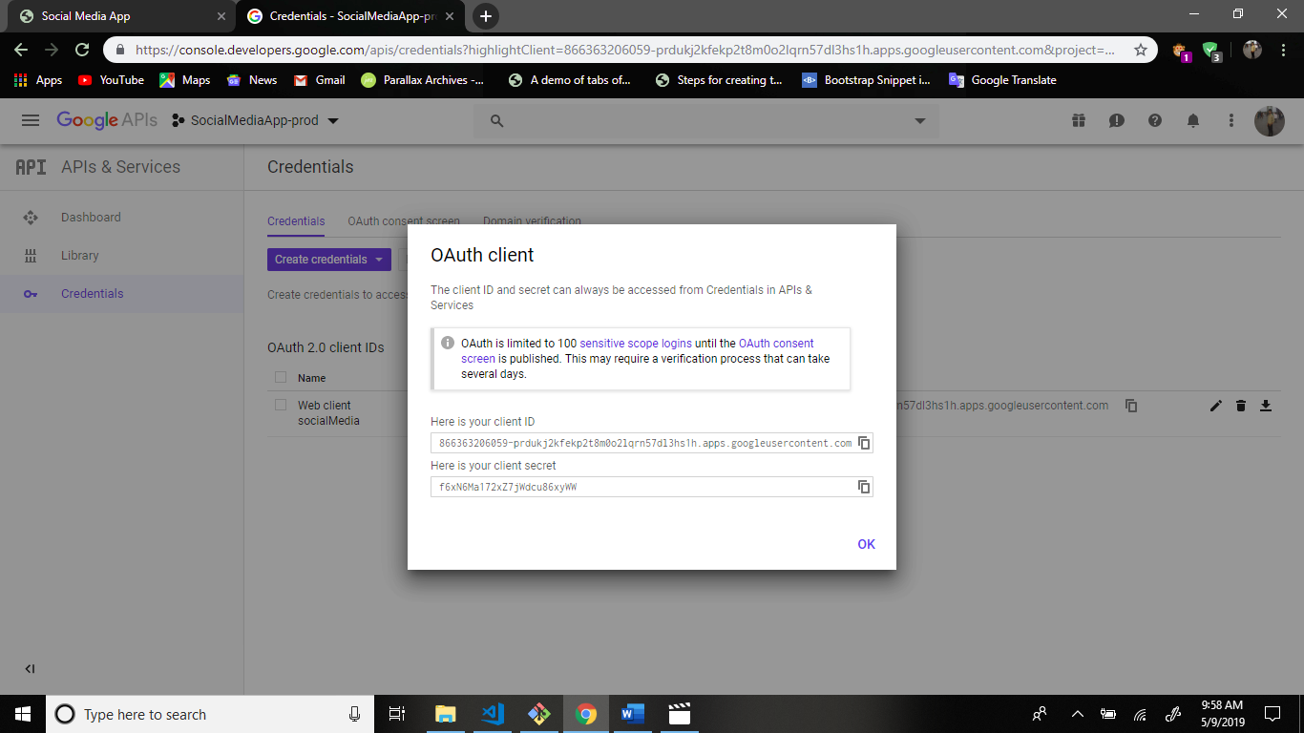

Client Id copy and go to your application keys-prod.js file paste this code.

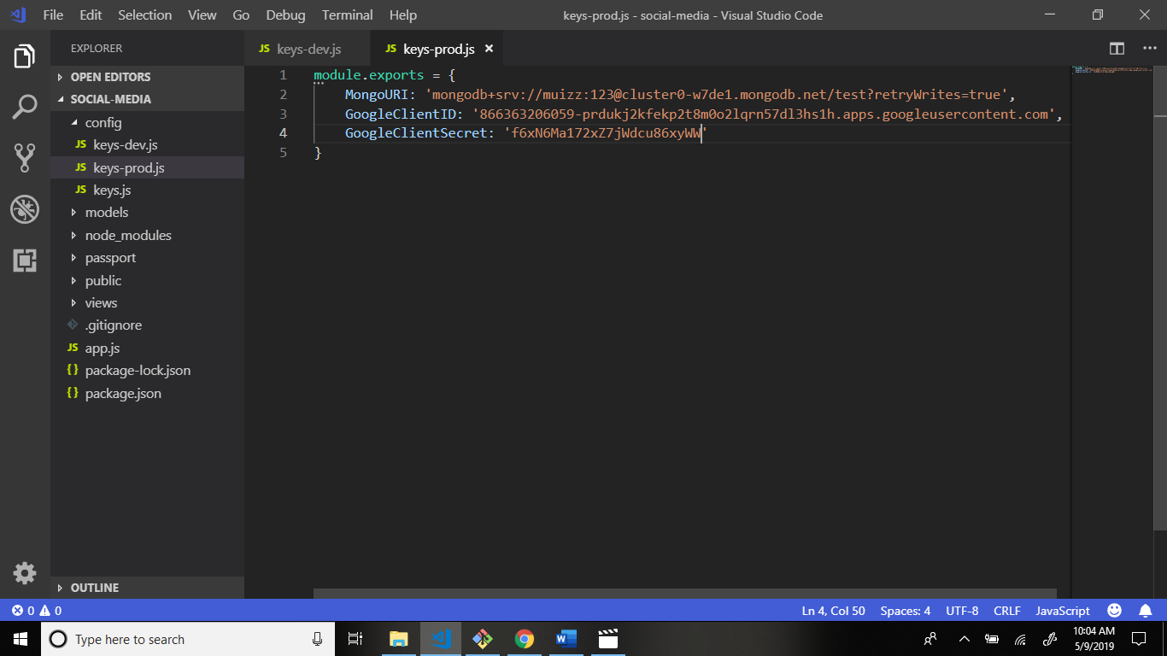

Now we deploy application in heroku.

Write command.

1 clear the terminal command: clear

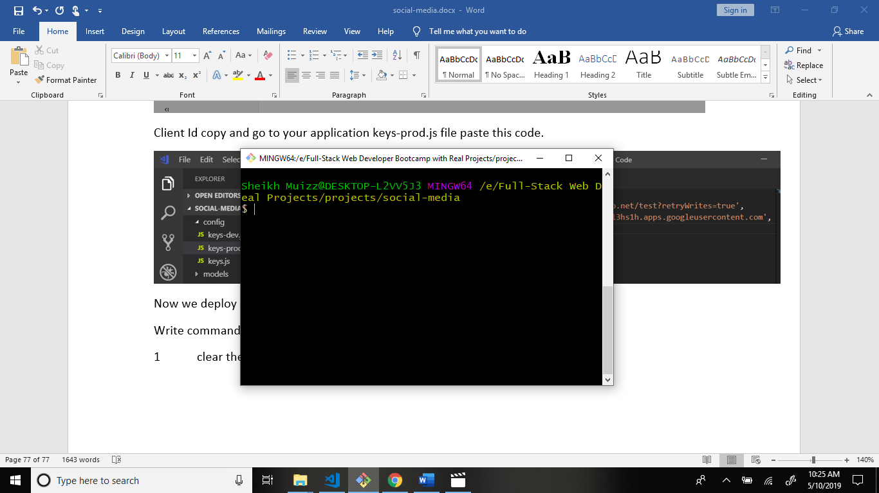

Now write command for inialize the git. Command: git init

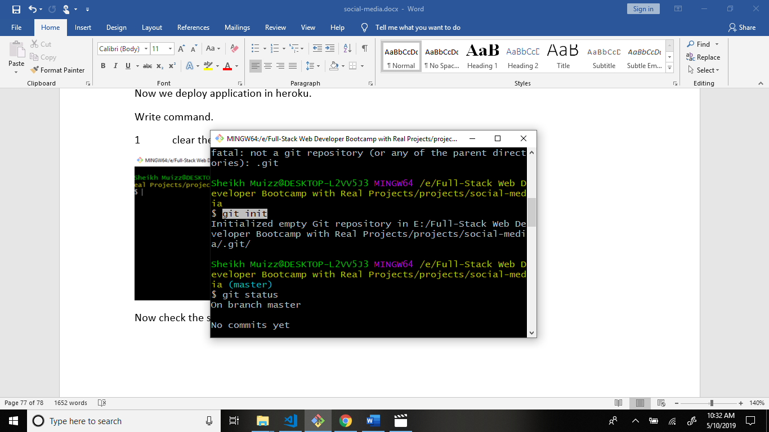

Now check the status your application command: git status

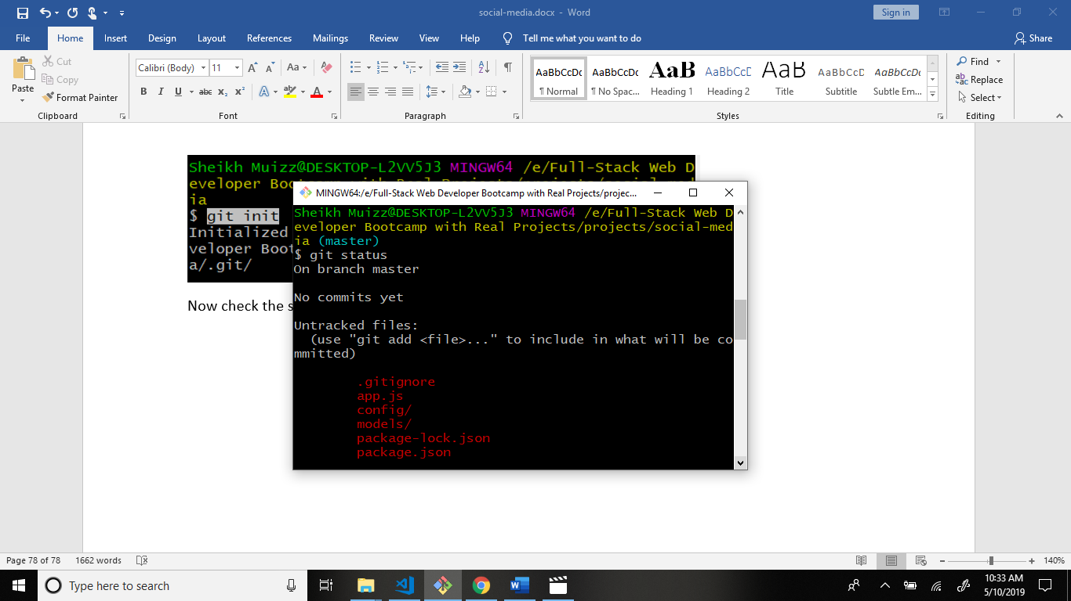

Now write command: git add .

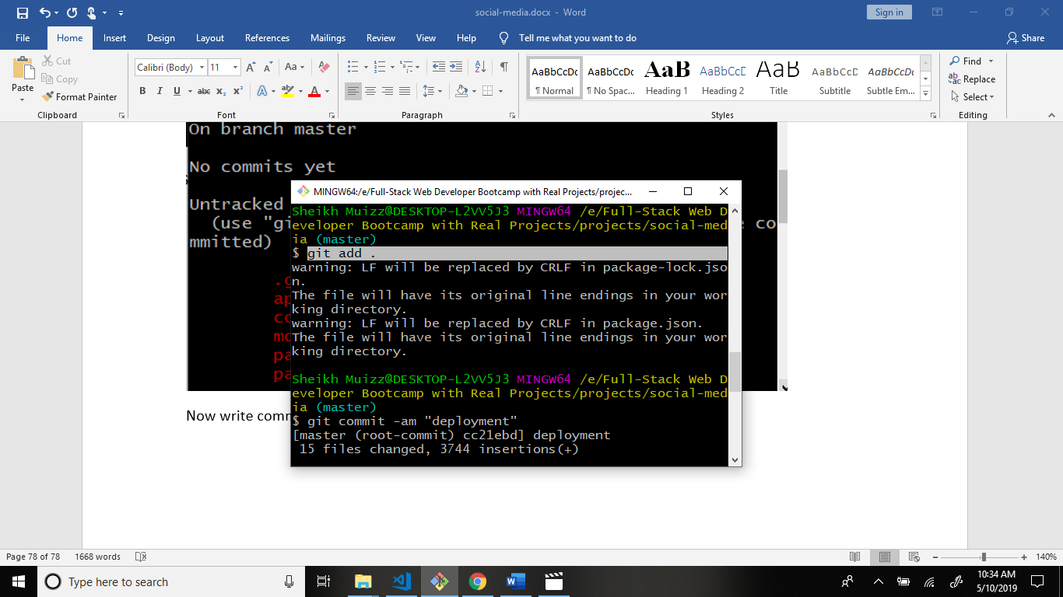

Now write one more command: git commit -am “deployment”

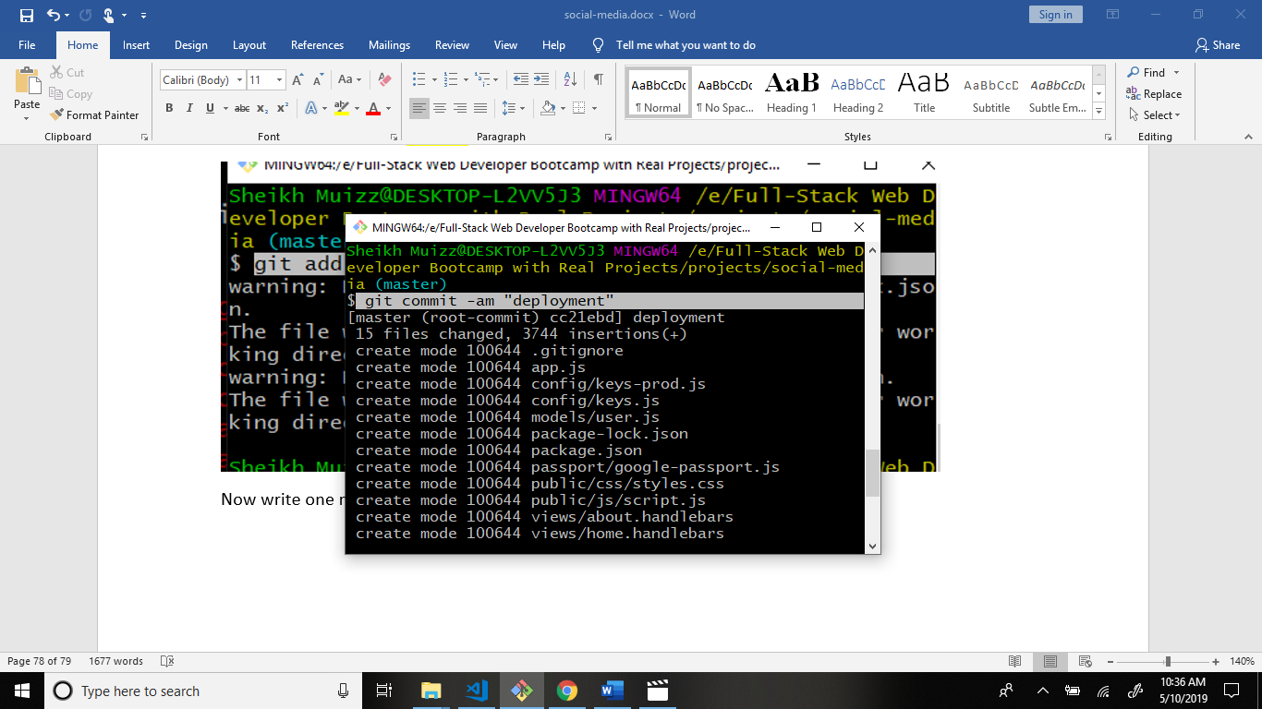

Now create heroku app. Command: heroku create

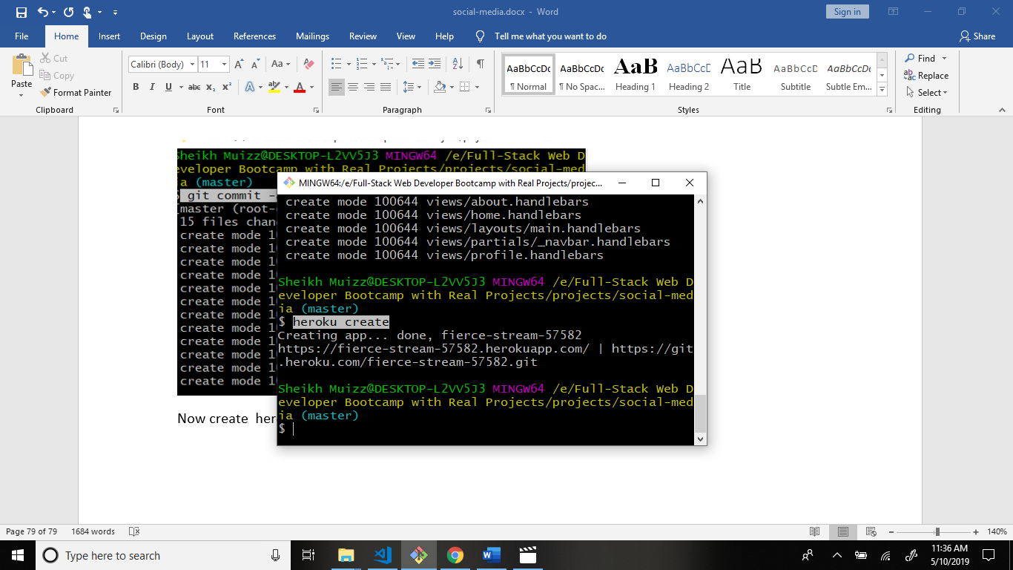

After this go to heroku.com website.

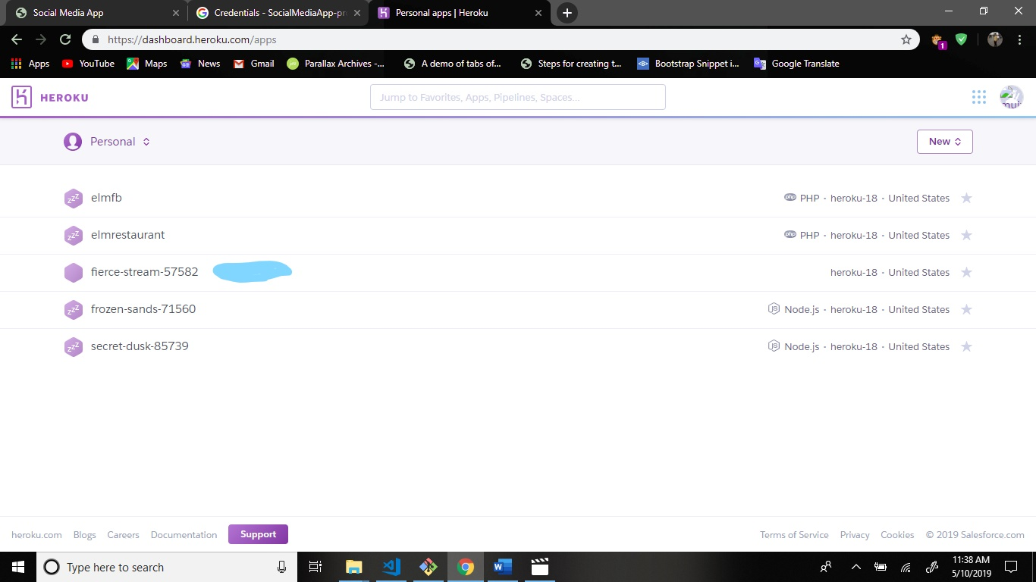

Open this app.

Go to deploy tab and scroll down.

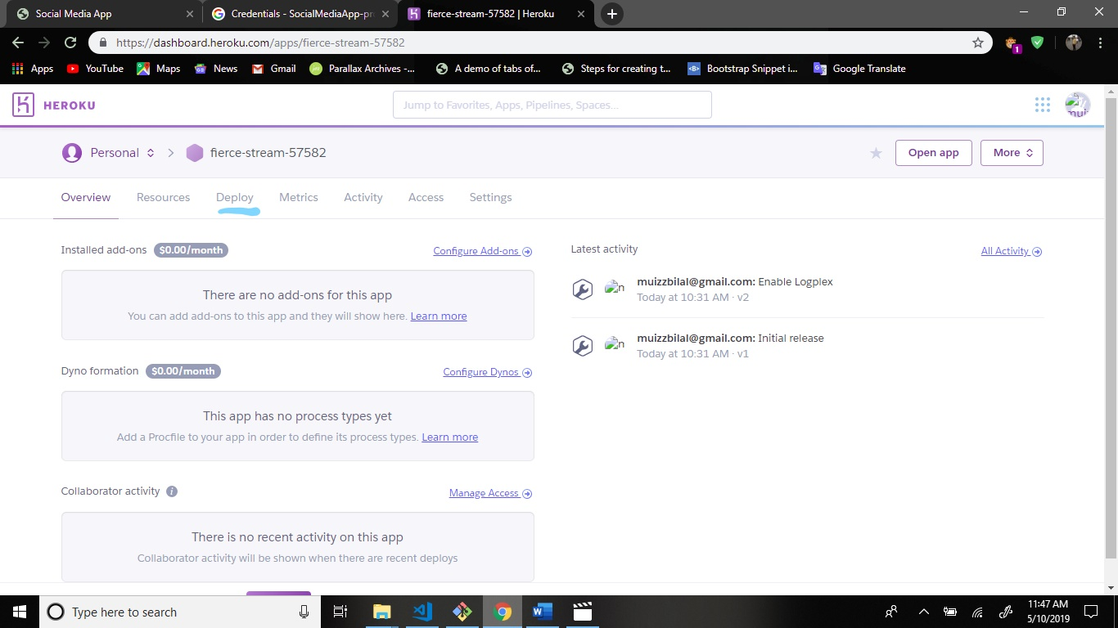

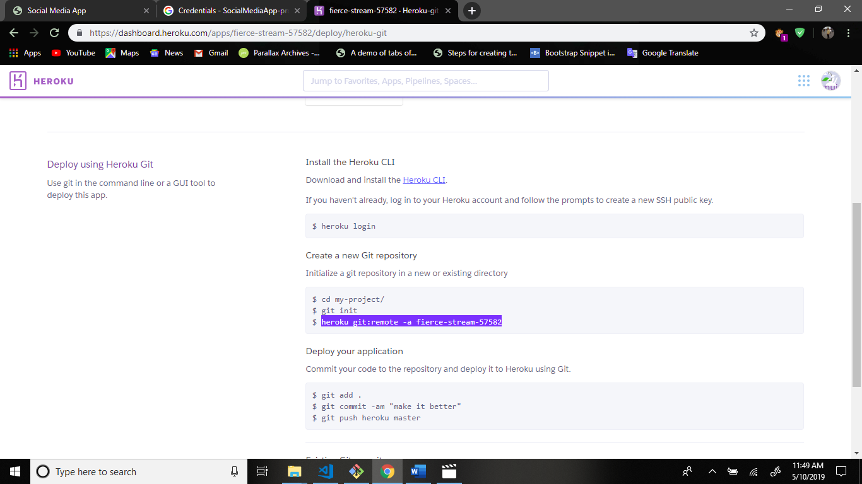

Copy this command and run the cli.

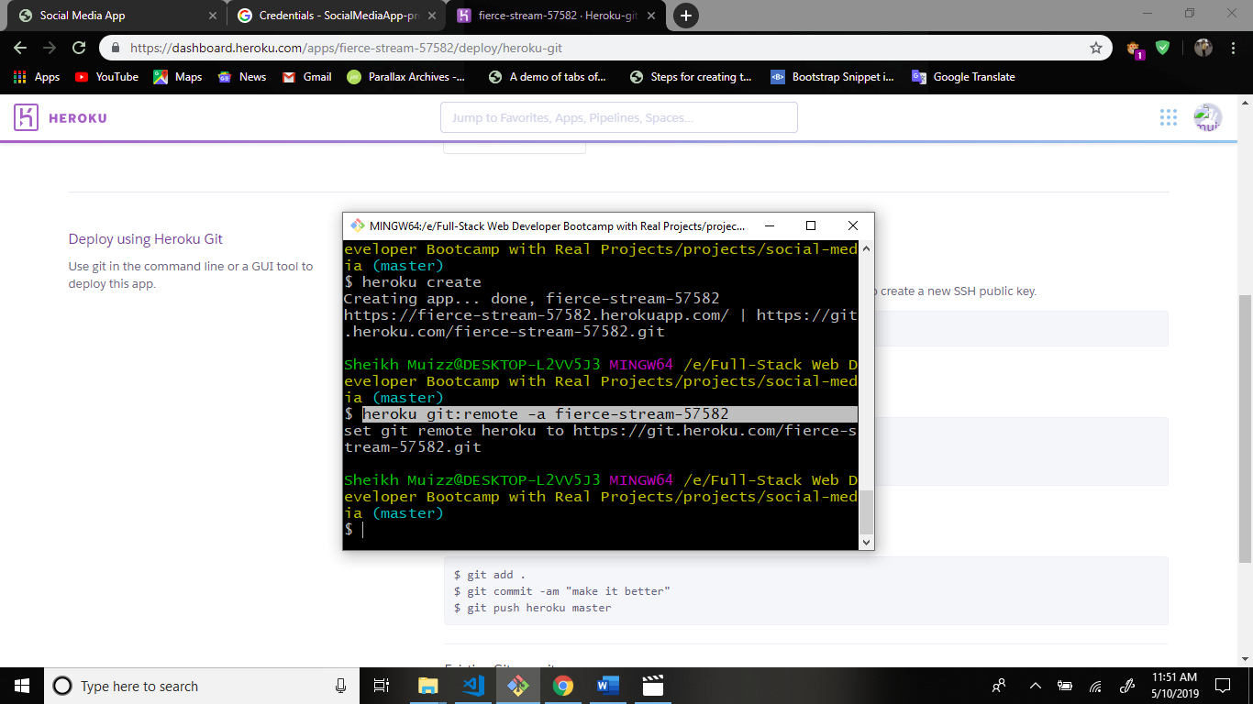

Now we application push to heroku. Command: git push heroku master

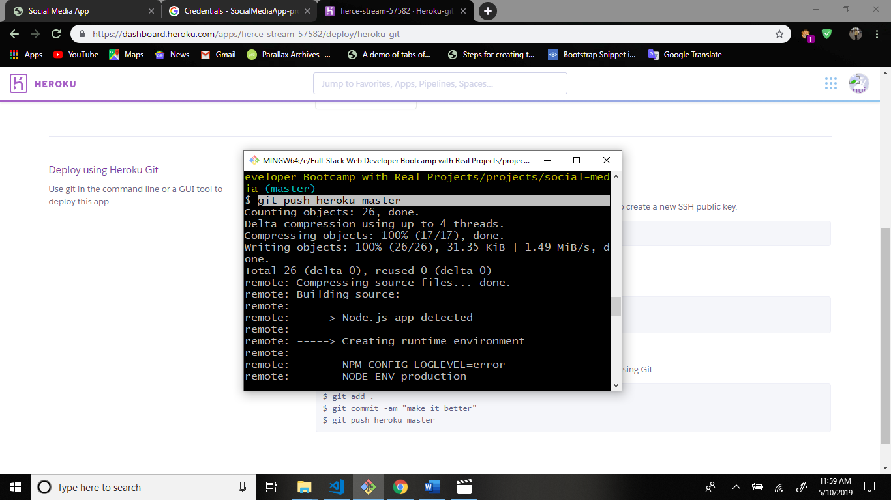

Now go to heroku app setting.

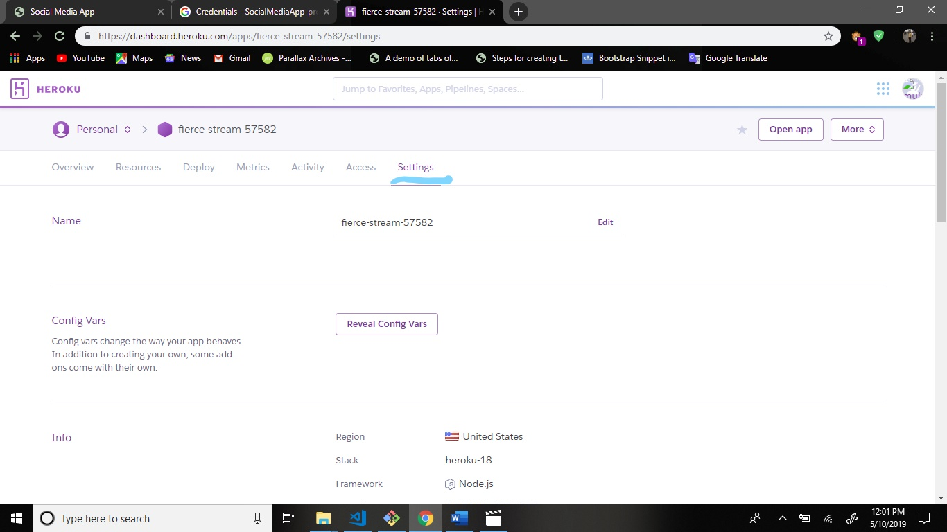

After this click reveal config vars

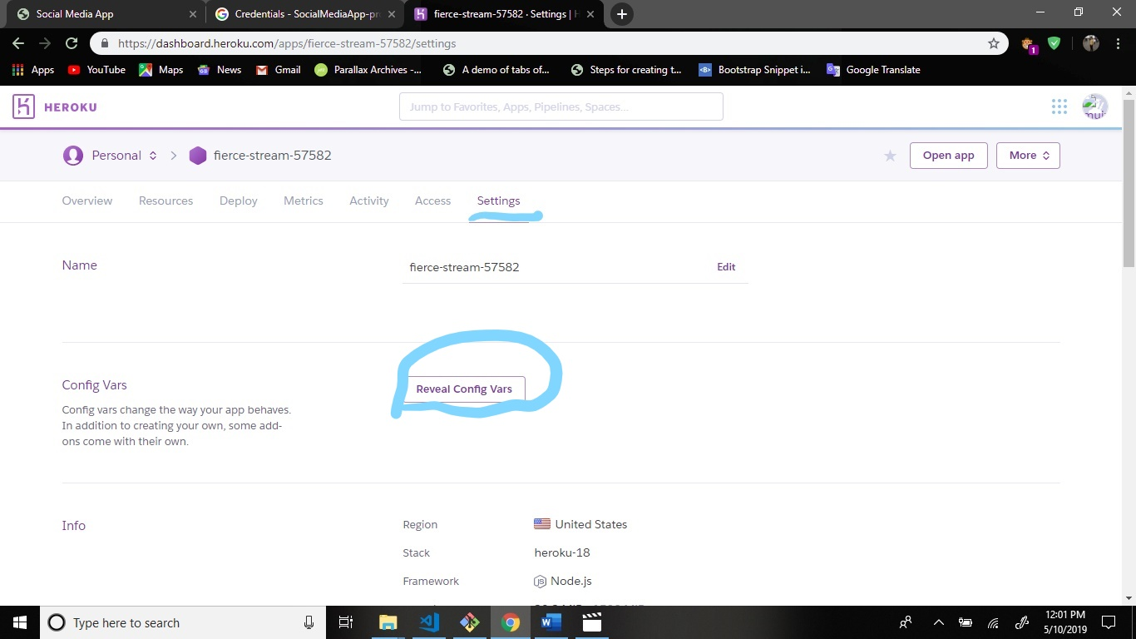

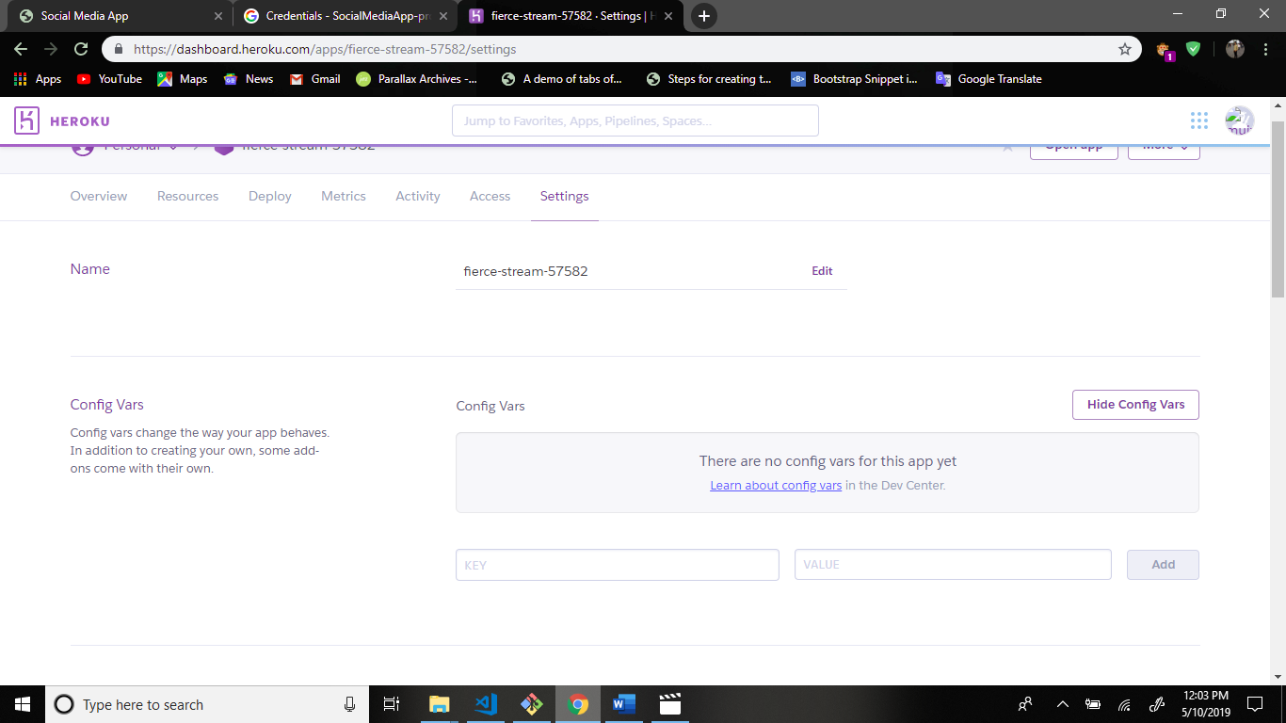

Now go to keys-prod.js file.

Cut this value and paste the heroku application setting.

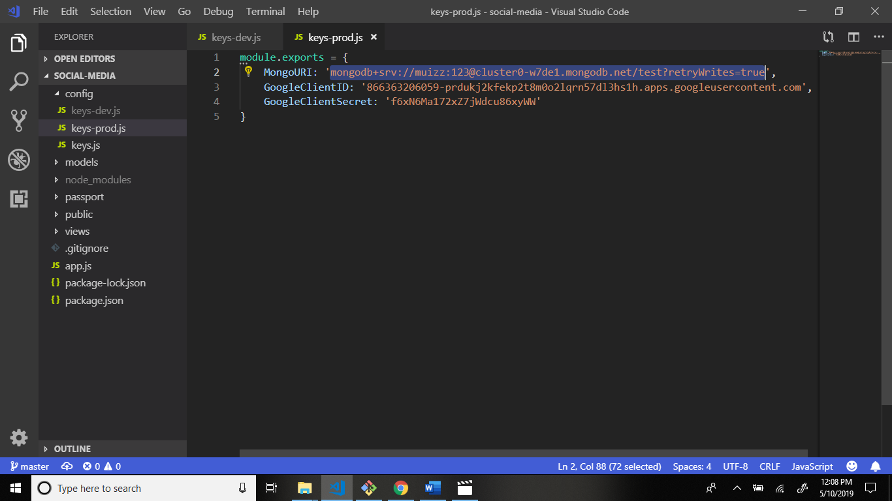

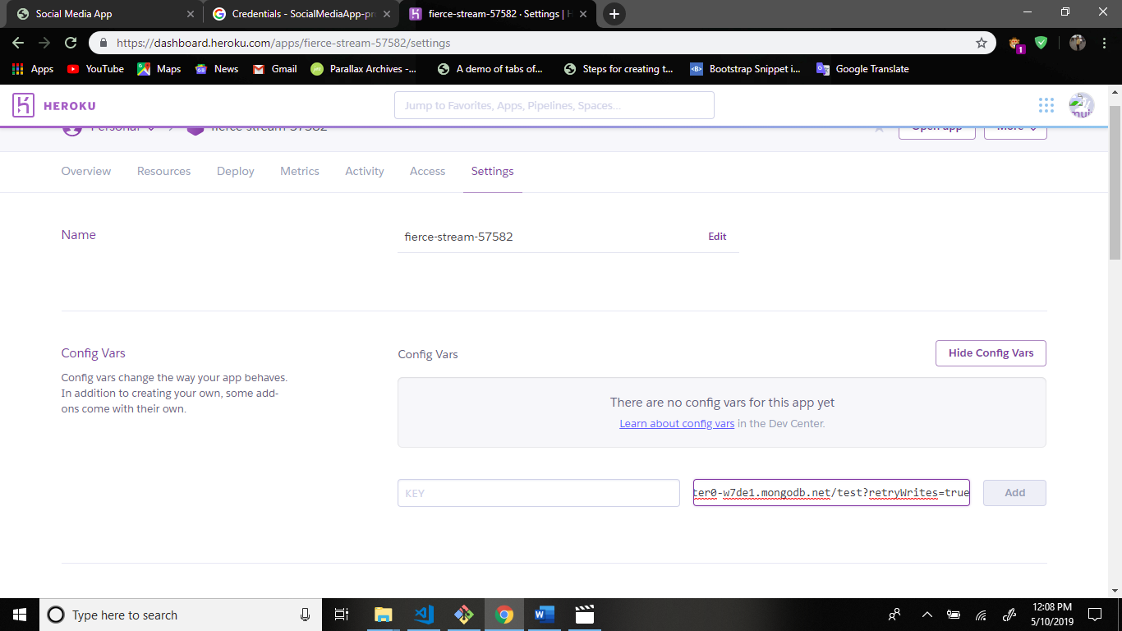

Go to keys-prod.js file and write code and copy the after written the env.

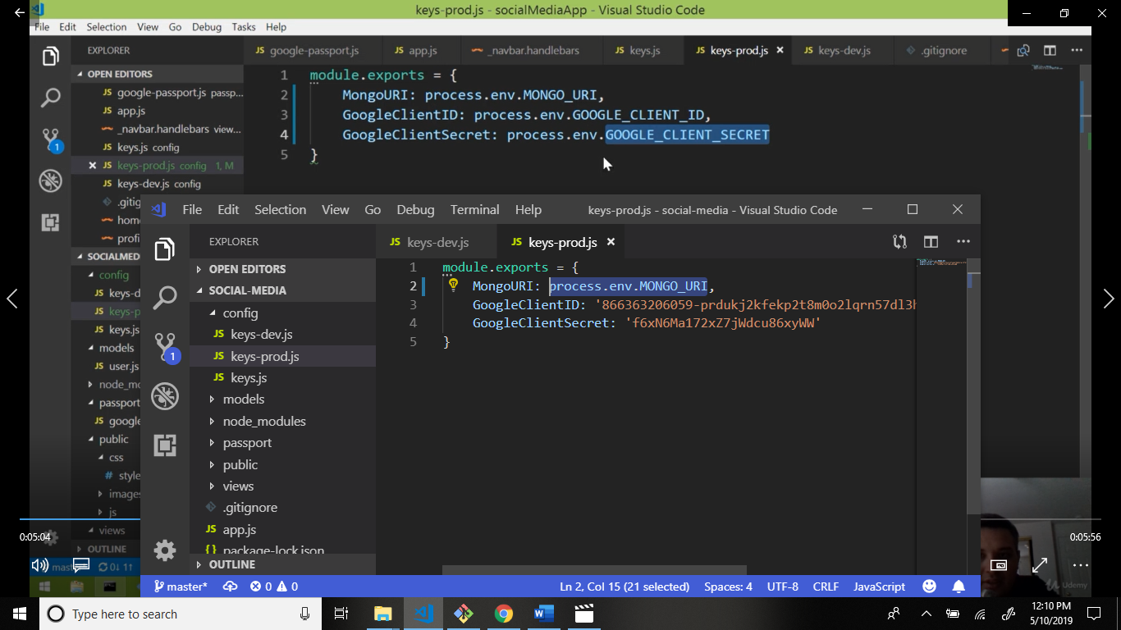

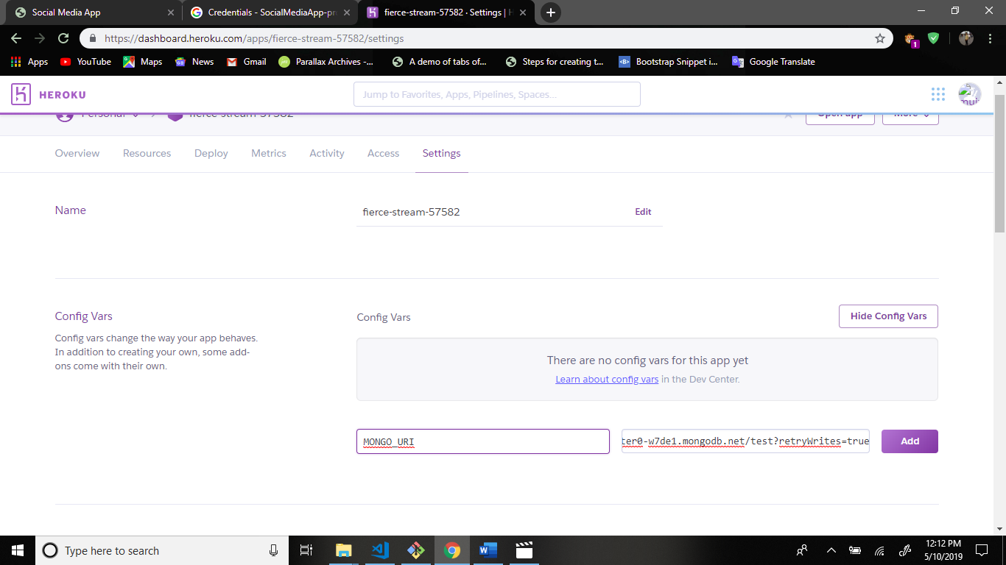

Click add button and.

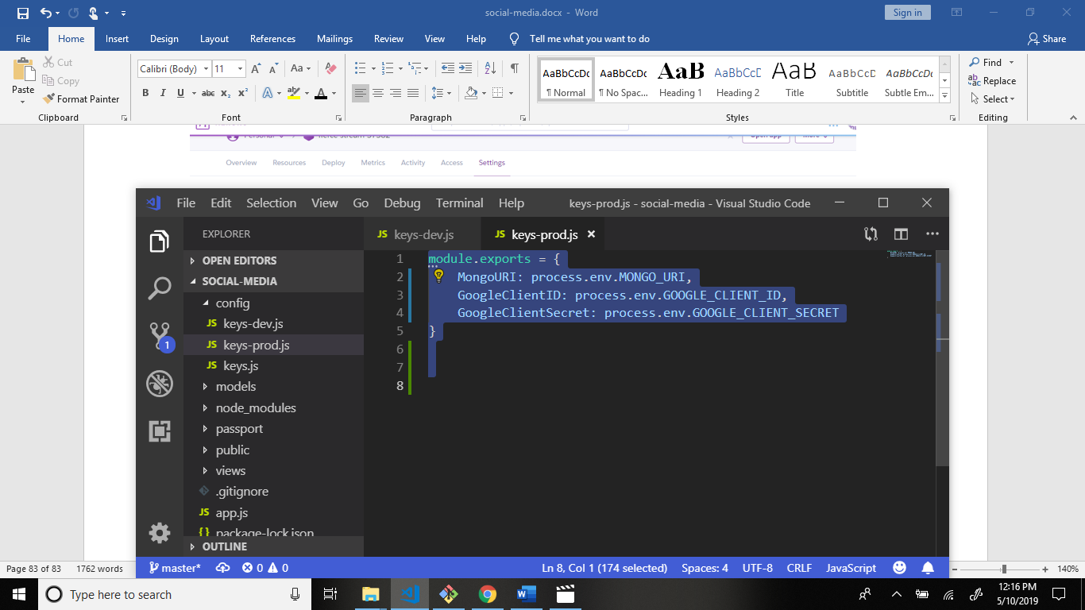

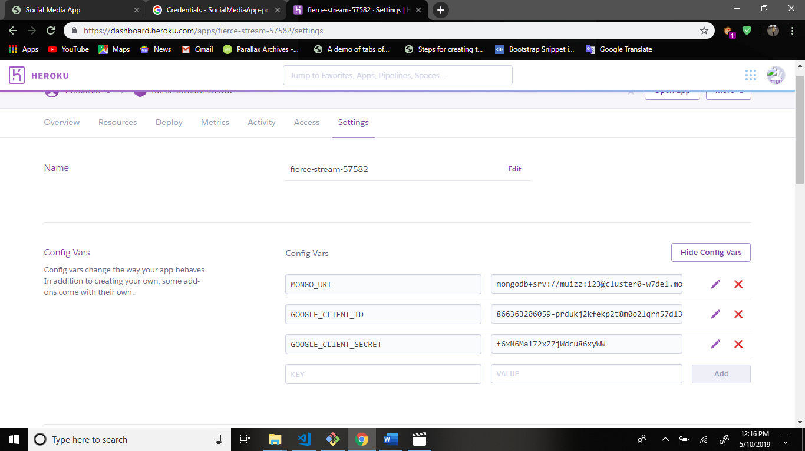

Now lets go to social media app.

And publish your application.

Command: git add .

Command: git commit -am “better”

Command: git push heroku master

Last command to open your application. Command: heroku open

Now your all application is publish.

Now start get information in facebook sign up.

Now firstly go to passportjs.org website: <http://www.passportjs.org/>

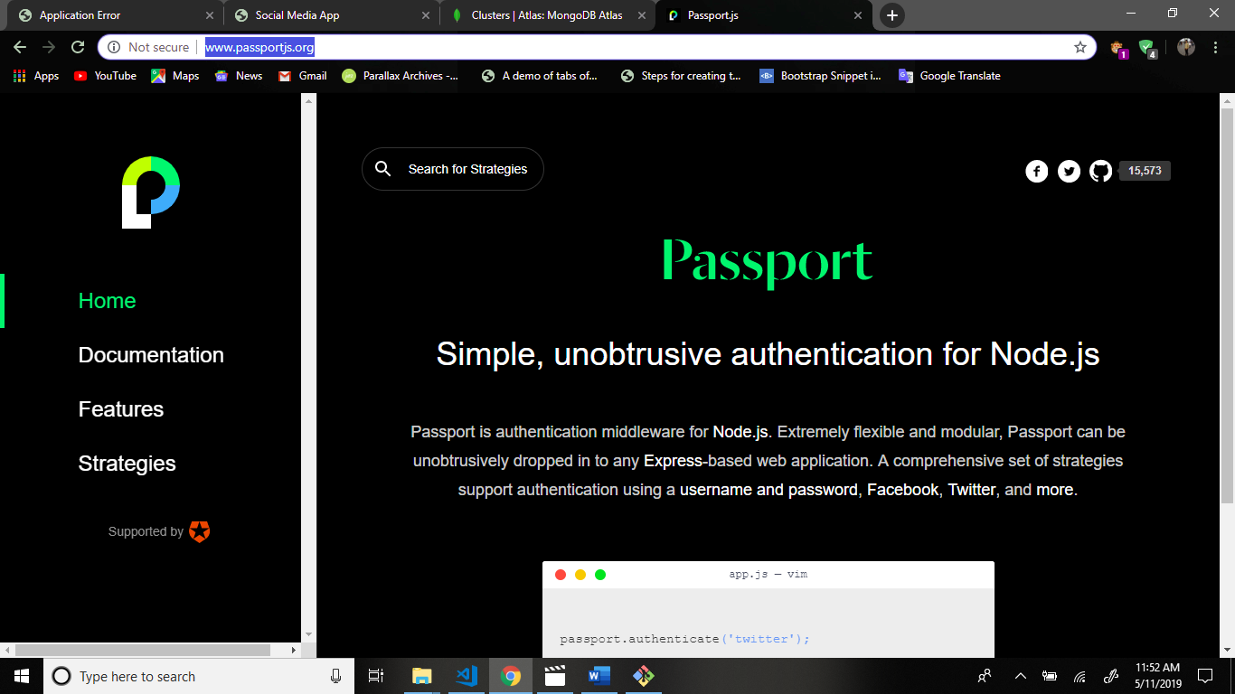

Now search the passport-facebook.

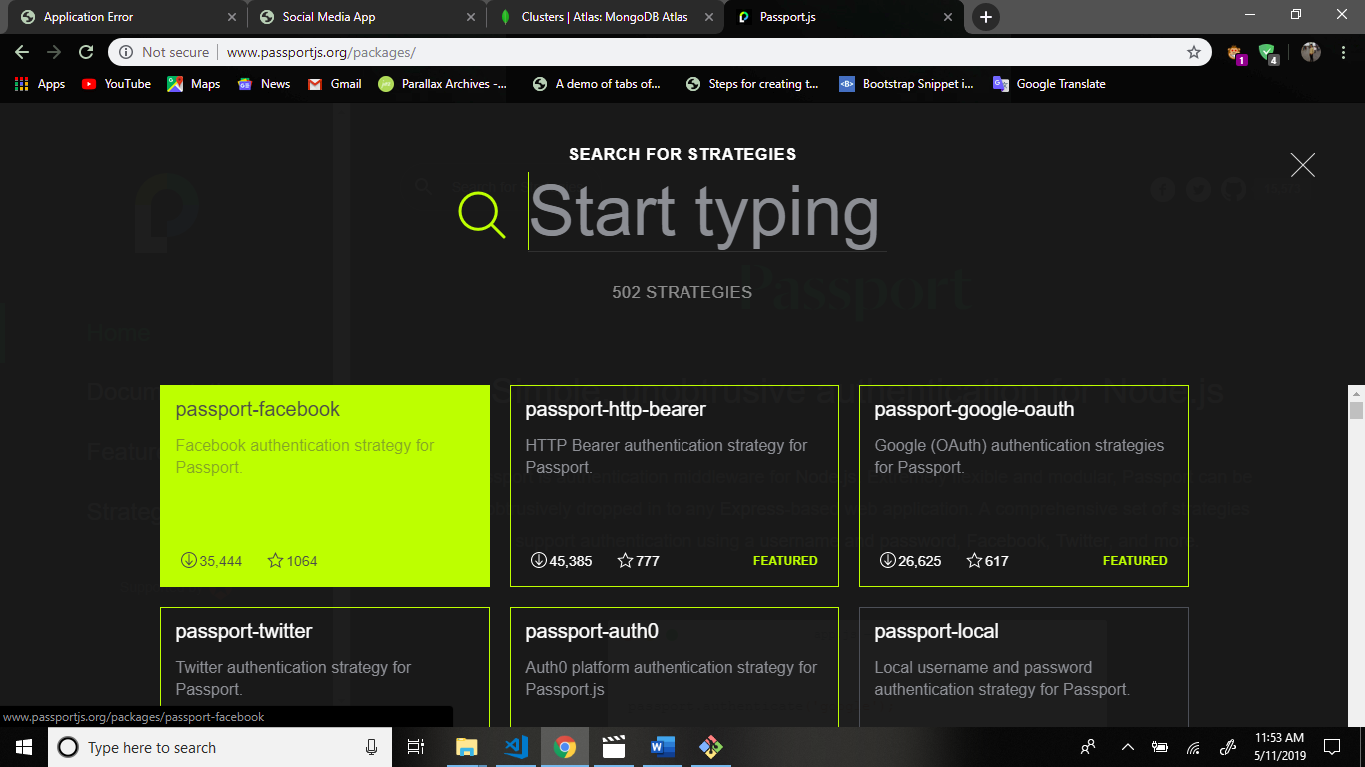

Scroll down and install the first command.

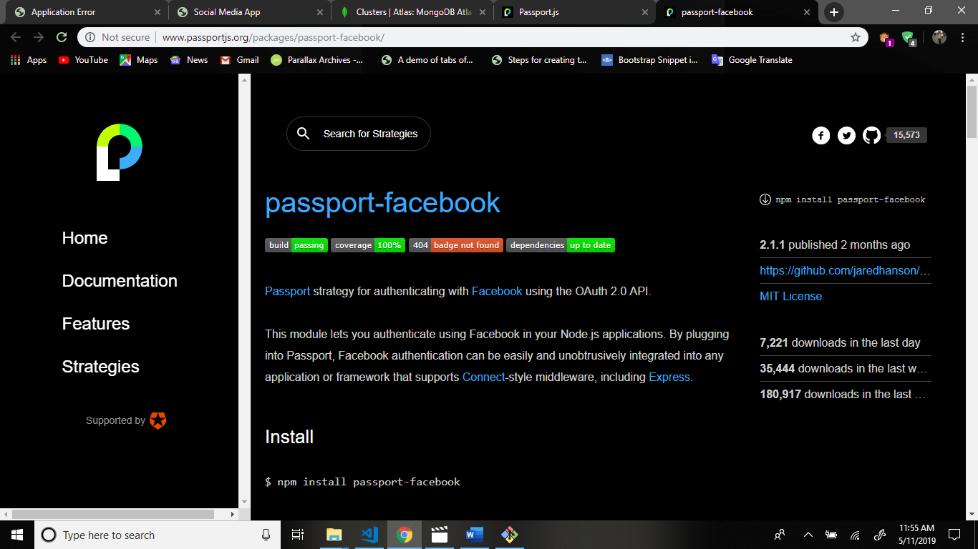

Now lets go to the terminal.

Now write command: npm i passport-facebook –save

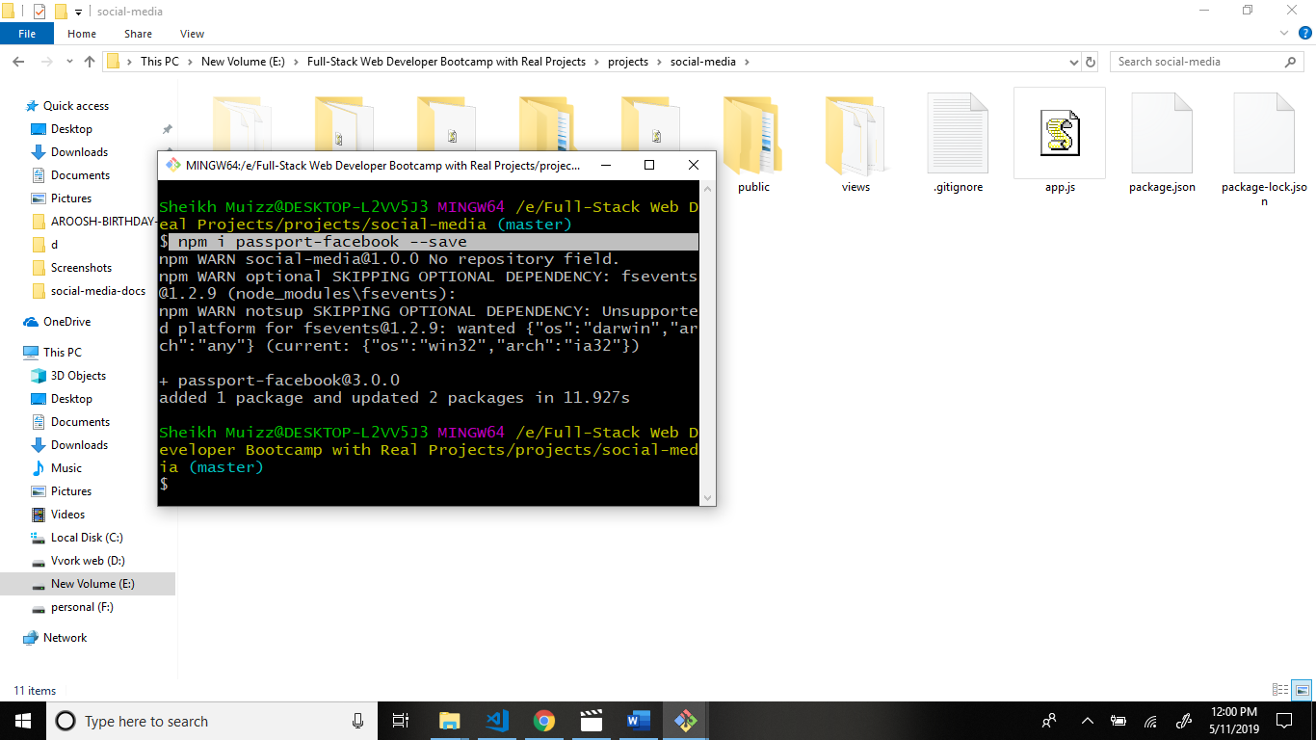

Now go to package.json file and see the dependecies is add to the file.

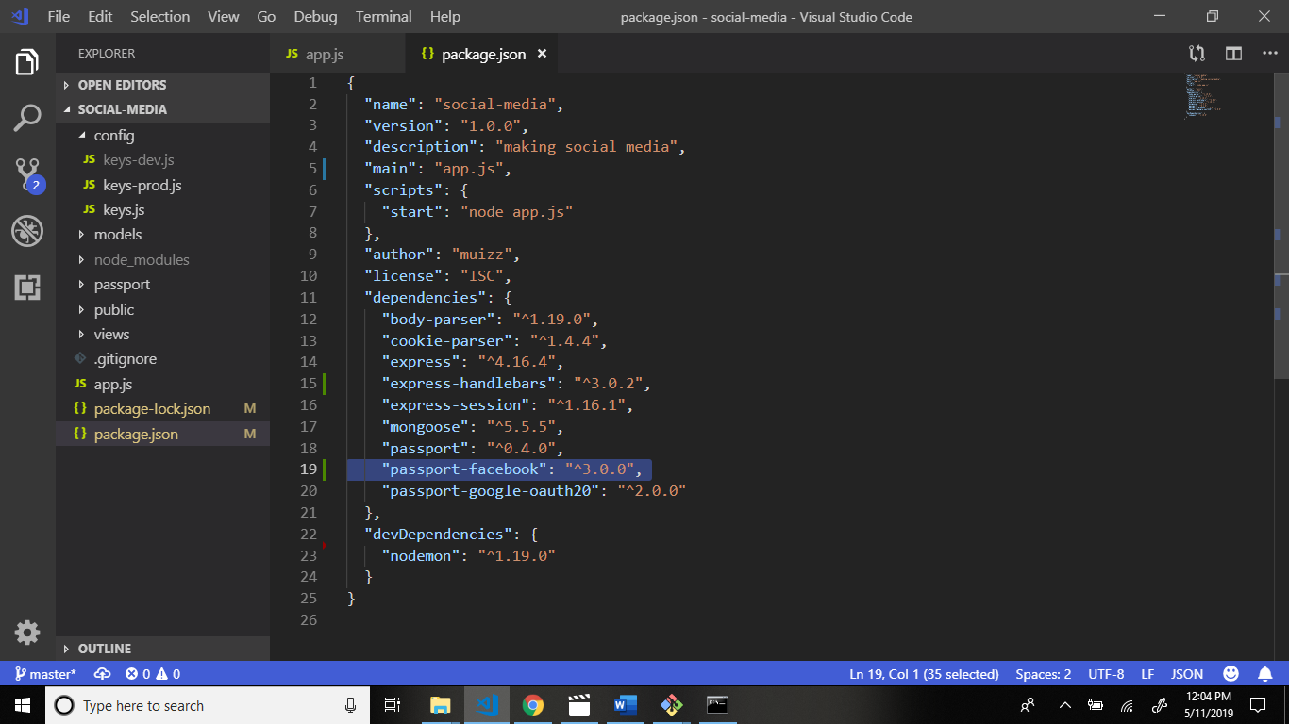

Now go to passportjs.org website and click facebook developers.

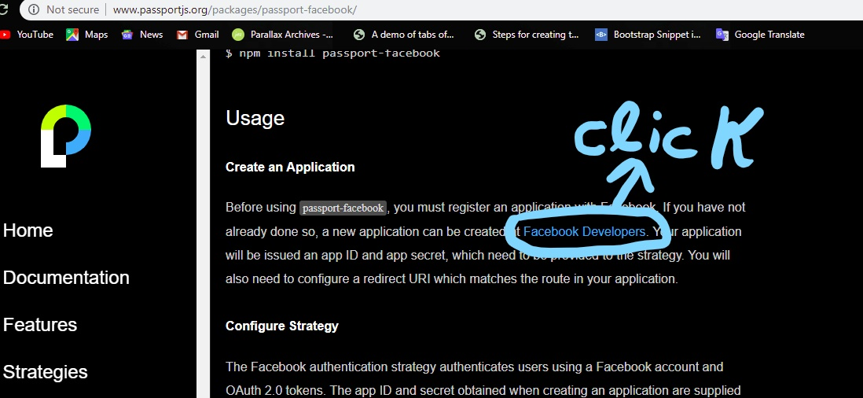

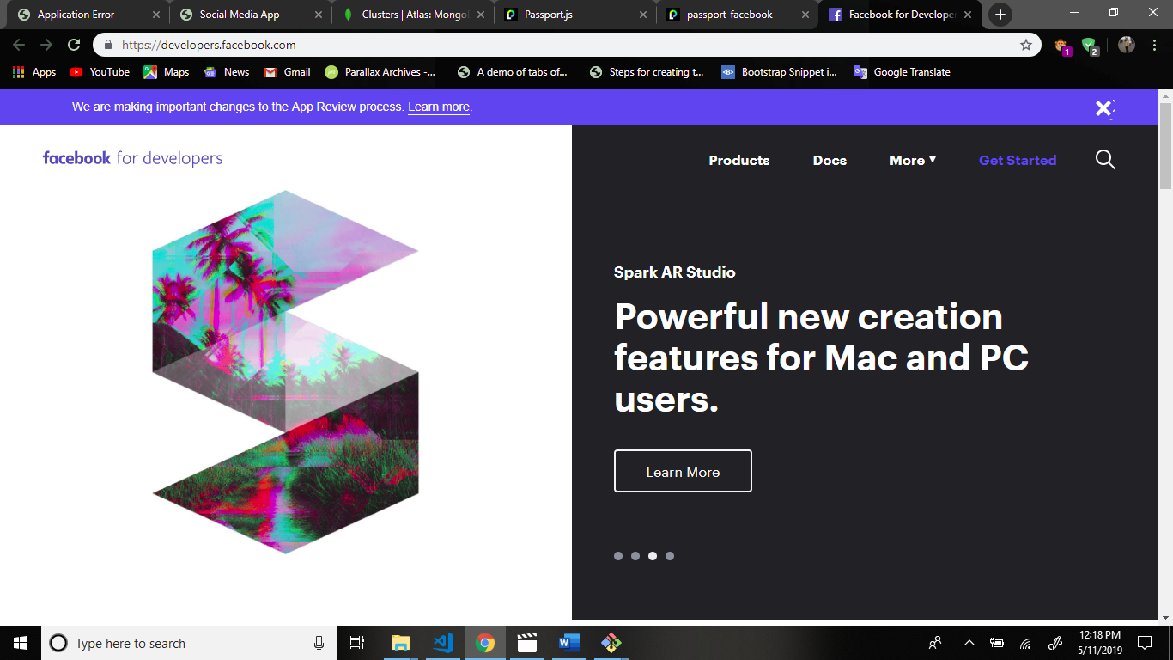

Now press get started button top right side in developers.facebook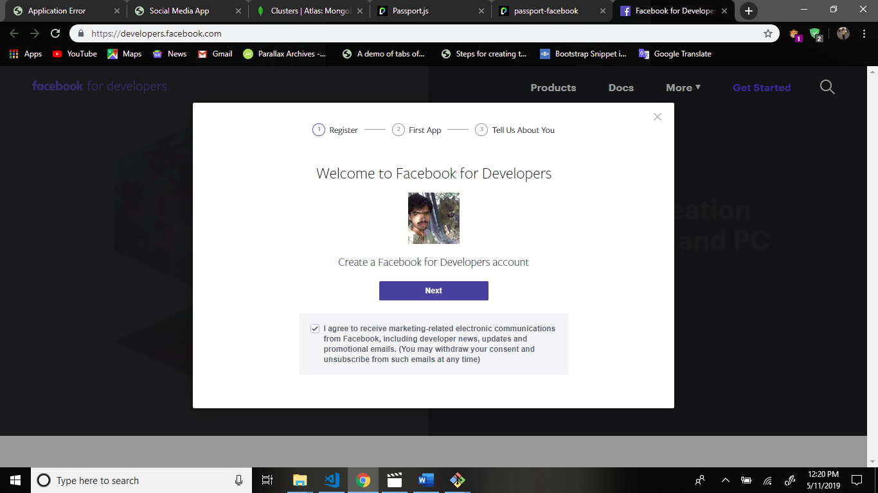

Press next button.

Now enter name application.

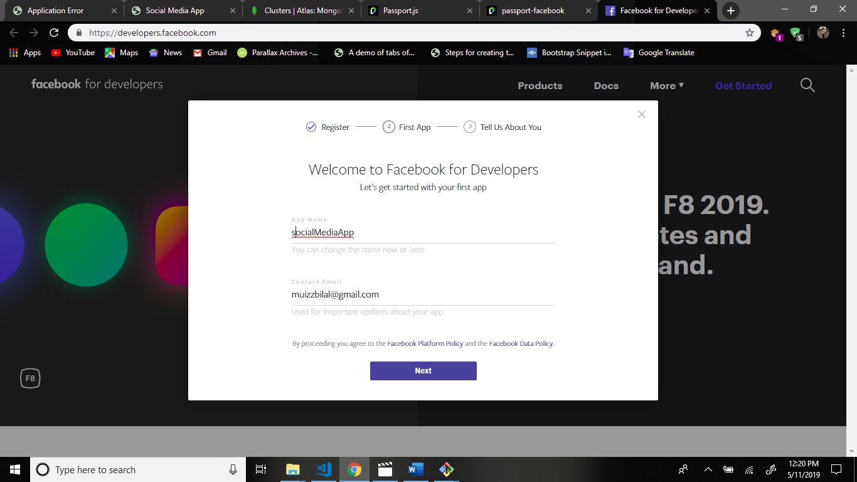

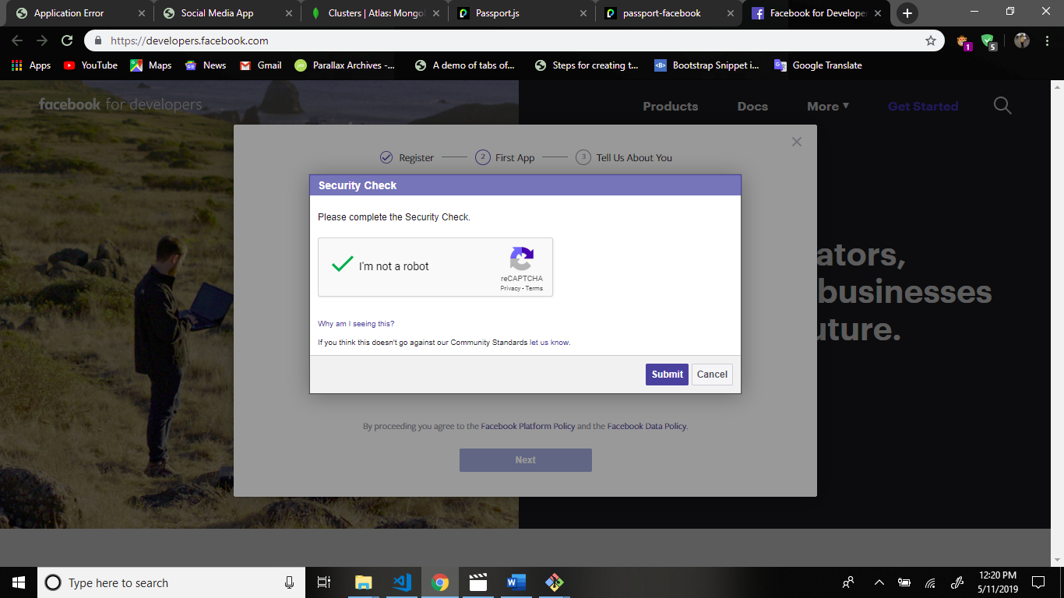

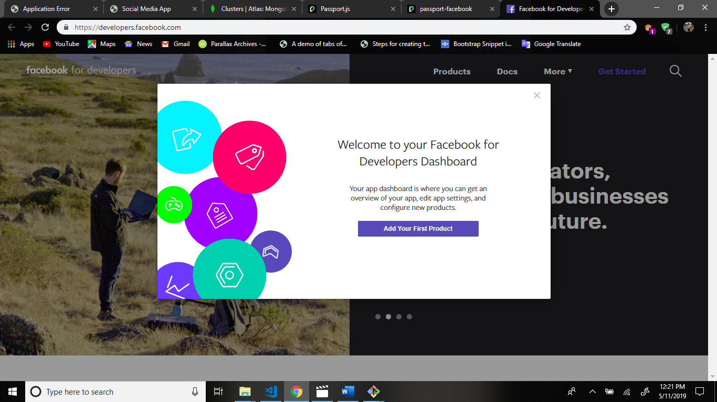

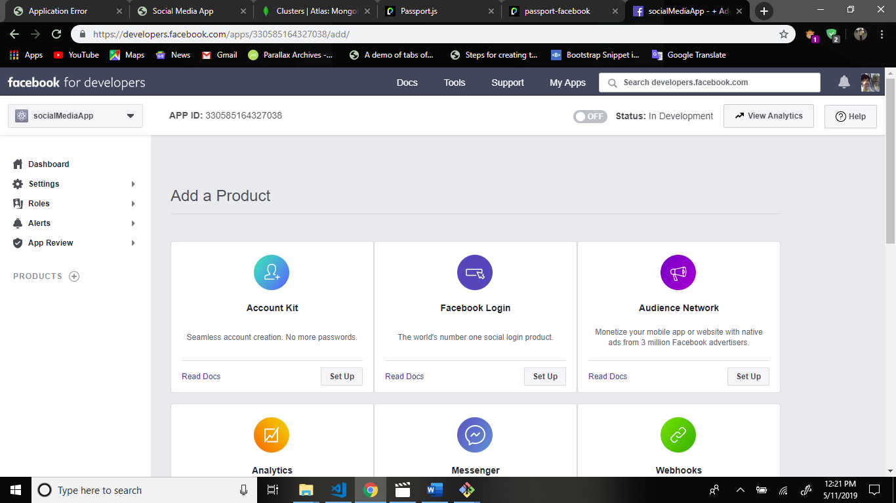

Now go to basic setting.

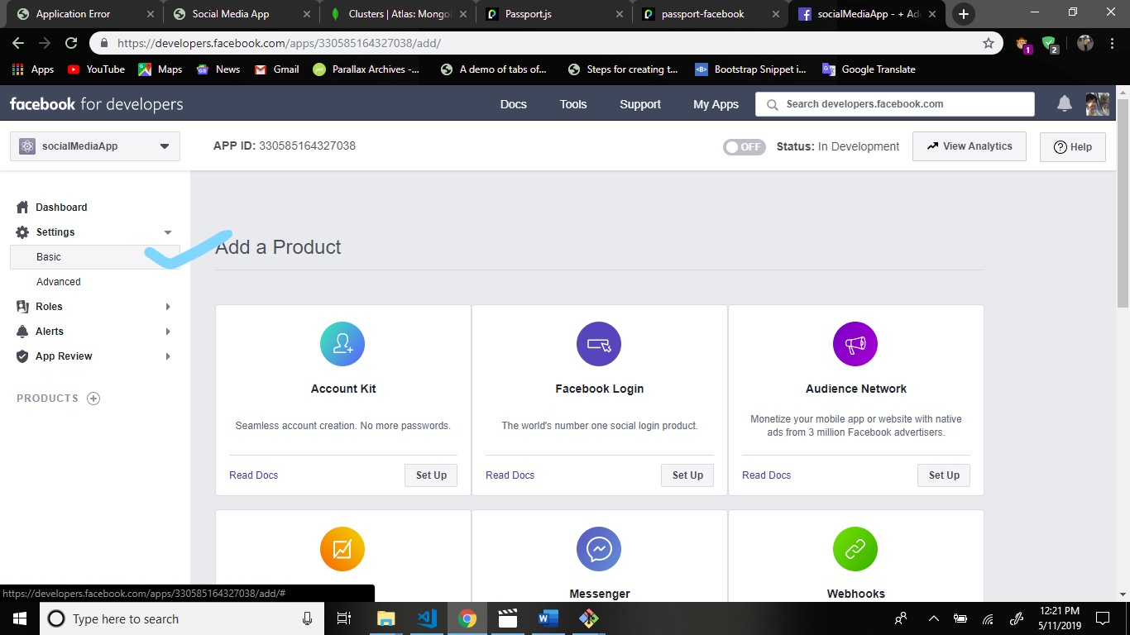

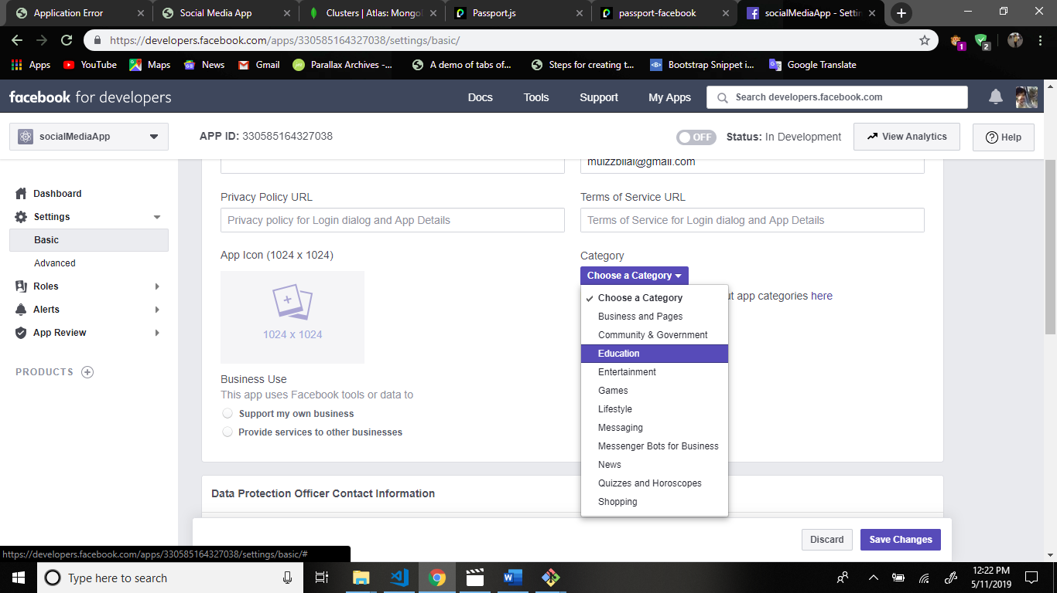

Scroll down and add platform.

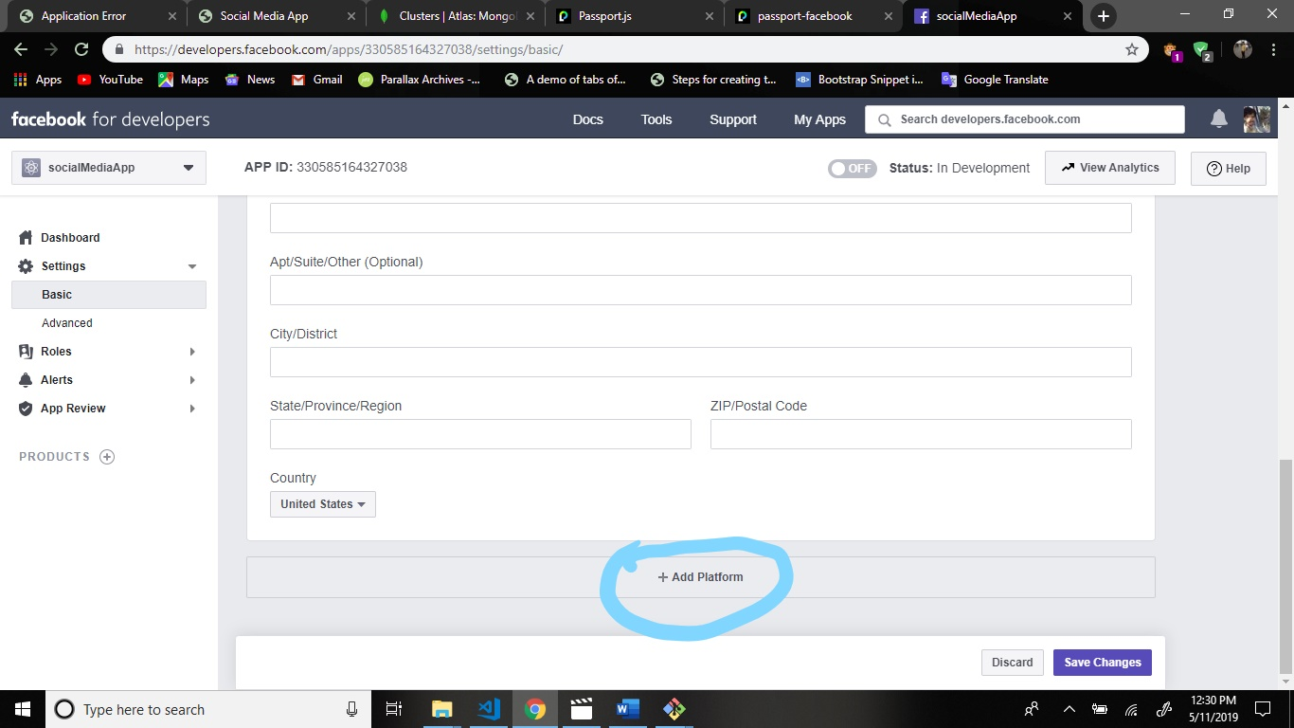

Now add web application pltform.

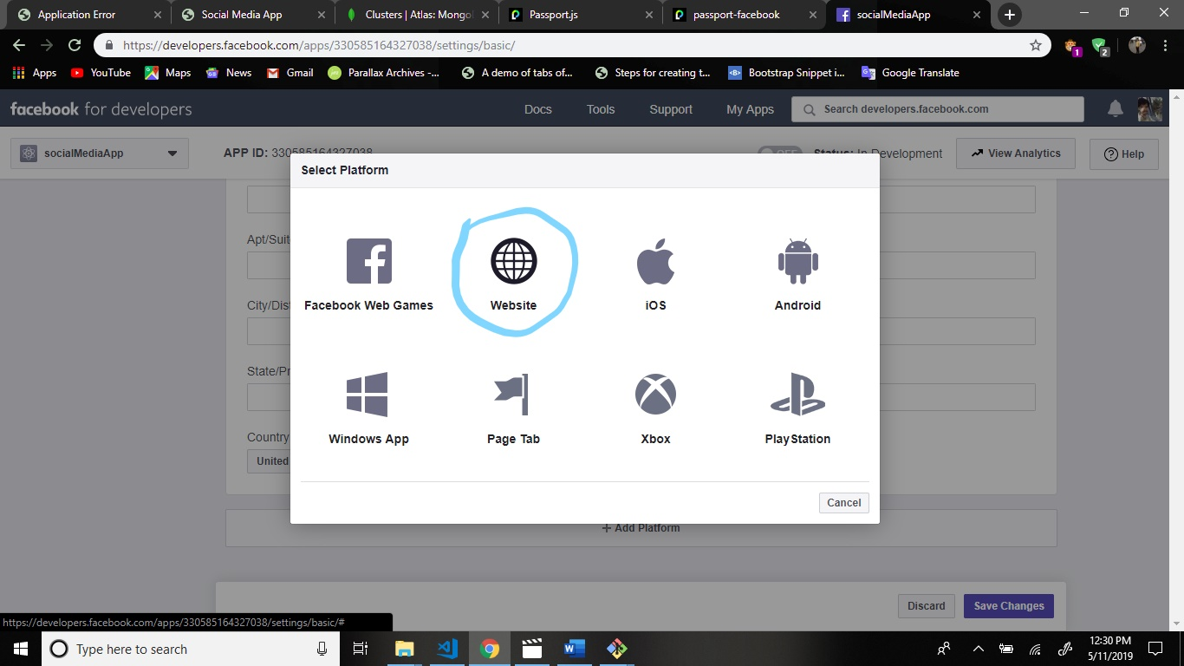

Now save changes.

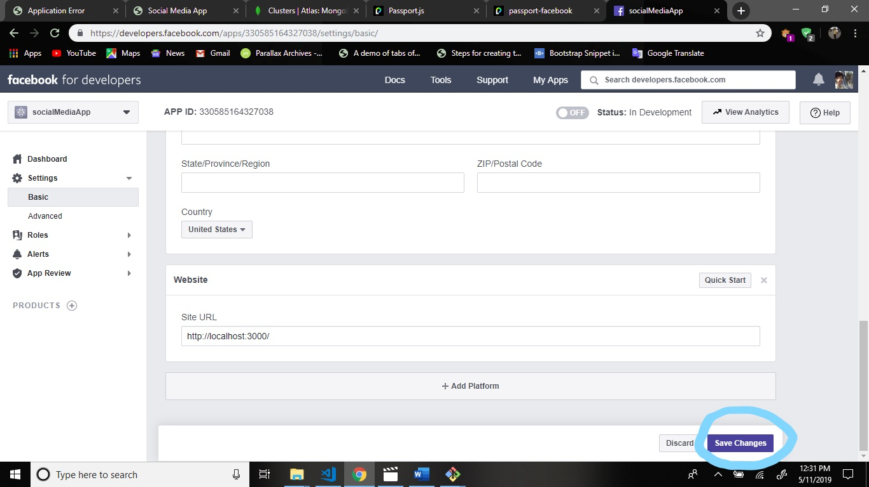

Now scroll up and copy the app ID and paste the keys.js file

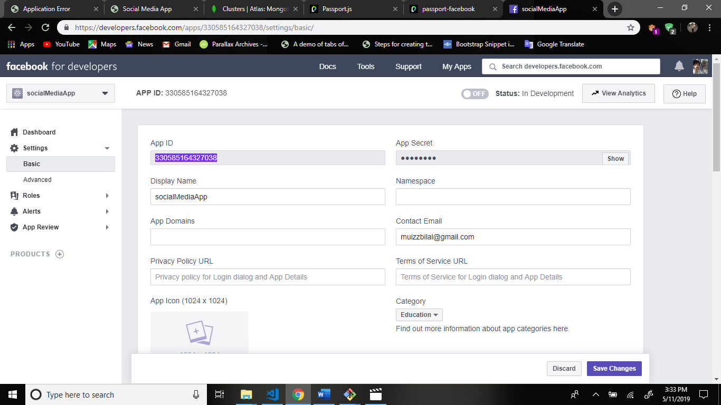

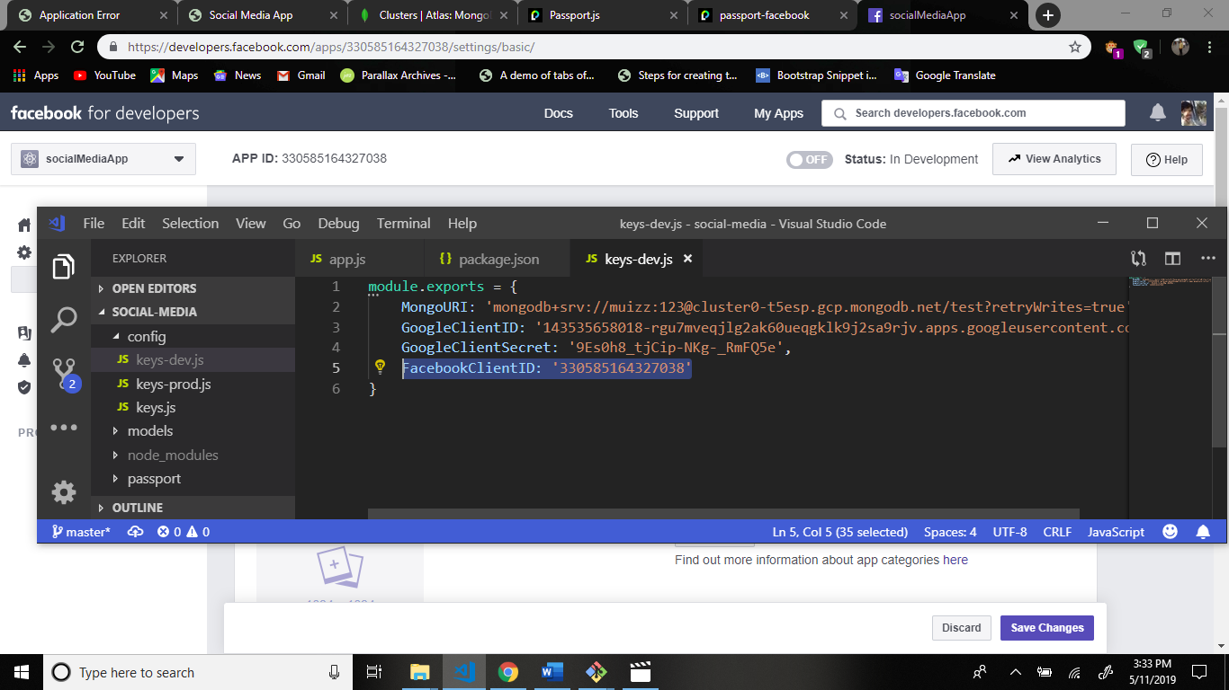

Copy this app secret code and paste the keys.js file.

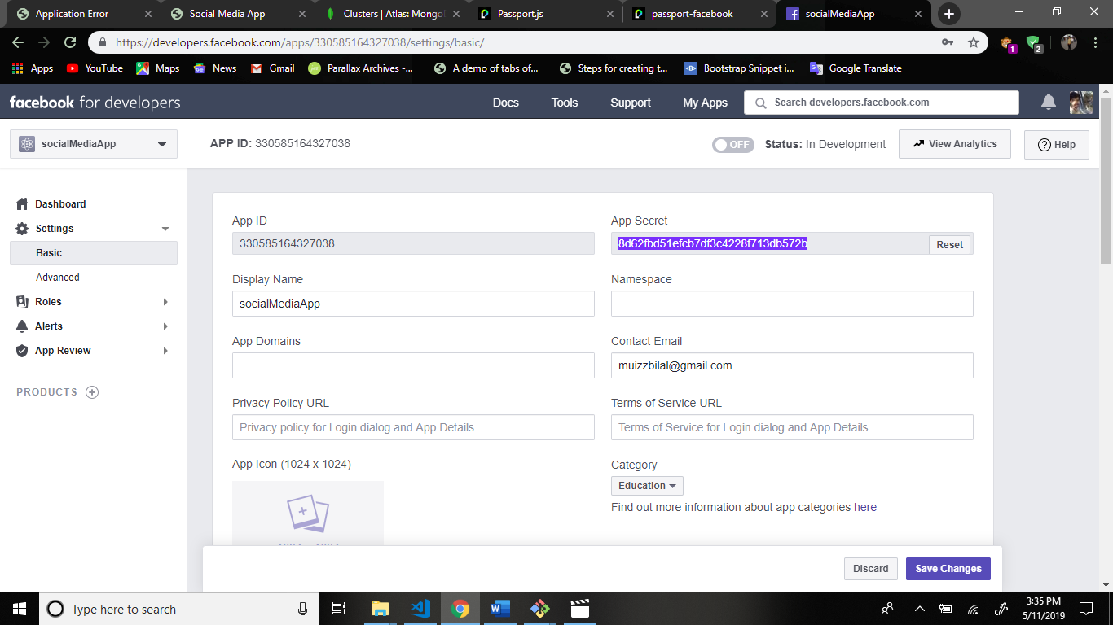

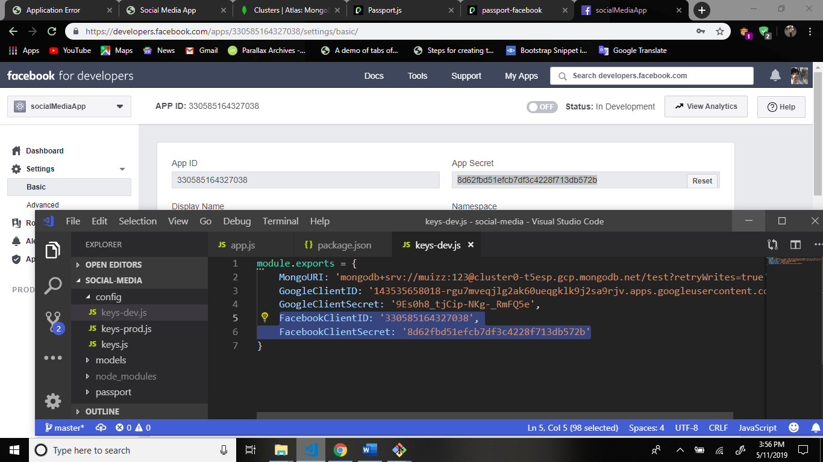

Now we create facebook-passport.js file in passport folder.

Structure:

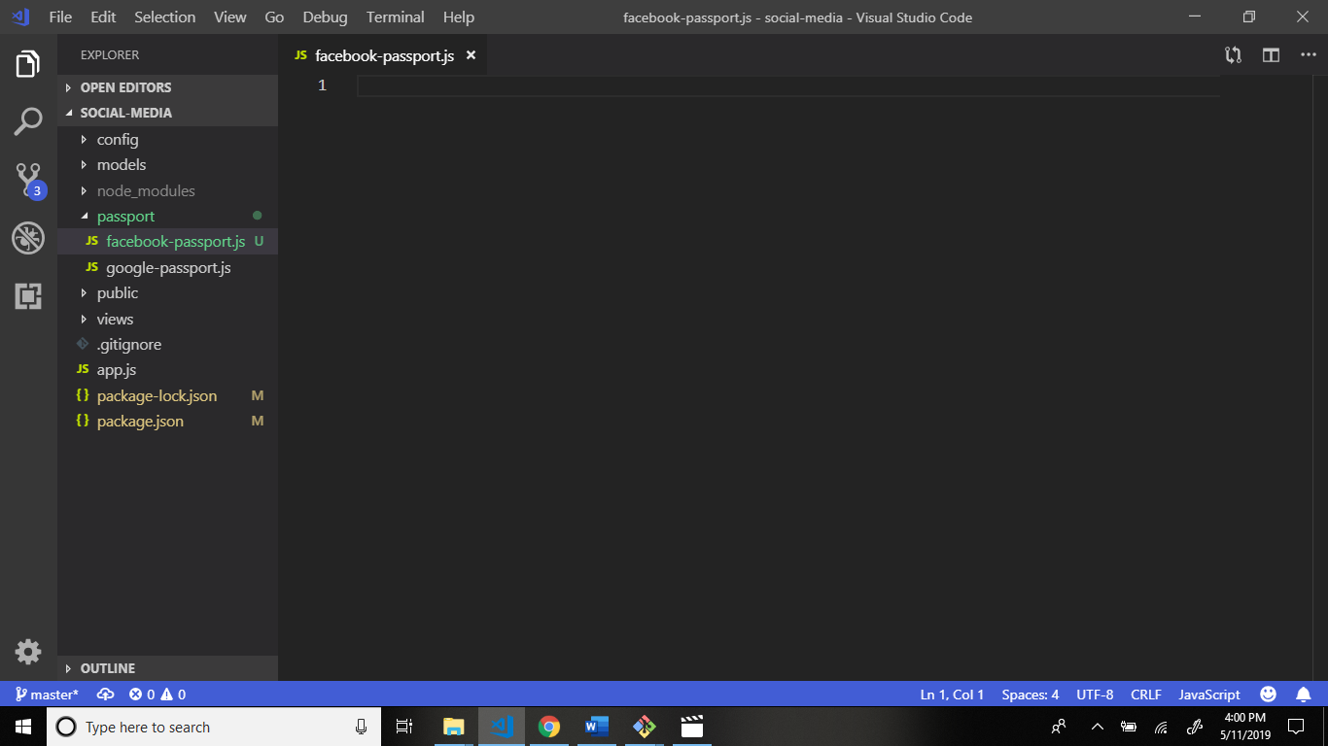

Now we write code.

Firstly require modules in facebook-passport.js file.

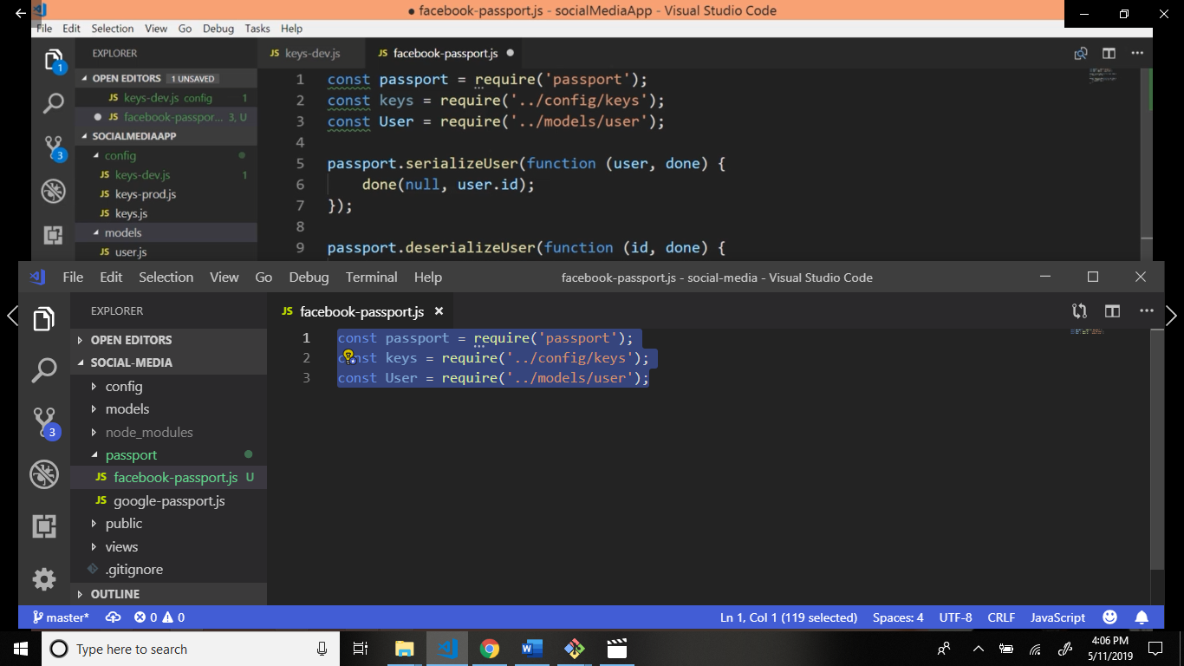

Now go to passportjs.org website and go to config and scroll down.

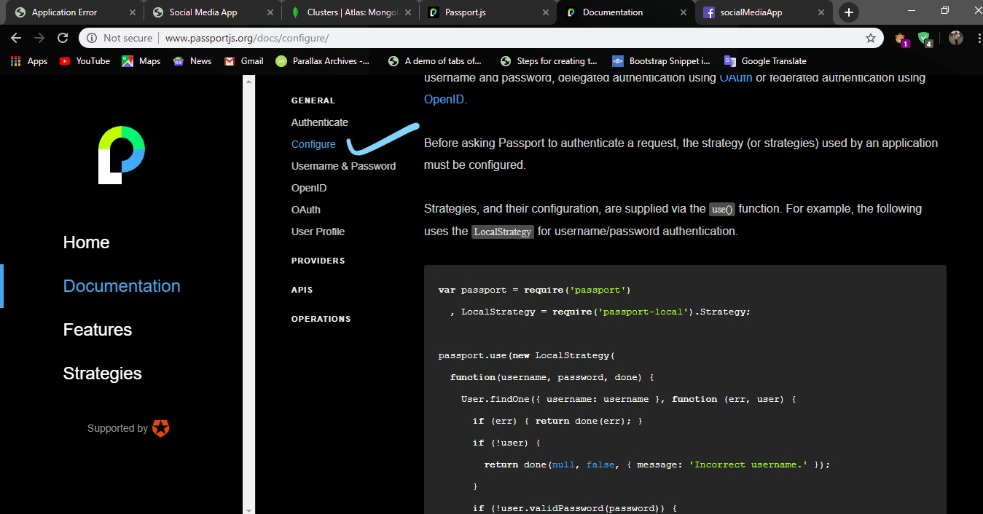

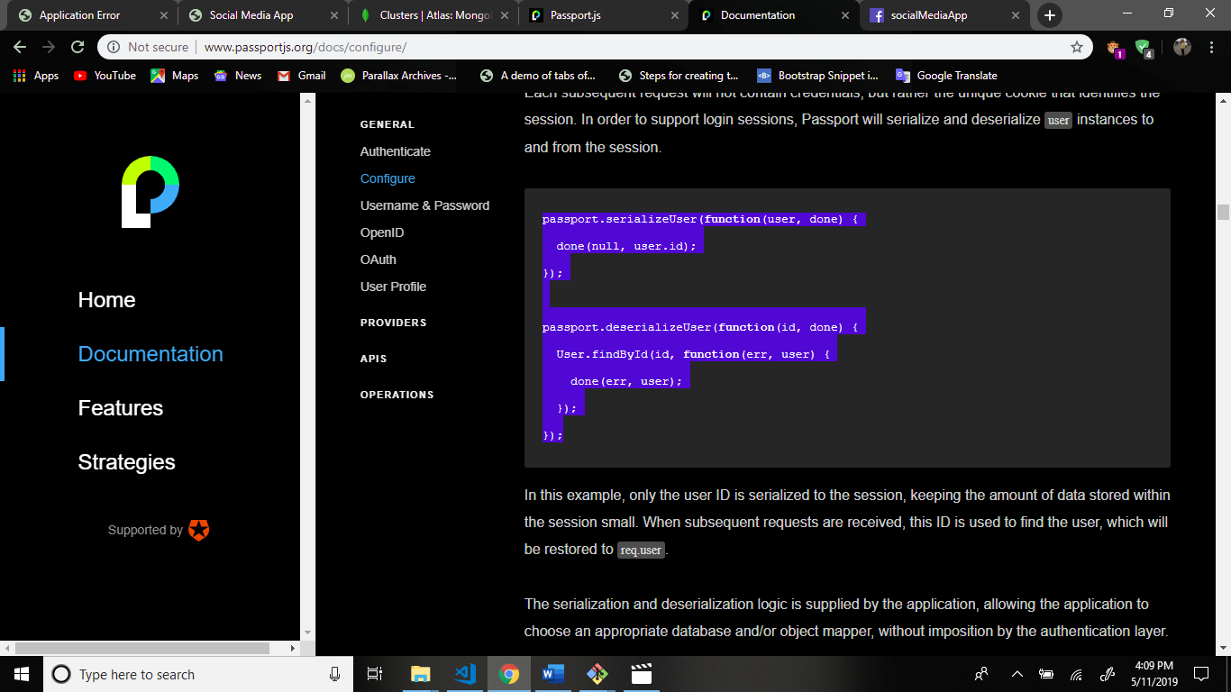

Copy this code and paste the facebook-passport.js file.

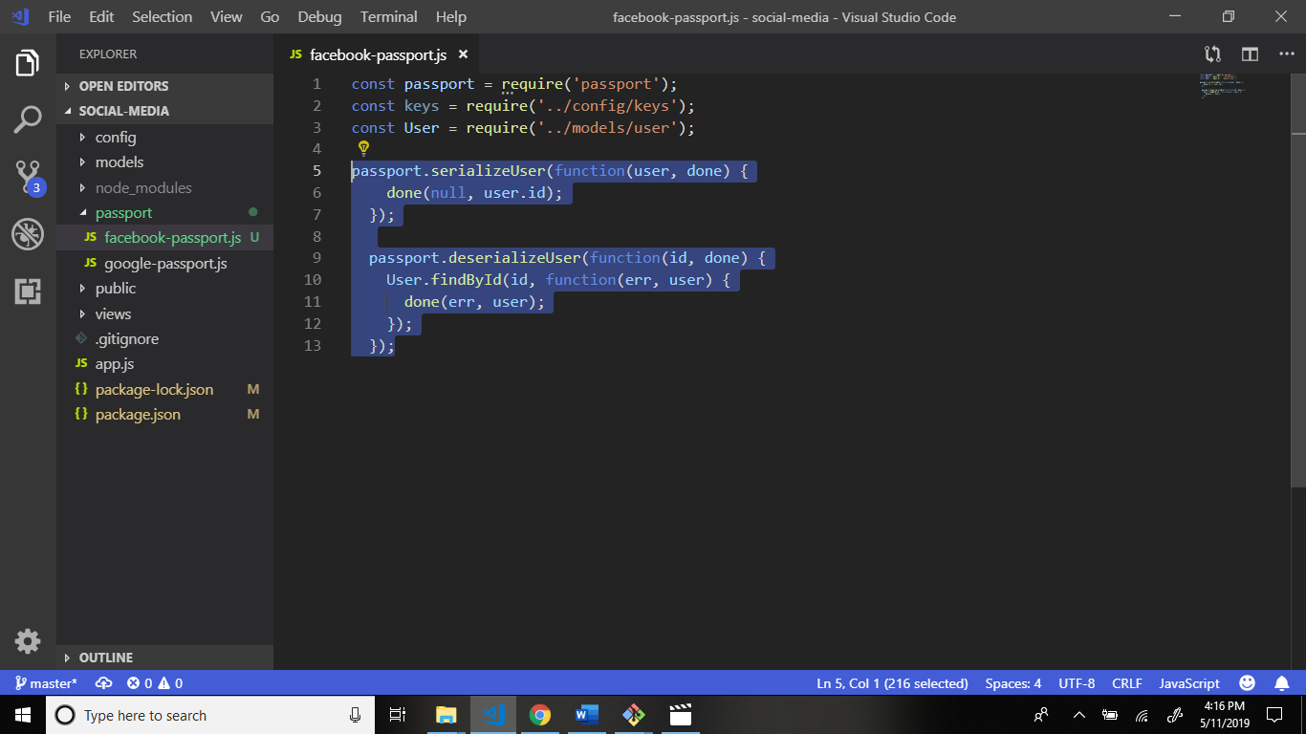

Now again go to passportjs.org website and go to strategies

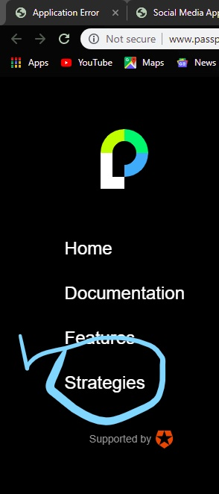

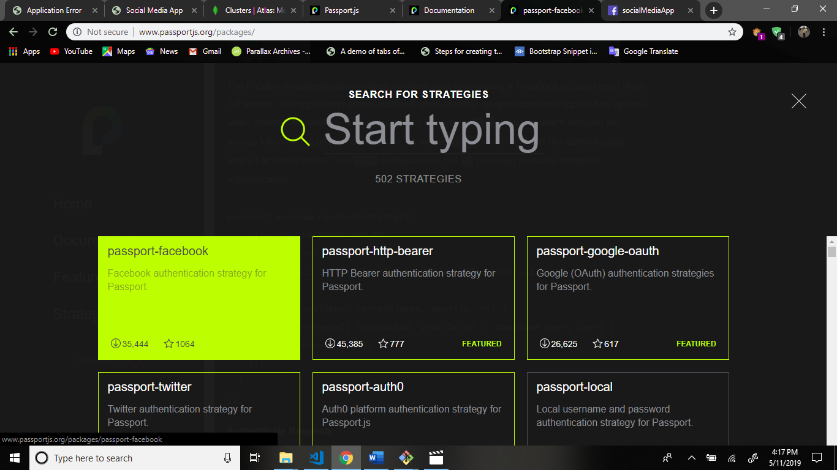

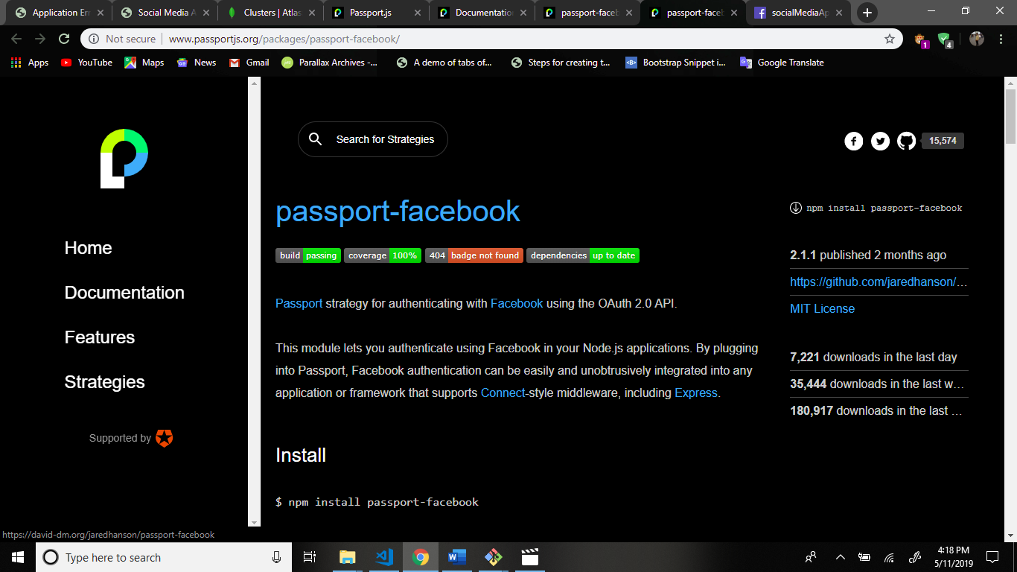

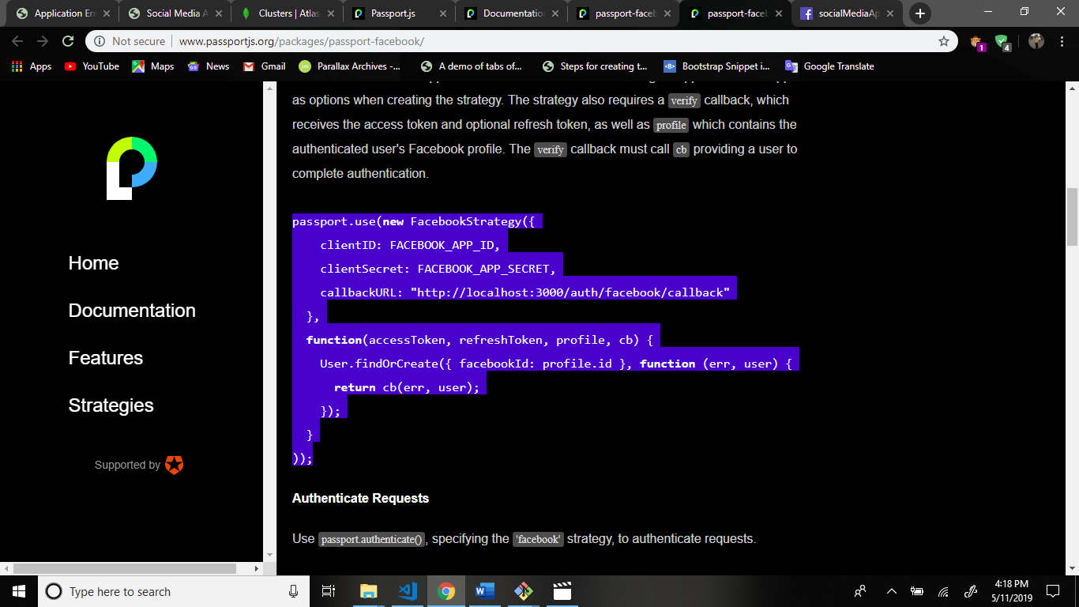

Paste the code and some changes.

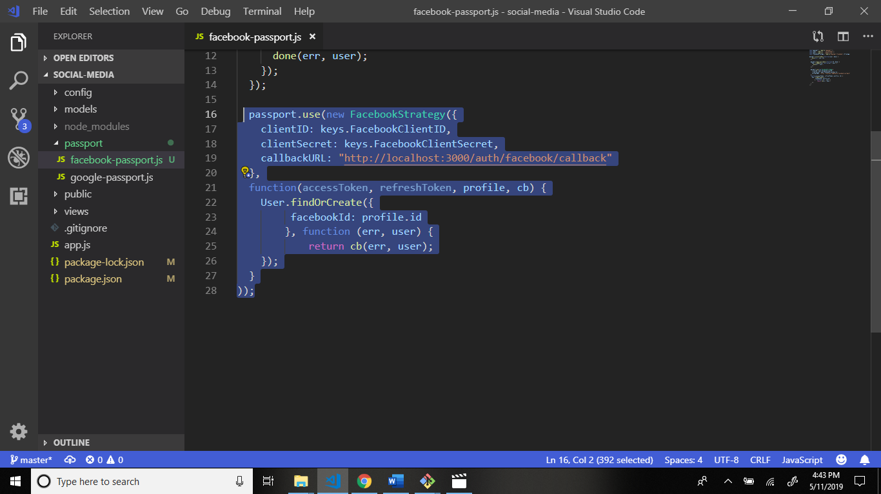

Now add const variables in facebook-passport.js file.

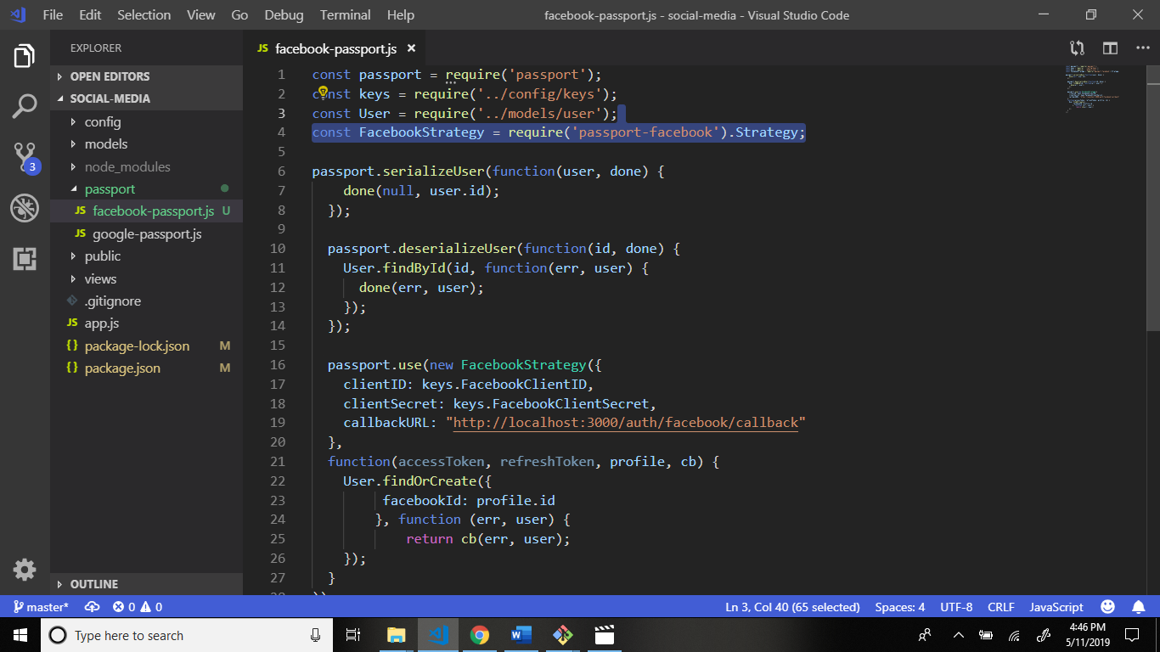

Now add some more changes.

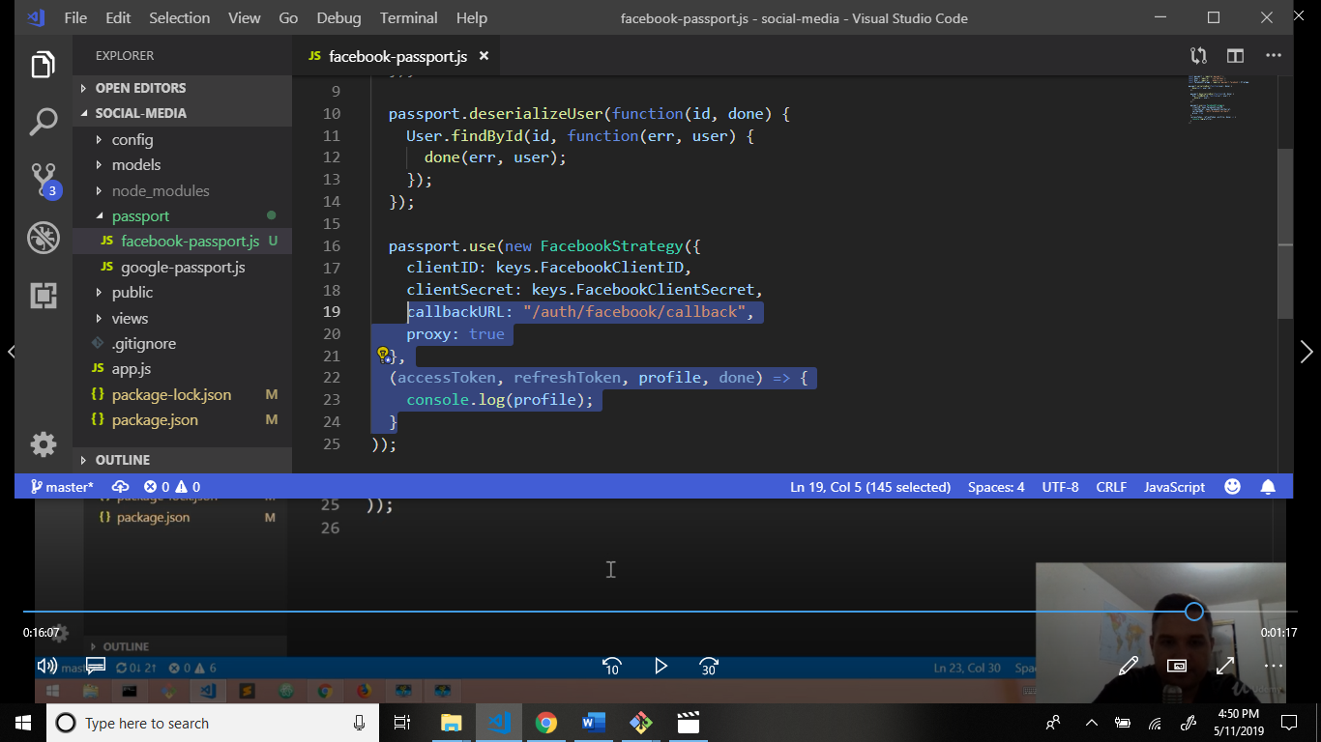

Now we handle route for facebook.

Go to passportjs.org website.

Copy this code and paste in app.js file after the google route.

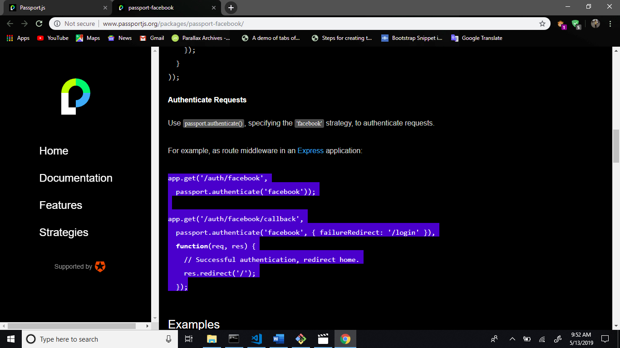

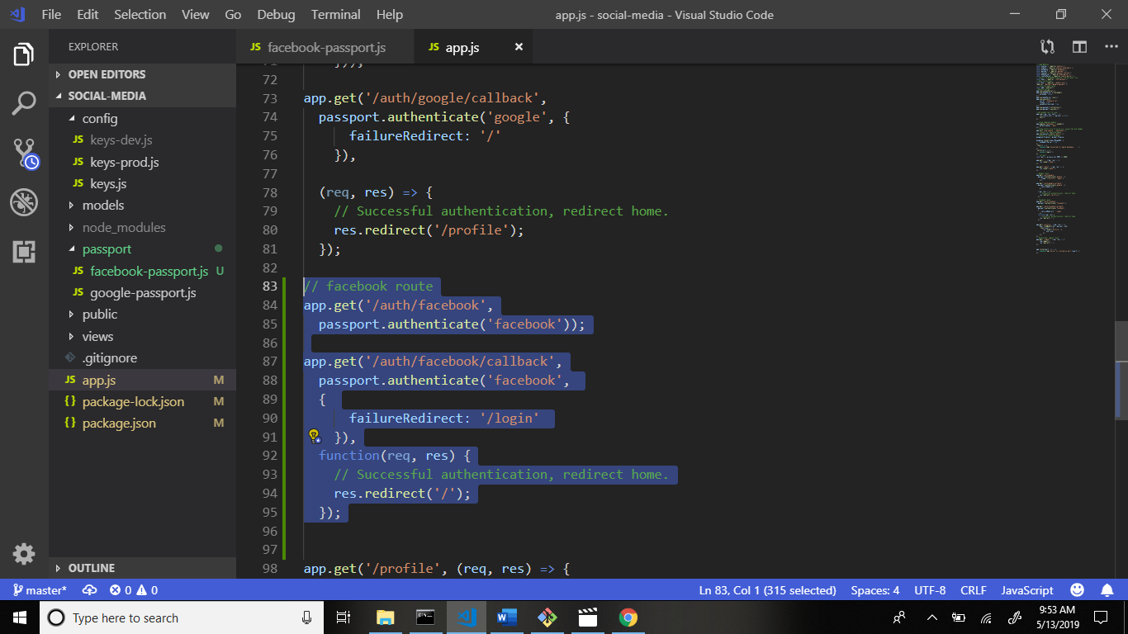

Now add some changes this code.

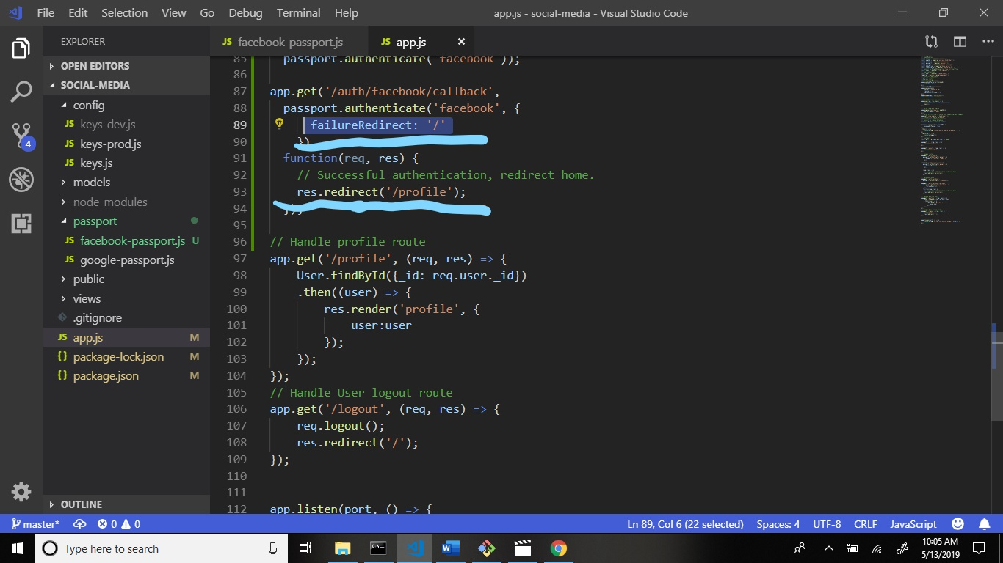

Now require the facebook-passport file in app.js file.

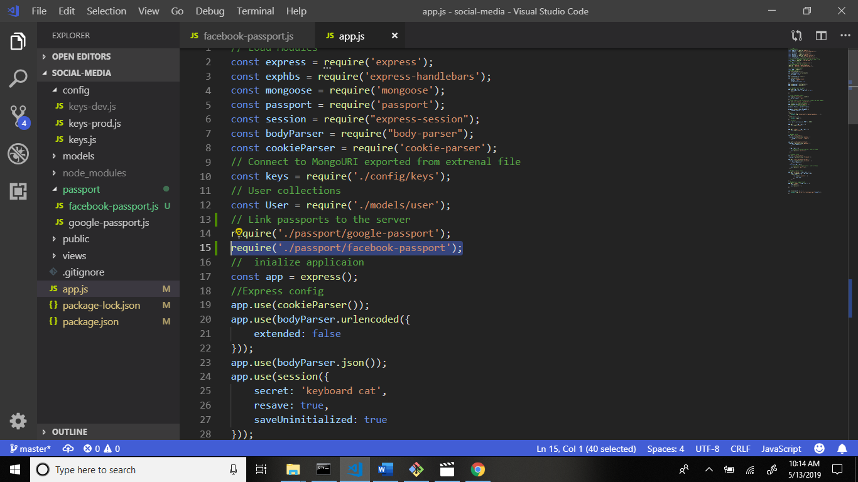

Now start the server and check output.

Command: nodemon

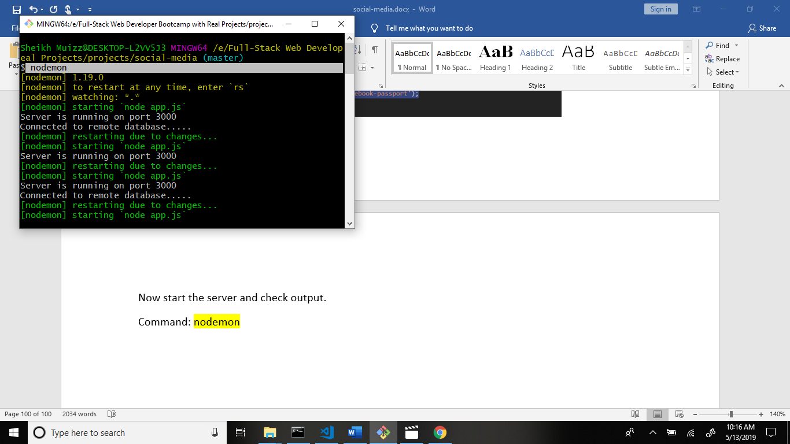

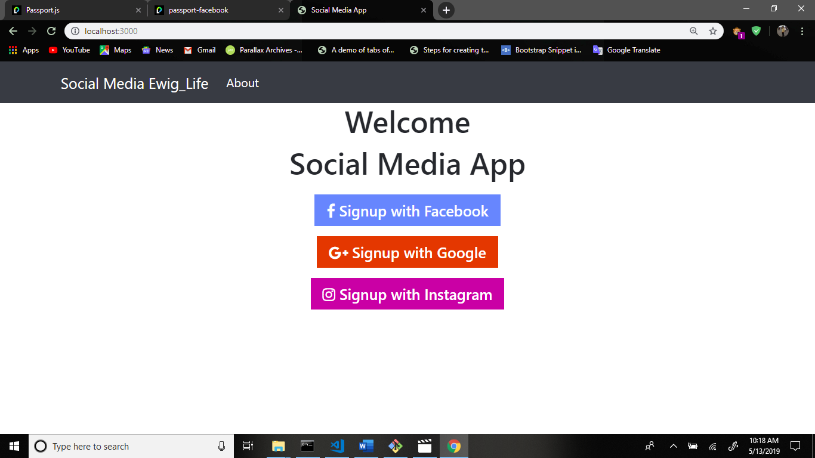

Now signUp the facebook and check the cli command.

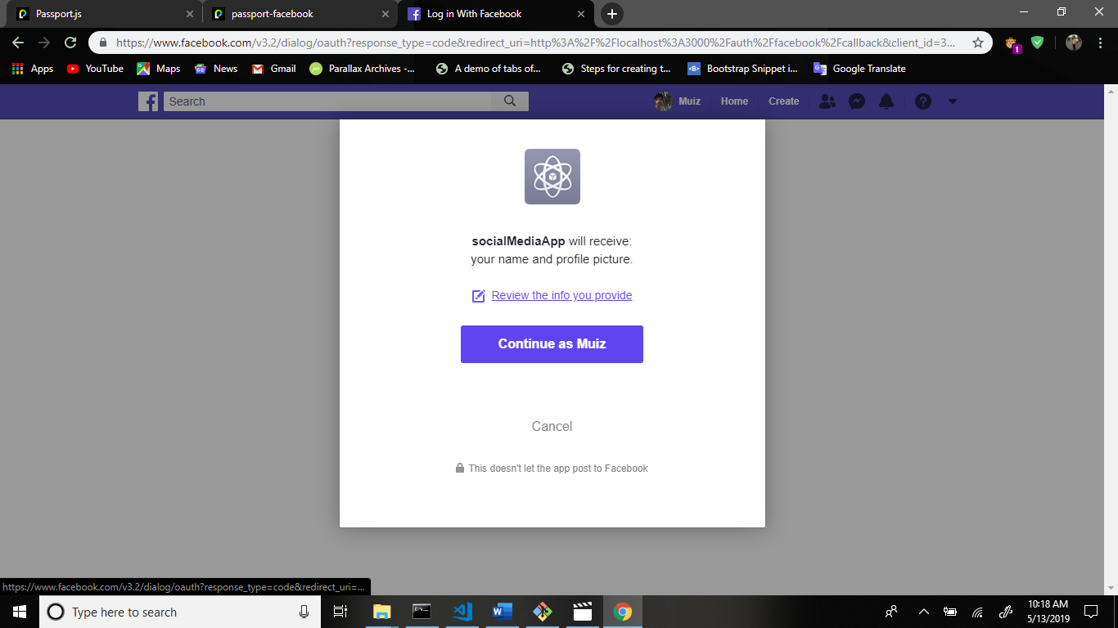

Receive information for facebook only display name.

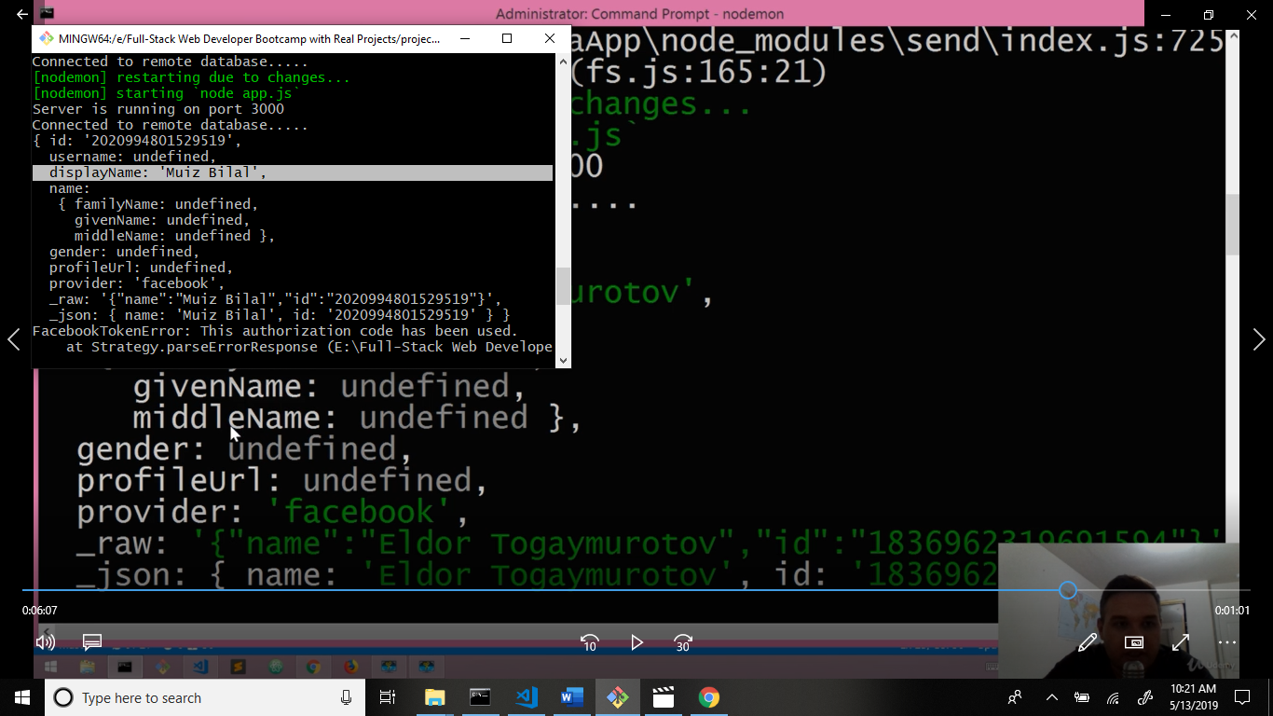

Now go to facebook-passport.js file and write some code.

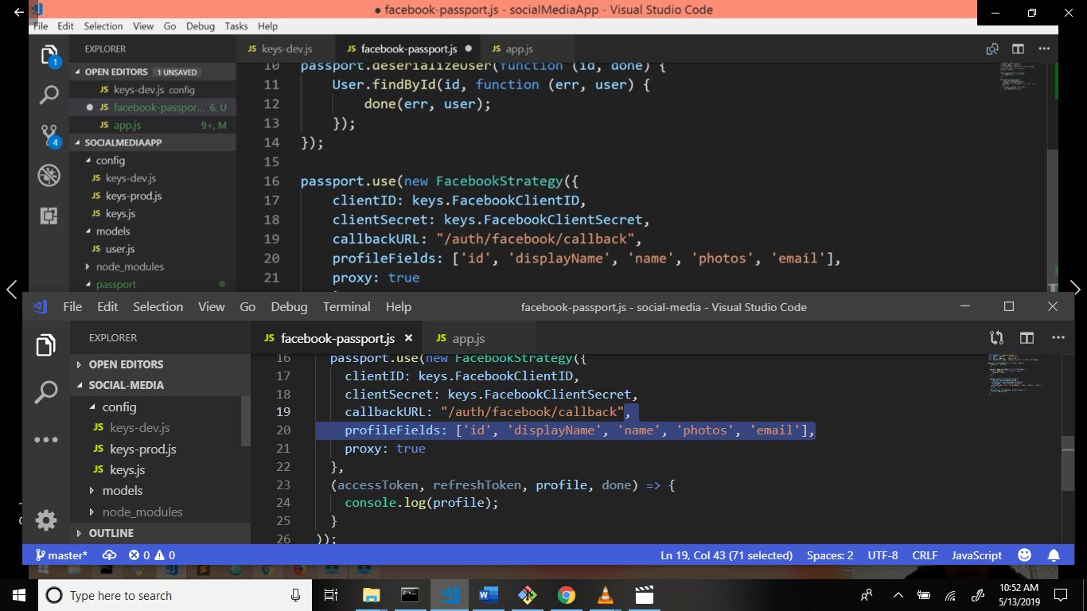

Now run the server and check the command promt or git bash. You can receive displayName, email, photos, id, name.

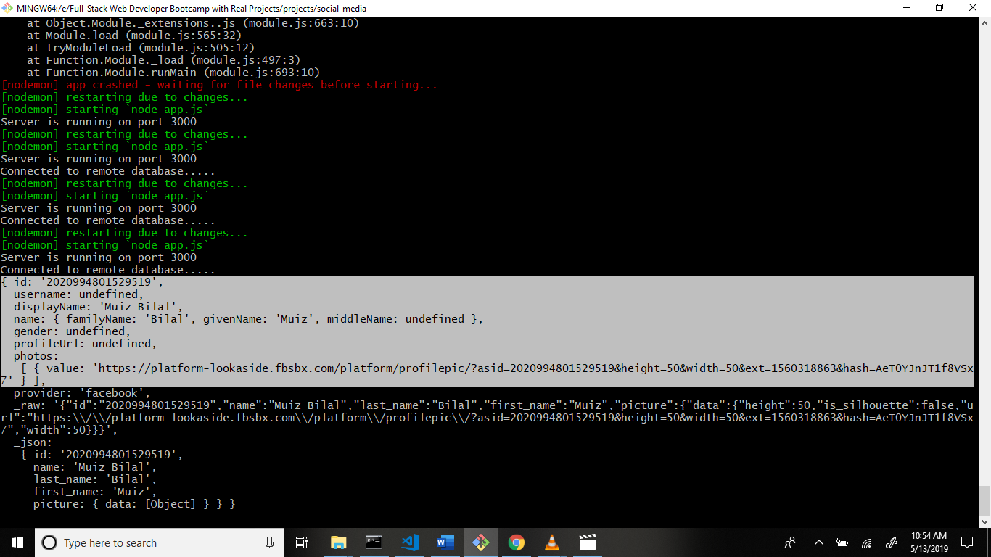

Now recieves value send the database and render the local server.

Now use if else condition.

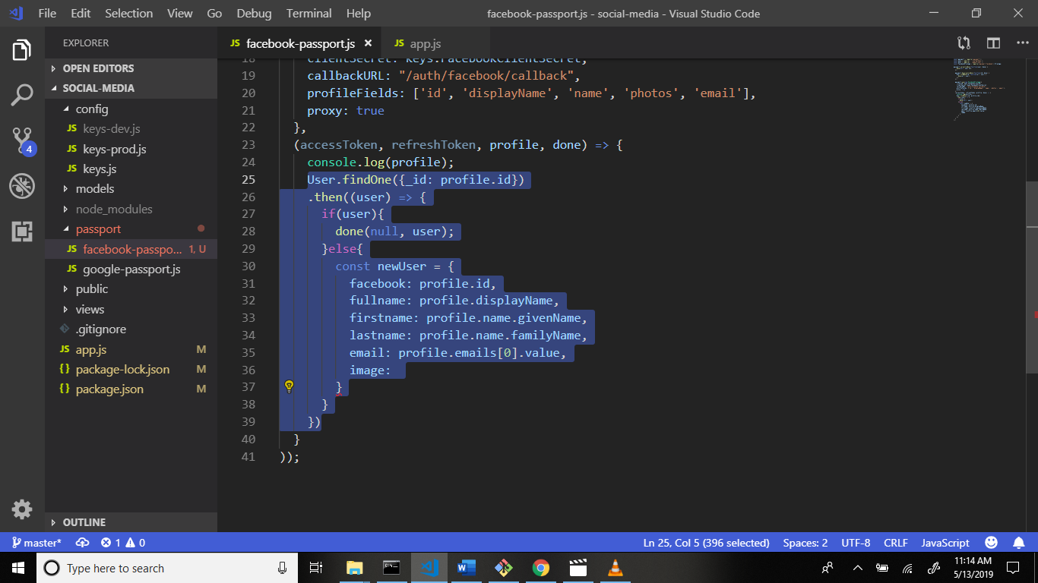

Now get image value and go to the developers.facebook.com website and search the using graph api

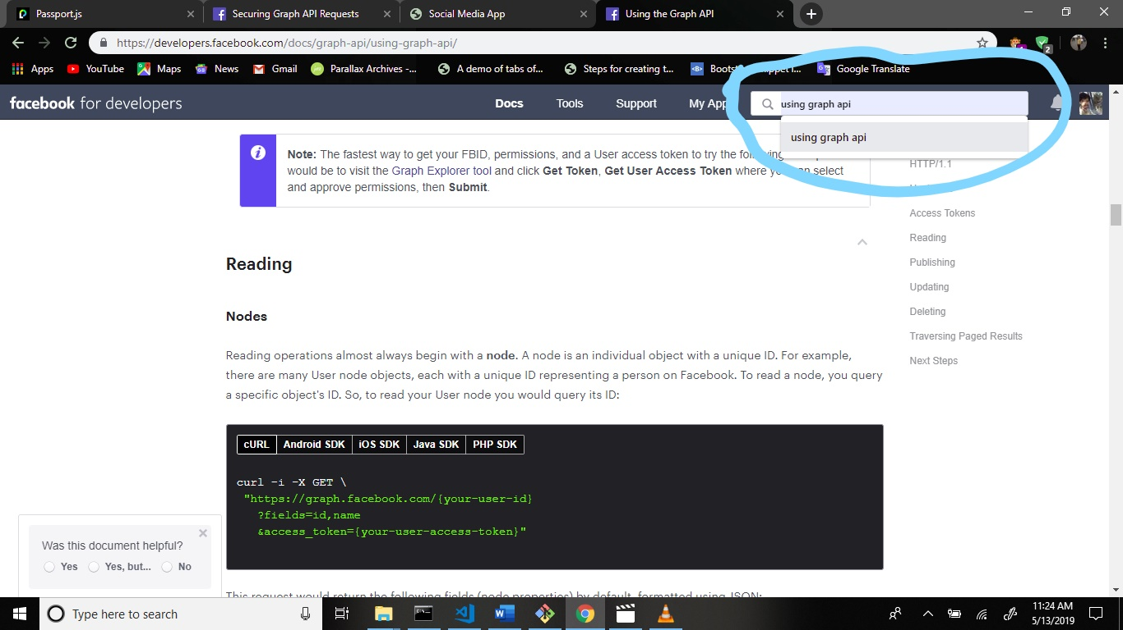

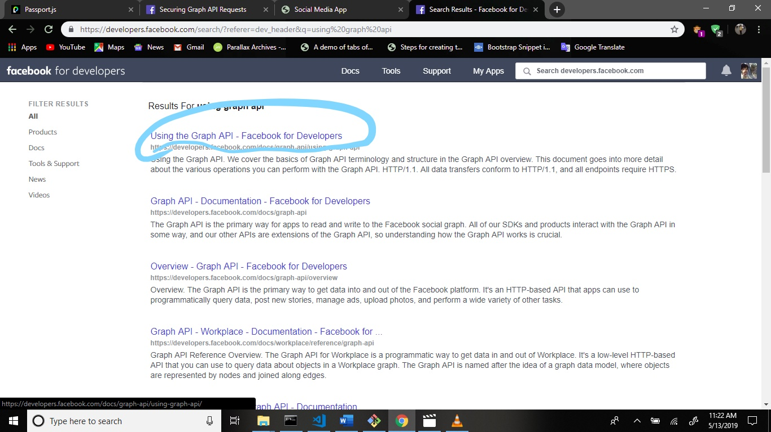

Scroll down.

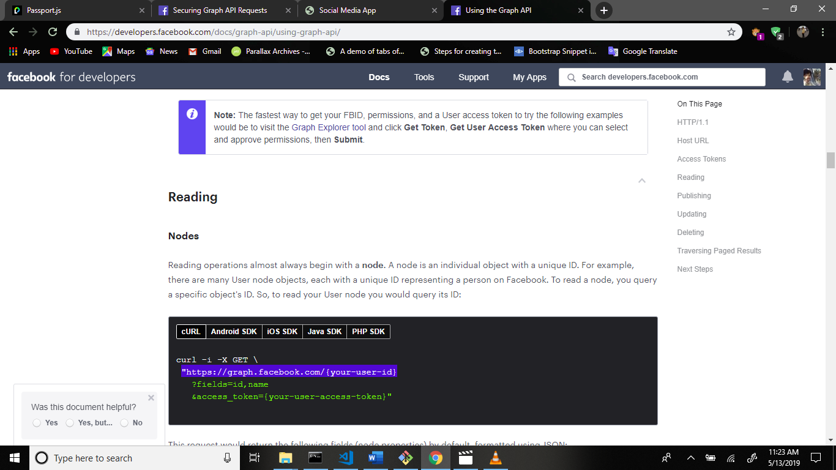

Copy this code and paste the facebook-passport.js file image getting method.

Paste the backets and some changes.

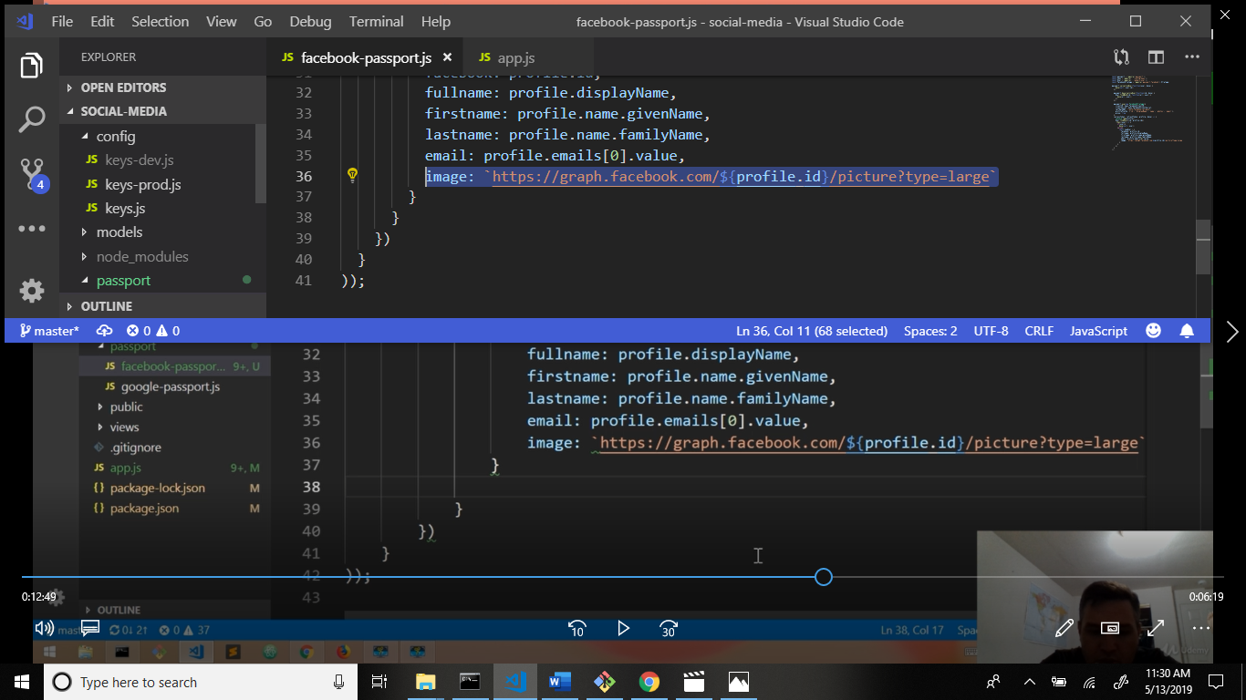

Now add some more changes.

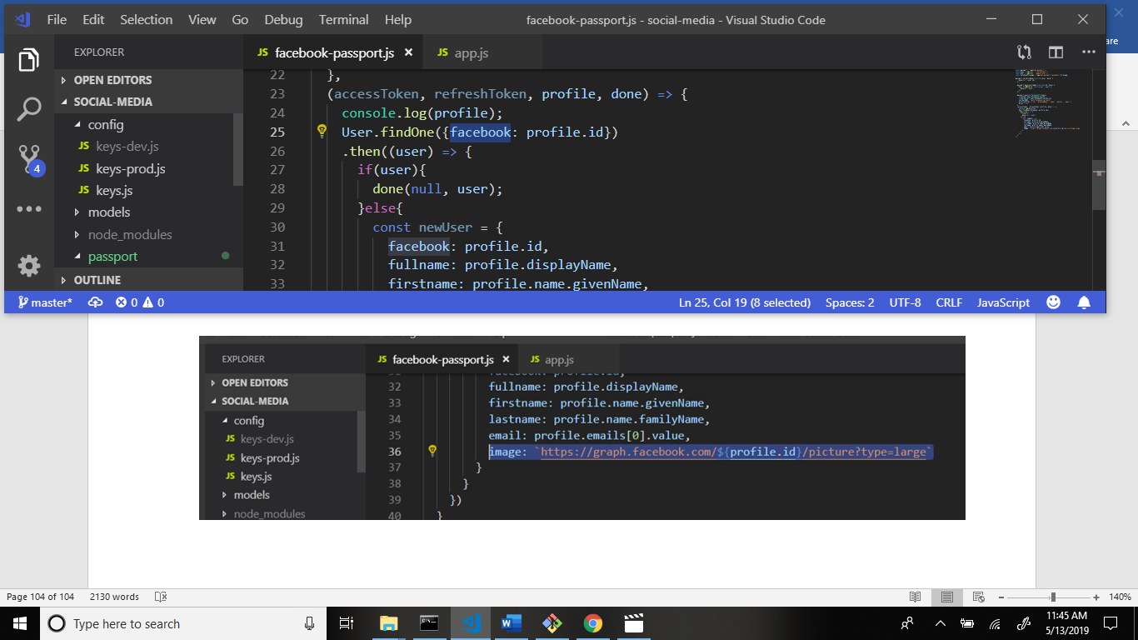

Now save the data in mongoDB write code.

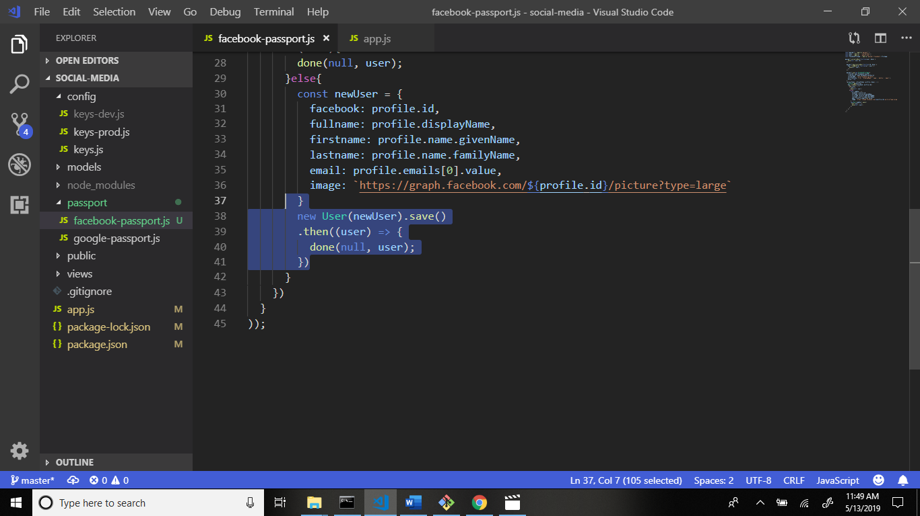

Run the local server and check the database.

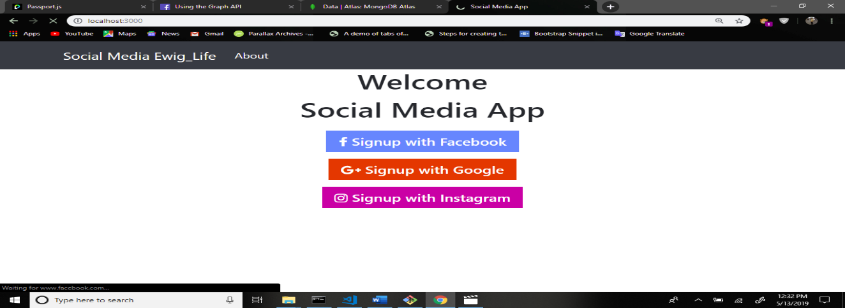

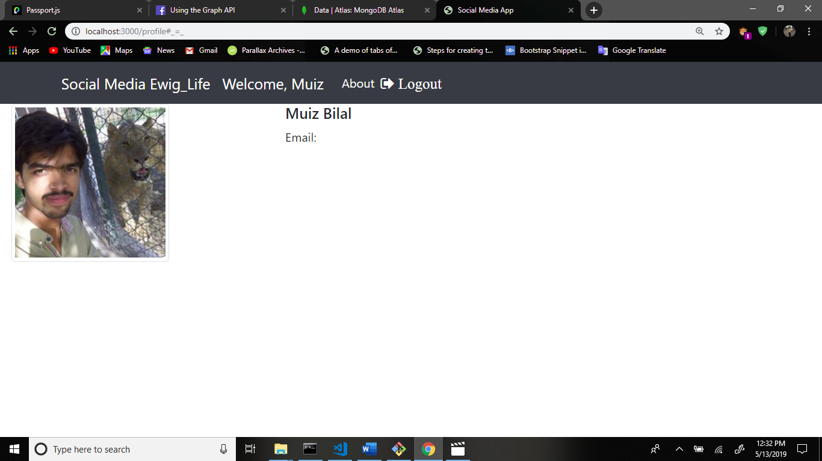

Database:

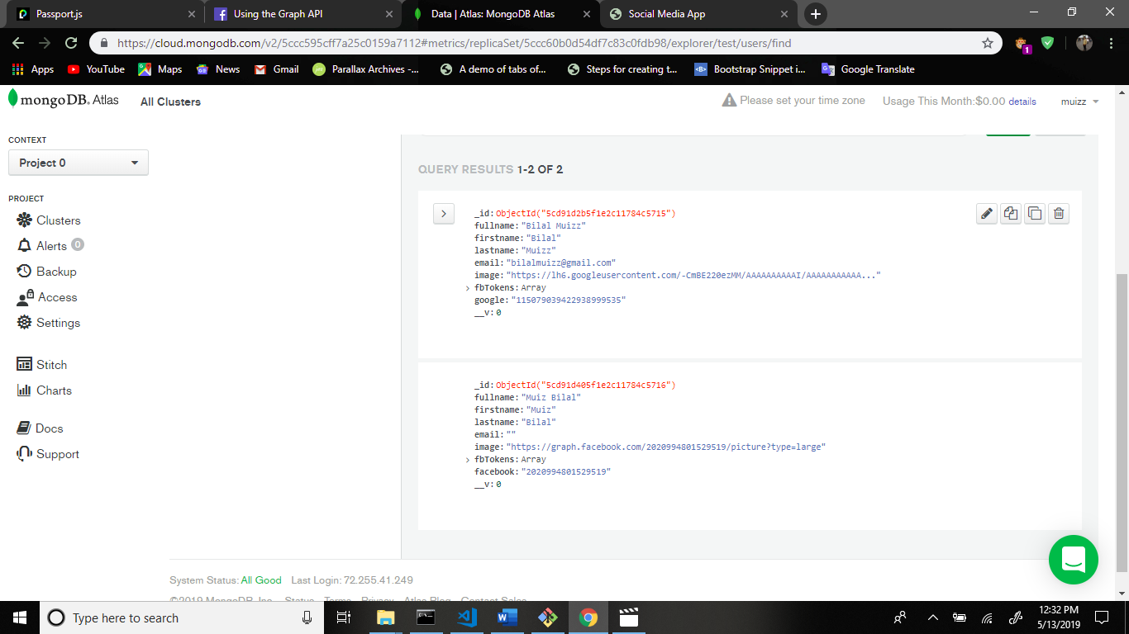

Now go to profile.handlebars file and add some changes.

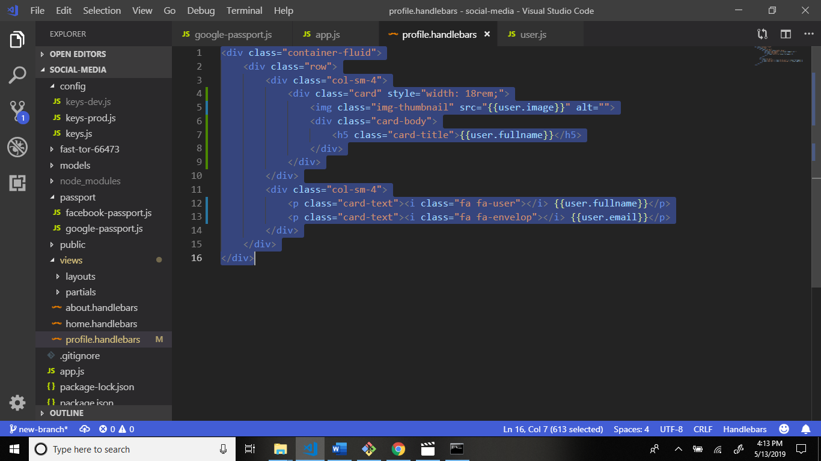

Now add some piece of code in app.js file.

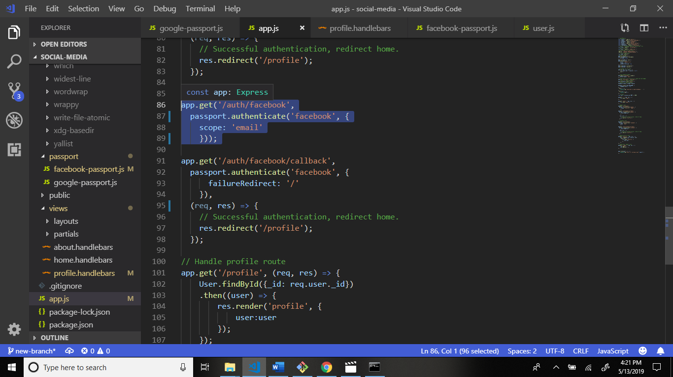

Now go to views > partials > navbar.handlebars file and write code.

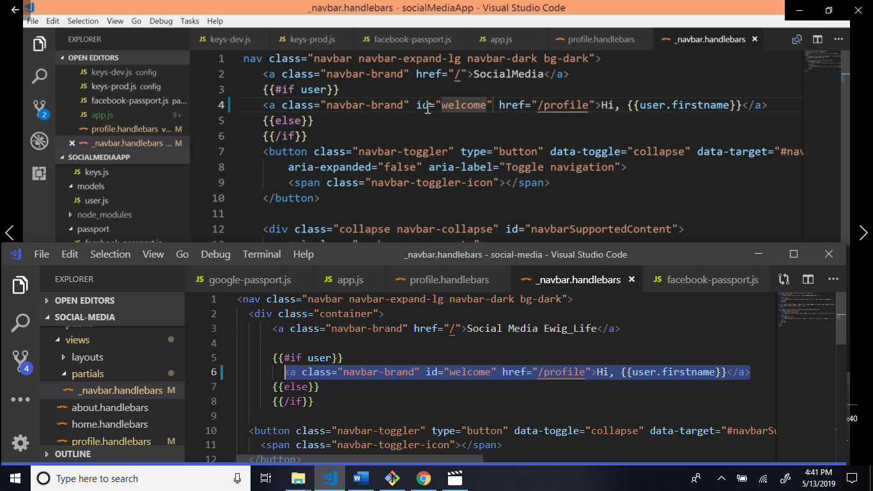

And write css public > css > style.css

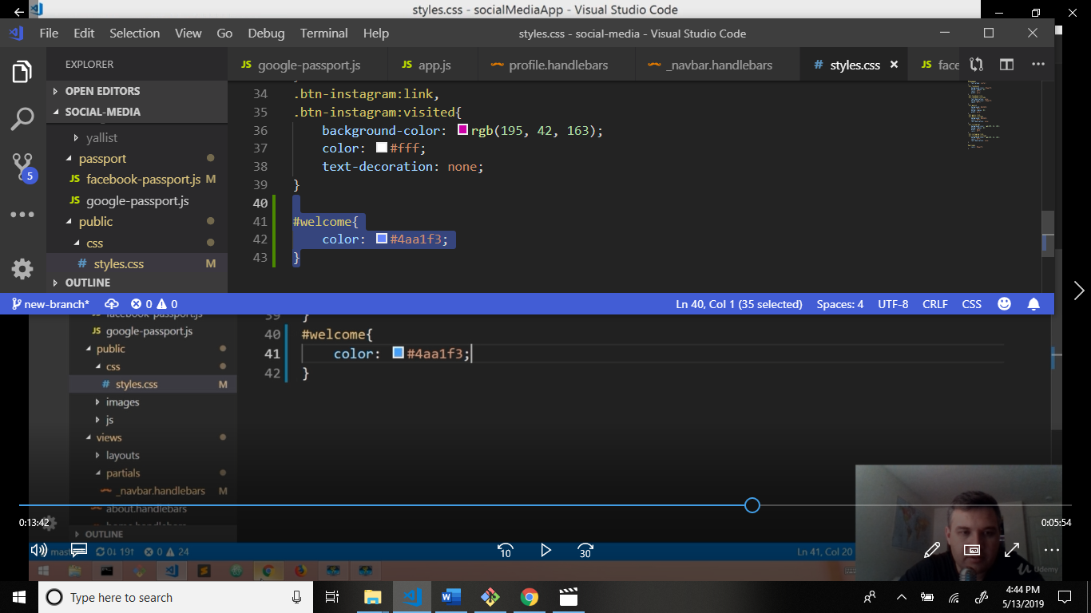

Now go to main.handlebars file : views > layouts > main.handlebars

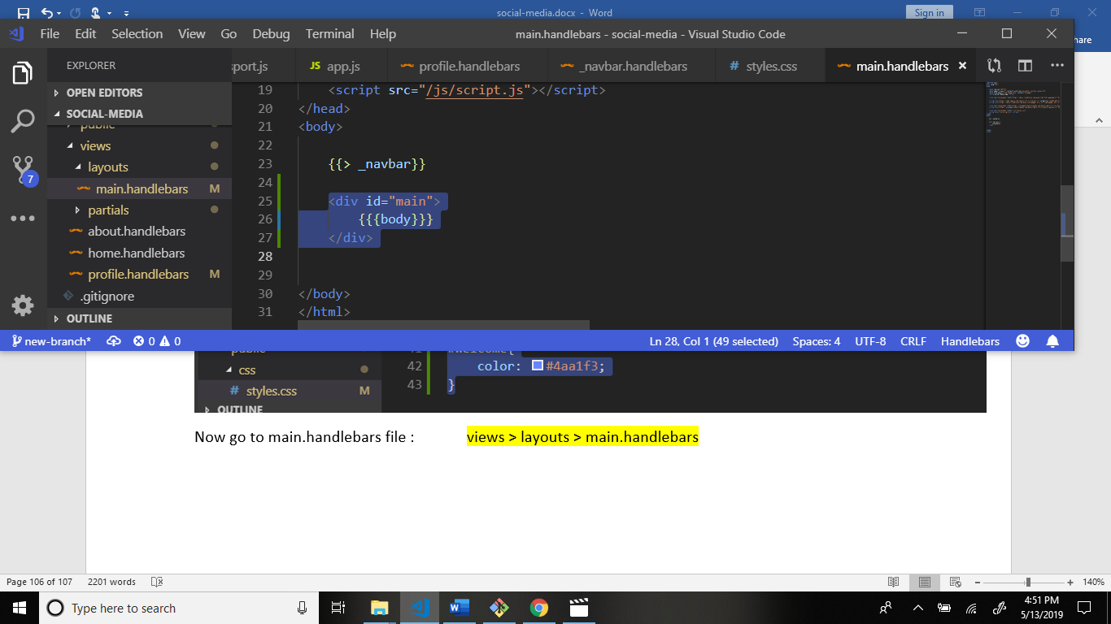

Css file write code.

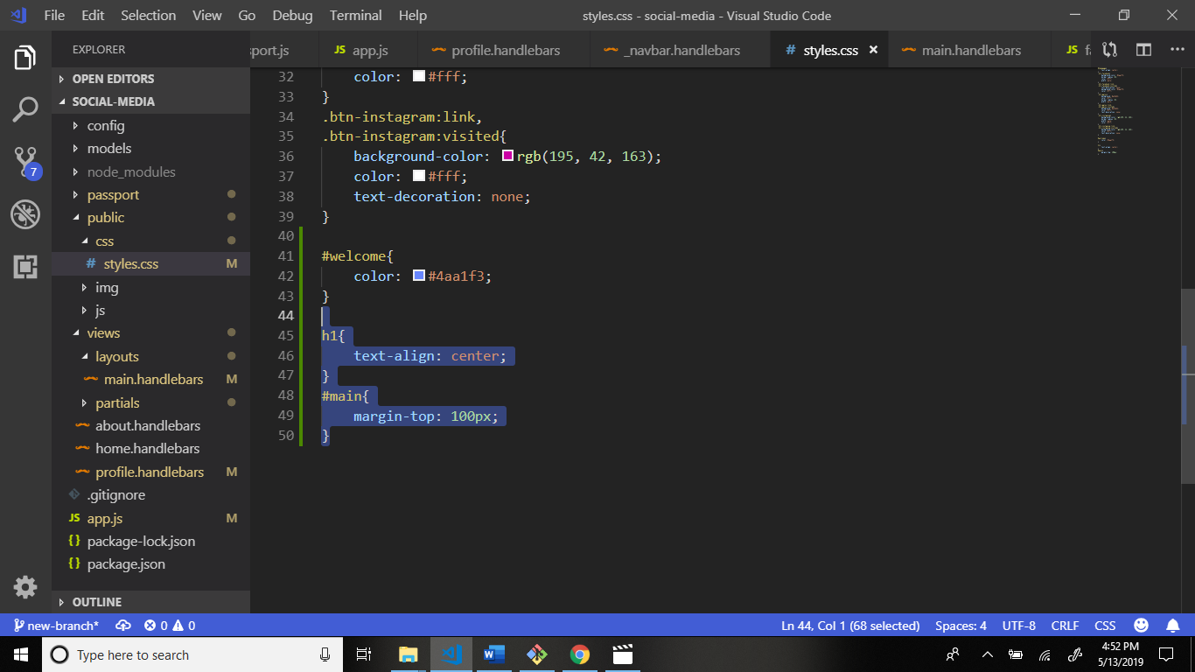

Output:

Command: nodemon

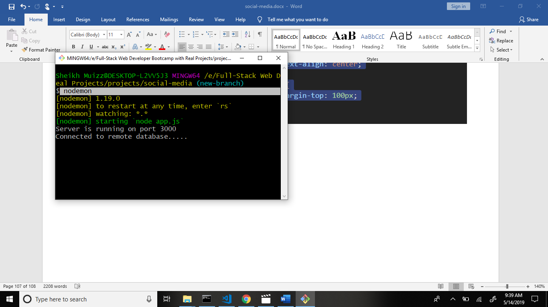

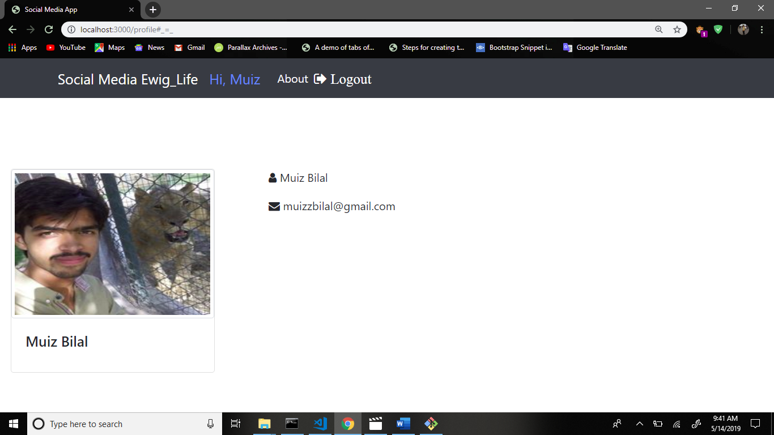

Now publish your code in github repository.

Command: git status

Command: git add .

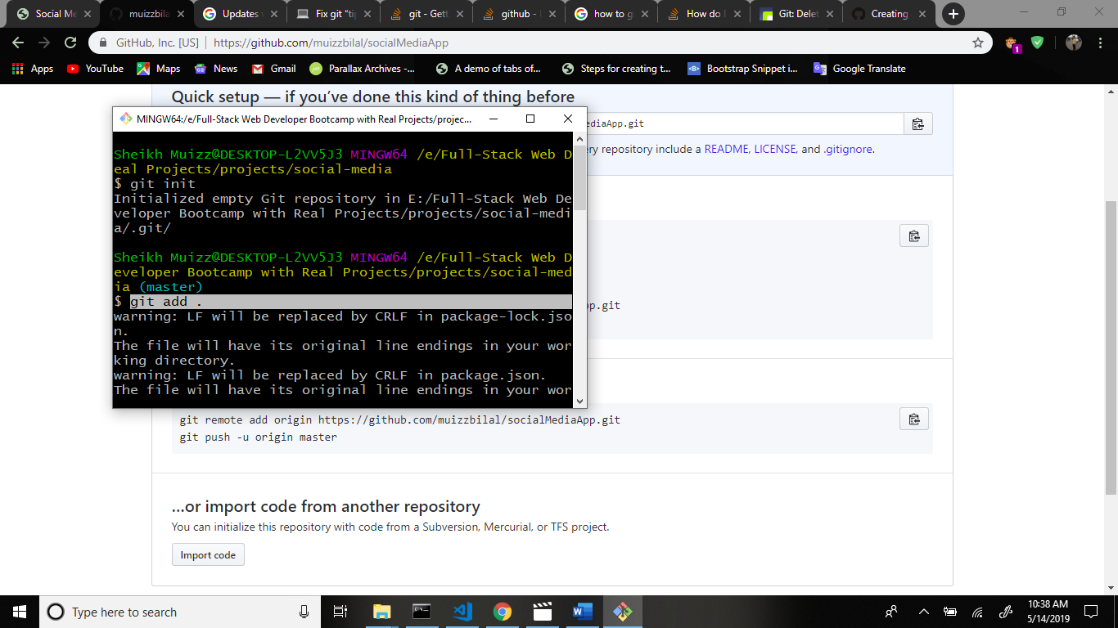

Command: git commit -am “ux done”

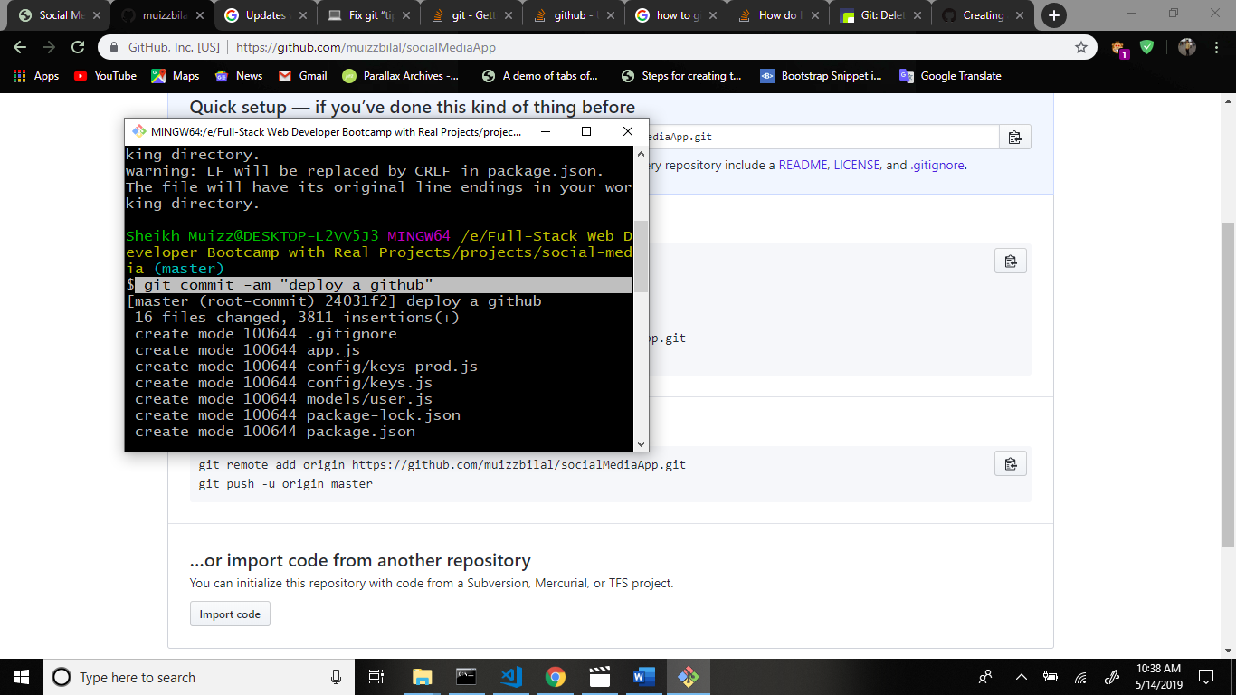

Command: git push origin master

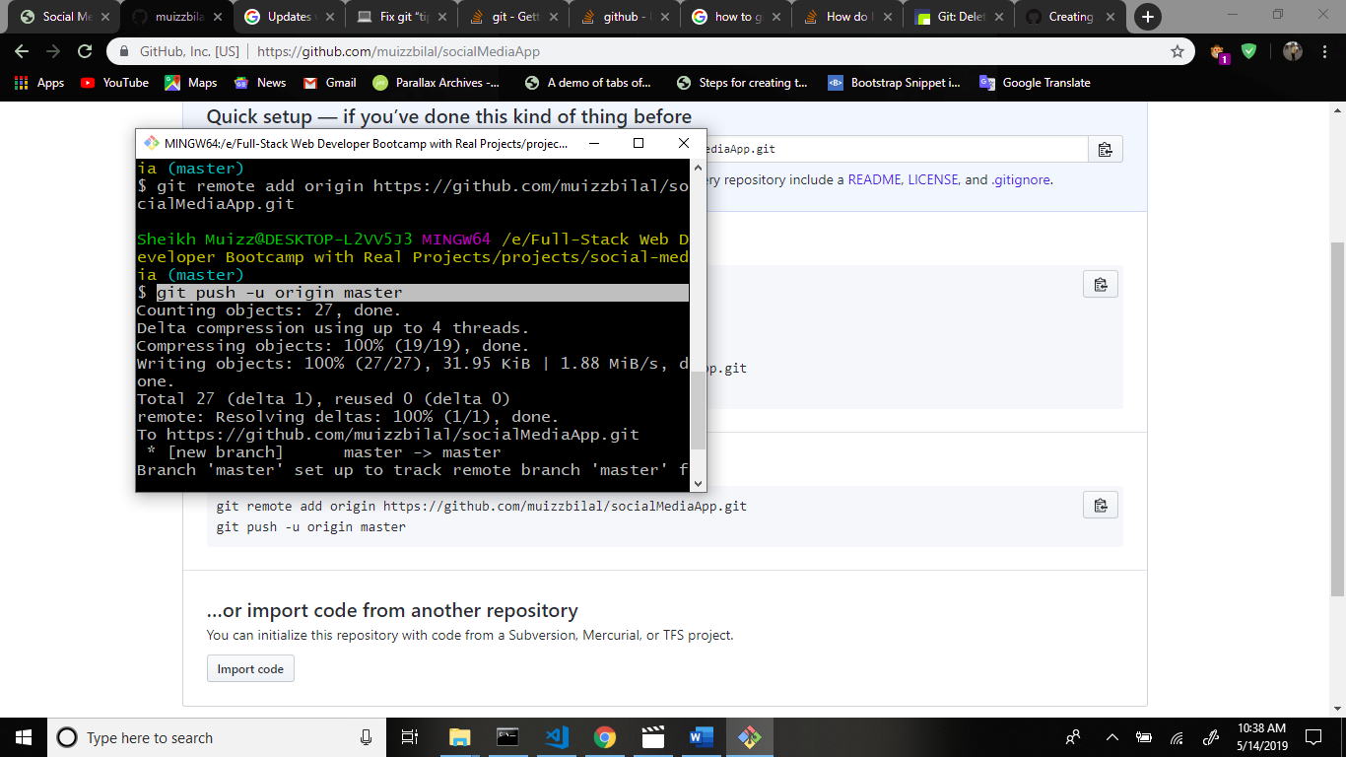

Now go to github repository and see your code is up to date.

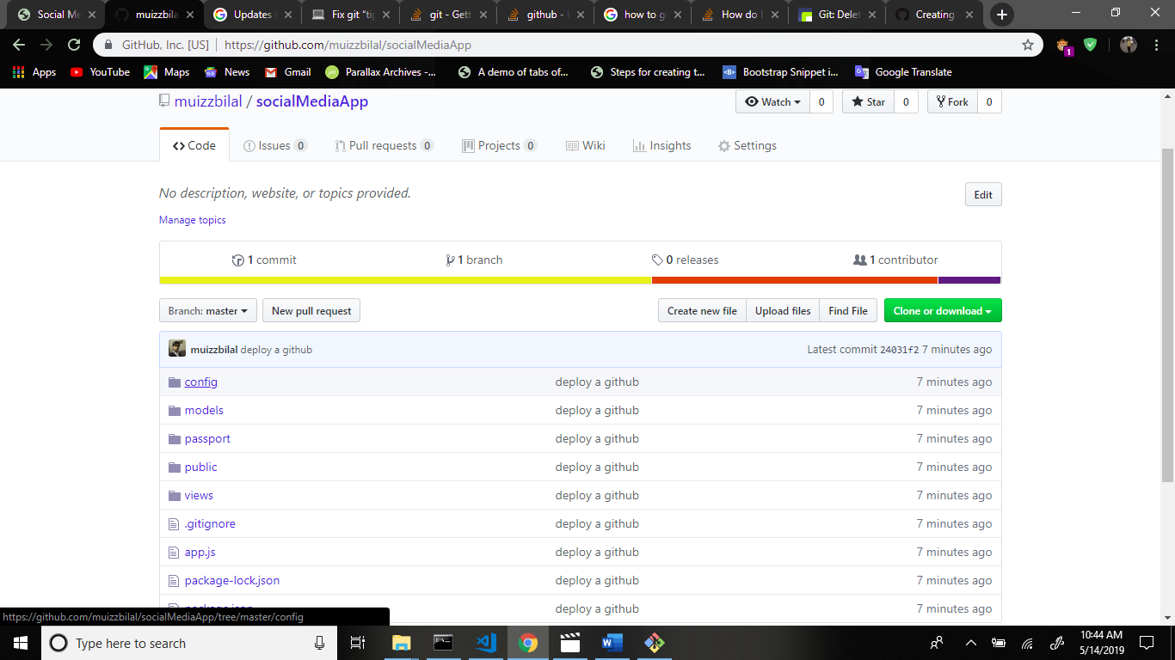

Now we signup the instagram and get data and save the mongo db.

Now go to the passportjs.org website and search the passport-instagram

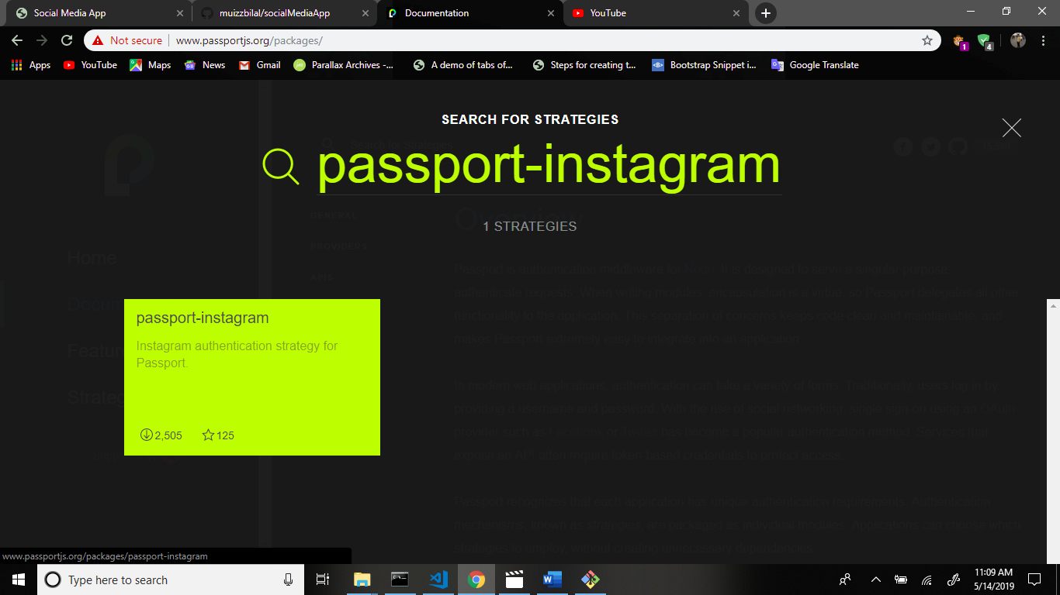

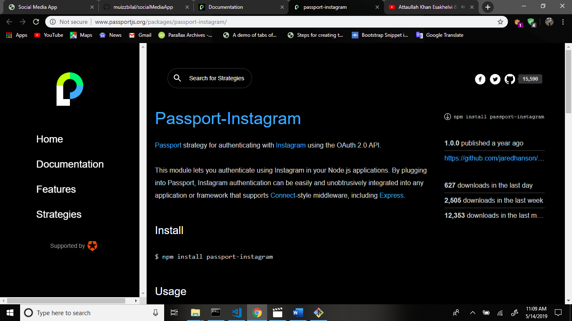

Now install the passport instagram module. Command: npm i passport-instagram

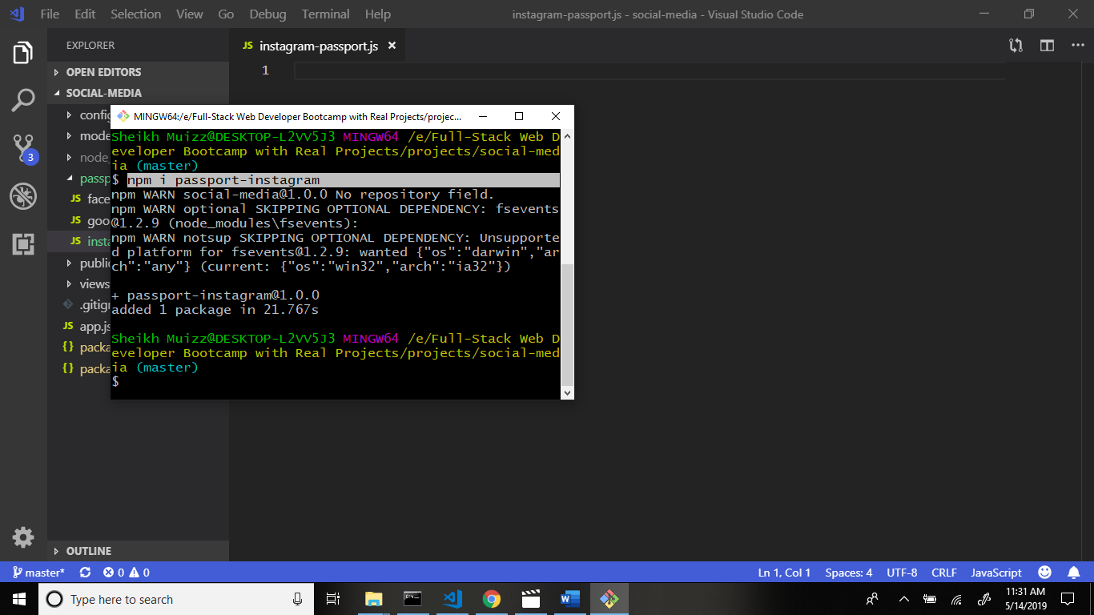

Now we create file in passport folder : instagram-passport.js file.

Structure:

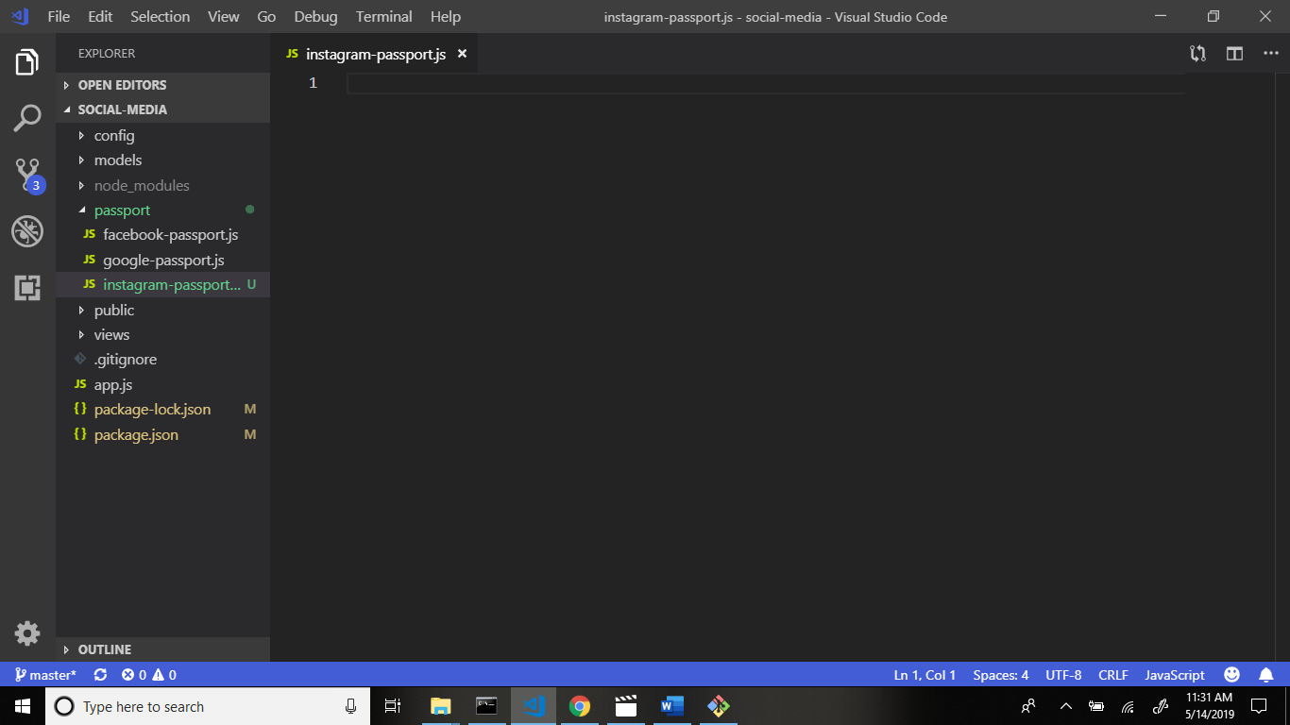

Now require modules in this file.

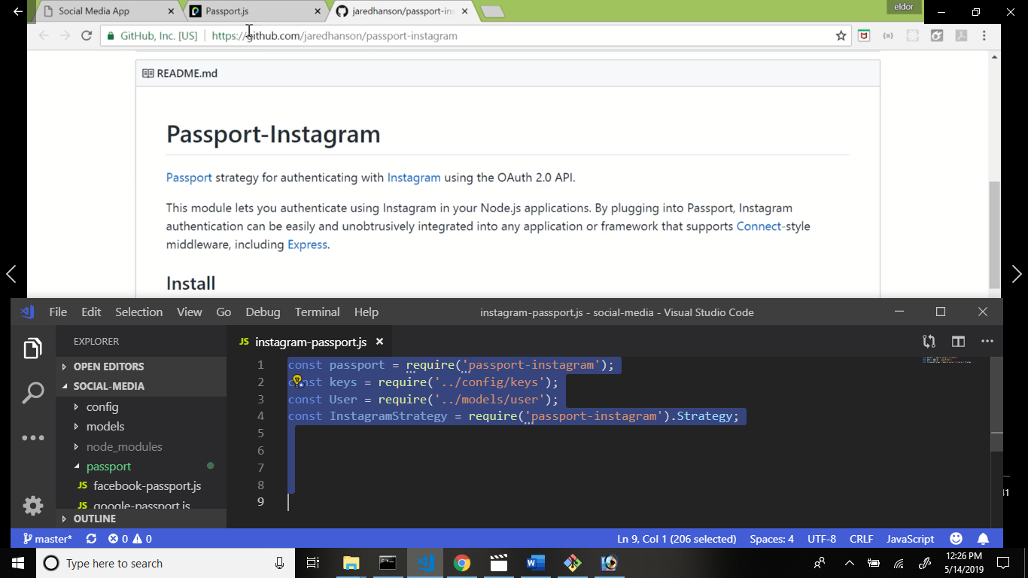

Now again go to the passportjs.org website press the documentation and go to the config.

Copy this code and paste the instagram-passport.js file.

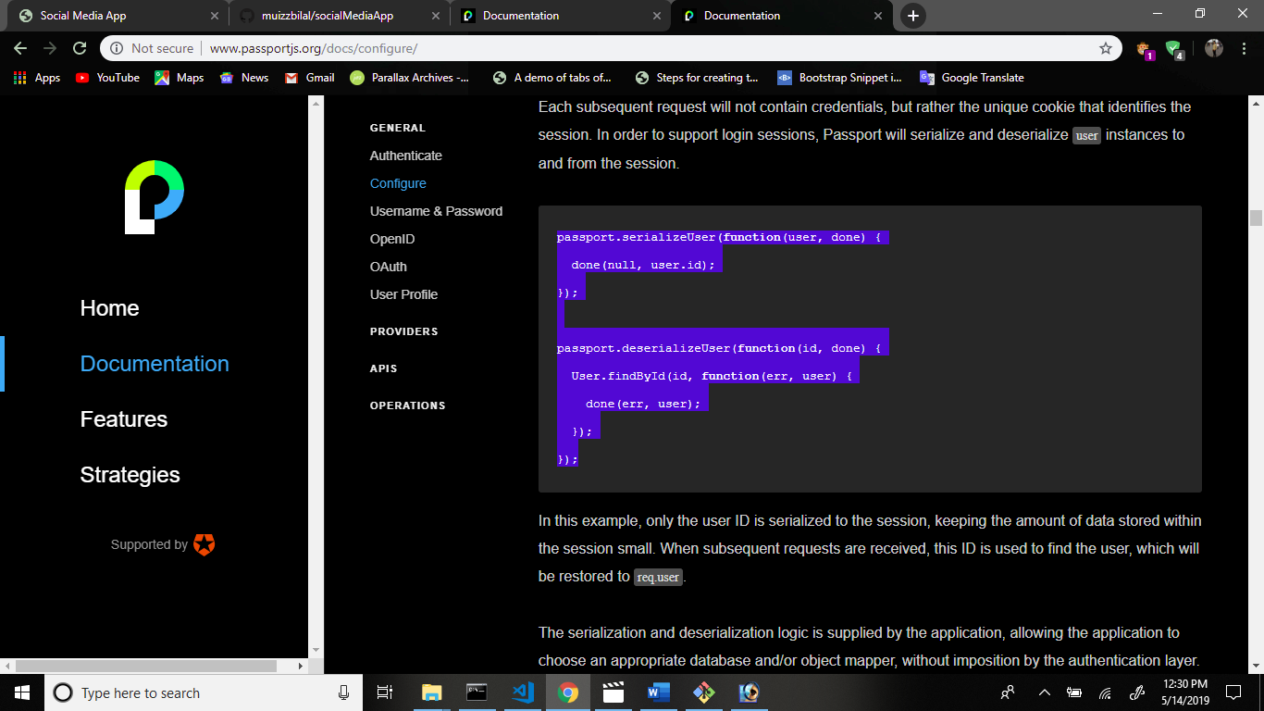

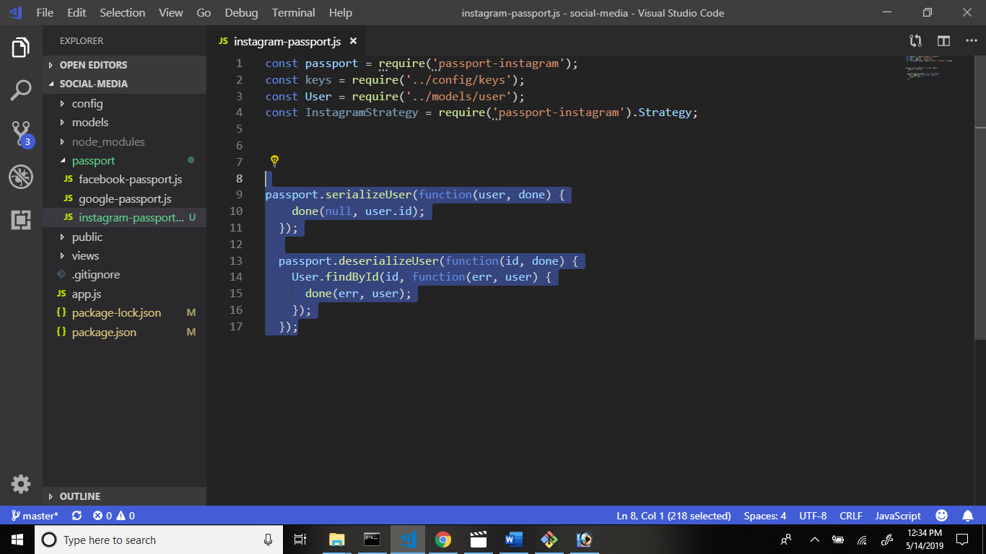

Now again go to the passportjs.org webite in main page and press the strategies and copy this code and paste the instagram-passport.js file.

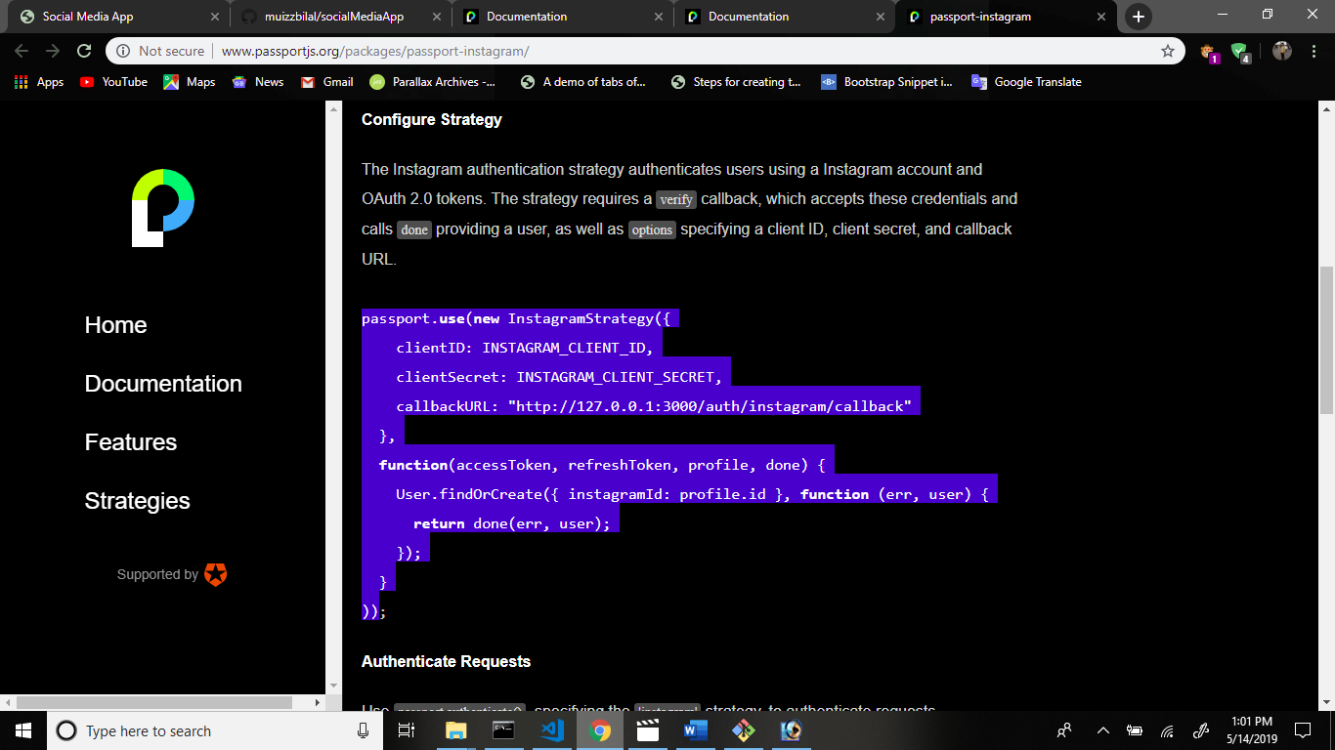

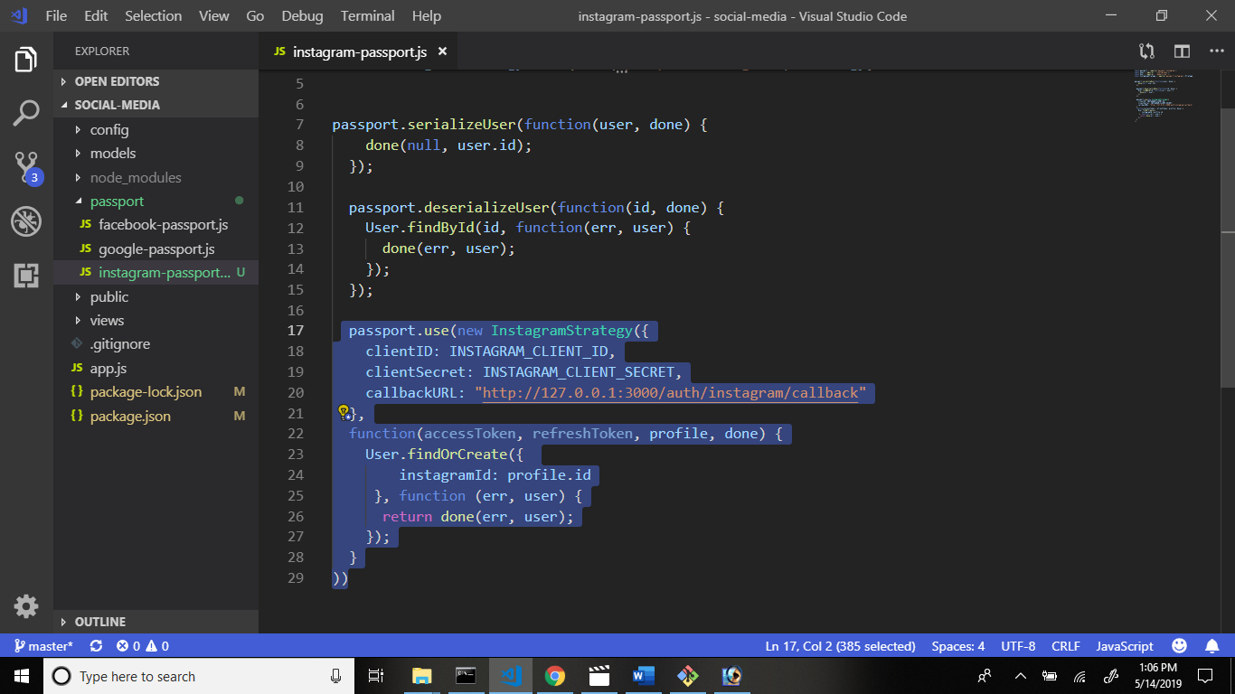

Now go to instagram/developers page in new tab.

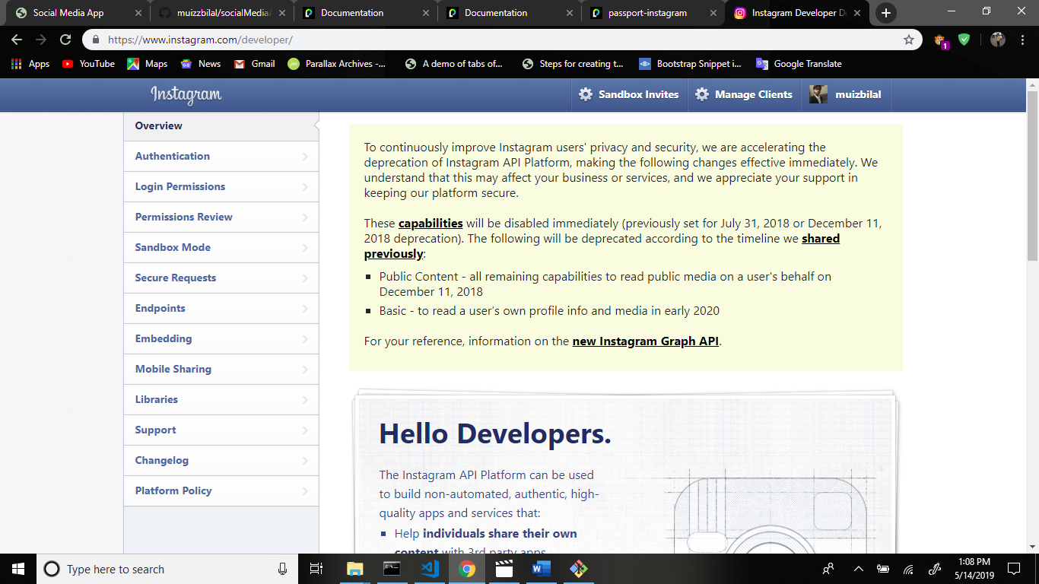

Now register your application.

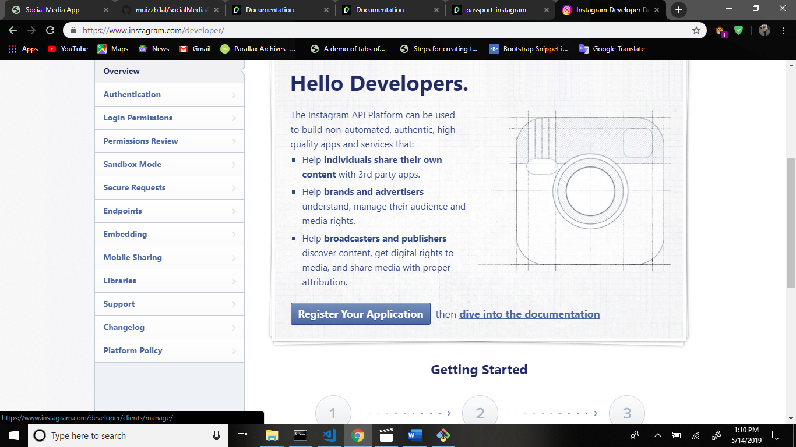

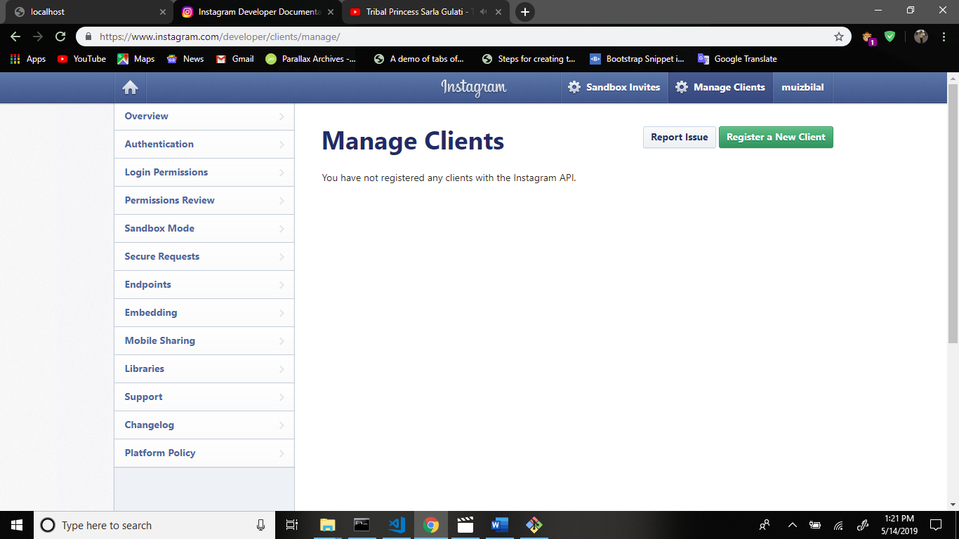

Now register a new client.

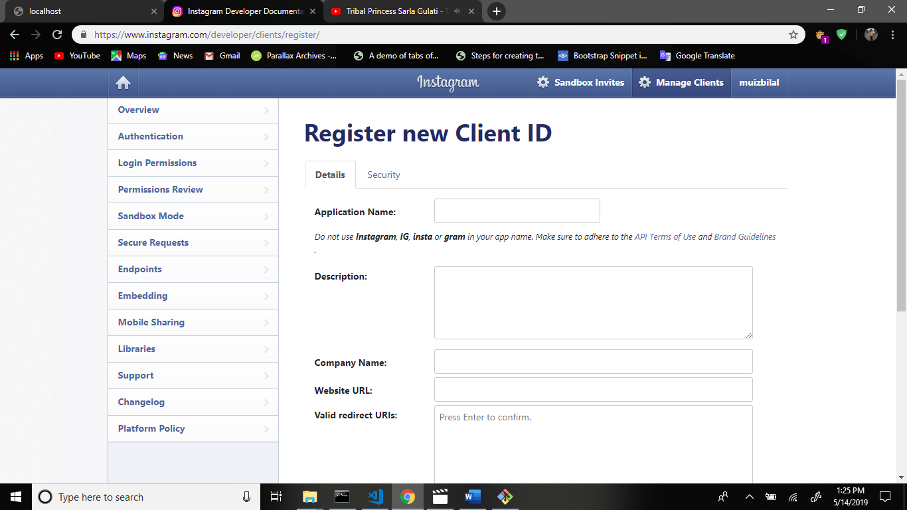

Fill this fields.

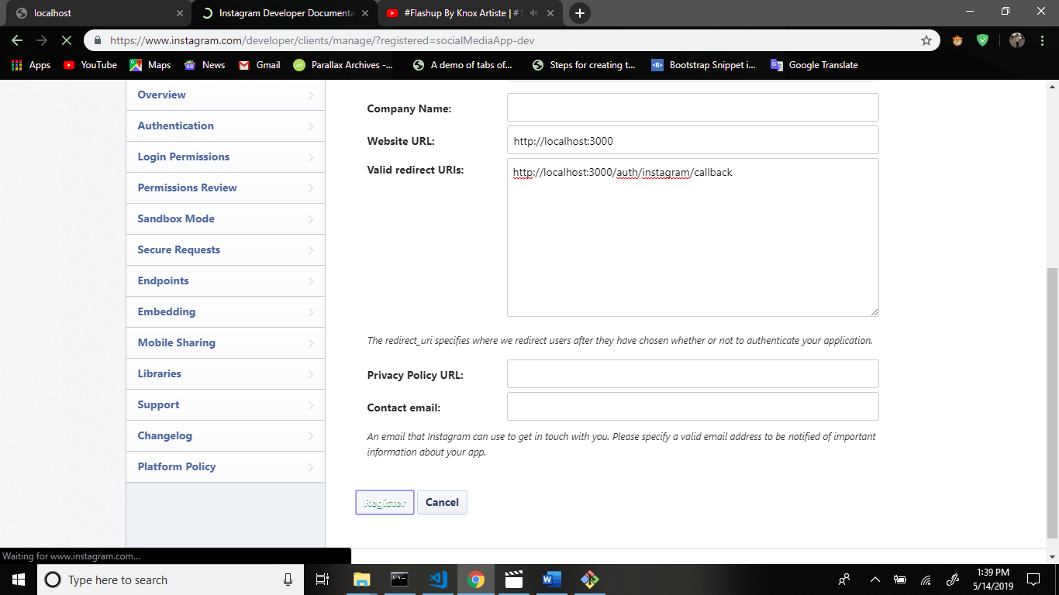

And press register.

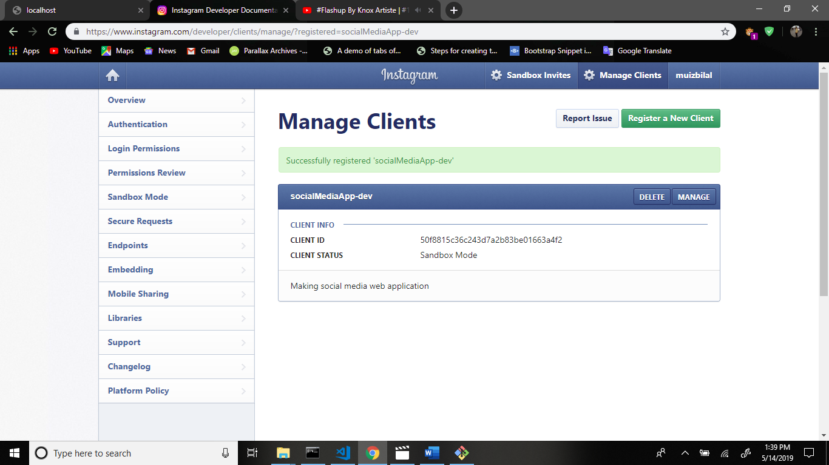

Go to manage.

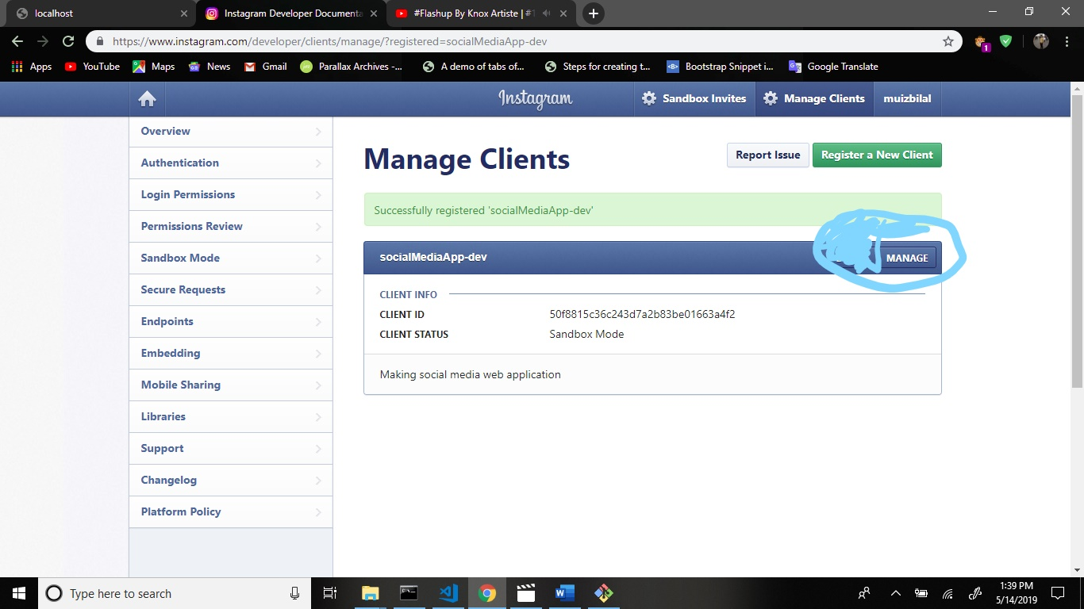

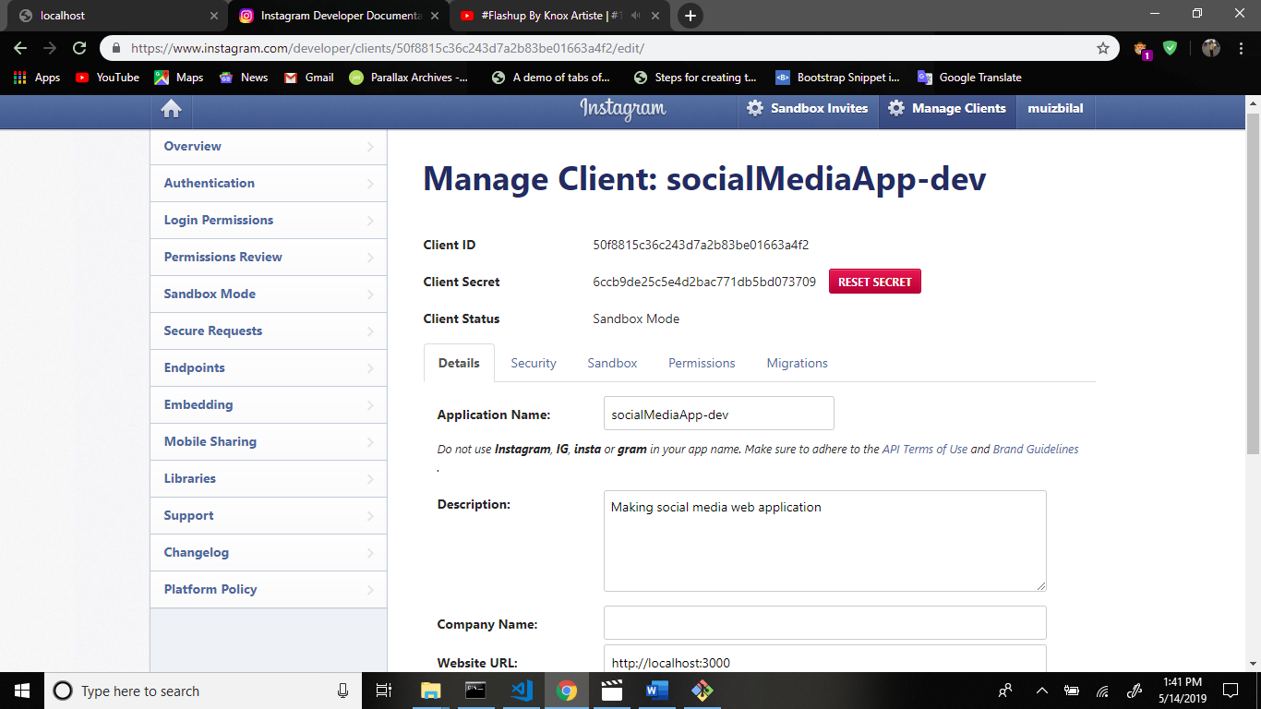

Copy the client id and client secret.

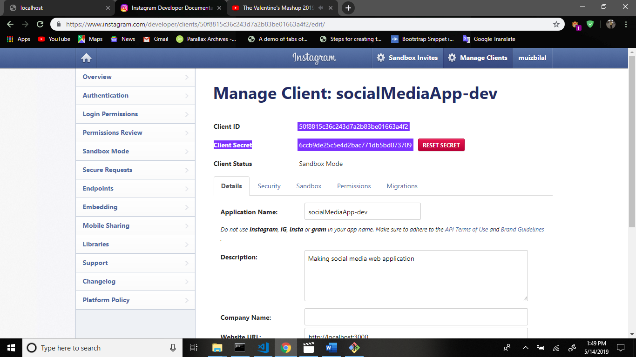

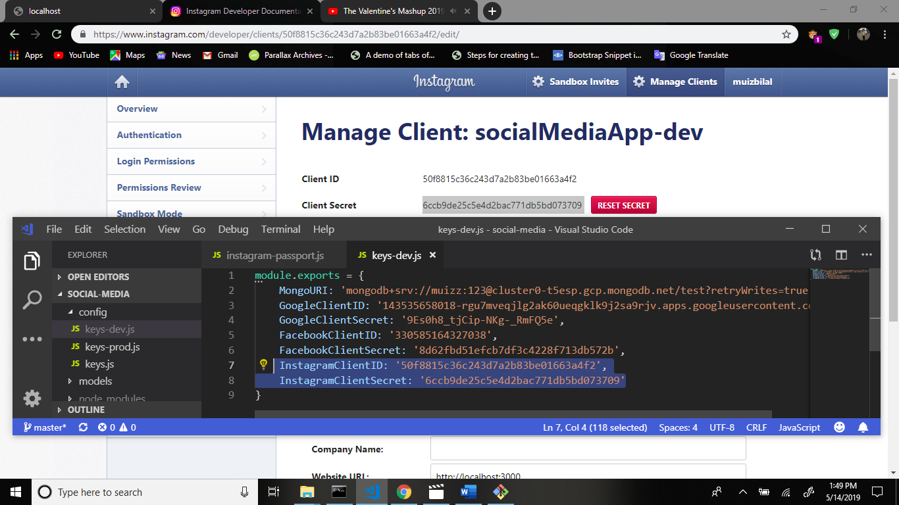

Go to the passportjs.org website and search the passport-instagram and copy this code and paste the app.js file.

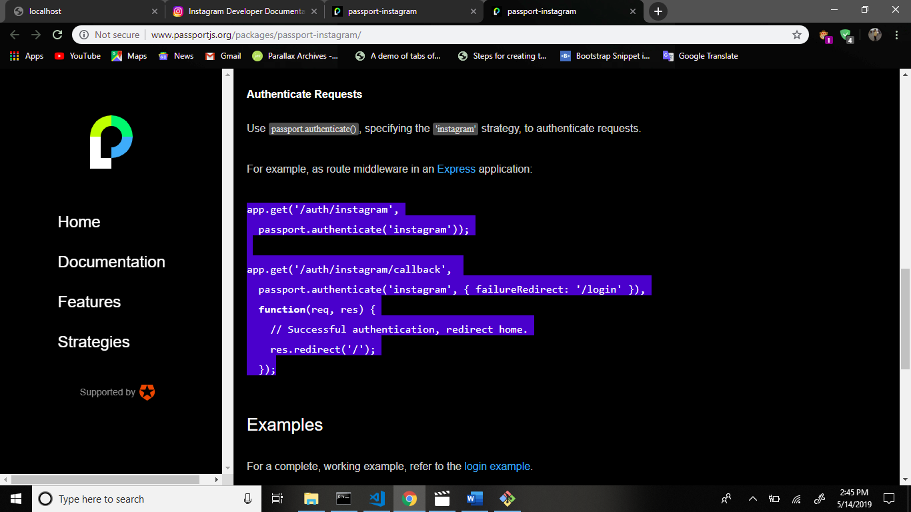

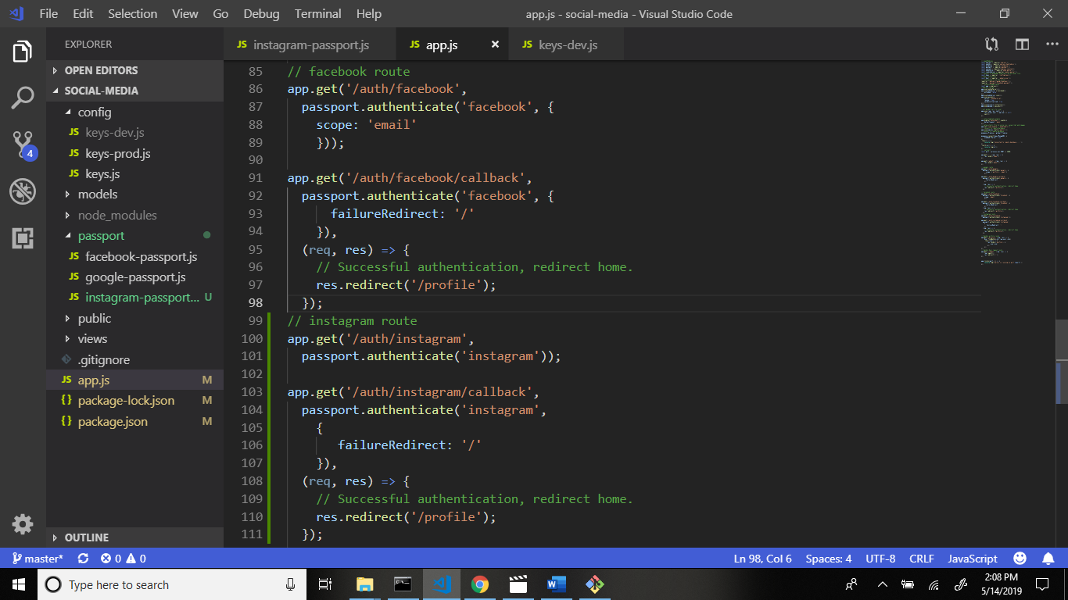

Now require the instagram-passport.js file in app.js file.

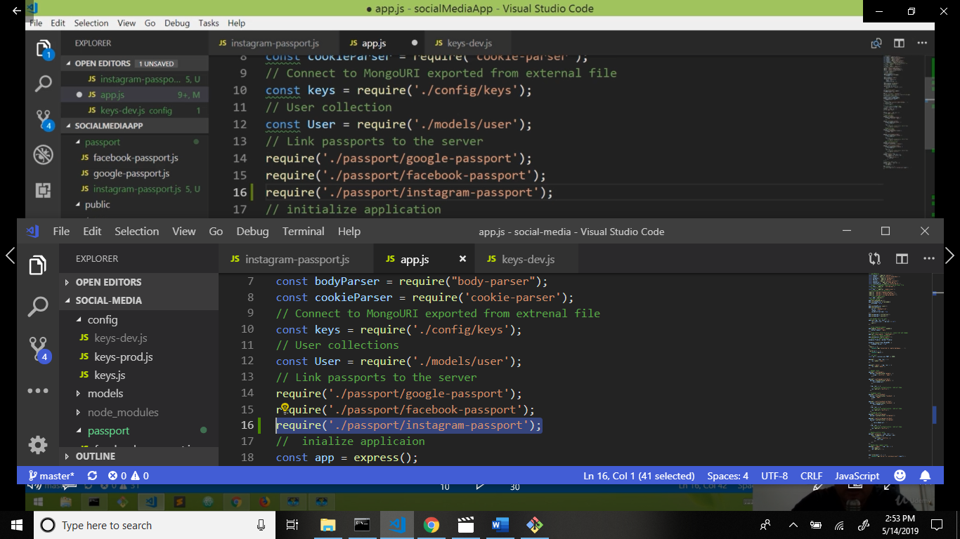

Now run the server. Command: nodemon

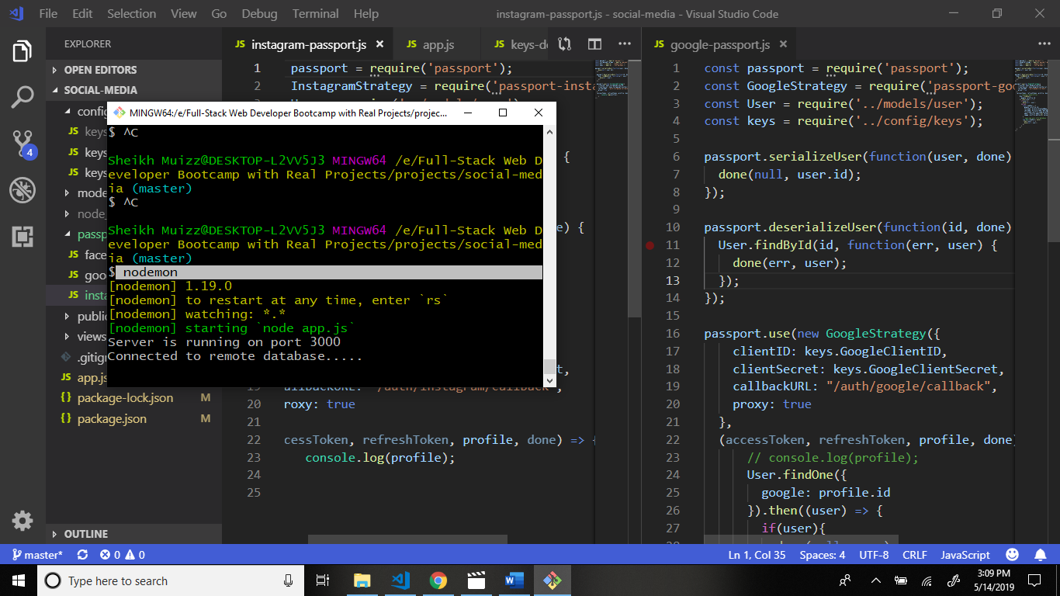

Output

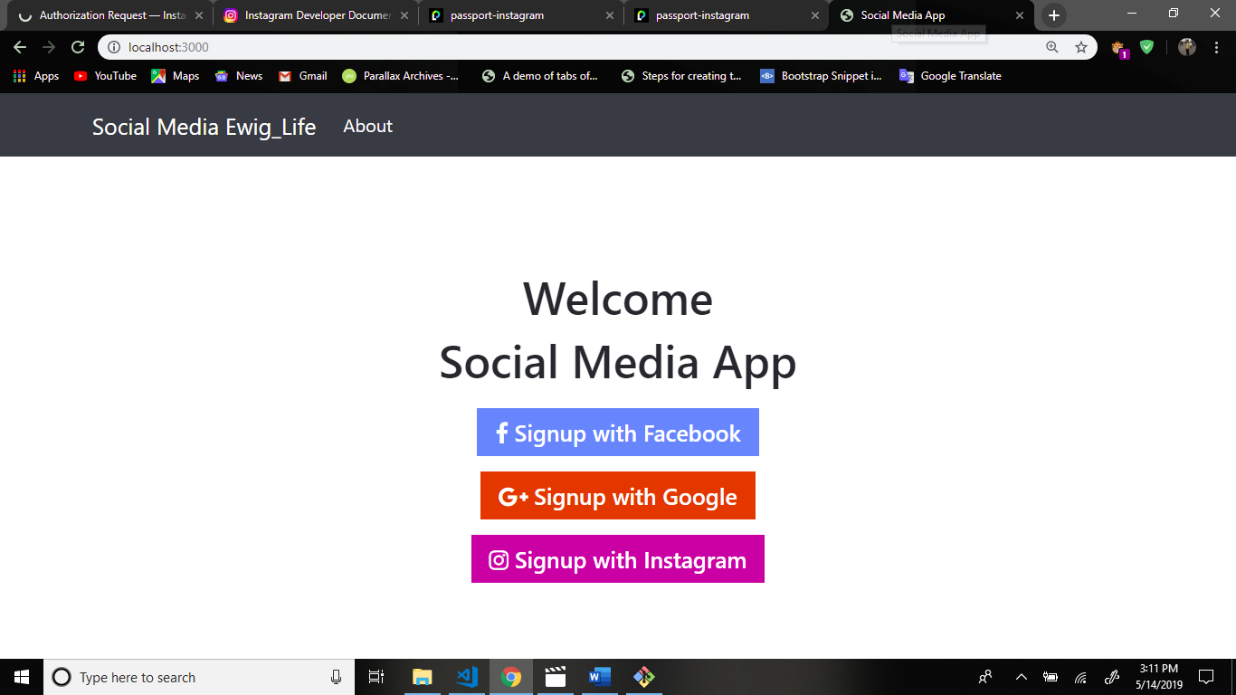

Now signup the instagram.

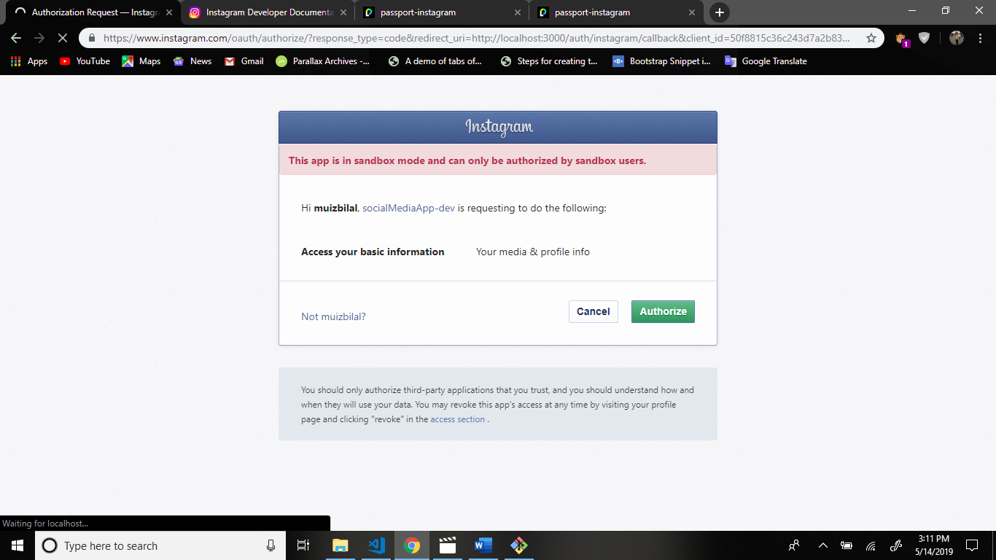

Now see your terminal

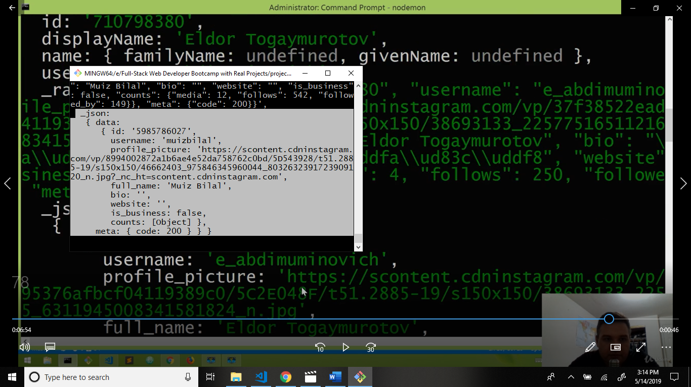

Now get data and render or save the data in mongodb.

Now if else condition use for data render.

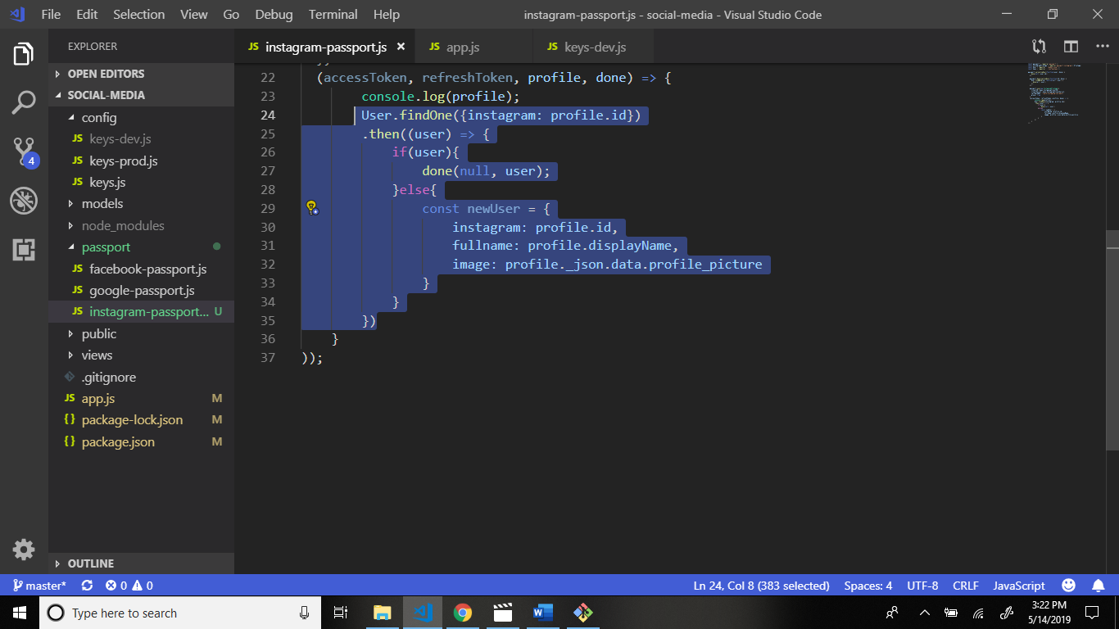

Now save the data in mongoDB.

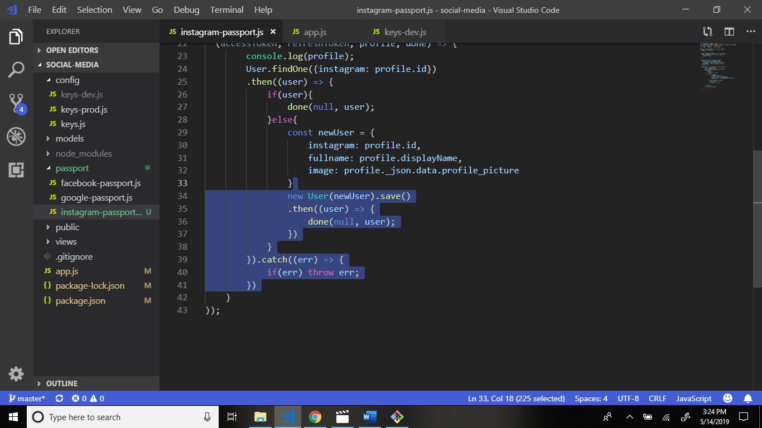

Now signUp the instagram.

And see output.

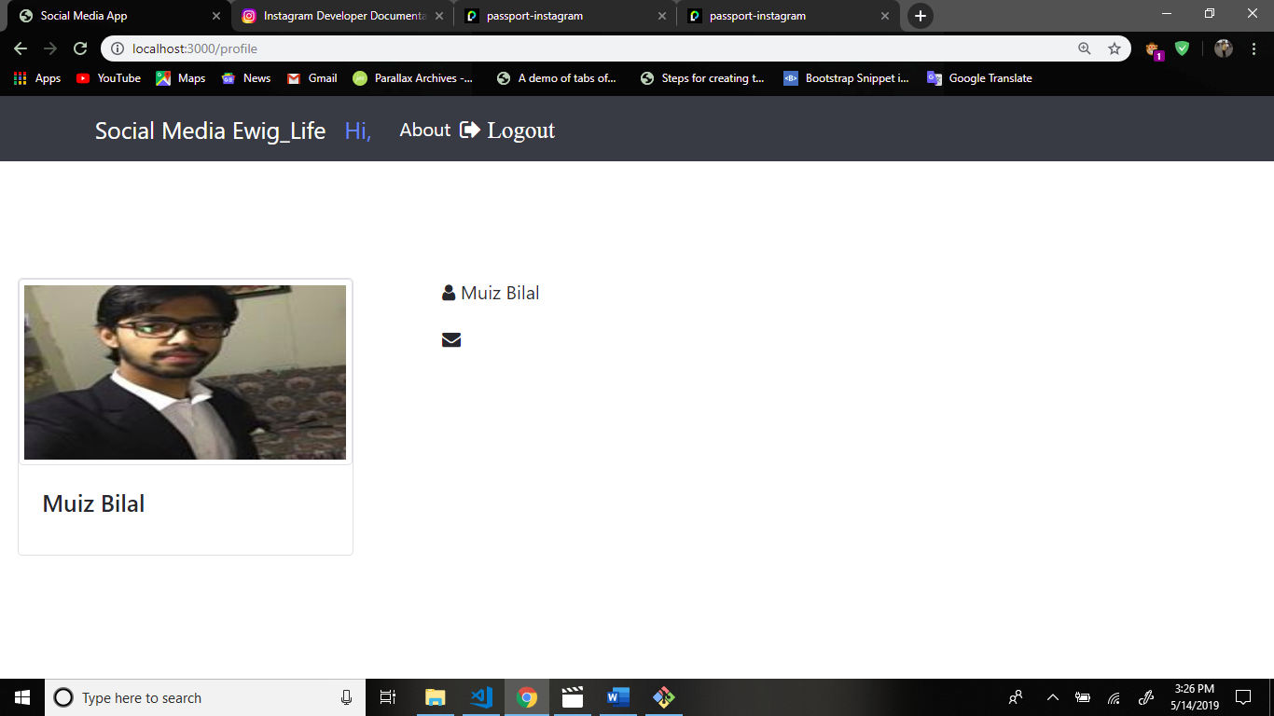

There will be no email address so you can make the email through this method.

Now go to profile.handlebars file and write code.

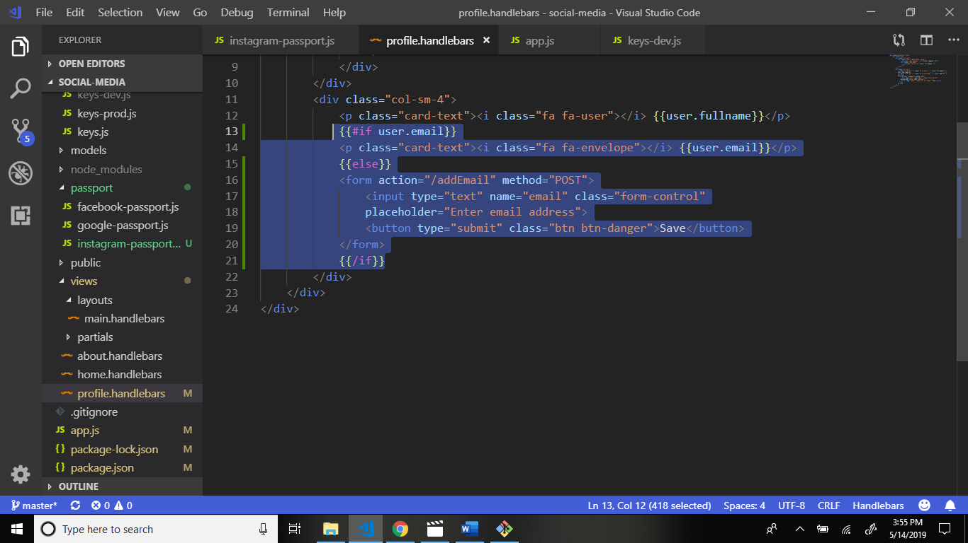

Now go to app.js file and routing.

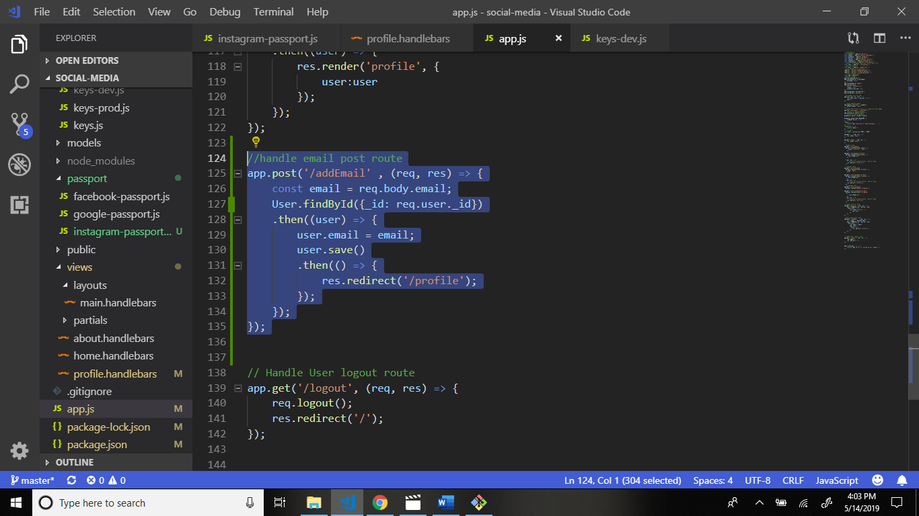

After this output.

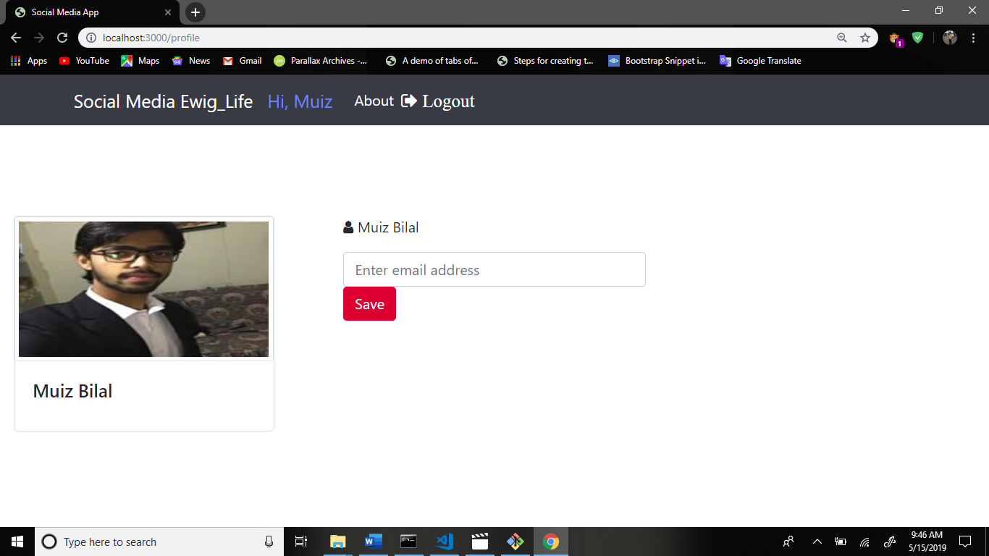

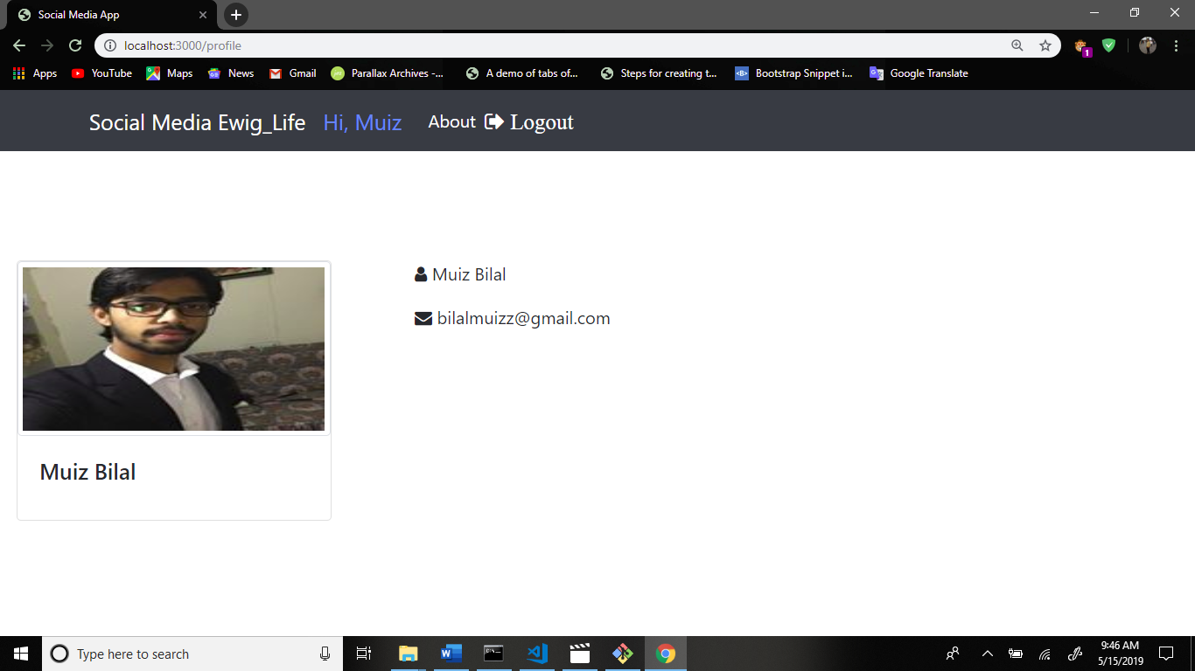

Now direct link the navigation bar /profile.

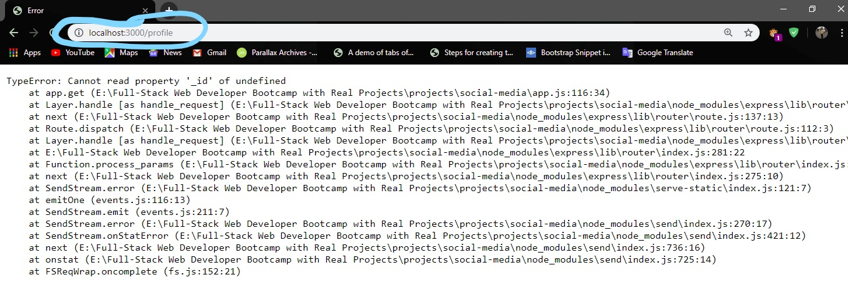

Now solve this problem.

Create folder helpers in main folder and create file auth.js in helpers folder.

Structure:

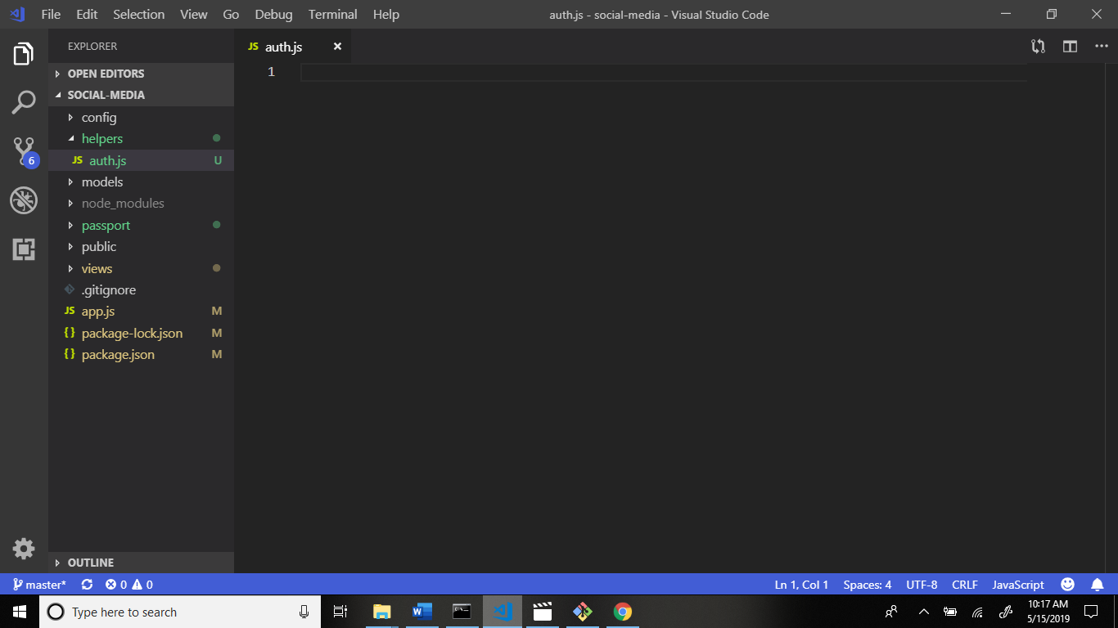

Write this code.

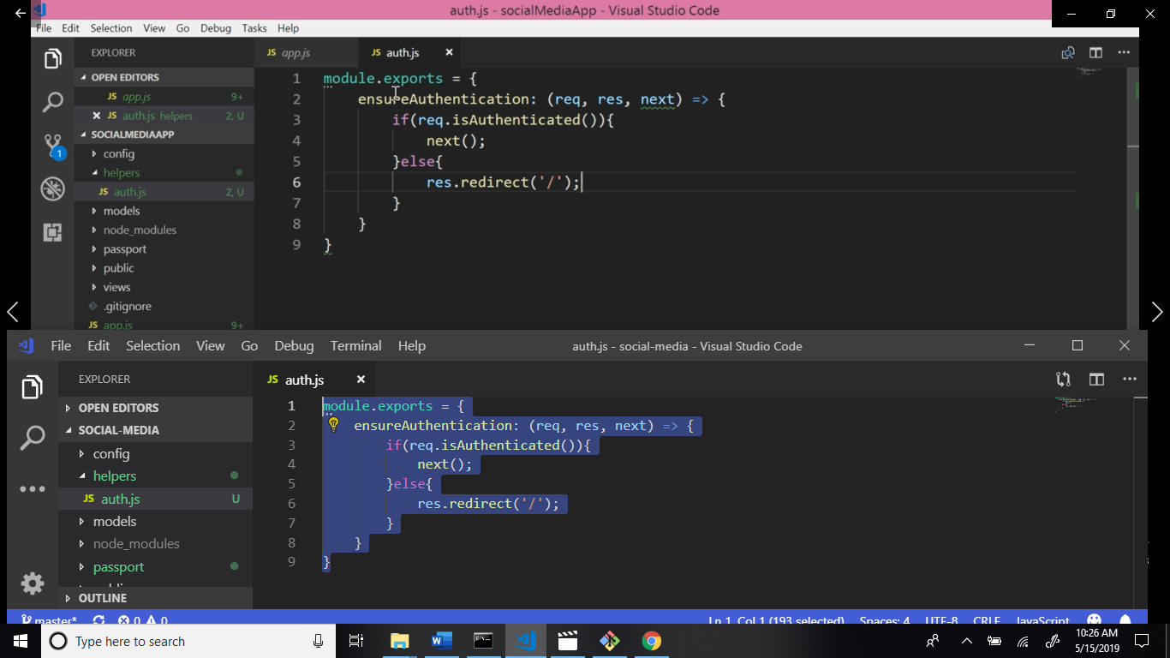

Now go to app.js file and this module require.

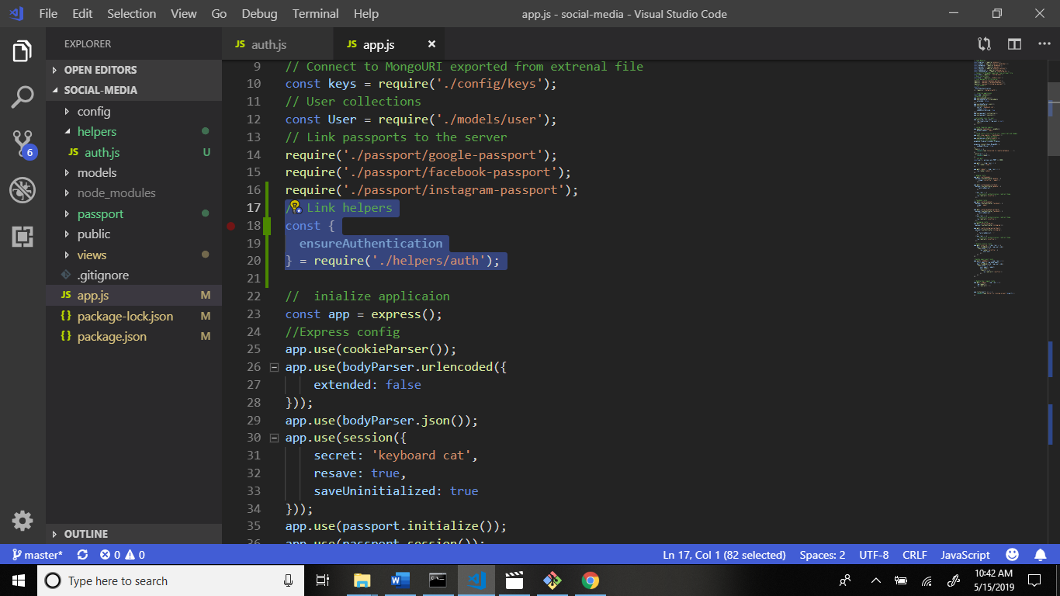

Now scroll down and add some code.

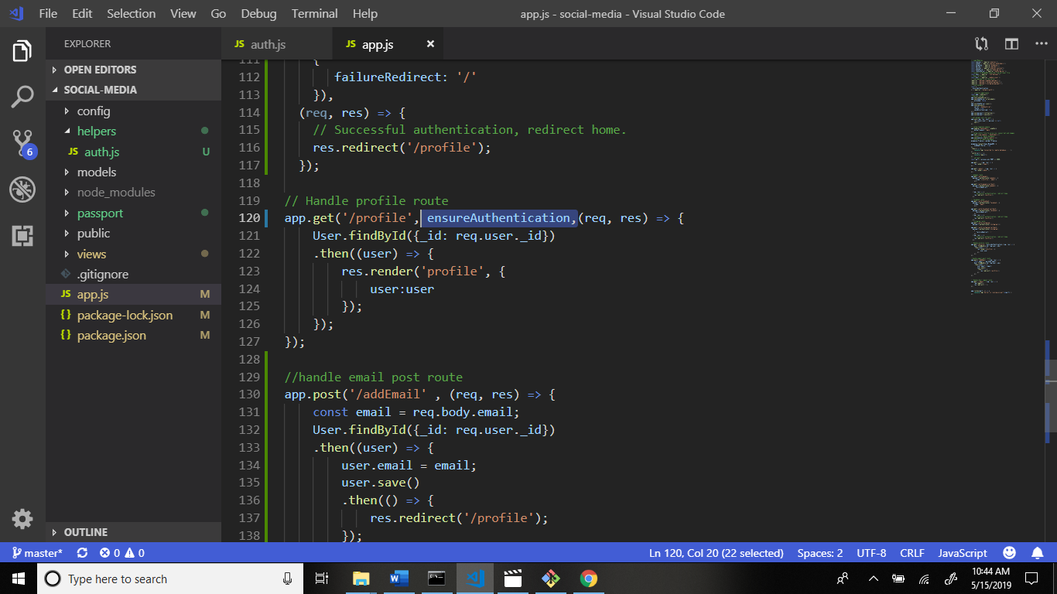

Check your output:

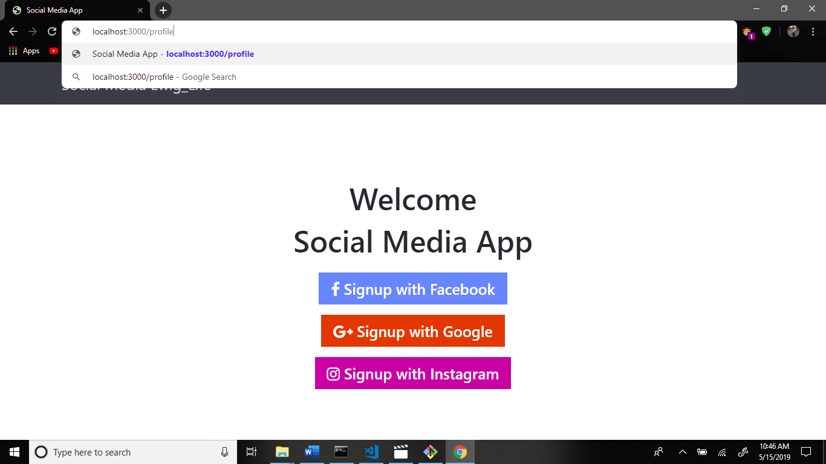

Now if else condition use if user is login then go to the profile page. Otherwise run else condition.

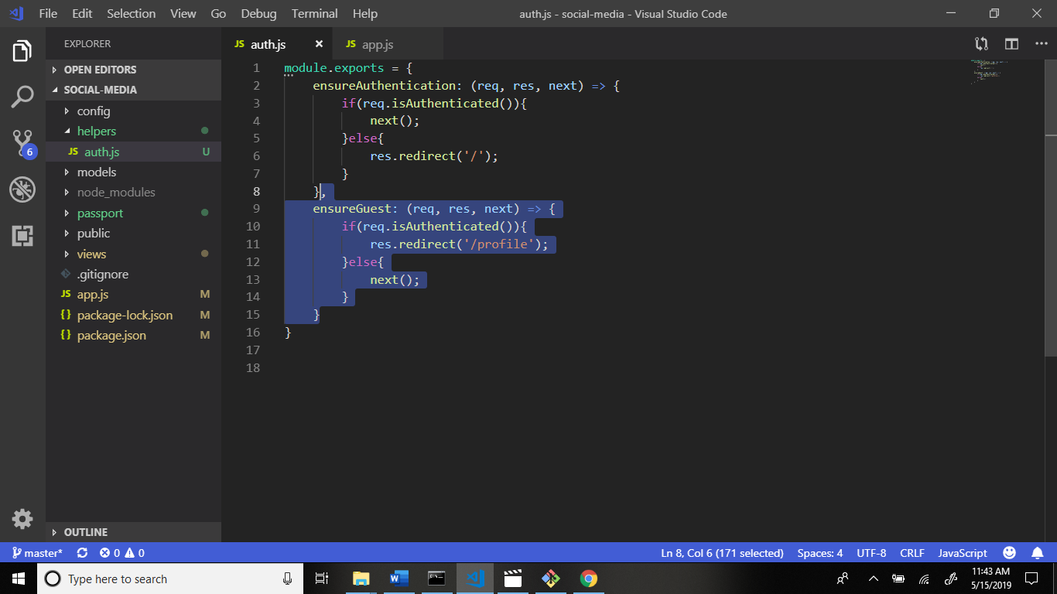

Now go to app.js file and call this ensureGuest.

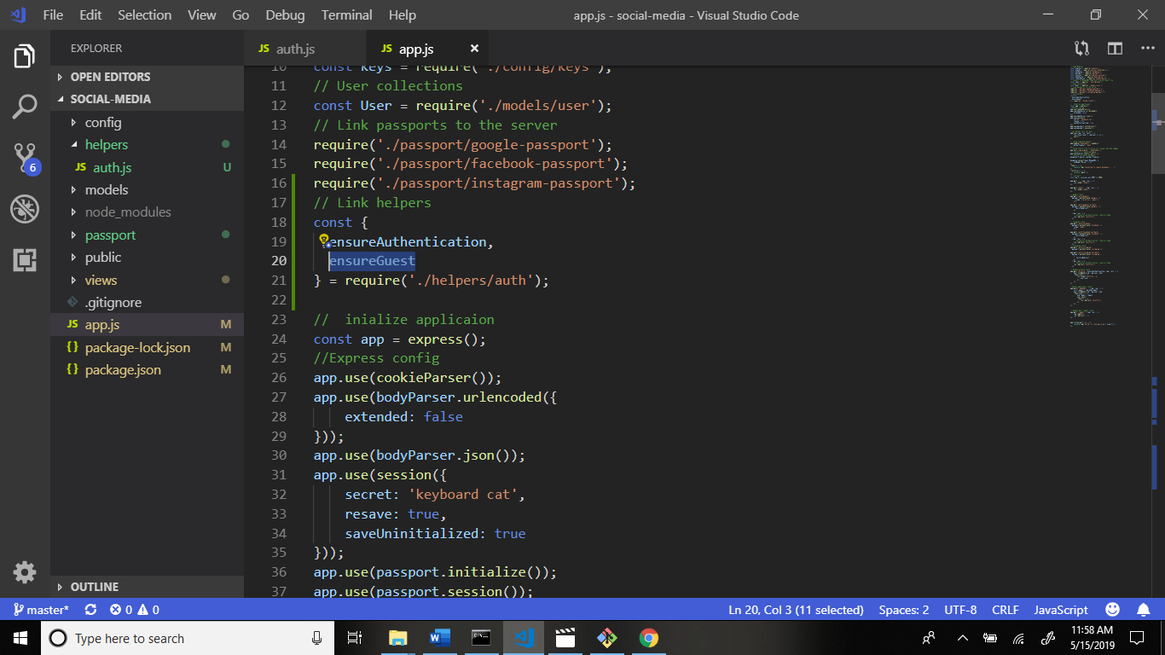

Now call this in routing.

Scroll down.

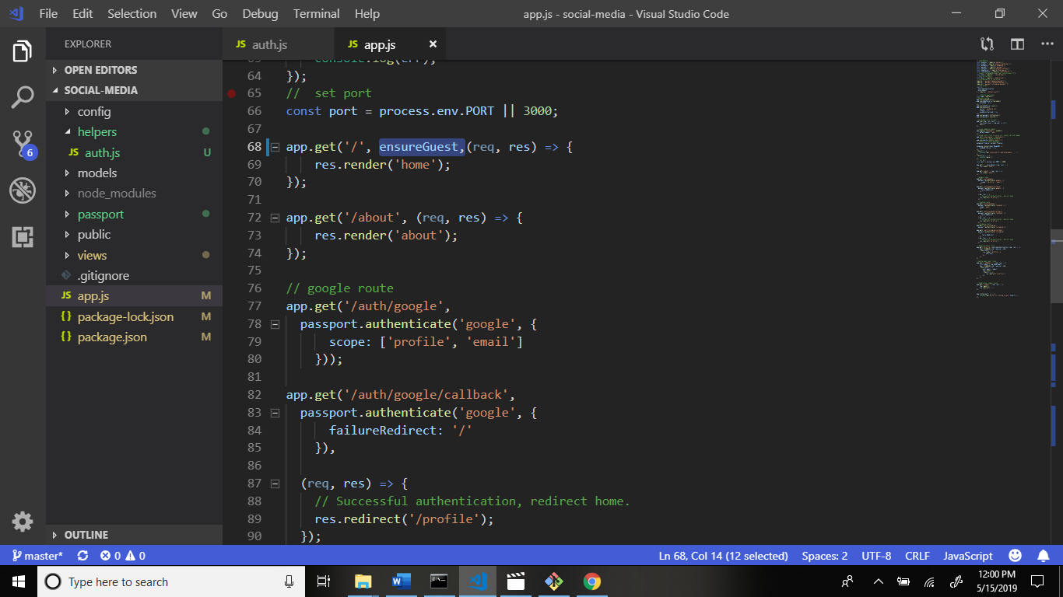

Now go to home.handlebars and remove if else conditions.

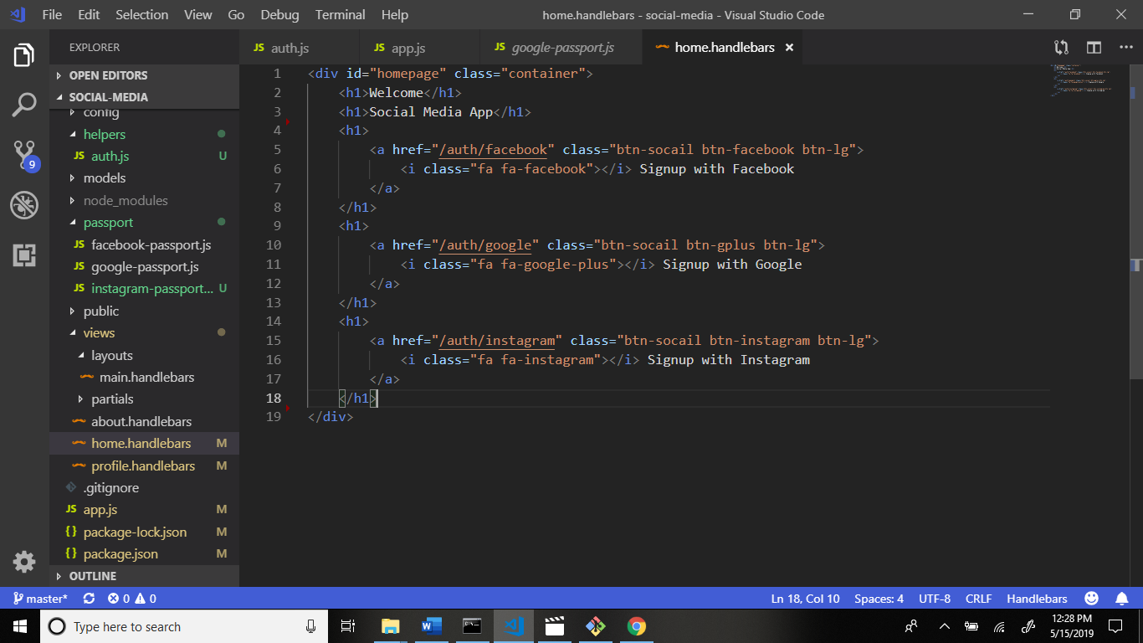

See output in navbar link:

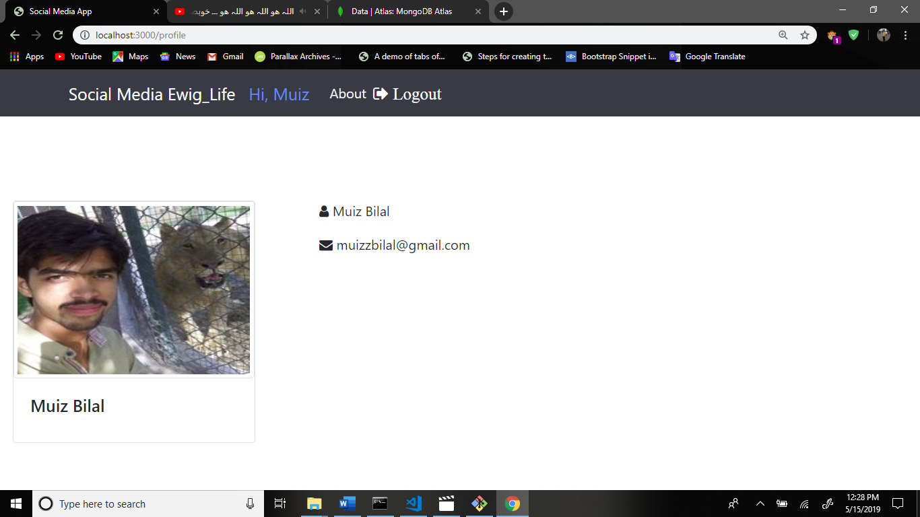

Now we get phone number in database and render.

Go to the profile.handlebars and write code.

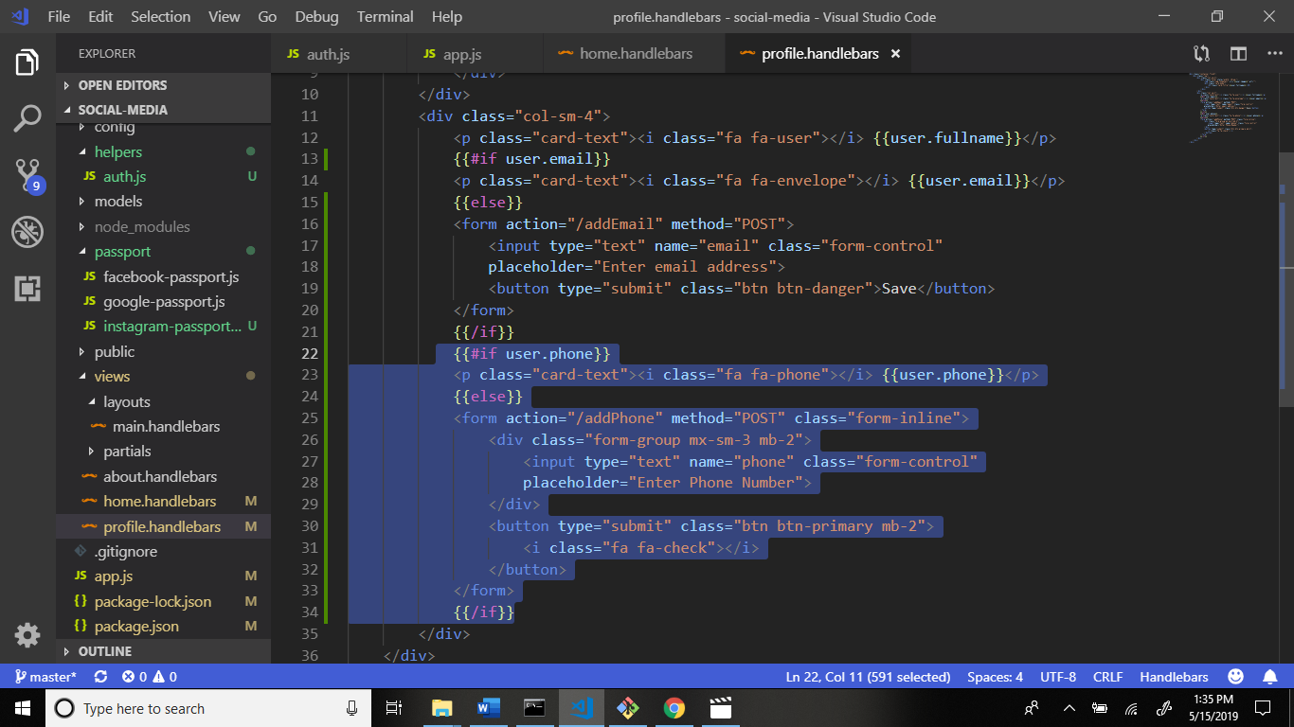

Now go to app.js file and phone routing write code after the addEmail routing.

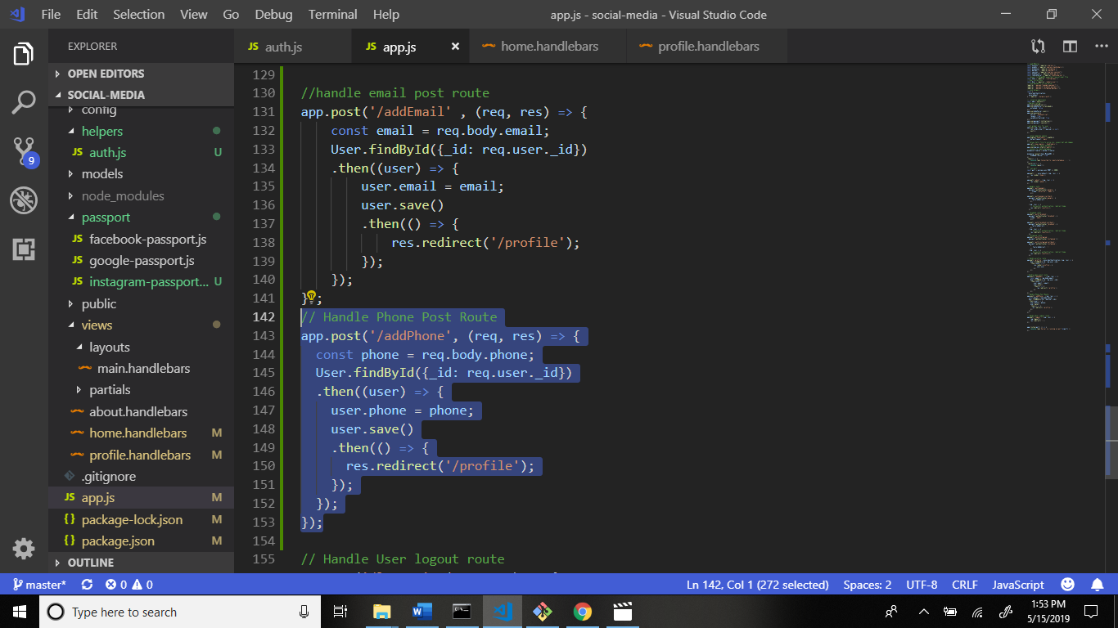

Output:

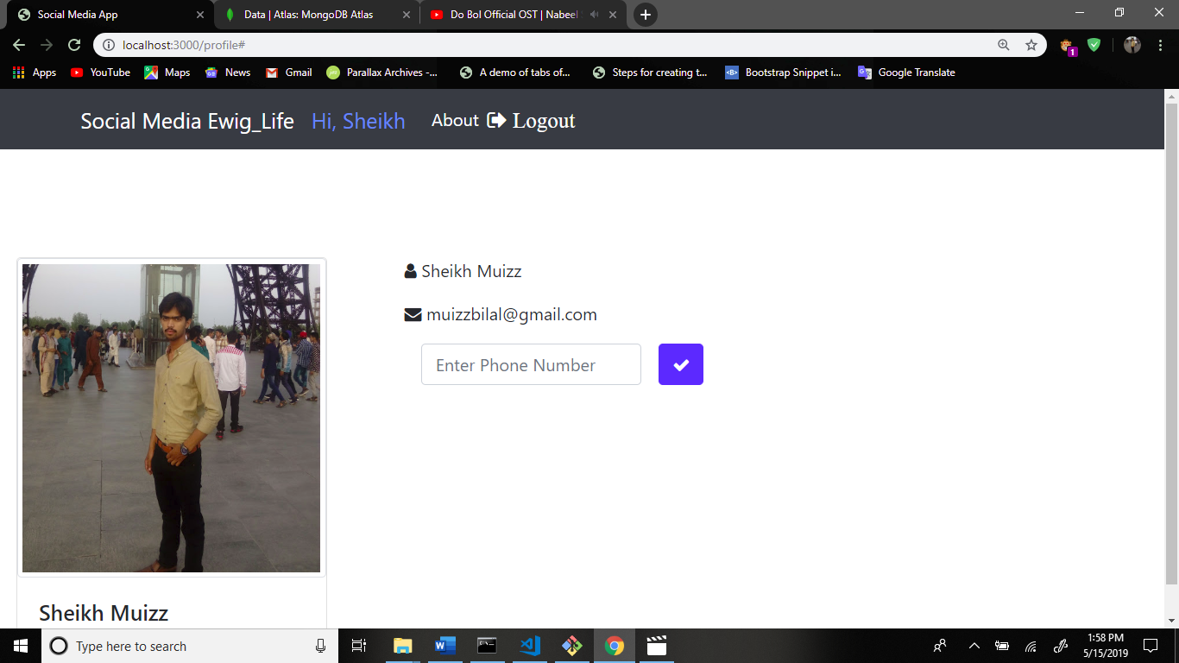

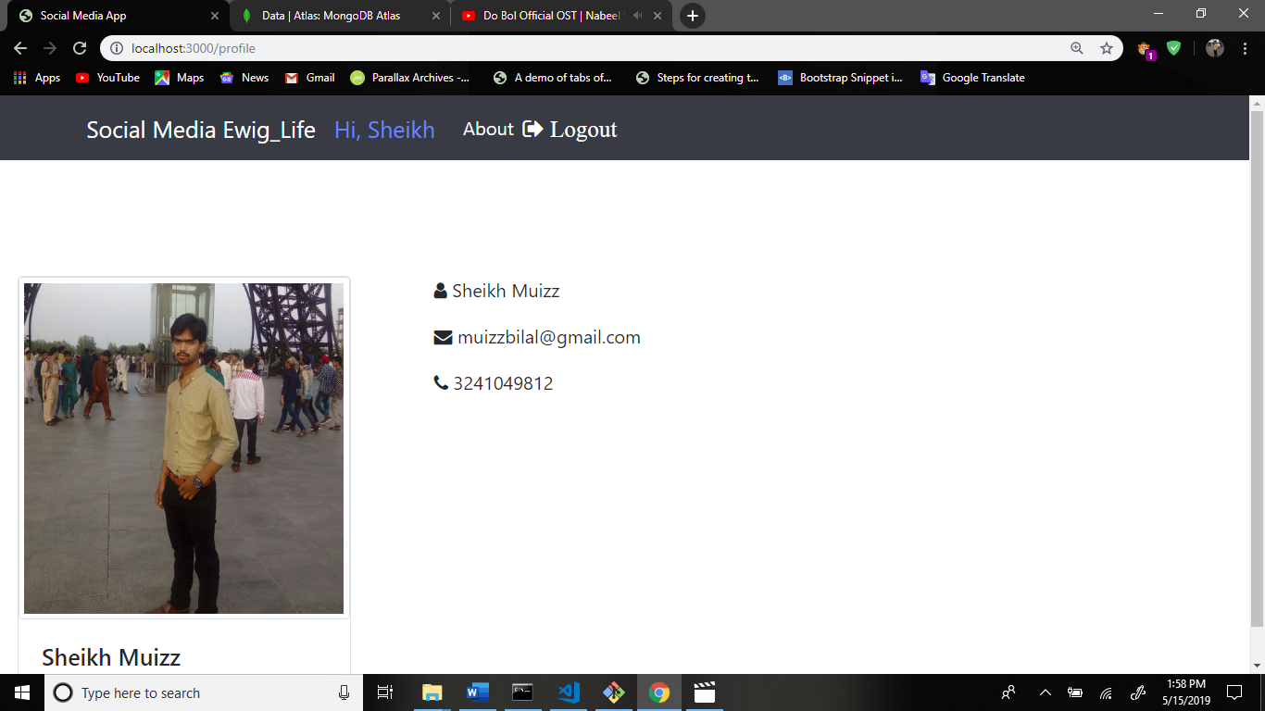

Now get location to the user.

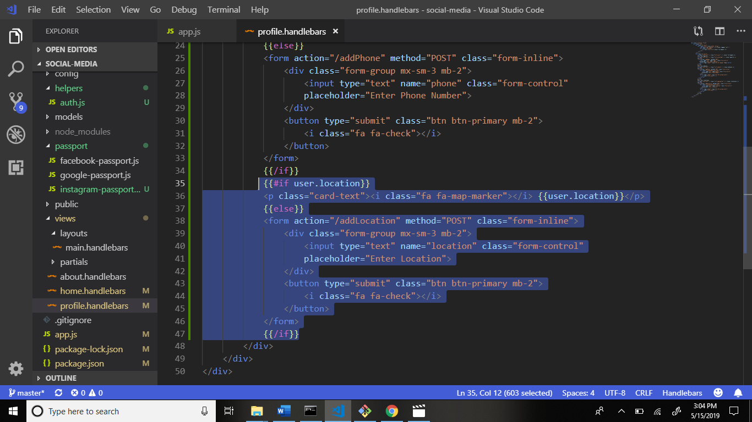

Now add routing in app.js file after the addphone handle route.

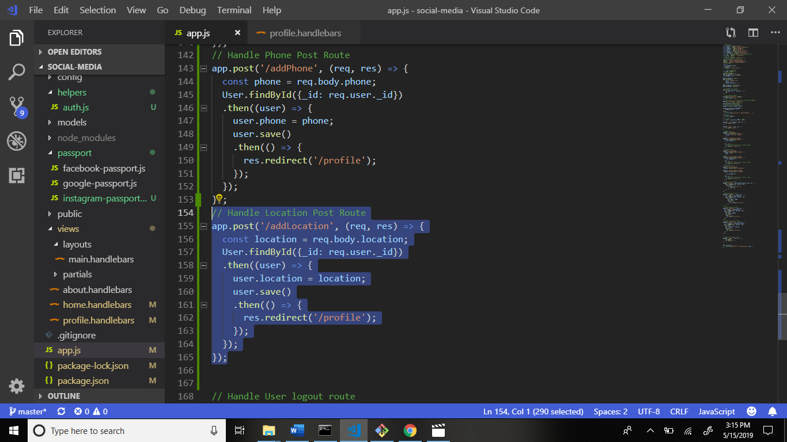

Now see output:

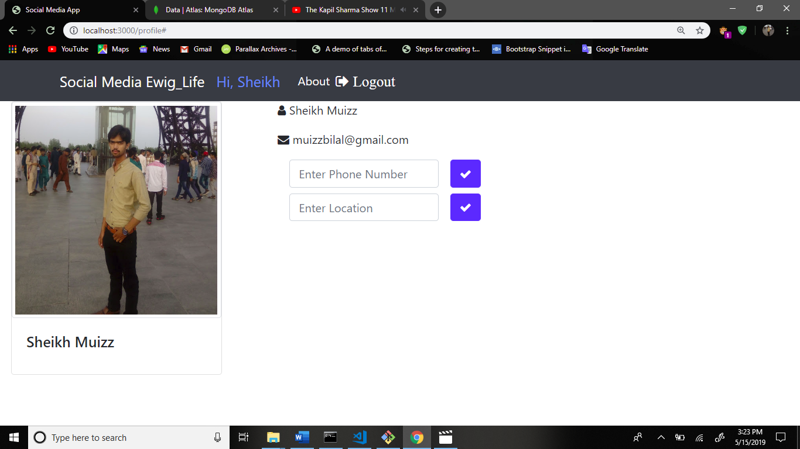

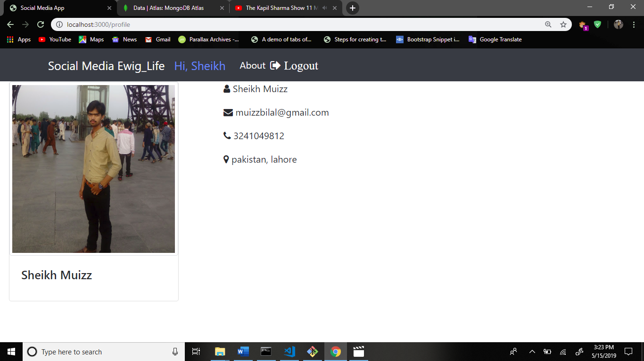

Now go to mongoDB and see the result your all data is save to the database.

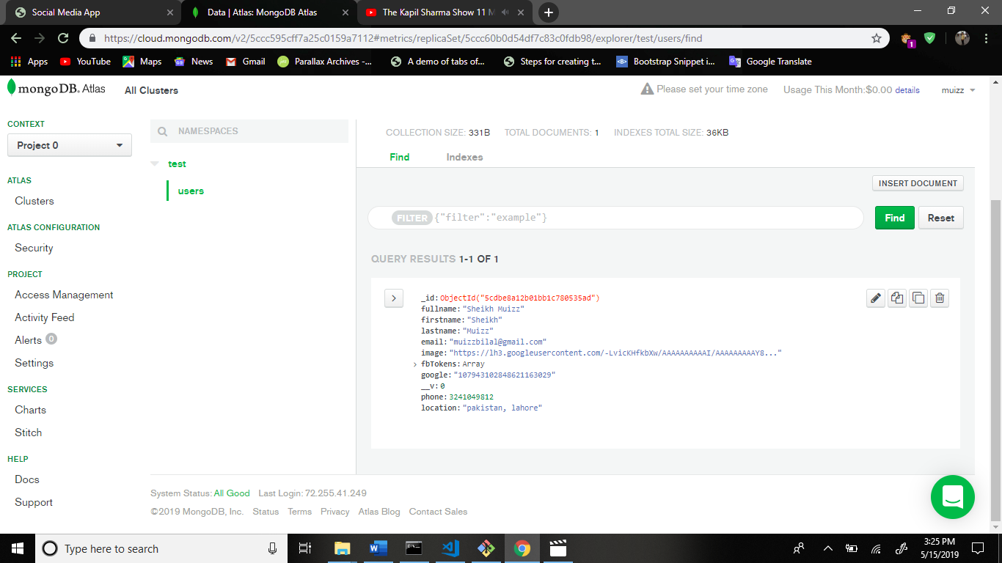

Now go to profile.handlebars and phone , location must be required.

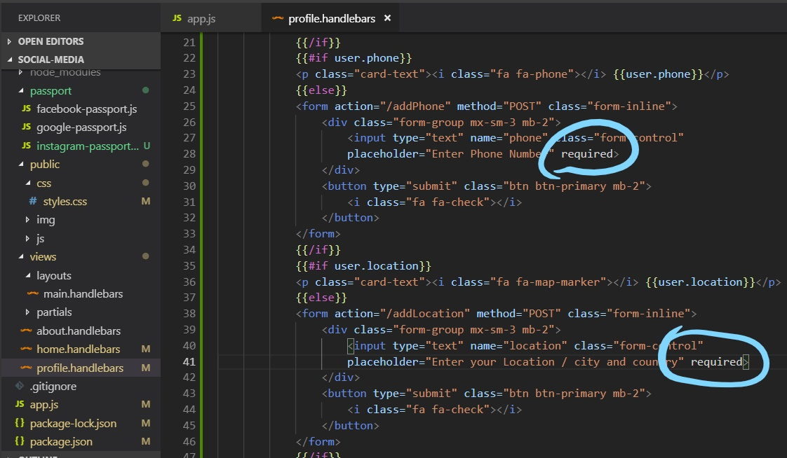

Now output:

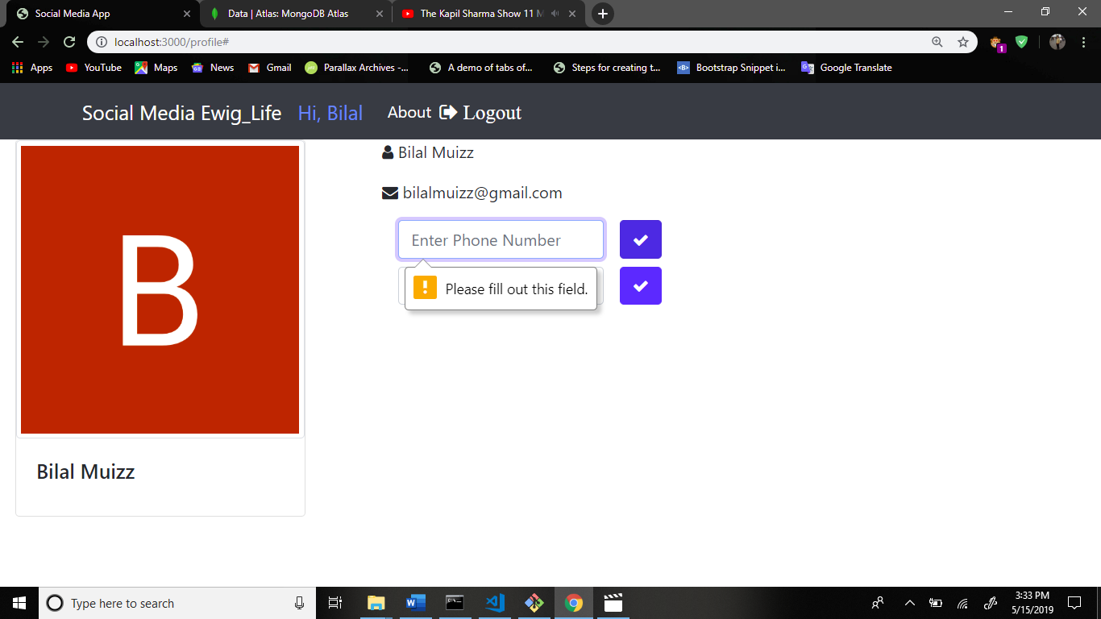

Now go to the navbar.handlebars file and some code remove.

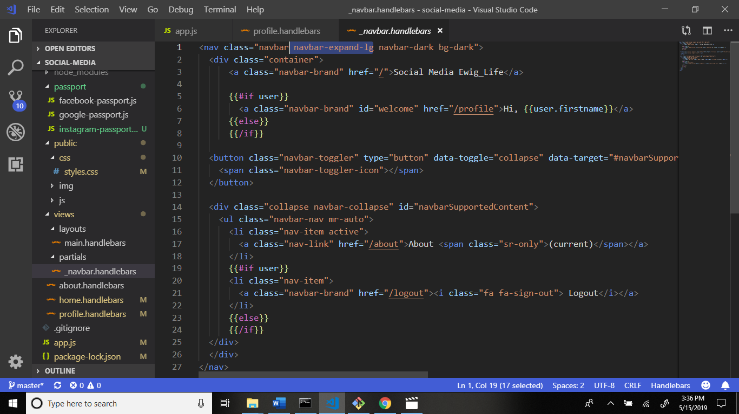

After:

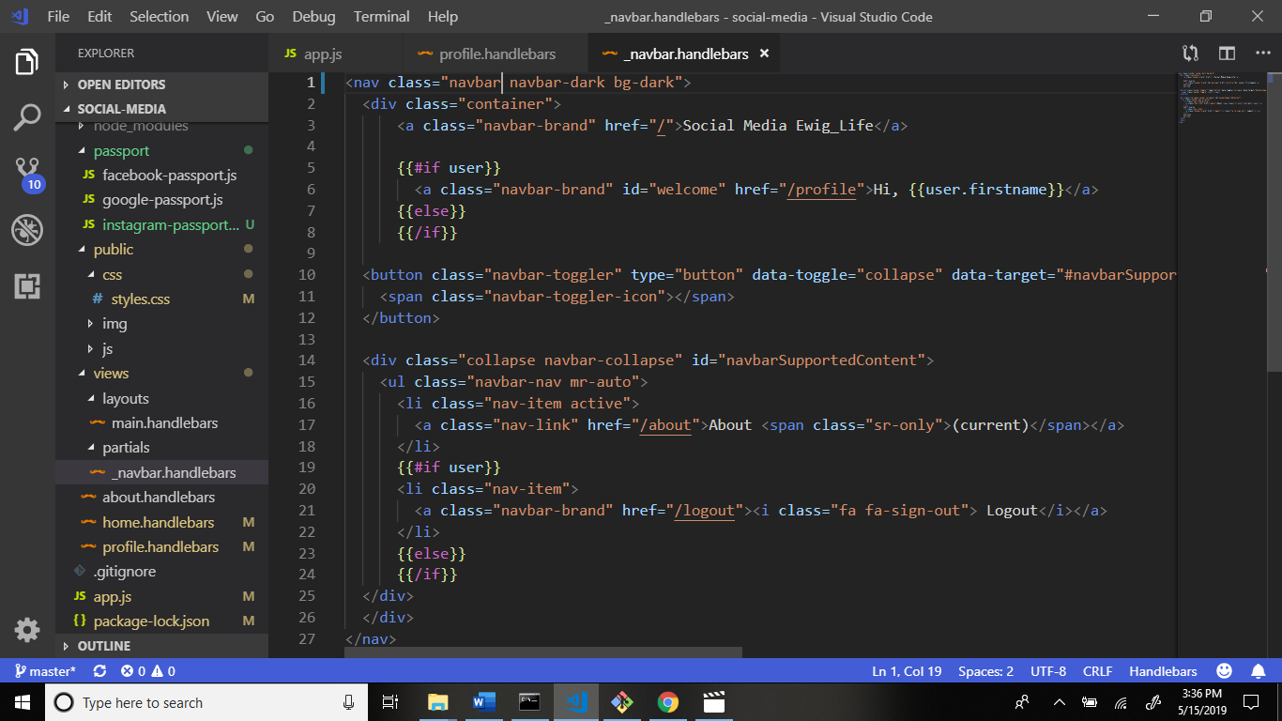

Output: 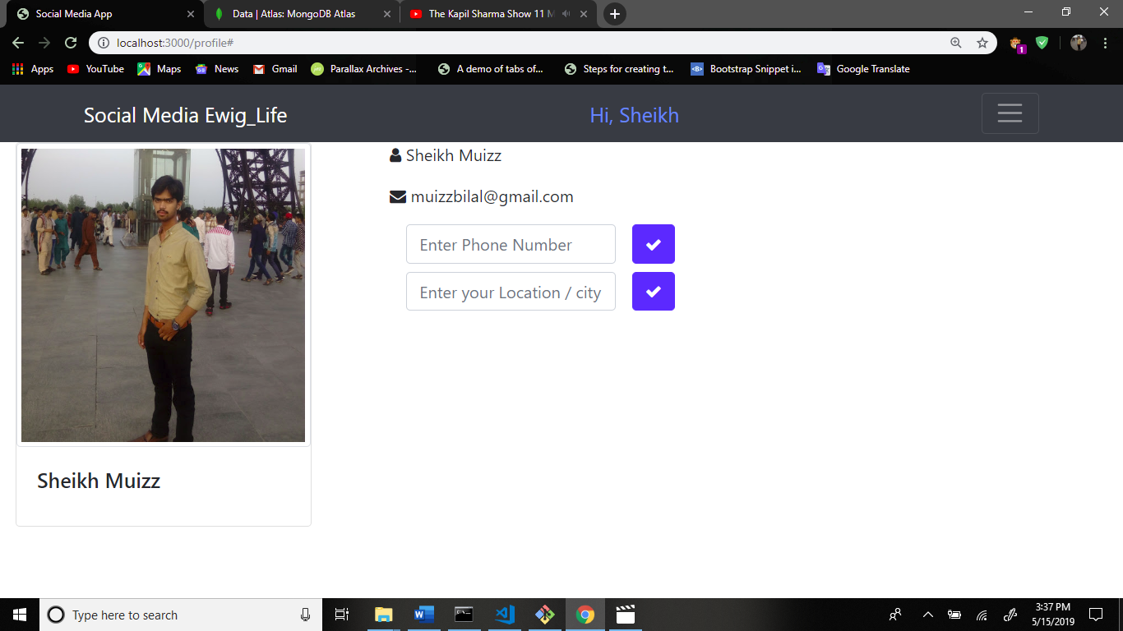

Now create page users.

Now write code in navbar.handlebars file.

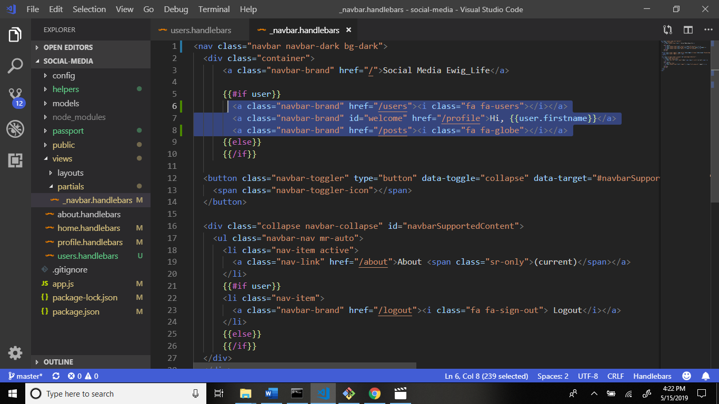

Output:

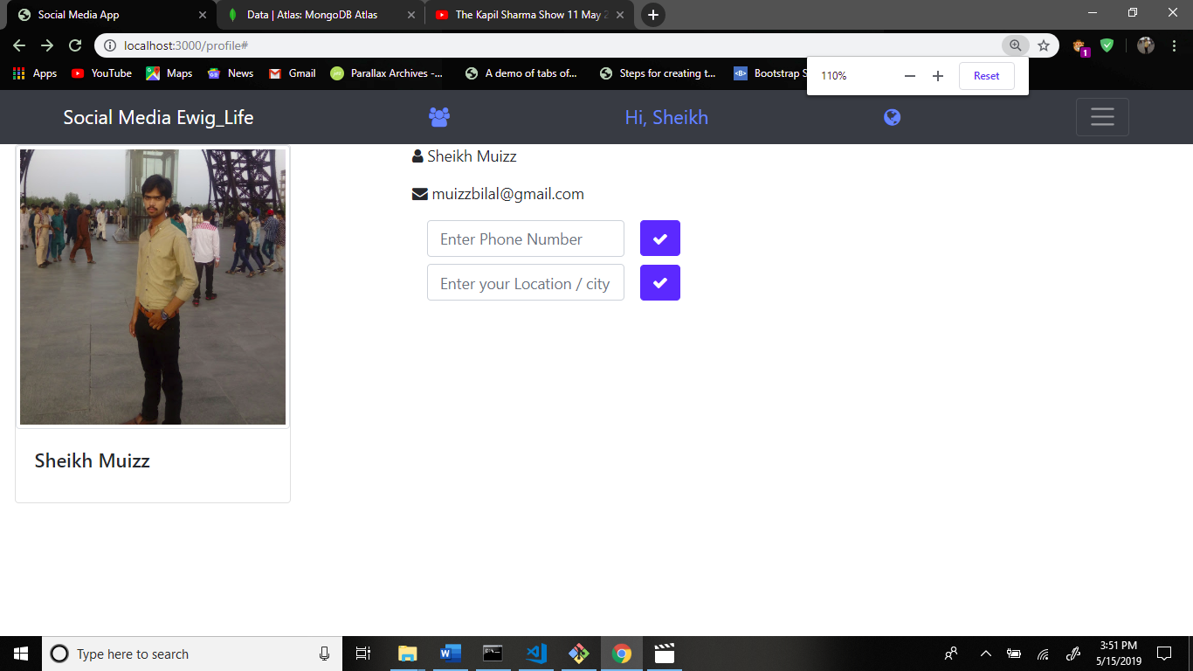

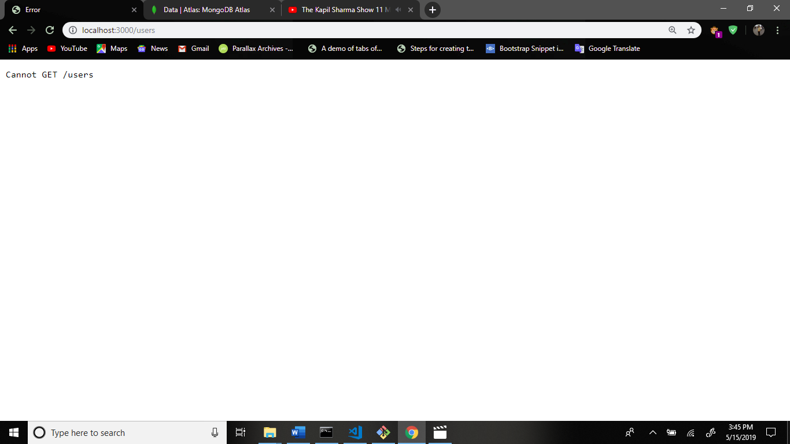

And now go to app.js file and write for routing after the profile route.

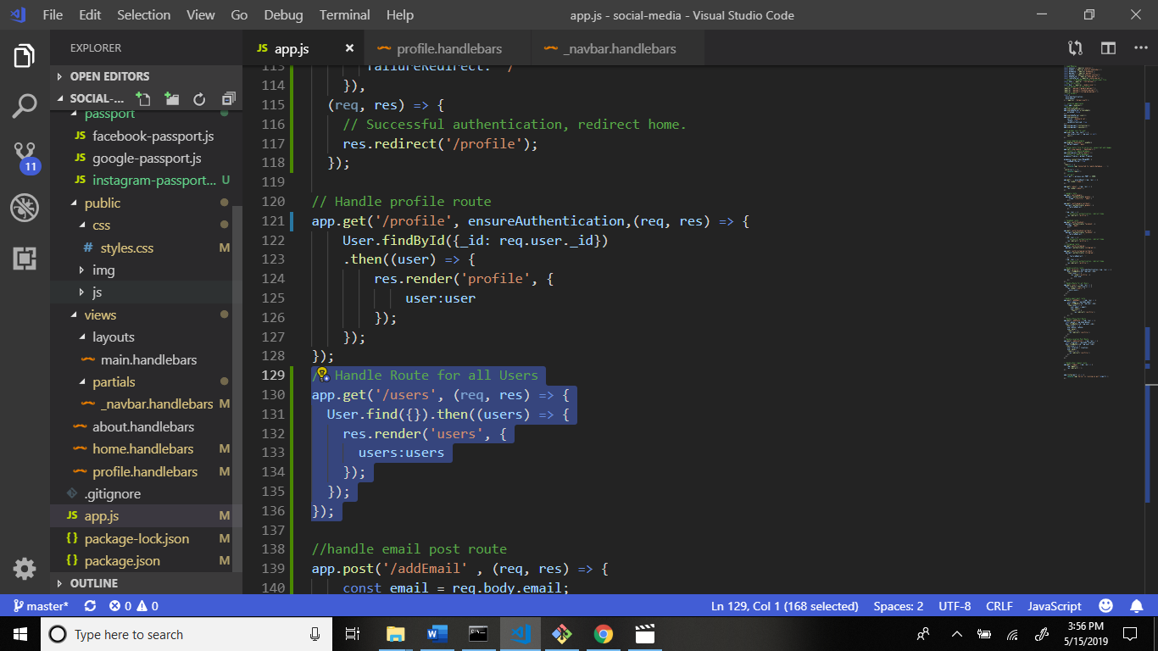

Now create file users.handlebars in views folder. Structure: application > views > users.handlebars

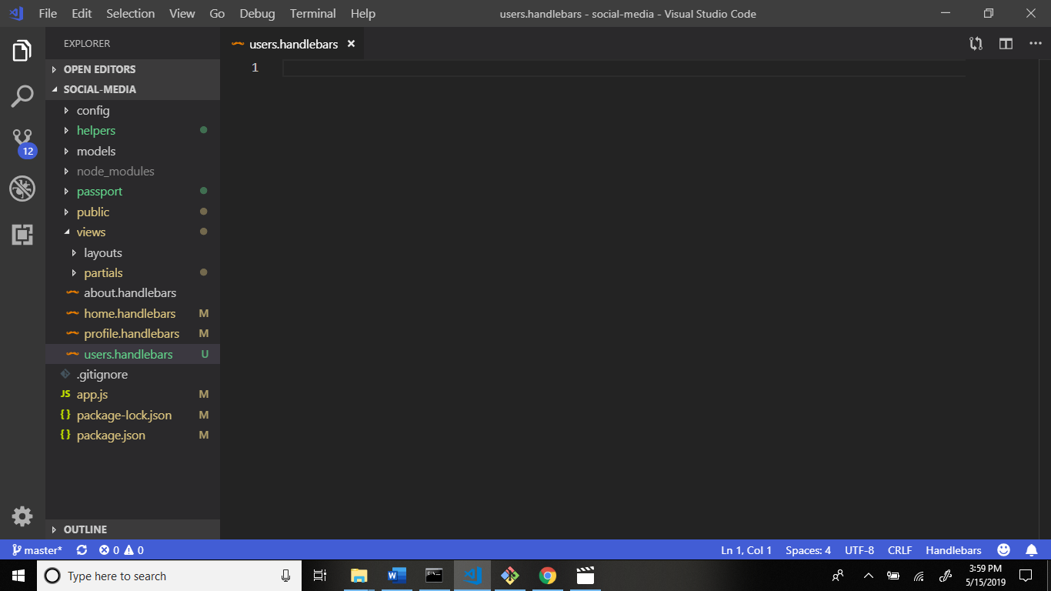

Write code this file.

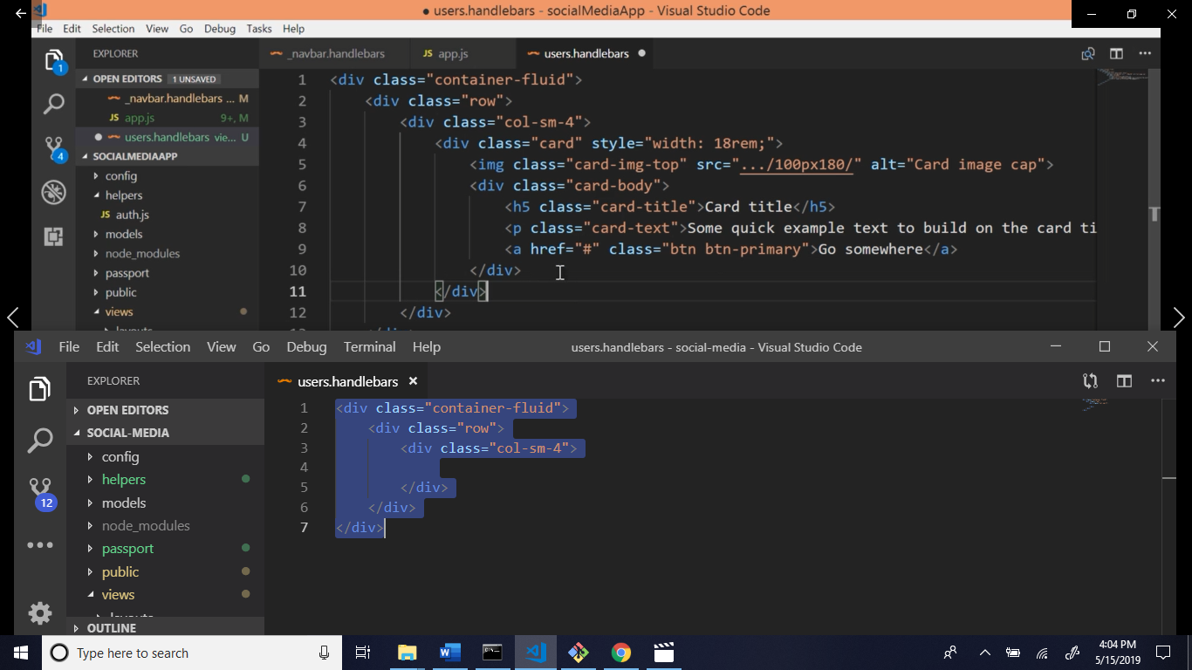

Firstly go to the bootstrap official website and search the card.

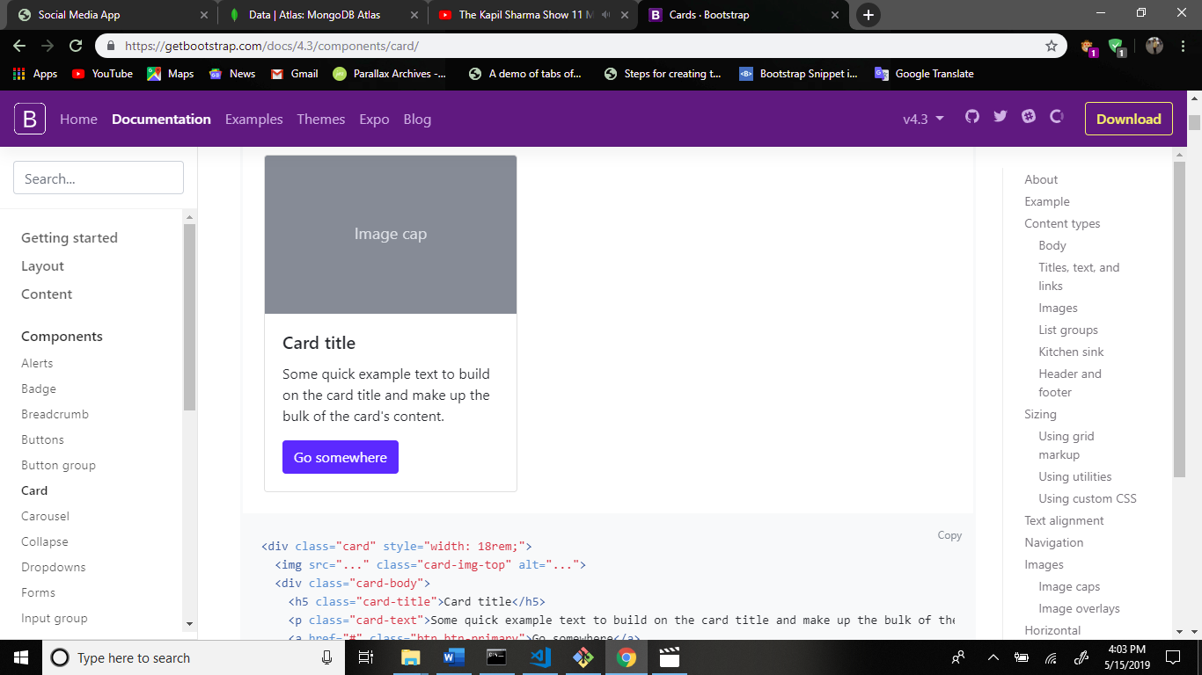

Copy this code and paste the users.handlebars file.

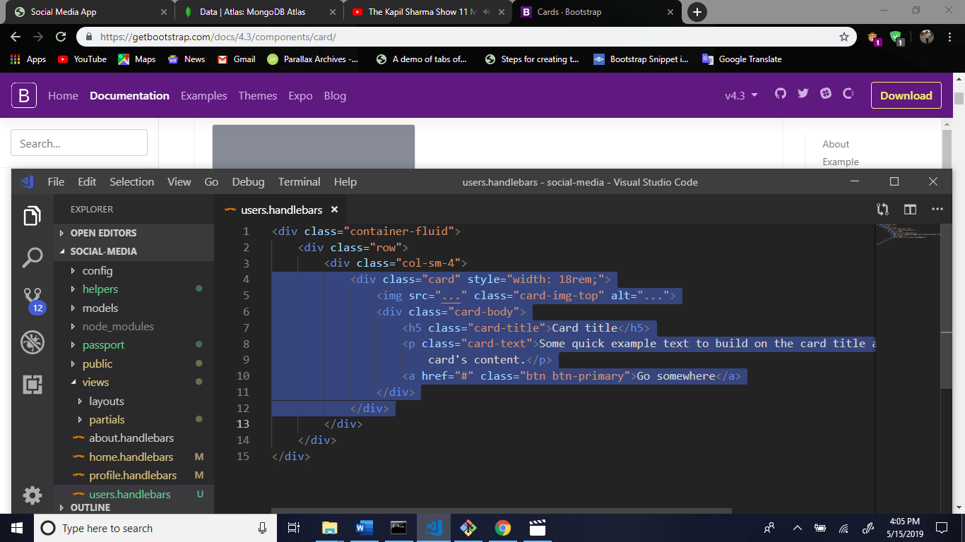

Now some changes this code.

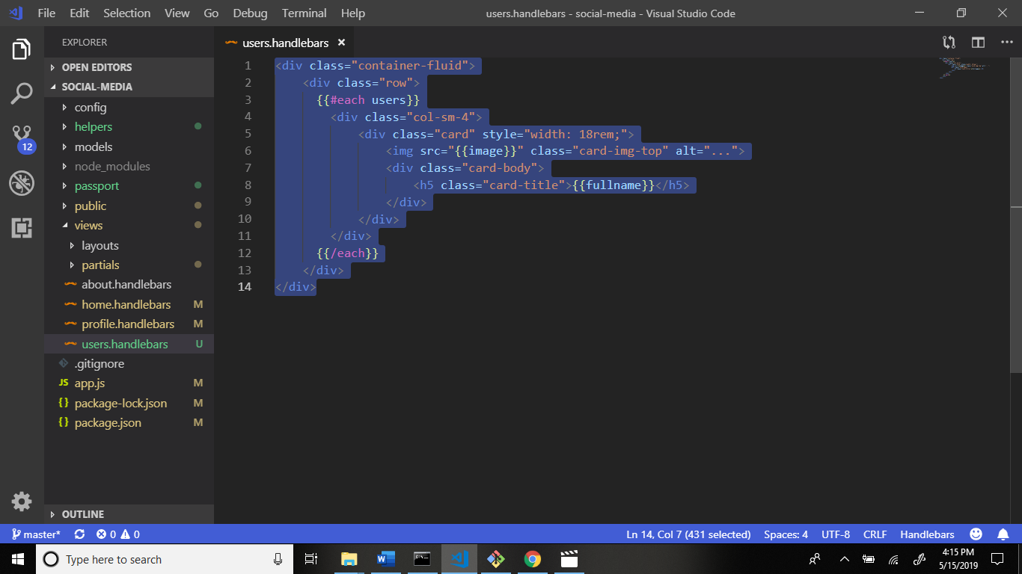

Output:

Click this:

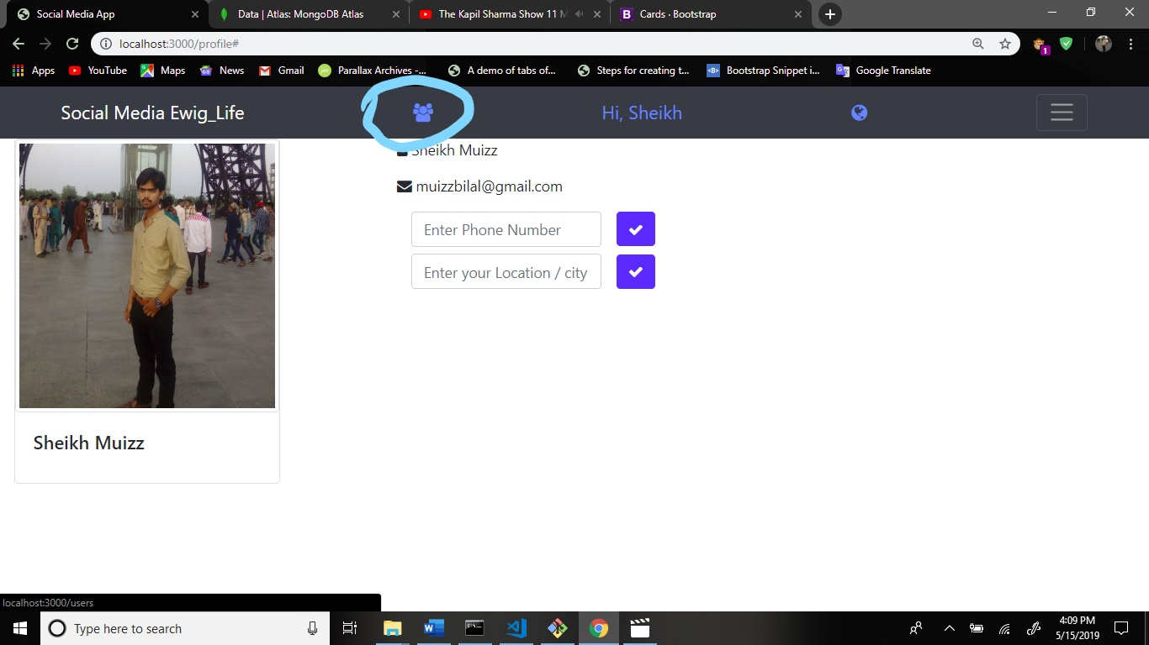

After:

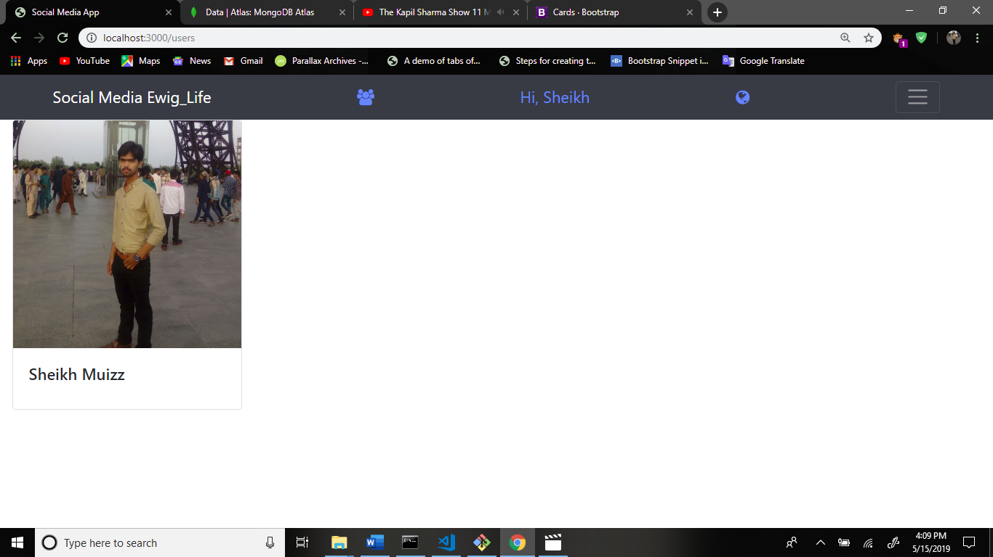

Now go to the navbar.handlebars file and some changes.

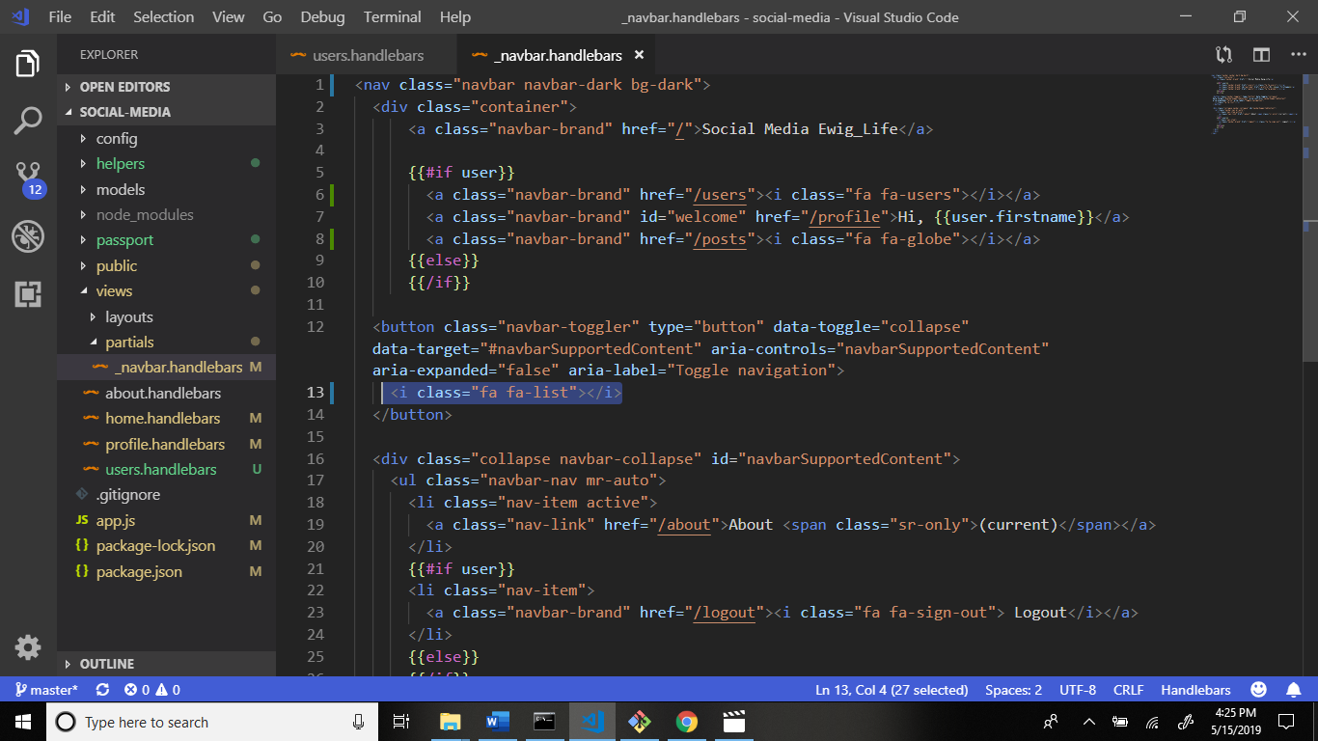

Output:

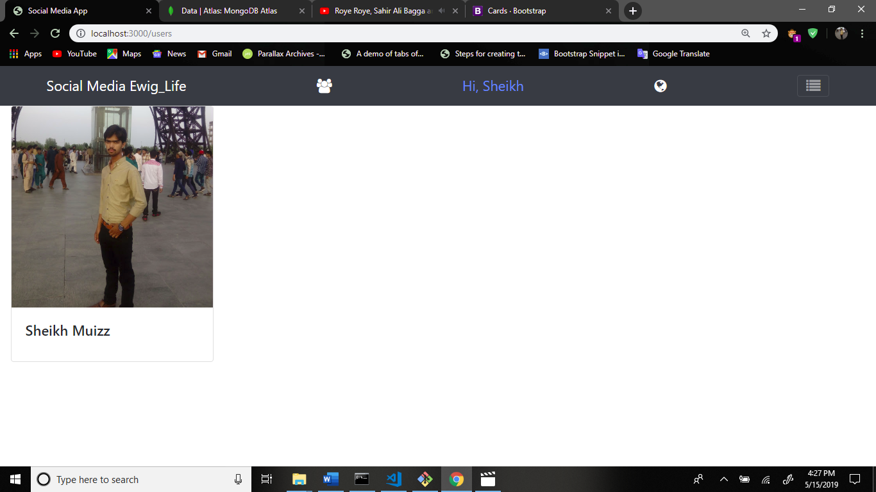

After this we create footer section. So create a file _footer.handlebars in partials folder. 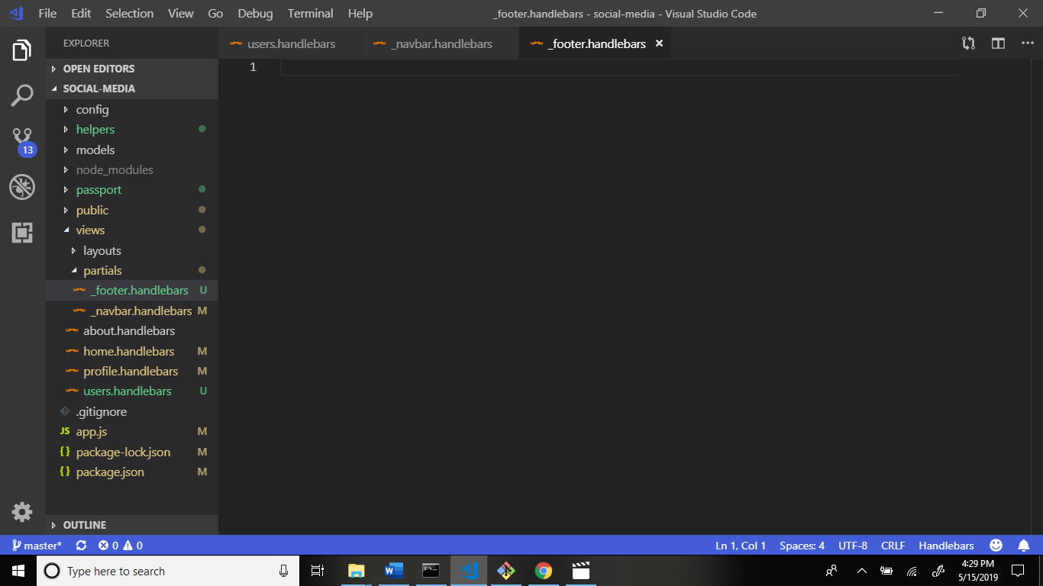

Now write code.

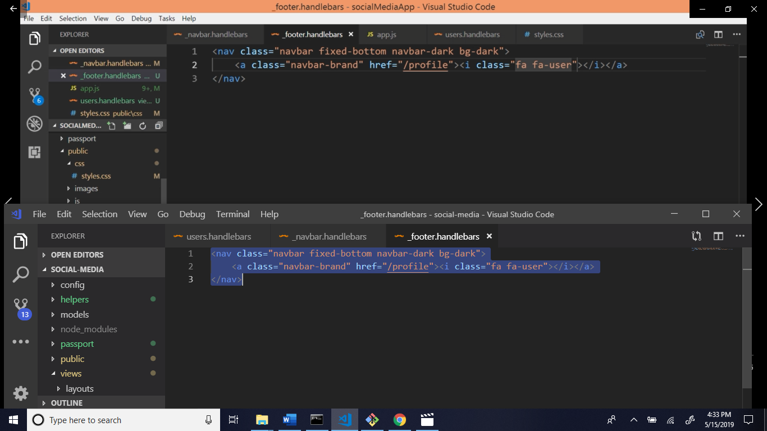

Now go to the main.handlebars file and call the footer section.

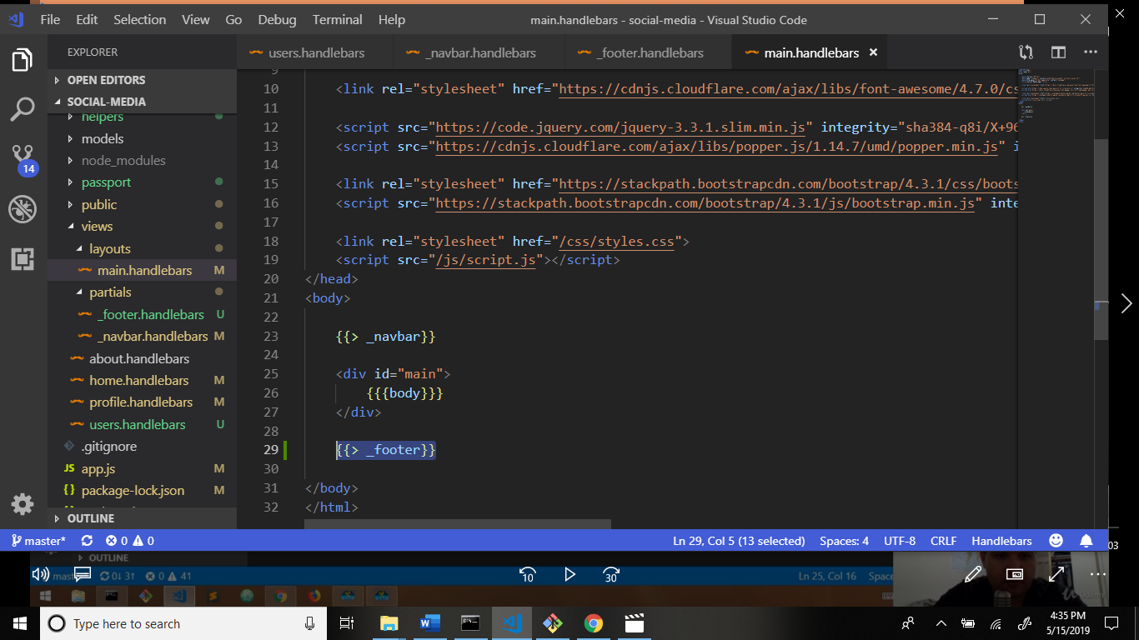

Output:

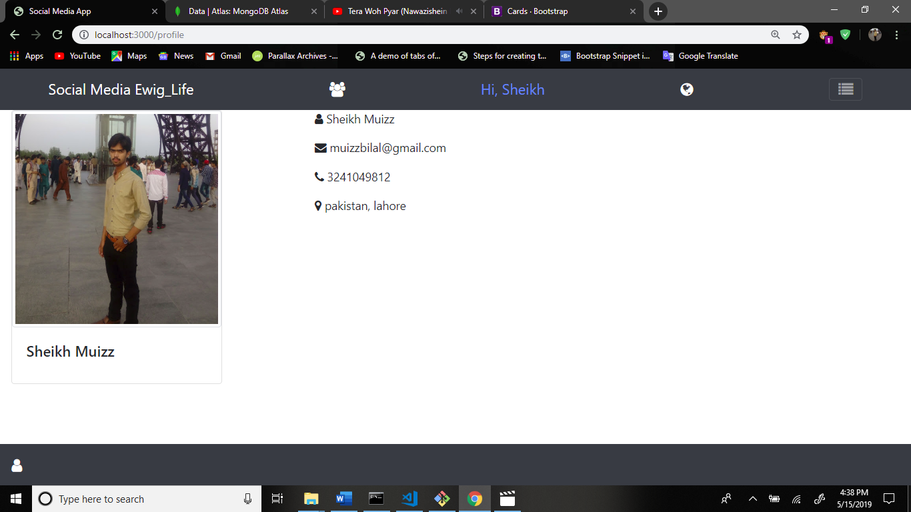

Now remove the name in navigation bar.

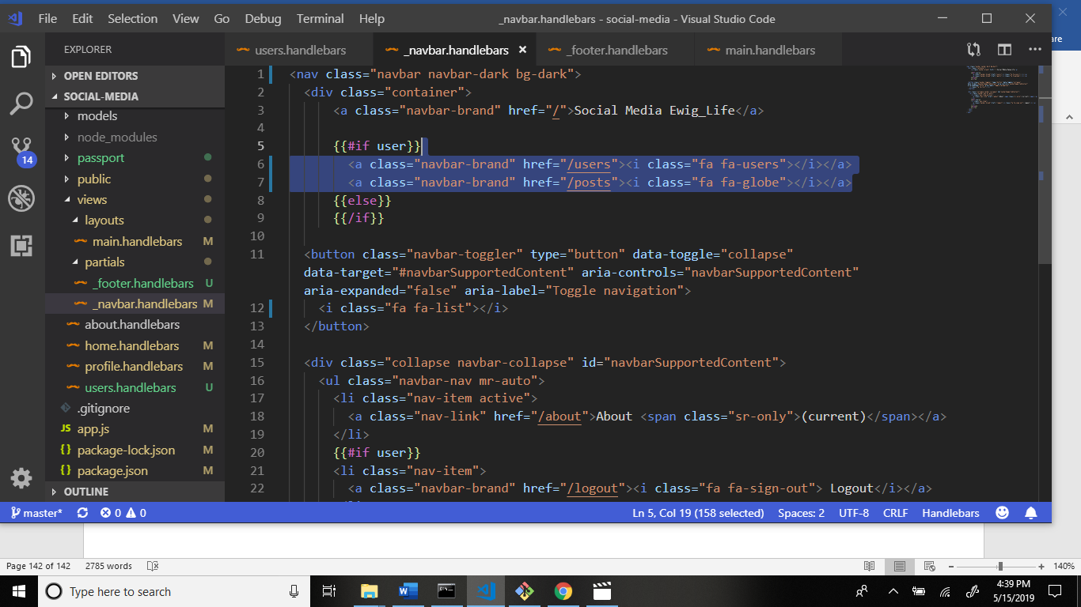

Output:

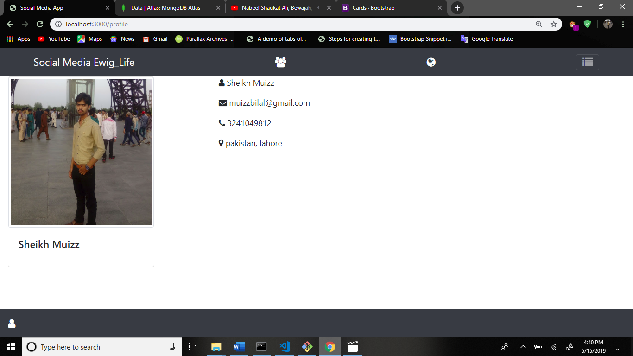

Now some code add in _footer.handlebars file.

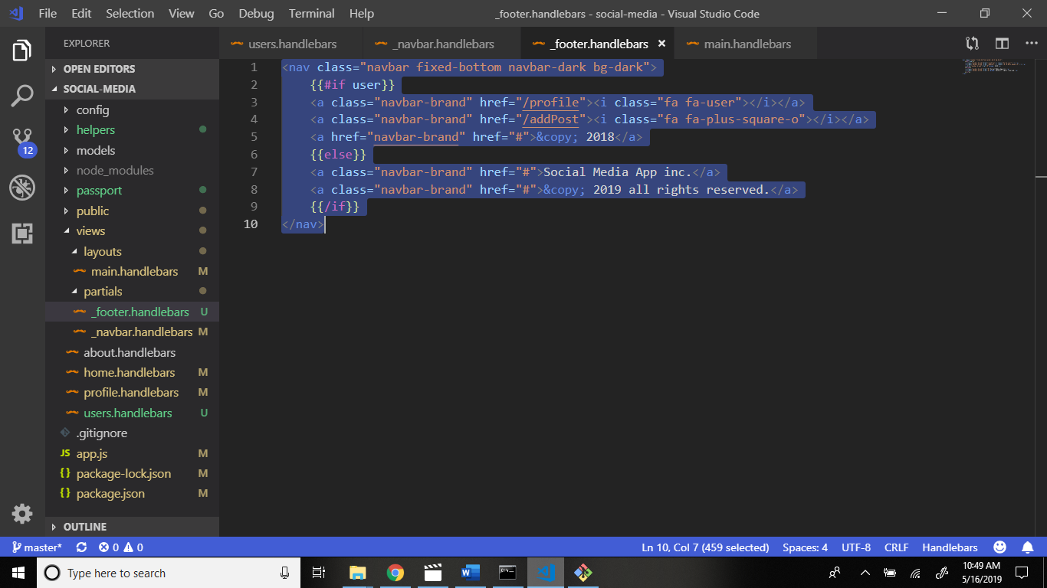

Output:

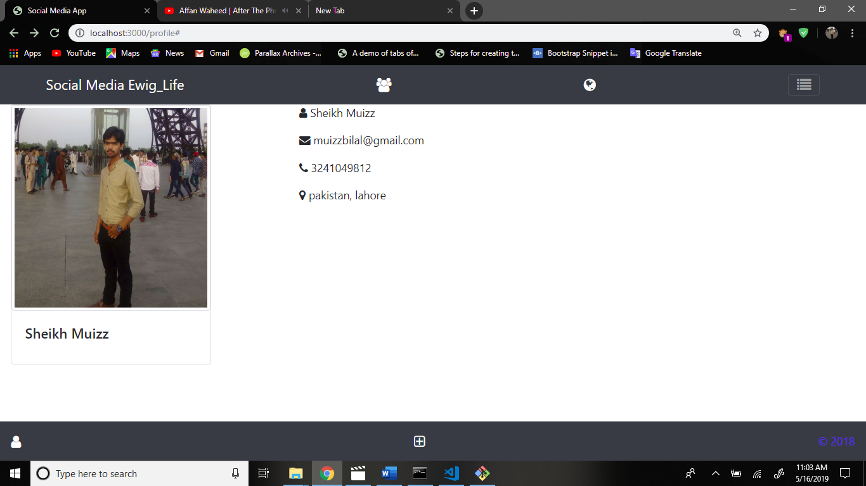

Now go to users.handlebars file and write code.

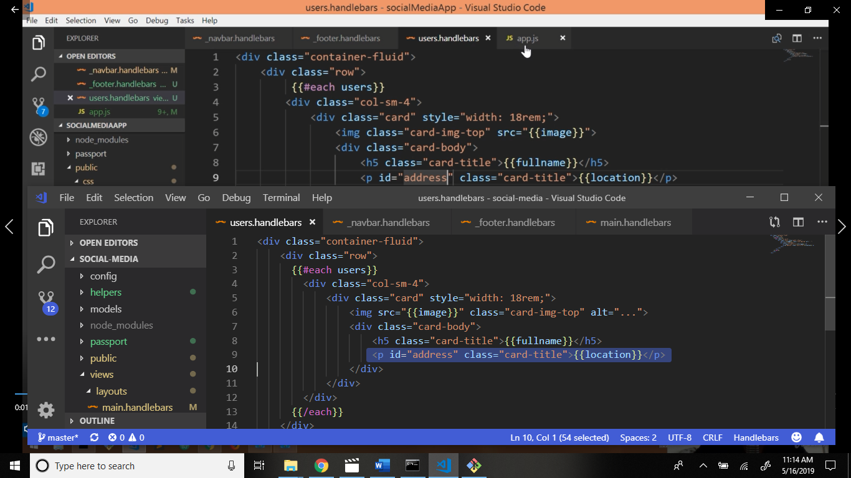

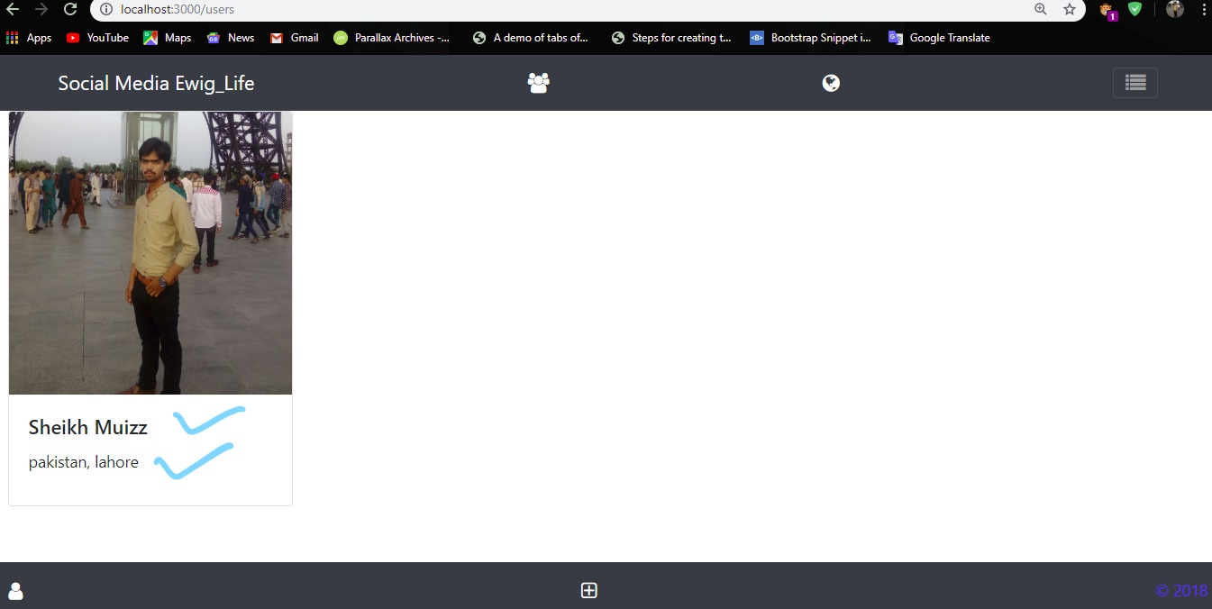

Now go to style.css file in css folder.

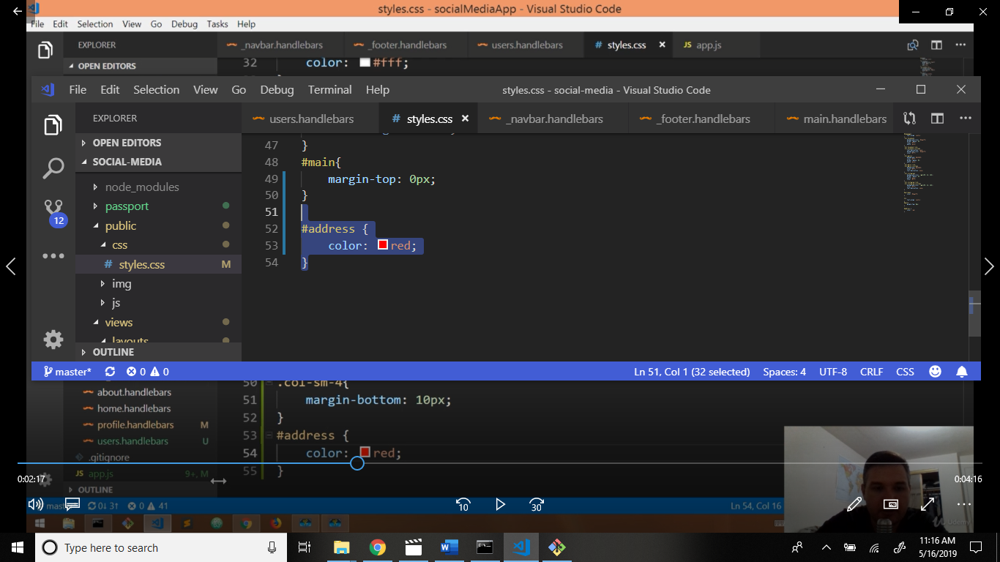

Now again go to users.handlebars file and write code.

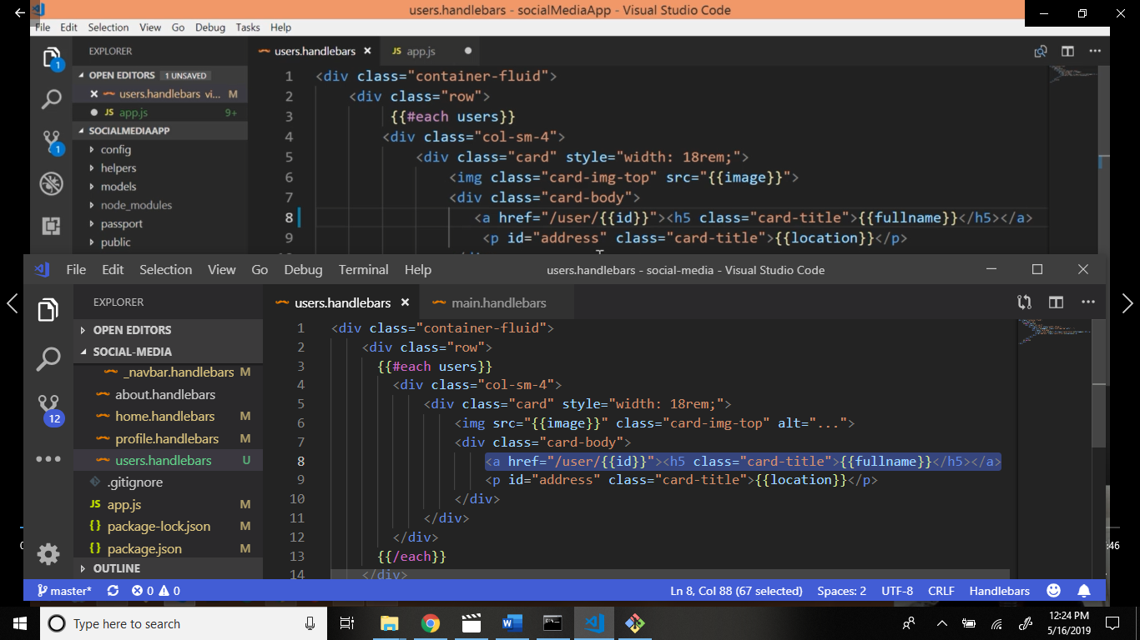

Output:

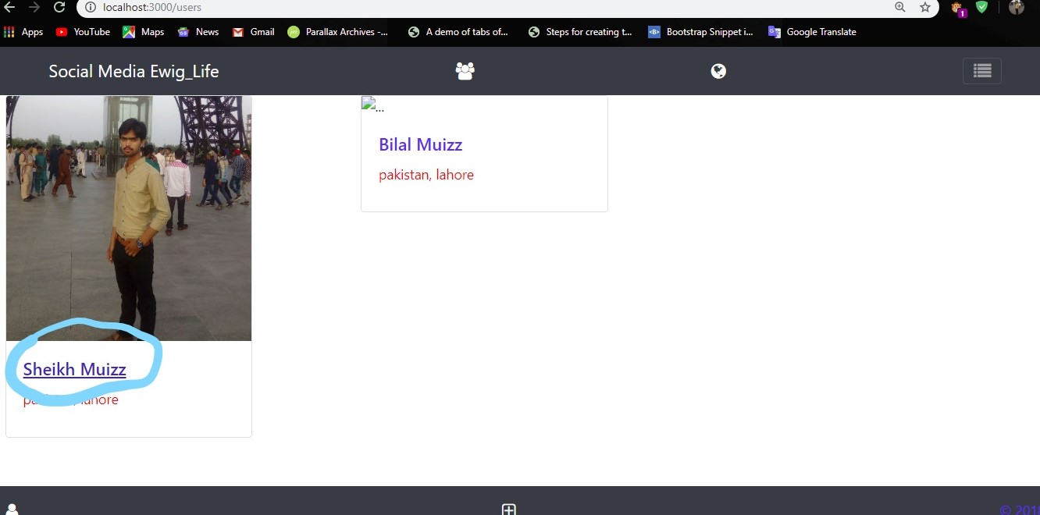

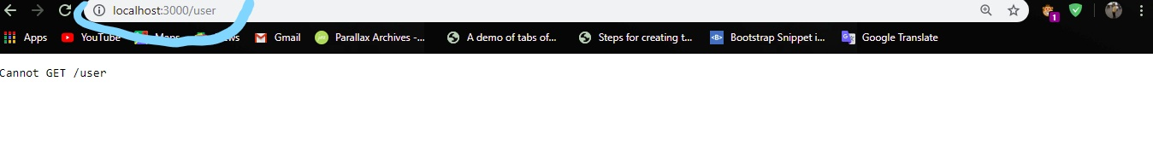

Now go to app.js file get routing and render the user information after the users route.

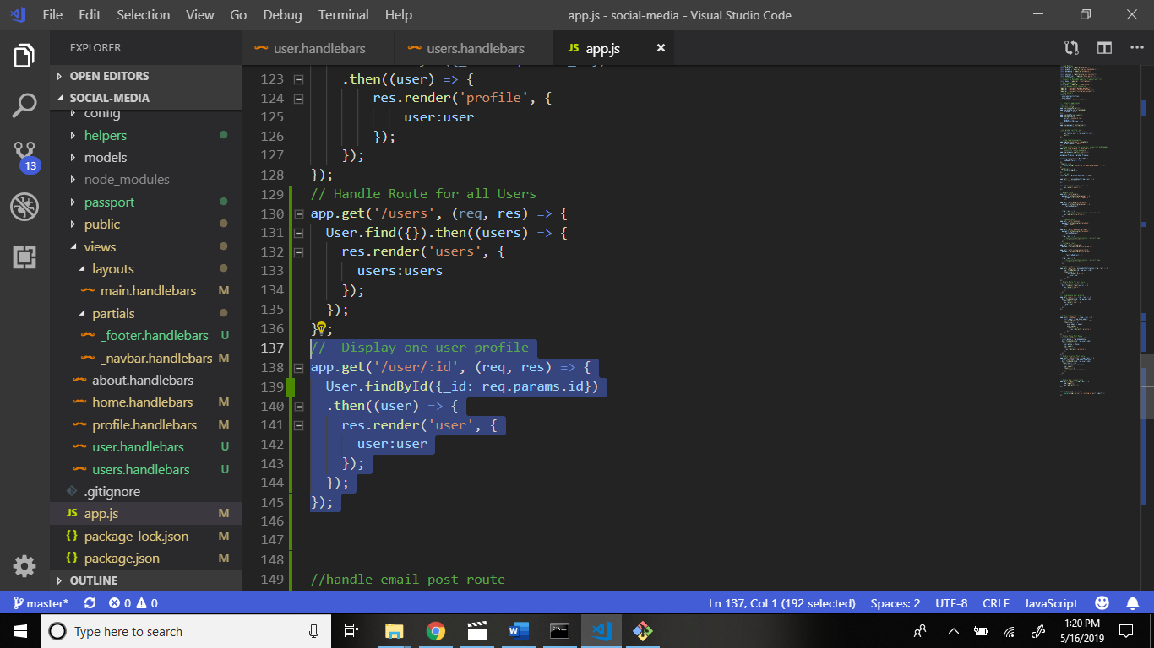

Now we create file user.handlebars in views folder.

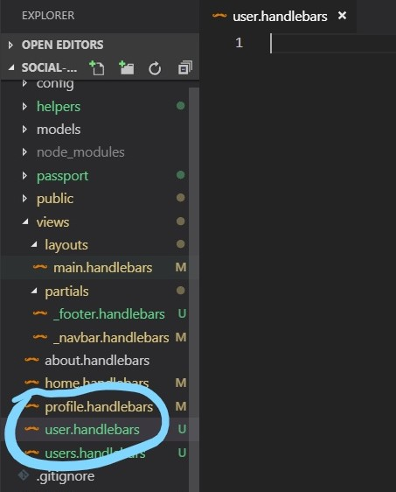

Write code.

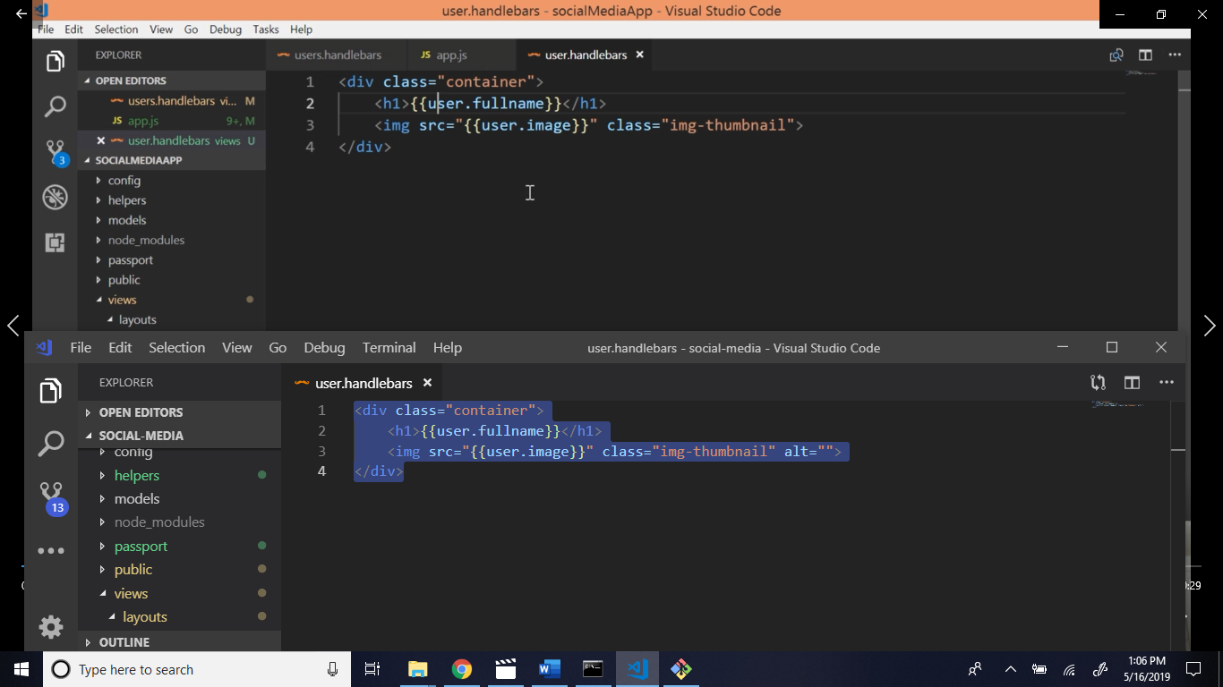

Output click the name:

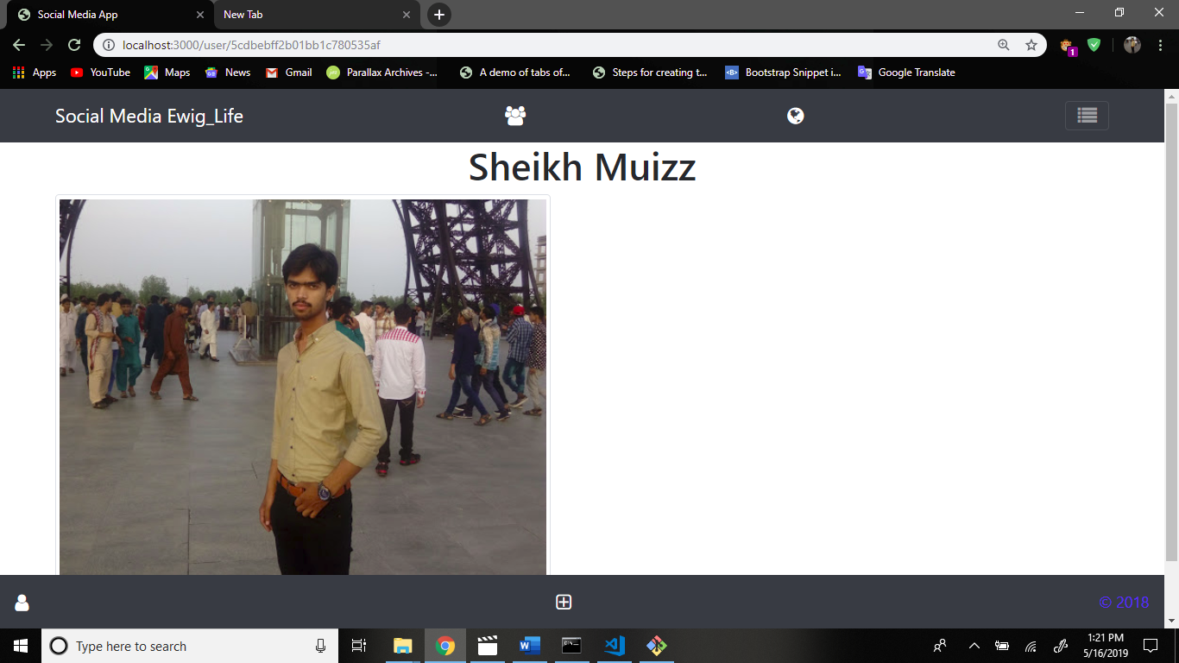

Now add some code in user.handlebars file.

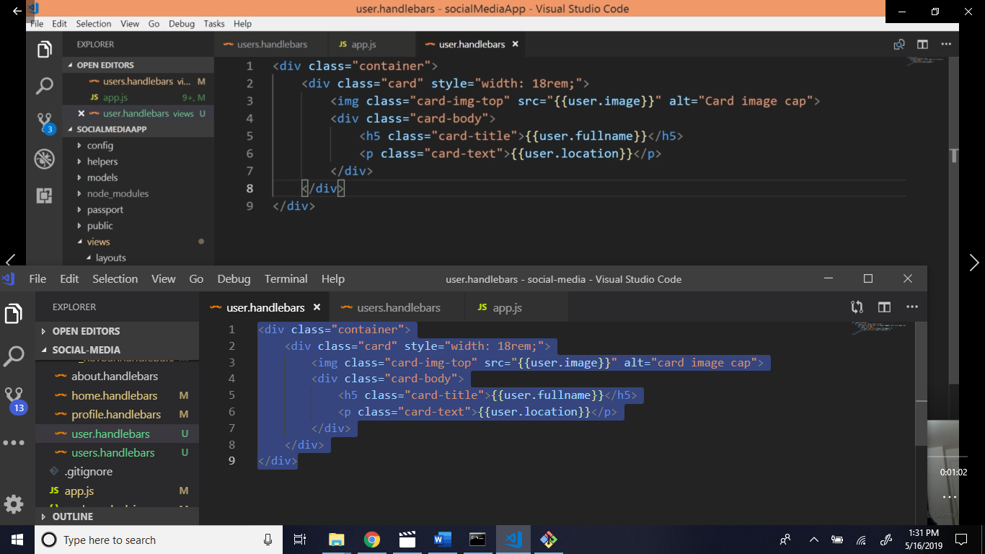

Now see output:

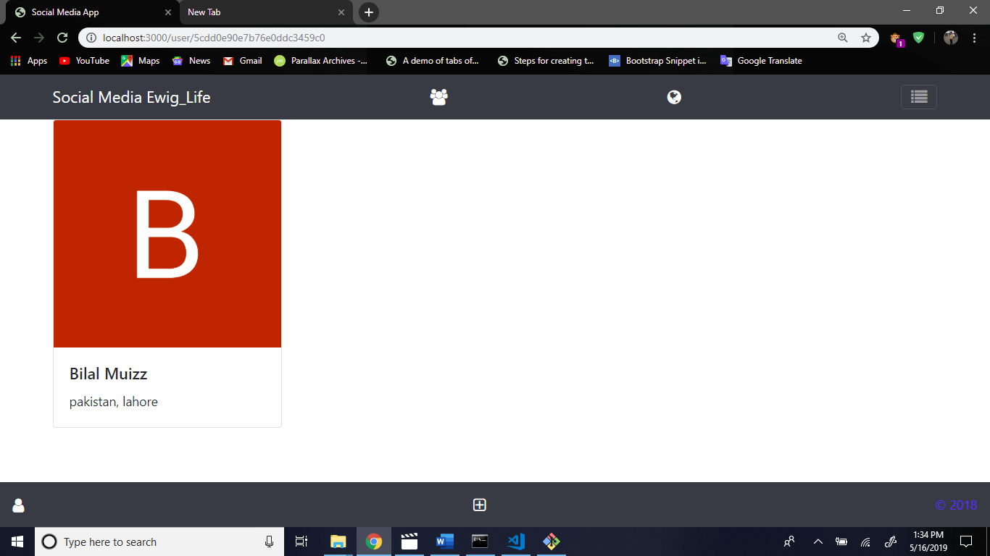

Now add code for posts section.

Firstly create file post.js in models folder.

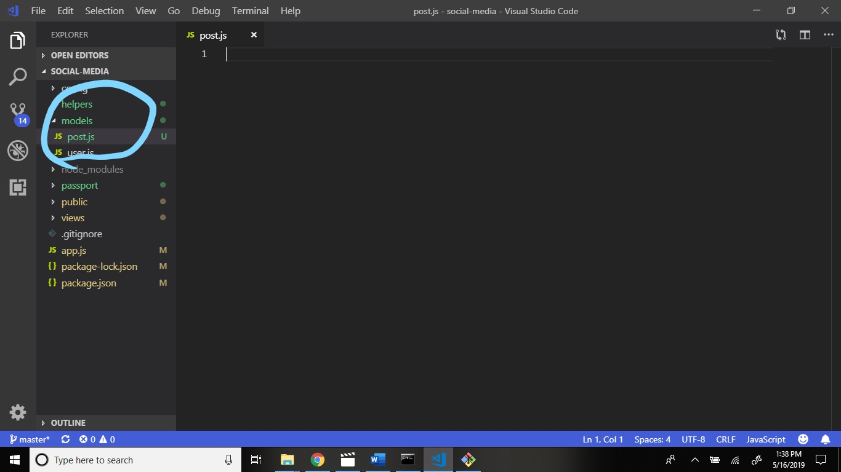

Now write code and define schema (means pattern).

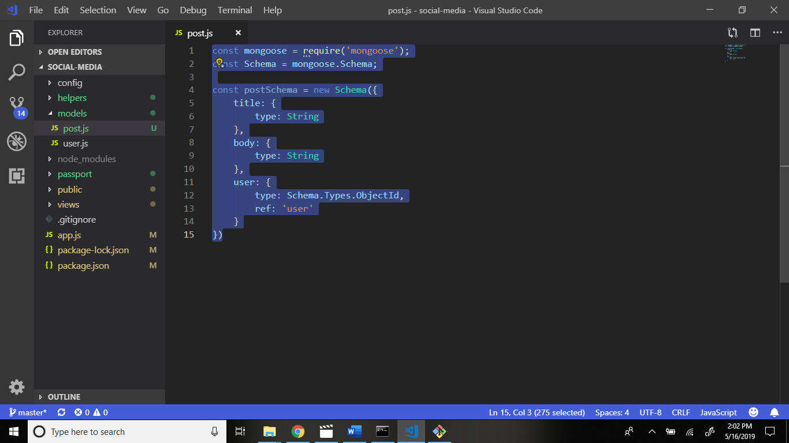

Now add comments section pattern define.

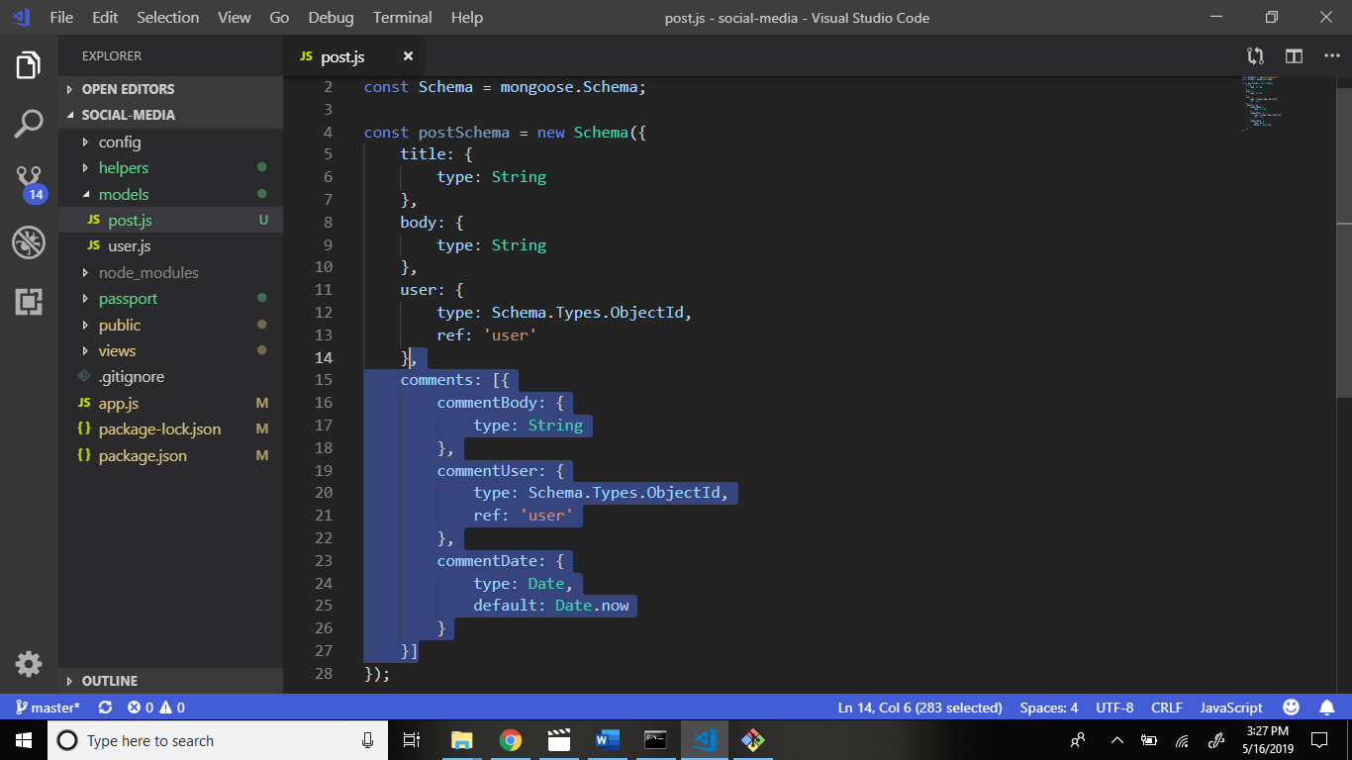

Now add module export.

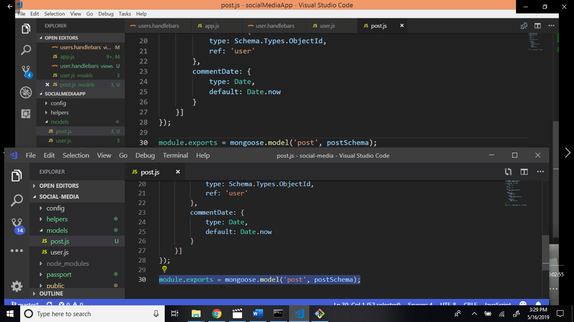

Now this file require in app.js file.

Go to app.js file and write code.

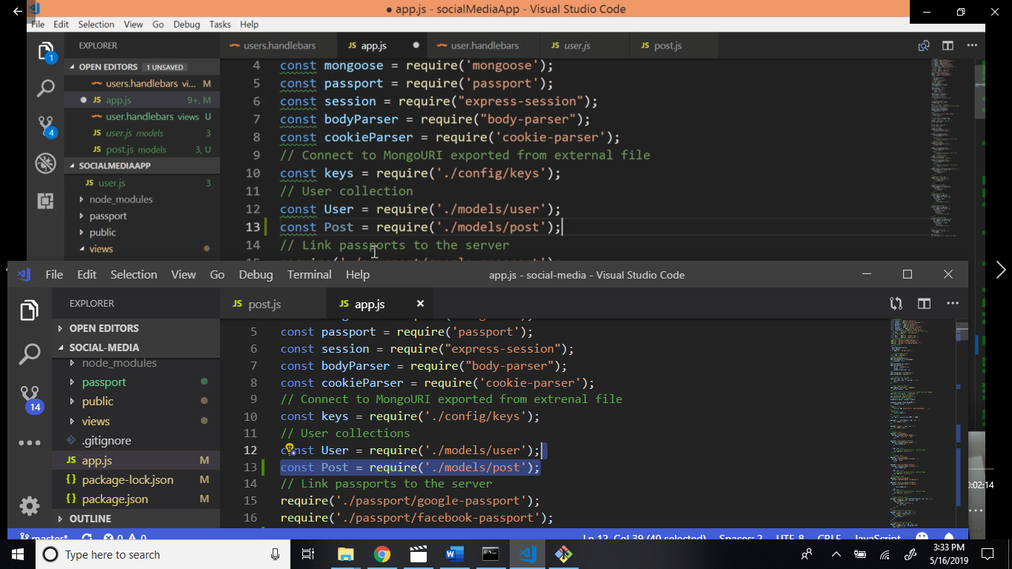

Now add date, status, allowcomment schema in post.js file.

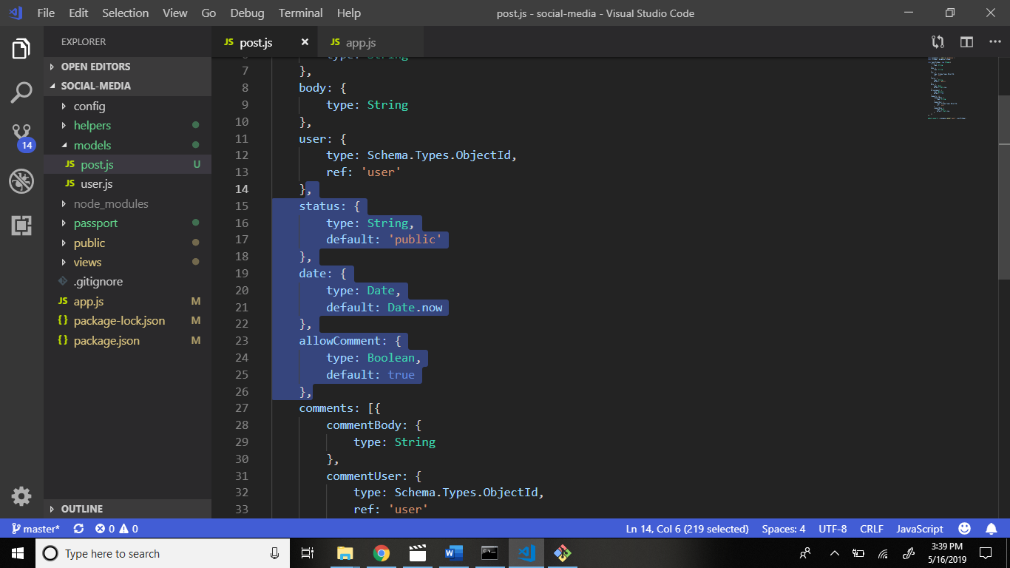

Firsly handle the post route.

Go to app.js file write code after the location route.

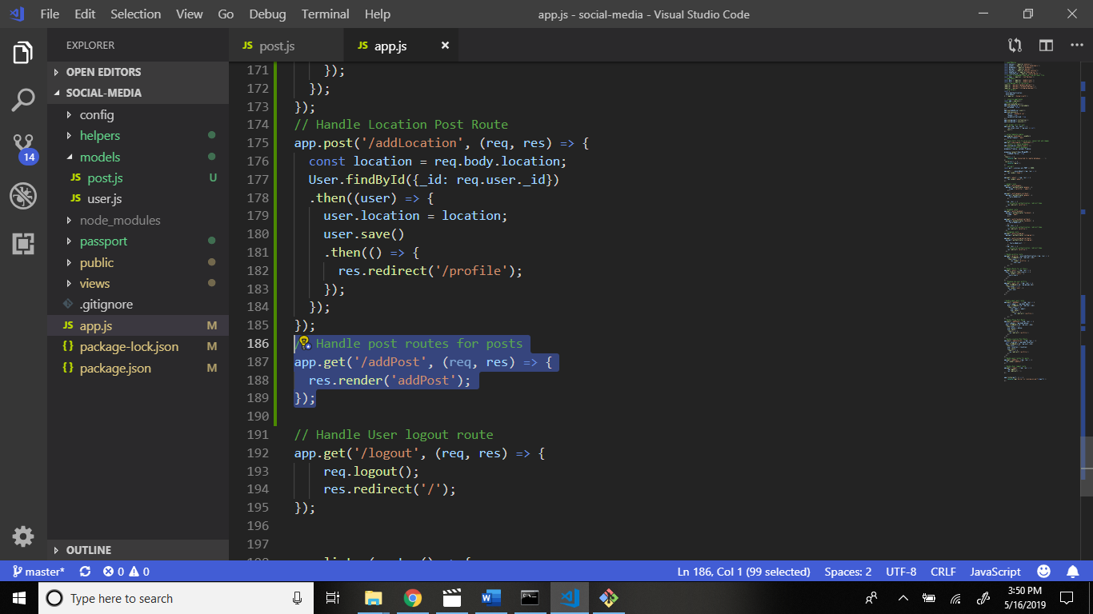

Now create file addPost.handlebars in views folder.

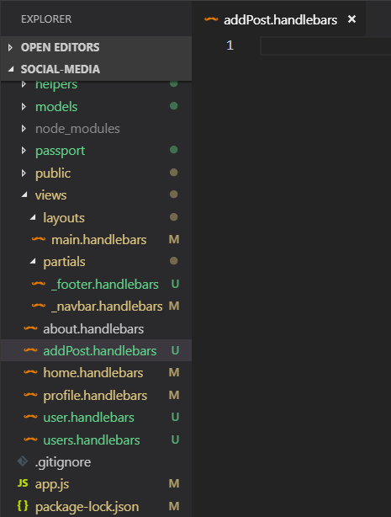

Now go to the official bootstrap website.

Copy this code and paste the addPost.handlebars file.

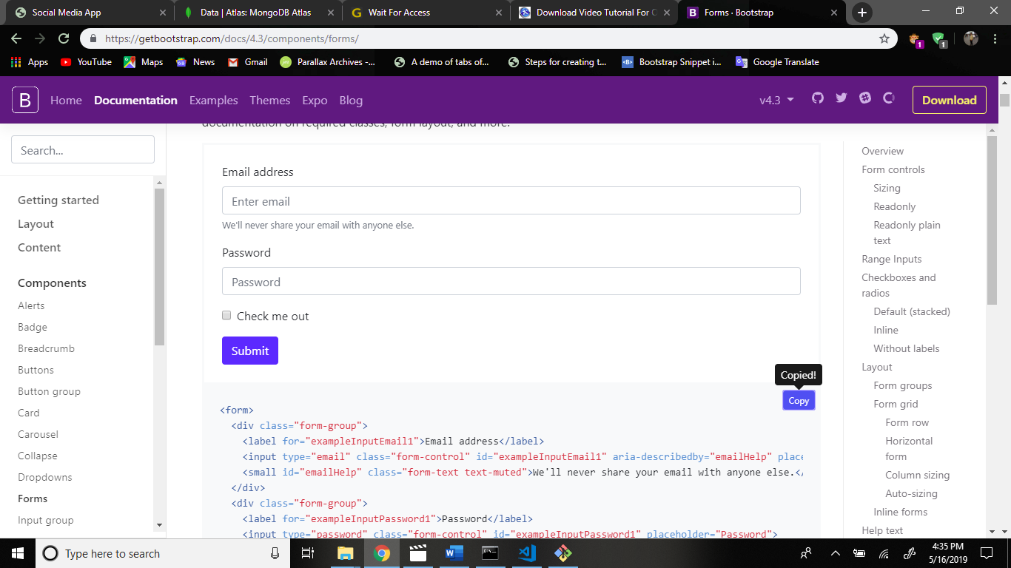

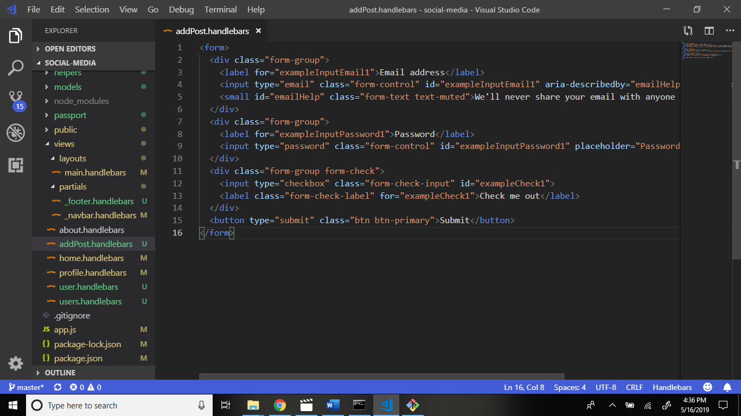

Now some changes this code.

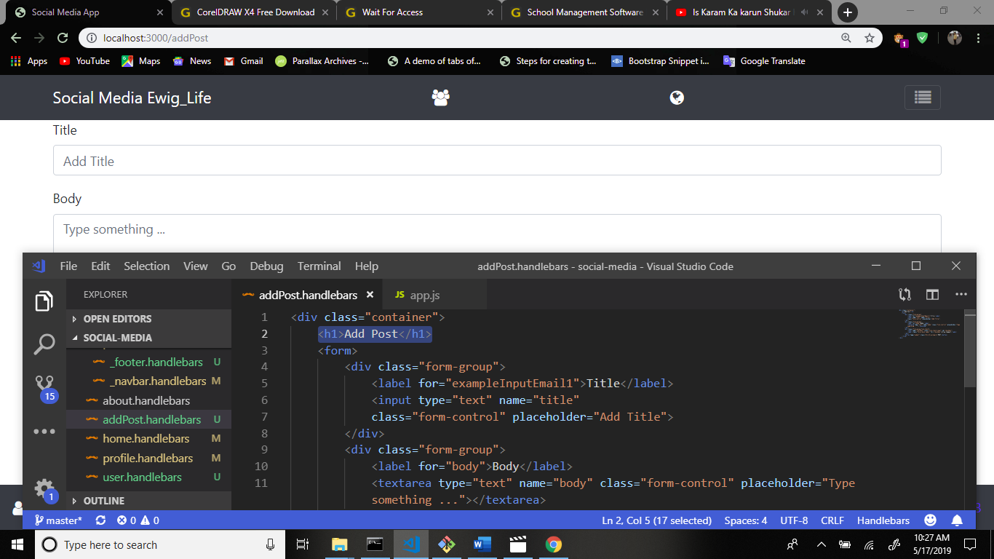

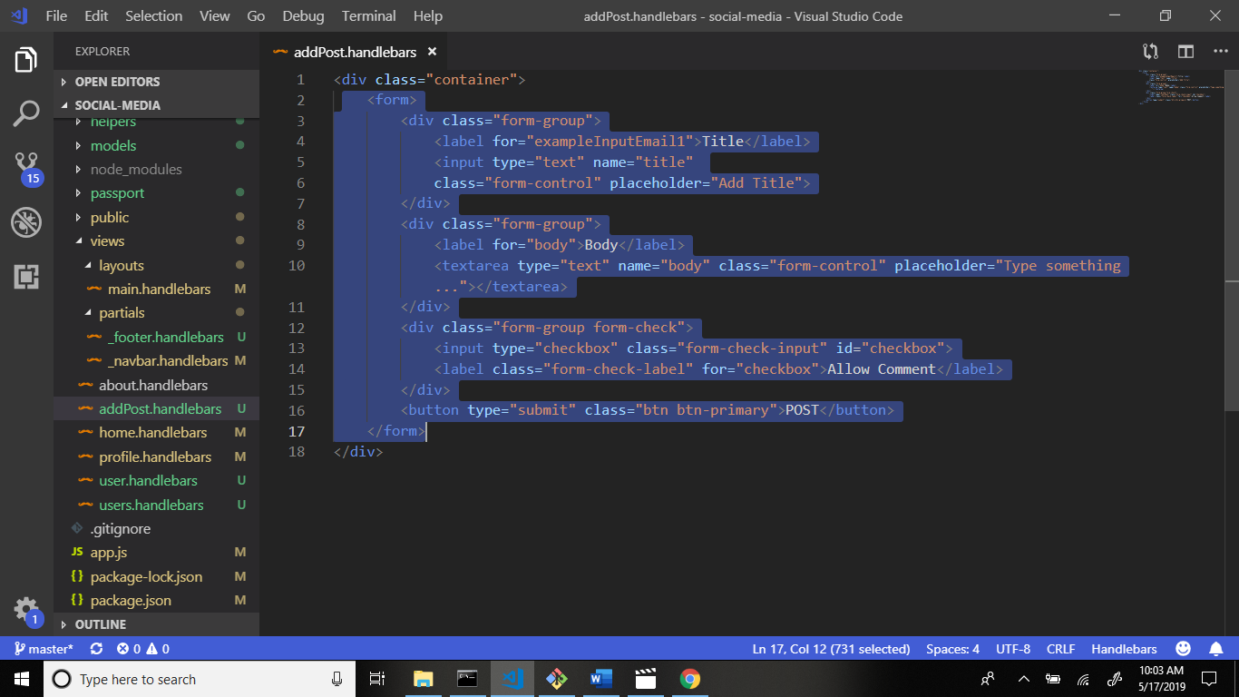

Now click this add post button.

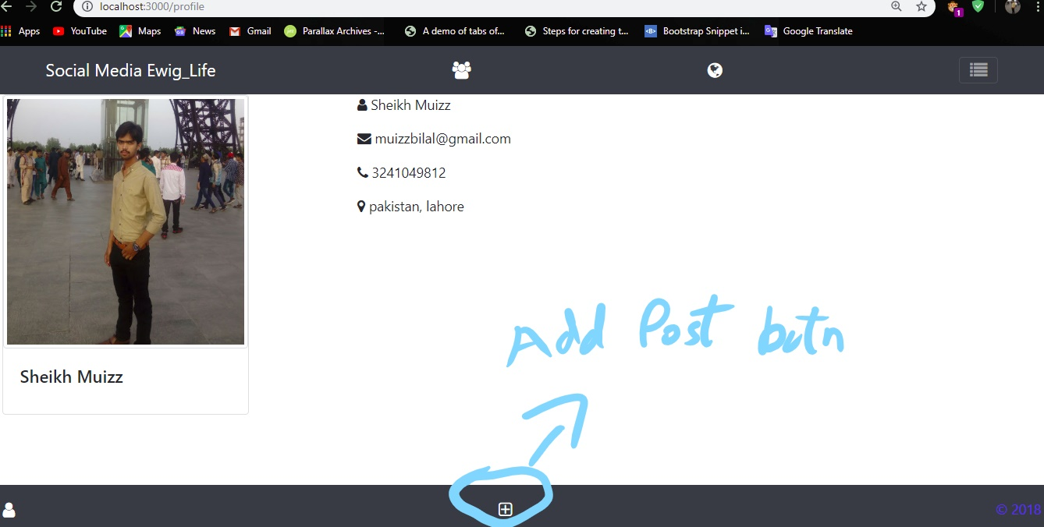

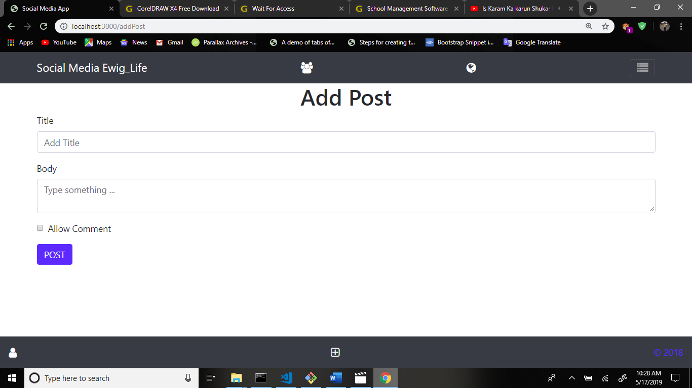

Now go to app.js file and write code for the correct path authentication from the users handling.

If user is login then show the users page otherwise redirect to the main page.

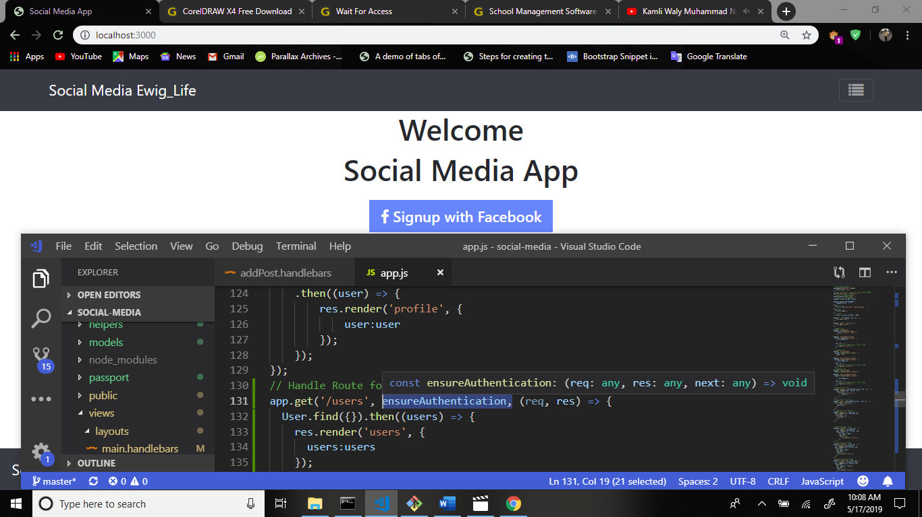

If you enter this url then show this output.

